**15848485 Leandri Kleyn Application Types Assignment 9 Feb 2012**

**Types of Applications**

1. **Web applications (Django)**

What is a web application?

A web application is a self-contained sub tree of the website1. You must write a web application to provide a website. It uses Servlets, Filters and JSP and any other java code to provide responses to client’s HTTP requests. Each web application is stored on and runs from the web server. It has a unique name and path or URL for ex. <http://server/webapp-name>. Scripts are coded to use for web applications. Examples of web applications include webmail, online retail sales, online auctions and wikis.

Benefits:

* Browser apps require little disk space on the client computer.
* Web apps do not require complex procedures to deploy in large organizations.

Drawbacks:

* Standards compliance is an issue with any non-typical office document creator, which causes problems when file sharing and collaboration becomes critical.
* They depend entirely on the availability of the server delivering the application.

When you would use them

You can use it when you are on the internet at your desktop computer or laptop.

Why you would use them

You can use them for web information or for your own personal use. You can use it to find out the weather, to play games, to do networking, to watch sport scores and to keep track of current headlines.

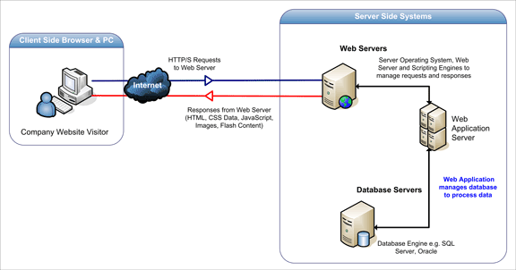

Demonstrative figure of web applications.2

1. **Mobile applications/ Tablet applications (CSharp)**

What is a mobile application?

Mobile apps are almost like internet applications that run on smartphones, cell phones and other mobile devices. Examples of mobile applications are a mobile-based instant messaging client, Gmail for mobile, Facebook for mobile, a web browser and games. People with an idea for an app start to train themselves to code and create it. The demand for mobile apps is growing each year, and so has the desire for the device to do more tasks to suit busy lifestyles.3 They are intended to enhance the features of portable devices.

Software requirements would be:

* Target mobile devices
* Functionality
* Usability
* Software security
* Software performance

When you would use them

Mobile apps are designed to educate, entertain or assist consumers in their daily lives.

Why you would use them

Mobile applications help users by connecting them to internet service which is accessed on desktop computers.

1. **Server applications (no GUI)**

What is a server application?

Server applications are very important, because it’s the main source of storage. Thus, security and reliability is of upmost importance, because all client computers rely on a server. It should execute procedures efficiently and it contains application logic SQL services. An app server acts as a set of components accessible to the software developer through an API defined by the platform itself

.4 Examples are Java application servers, PHP application servers and Base4 Application Server. The EJB (Enterprise JavaBean) component model can be found on J2EE (Java 2 Platform, Enterprise Edition) application servers.

Advantages of application servers:

* Data and code integrity
* Centralized configuration
* Security
* Performance
* Total cost of ownership
* Transaction support

When you would use them

Servers runs 24/7 and rarely stop functioning, only for repair or if a failure occurs. Application servers provide methods that client applications can call and serve business logic to application programs through a number of protocols.

Why you would use them

You would use them in big companies so that the main servers can function. Servers keep backups and provide information based on user requests.

Applications for server operating systems:

* Printer and file sharing
* Caching
* Website services
* Terminal services
* Email, groupware and messaging



Abstract figure of the interaction between a server and computers.5

1. **Desktop applications (Utilities, browsers, mail clients (CSharp))**

What is a desktop application?

A desktop application is an application that runs stand alone in a desktop or laptop computer. It is different from a web application for the latter requires the Web browser to run. Examples are Feedalizer, Twhirl, Windows Live Writer, Google Analytics (AIR) and Microsoft Office. Google recently launched Google Desktop which makes it easier for users to search their own PCs for emails, files, music, photos, Web pages and more. Desktop apps run offline and run off the web browser. It is computer software designed to help the user to perform specific tasks. System software serves the application, which in turn servers the user.

When you would use them

You would use desktop applications when you work on your desktop personal computer or laptop.

Why you would use them

Different types of application software would indicate why you would use them.

Classification of application software:

* Enterprise software
* Accounting software
* Office suites
* Graphics software
* Media players
* Information worker software
* Educational software
* Simulation software

1. **Scripts (Python)**

What are scripts?

A computer script is a list of commands that are executed by a certain program or scripting engine. Script files are text documents that contain instructions written in a certain scripting language. Most scripts can be opened and edited using a basic text editor. A script language is a simple programming language with which you can write scripts. It is also used for finding and showing

websites on the internet.

Types of scripting languages:

* Job control languages and shells
* GUI scripting
* Application-specific languages
* Web browsers
* Text processing languages
* General-purpose dynamic languages
* Extension/embeddable languages

When you would use them

Scripts may be used to automate processes on a local computer or to generate Web pages on the Web.

Why you would use them

DOC scripts and VB Scripts may be used to run processes on Windows machines, while AppleScript scripts can automate tasks on Macintosh computers. ASP, JSP and PHP scripts are often run on Web servers to generate dynamic Web page content.6

**Footnotes**

1<http://www.caucho.com/resin-3.0/webapp/begin.xtp#Example-web-application>

2<http://www.acunetix.com/websitesecurity/web-applications.htm>

3<http://www.ehow.com/facts_6001849_define-mobile-application.html>

4<http://en.wikipedia.org/wiki/Application_server>

5<http://www.2x.com/applicationserver/features/>

6http://www.techterms.com/definition/script