**Leandro de Melo Silva**

**Trainee Cast Group**

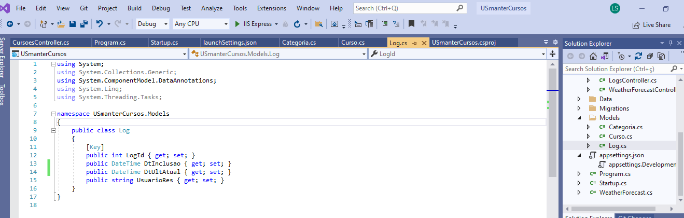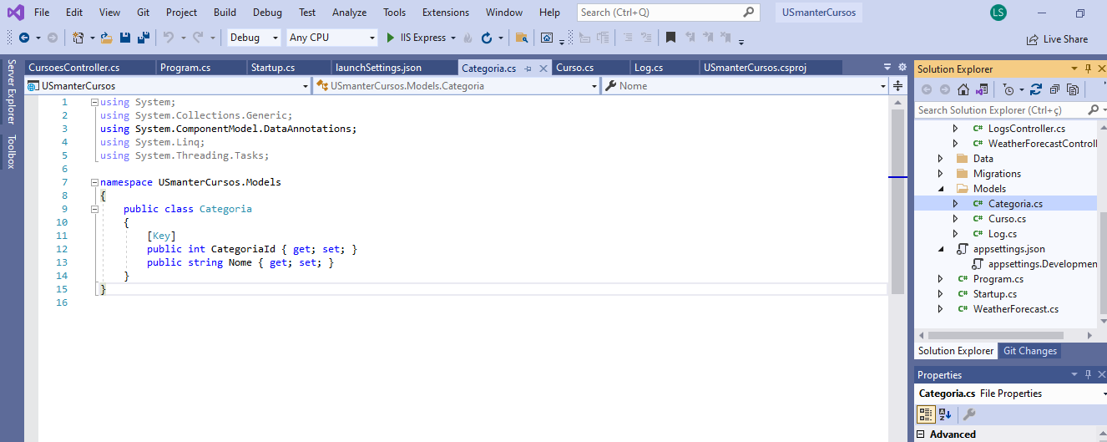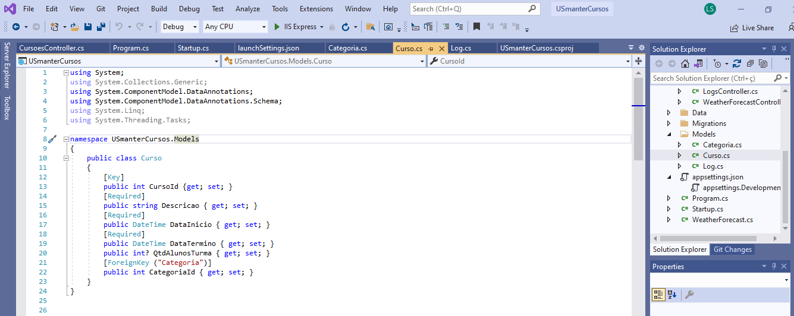Back-End - Models Criadas

Configuração Conexão com banco de Dados

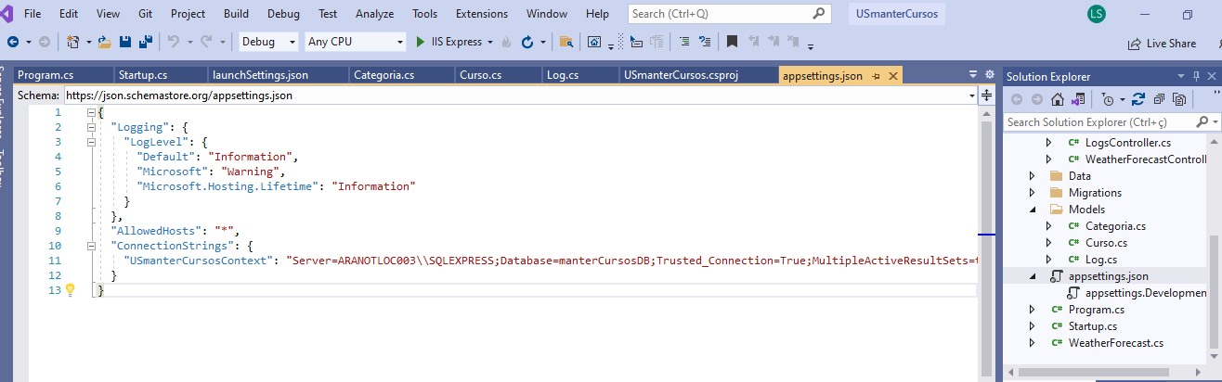

Configuração da Porta URL

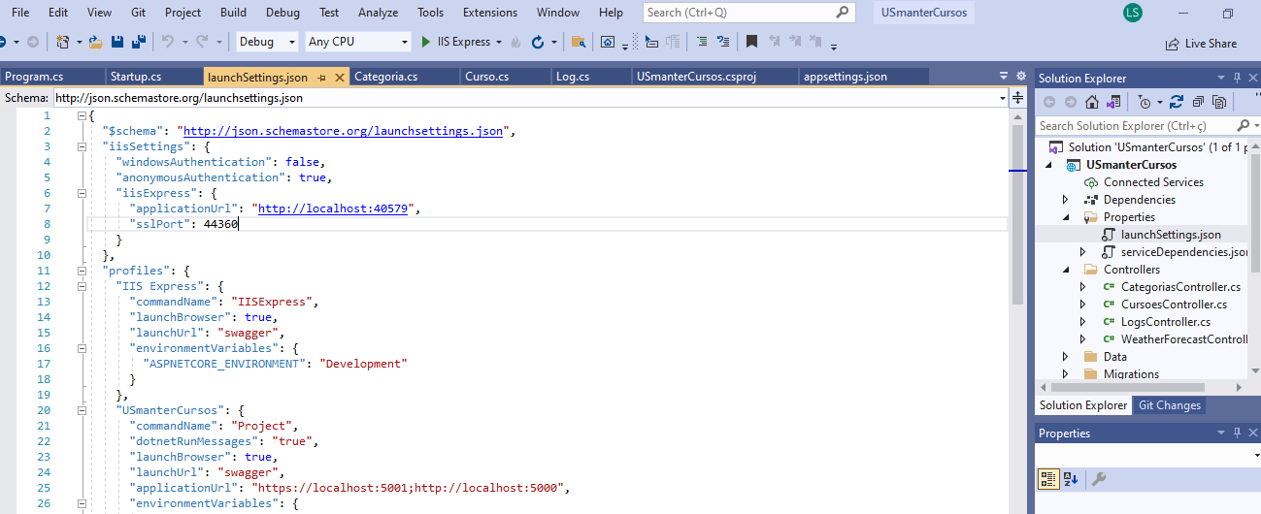

Migrations Realizadas

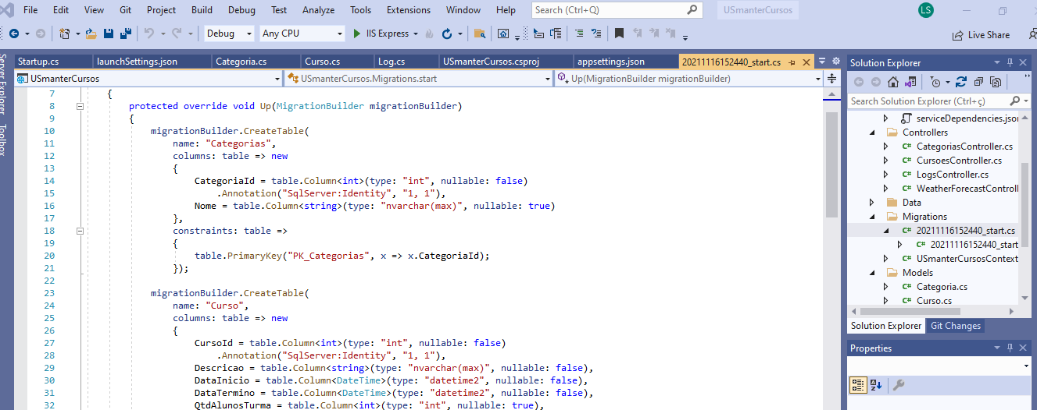

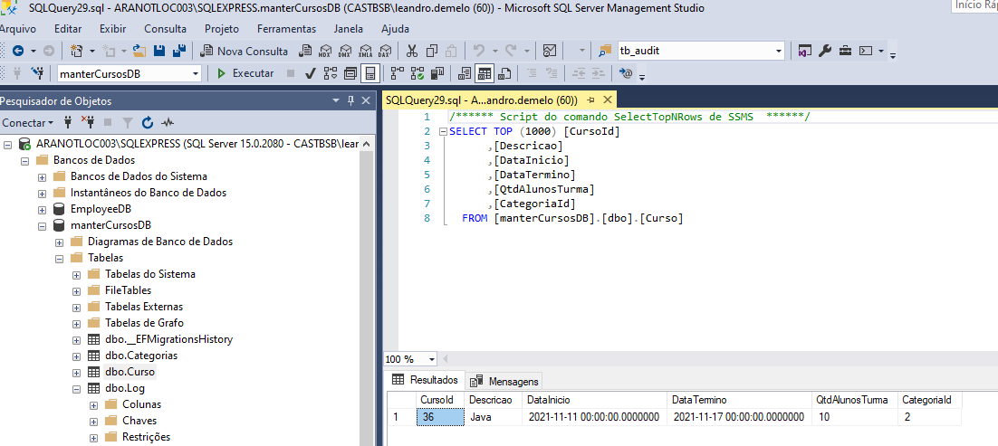

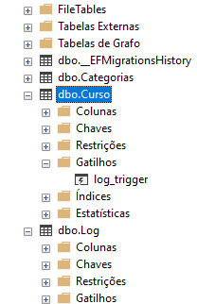

Script Banco de Dados

IF OBJECT_ID(N'[__EFMigrationsHistory]') IS NULL

BEGIN

CREATE TABLE [__EFMigrationsHistory] (

[MigrationId] nvarchar(150) NOT NULL,

[ProductVersion] nvarchar(32) NOT NULL,

CONSTRAINT [PK___EFMigrationsHistory] PRIMARY KEY ([MigrationId])

);

END;

GO

BEGIN TRANSACTION;

GO

CREATE TABLE [Categorias] (

[CategoriaId] int NOT NULL IDENTITY,

[Nome] nvarchar(max) NULL,

CONSTRAINT [PK_Categorias] PRIMARY KEY ([CategoriaId])

);

GO

CREATE TABLE [Curso] (

[CursoId] int NOT NULL IDENTITY,

[Descricao] nvarchar(max) NOT NULL,

[DataInicio] datetime2 NOT NULL,

[DataTermino] datetime2 NOT NULL,

[QtdAlunosTurma] int NULL,

[CategoriaId] int NOT NULL,

CONSTRAINT [PK_Curso] PRIMARY KEY ([CursoId])

);

GO

CREATE TABLE [Log] (

[LogId] int NOT NULL IDENTITY,

[DtInclusao] datetime2 NOT NULL,

[DtUltAtual] datetime2 NOT NULL,

[UsuarioRes] nvarchar(max) NULL,

CONSTRAINT [PK_Log] PRIMARY KEY ([LogId])

);

GO

INSERT INTO [__EFMigrationsHistory] ([MigrationId], [ProductVersion])

VALUES (N'20211116152440_start', N'5.0.12');

GO

COMMIT;

GO

Front End

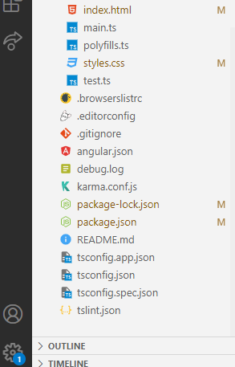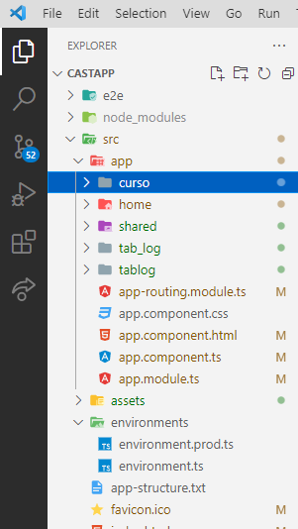

Em funcionamento

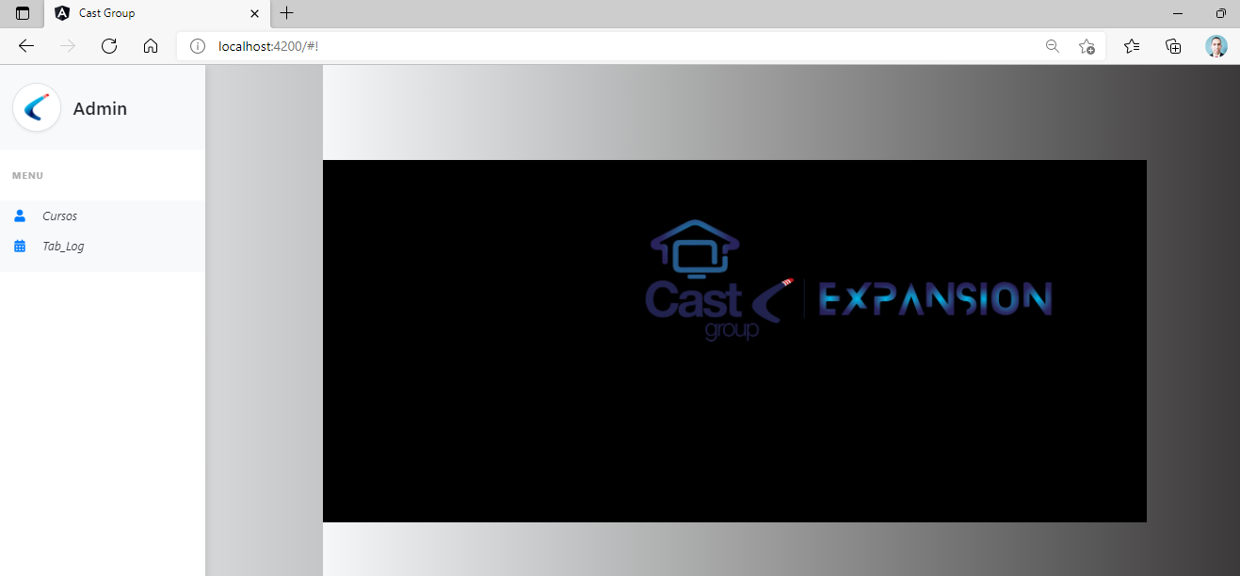

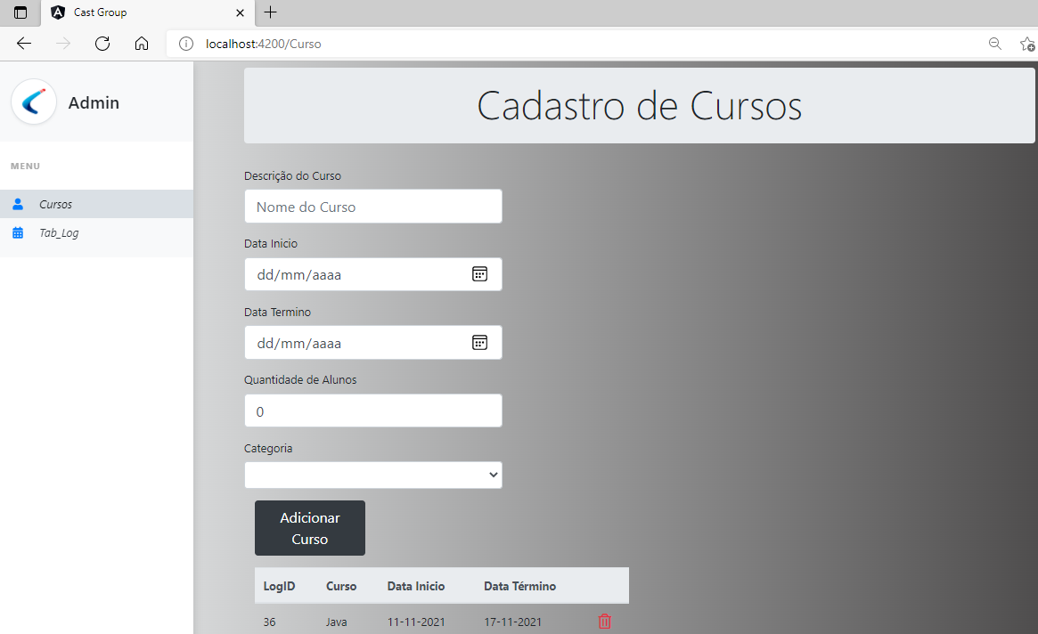

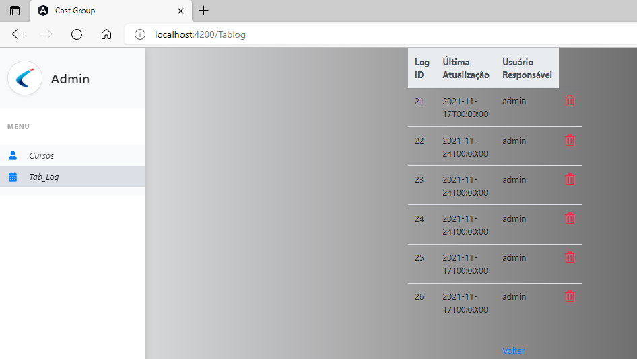

Evidências de Teste

