Execicio 4

Leandro de Souto Lima - 116211245

Questao 1
#codigo
X <- c(1,2,3,3,5);
media2 <- 1:1000;
media3 <- 1:1000;
media2ComReposicao <- 1:1000;
media3ComReposicao <- 1:1000;
media5ComReposicao <- 1:1000;
media10ComReposicao <-1:1000;
for (i in 1:1000){
media2[i] <- mean(sample(X,2,FALSE));
media3[i] <- mean(sample(X,3,FALSE));
media2ComReposicao[i] <- mean(sample(X,2,TRUE));
media3ComReposicao[i] <- mean(sample(X,3,TRUE));
media5ComReposicao[i] <- mean(sample(X,5,TRUE));
media10ComReposicao[i] <- mean(sample(X,10,TRUE));
}

hist(media2);
hist(media3);
hist(media2ComReposicao);
hist(media3Comreposicao);
hist(media5ComReposicao);
hist(media10ComReposicao);

mean(media2);
mean(media3);
mean(media2ComReposicao);
mean(media3ComReposicao);
mean(media5ComReposicao);
mean(media10ComReposicao);
mean(X);

#histogram
Media 2 sem reposiçao Media 3 Sem reposiçao
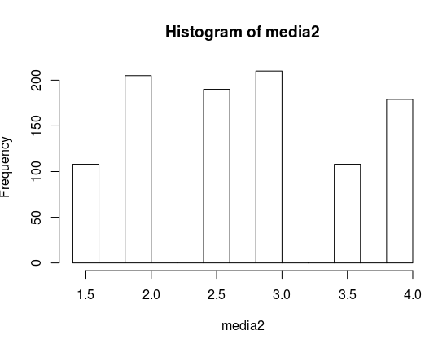
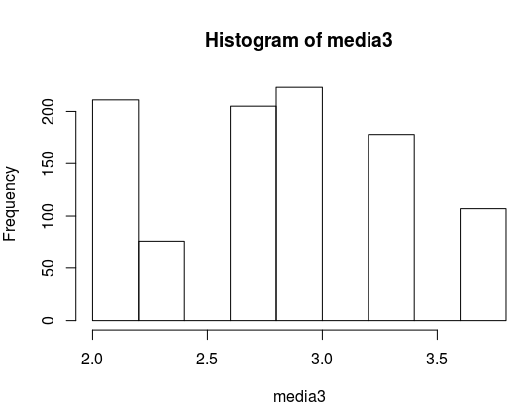

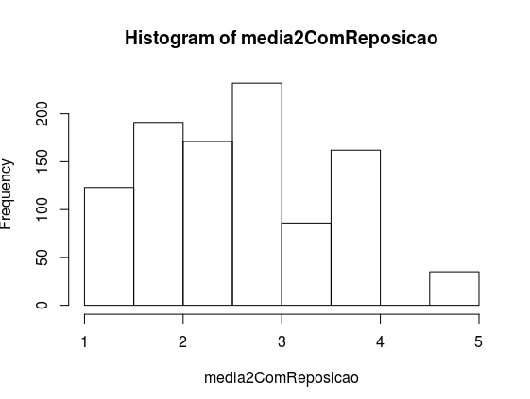
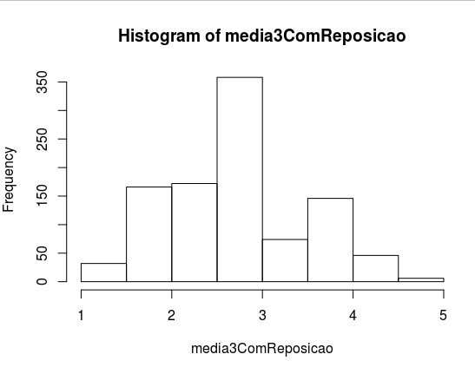

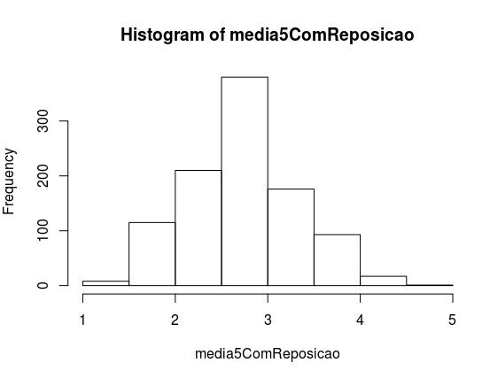
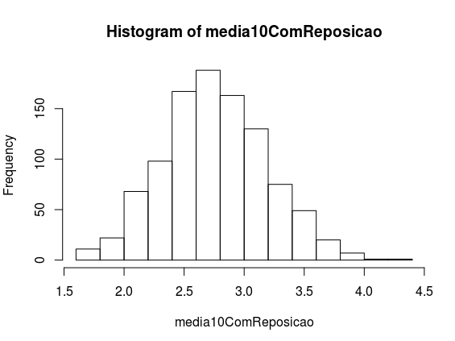

#saida
> mean(media2);
[1] 2.771
> mean(media3);
[1] 2.800667
> mean(media2ComReposicao);
[1] 2.7905
> mean(media3ComReposicao);
[1] 2.789667
> mean(media5ComReposicao);
[1] 2.781
> mean(media10ComReposicao);
[1] 2.8078
> mean(X);
[1] 2.8

Questao 2

#codigo

a <- 1:1000;
b <- 1:1000;
for (i in 1:1000){
x<- rnorm(100,100,5)
a[i] <- mean(x)
b[i] <- var(x)
}
hist(a,main = "distribuçoes
das medias amostrais")
hist(b, main = "variancias amostrais")

#histogram

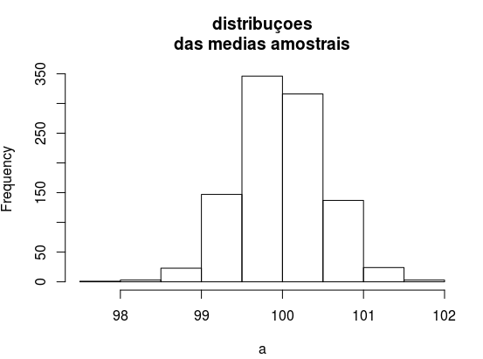
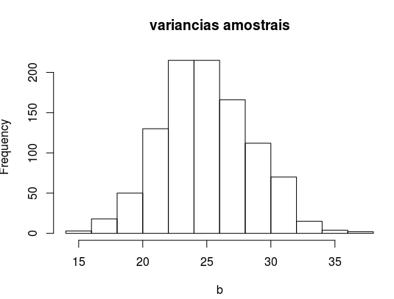

aparentimente as duas estao parecidas só que uma estar no intervalo de entre 90 e 110
e a outra estar entre 0 e 40

Questao 3

#codigo

#c = distidruiçao estimada
c <- 1:1000;
d <- 1:1000;
for (i in 1:1000){
x<- rnorm(100,100,5)
c[i] <- 1/mean(x)
}
mean(c)
var(c)

#saida
> mean(c)
[1] 0.01000148
> var(c)
[1] 2.609682e-09

