Leandro de Souto Lima
mat: 116211245

Execicio 3

Questao 1

#- Codigo

x0 <- 5
Xrandom <- 1:1000
for(xi in 2:1000){
x0 <- (x0 + 1)%%200
Xrandom[xi] <- x0/200
}
hist(Xrandom)

#- grafico
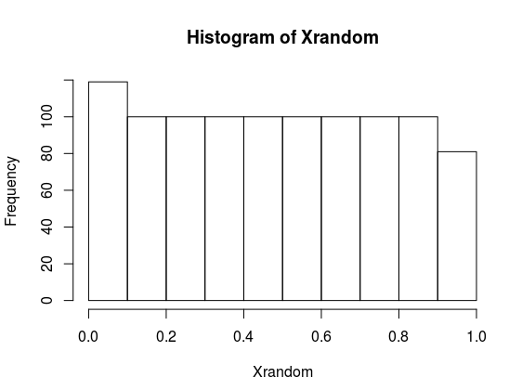

Questao 2

# Condigo

yRandom <--(log(1-Xrandom))/2

hist(yRandom)

#grafico

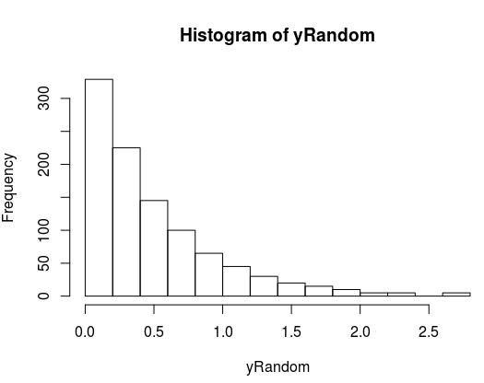

Questao 3

# codigo

nBinomial <-rbinom(1000,10, 0.2)

hist(nBinomial)

#grafico

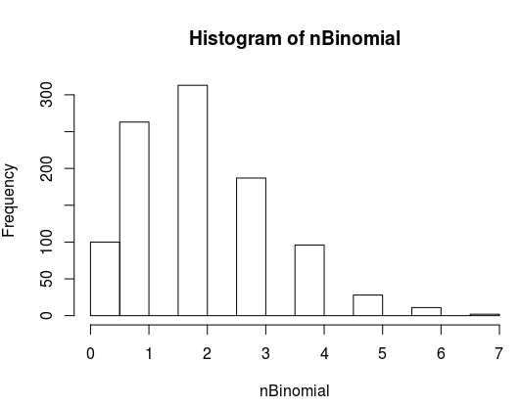

Questao4

#codigo

aRandom <- rnorm(1000,0,1)
bRandom <- rnorm(1000,0,1)
cRandom <- rnorm(1000,0,1)

nRandom <- aRandom**2 + bRandom**2 + cRandom**2

hist(nRandom)

#grafico

