

Practices for Secure Software Report

Table of Contents
Document Revision History 3
Client 3
Instructions 3
Developer 4
1. Algorithm Cipher 4
2. Certificate Generation 4
3. Deploy Cipher 4
4. Secure Communications 4
5. Secondary Testing 4
6. Functional Testing 4
7. Summary 4
8. Industry Standard Best Practices 4

Document Revision History

Version | Date | Author | Comments
1.0 | August 17, 2026 | Leanne Byrne

Client



Instructions

Submit this completed practices for secure software report. Replace the bracketed text with the relevant information. You must document your process for writing secure communications and refactoring code that complies with software security testing protocols.

- Respond to the steps outlined below and include your findings.
- Respond using your own words. You may also choose to include images or supporting materials. If you include them, make certain to insert them in all the relevant locations in the document.
- Refer to the Project Two Guidelines and Rubric for more detailed instructions about each section of the template.

Developer
Leanne Byrne

Algorithm Cipher

For Artemis Financial's file verification requirement, I recommended the SHA-256 cryptographic hash algorithm, which is part of the SHA-2 family developed by the National Security Agency and published by the National Institute of Standards and Technology. The client's stated need was a data verification step that confirms a transferred file has not been altered in transit. That is an integrity problem rather than a confidentiality problem, and hashing is the correct tool for it. A hash function takes an input of any length and produces a fixed-length output, and any change to the input, even a single character, produces a completely different output. Artemis Financial can therefore compare the checksum generated before transfer with the checksum generated after transfer, and any mismatch signals that the data was modified.
SHA-256 produces a 256-bit digest, which is rendered as a 64-character hexadecimal string. The bit length matters because it determines how difficult it is to find two different inputs that produce the same output, which is known as a collision. With 256 bits there are 2^256 possible outputs, and the birthday bound means an attacker would need roughly 2^128 operations to find a collision by brute force. That figure is far beyond what is computationally feasible with current or foreseeable hardware. By contrast, MD5 produces a 128-bit digest and SHA-1 produces a 160-bit digest, and both have been broken by practical collision attacks. I ruled both out for that reason.
It is worth distinguishing hashing from encryption, because the two are often confused. Encryption is reversible by design, since the intended recipient needs to recover the original data, and it relies on keys. Symmetric encryption such as AES uses the same key to encrypt and decrypt, which is fast but requires both parties to already share the key securely. Asymmetric encryption such as RSA uses a public key to encrypt and a private key to decrypt, which solves the key distribution problem at the cost of slower performance. Hashing is different from both. It is deliberately one-way, and it uses no key at all. There is no way to reverse a SHA-256 digest back to the original input, which is exactly the property that makes it suitable for verification and for password storage.
Random numbers still matter in this application even though the hash itself does not use them. The TLS handshake that secures the connection generates random values on both the client and server side, and those values feed into the session key derivation. If those random numbers were predictable, an attacker could reproduce the session key and decrypt the traffic. Java addresses this through the SecureRandom class, which draws from a cryptographically strong entropy source rather than the predictable pseudo-random generator used by the standard Random class. The self-signed certificate I generated for this project also depends on strong randomness during key pair generation.
The history of these algorithms is a useful reminder that cryptographic choices have a shelf life. MD5 was published in 1992 and was widely trusted until researchers demonstrated practical collisions in 2004. SHA-1 followed a similar path, moving from standard to deprecated after the SHAttered attack in 2017 produced two different PDF files with the same SHA-1 hash. SHA-2, which includes SHA-256, was published in 2001 and remains unbroken. NIST has already standardized SHA-3 as a structurally different successor, not because SHA-2 has failed but because having an alternative built on different mathematics is prudent. The lesson for Artemis Financial is that algorithm selection should be revisited periodically rather than treated as a decision made once.

Certificate Generation
Insert a screenshot below of the CER file.

I generated self-signed certificates using the Java Keytool utility included with the JDK. The keystore the application loads at runtime is a PKCS12 file named artemis_financial.p12, containing an RSA key pair with a 2048-bit modulus under the alias artemis. I placed it in the src/main/resources directory of the rest-service project so that Spring Boot could locate it on the classpath at startup. I generated it with the genkey command, supplying the distinguished name interactively, and keytool signed it using its default signature algorithm from the SHA-2 family.
I chose PKCS12 over the older JKS format for the application keystore because PKCS12 is an open standard rather than a Java-specific one, and Oracle has designated it as the default keystore type since Java 9. The 2048-bit RSA key length reflects current NIST guidance for keys that need to remain secure for the near term. The signature algorithm matters as much as the key length here, because a certificate signed with a broken hash function is undermined regardless of how strong its key is. Keytool defaults to a SHA-2 family algorithm, which is why the printcert output below reports SHA384withRSA rather than the SHA-1 signatures that browsers now reject outright.
To demonstrate that a certificate was correctly generated and can be exported, I used the keytool export command to write the public certificate out to a CER file, and then read it back with the printcert command to confirm its contents. The output below shows the subject and issuer as identical, which is what identifies it as self-signed, along with the serial number, validity window, SHA-1 and SHA-256 fingerprints, signature algorithm, and key size. A CER file contains only the public certificate and not the private key, which is what makes it safe to distribute. A client that needs to trust this server can import that file, and in a production deployment it is the certificate signing request derived from the key pair that would be submitted to a certificate authority instead.
A self-signed certificate is appropriate for a development environment but would not be acceptable in production. The certificate asserts the server's identity, but nothing vouches for that assertion except the server itself, which is why browsers display a warning when they encounter one. In production, Artemis Financial would obtain a certificate from a recognized certificate authority, which validates the requester's control of the domain and signs the certificate with its own trusted root. The technical mechanism is identical; what differs is the chain of trust behind it.
Figure 1. Generating the self-signed certificate with Java Keytool
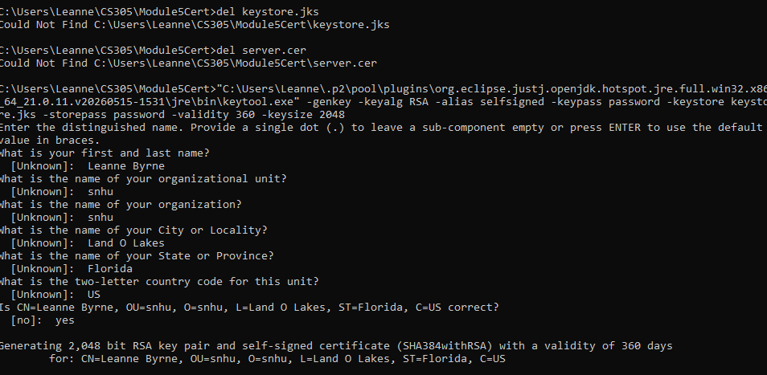
Figure 2. Contents of the exported CER file, read back with keytool printcert
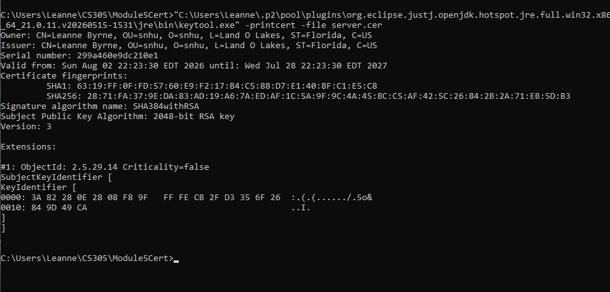

Deploy Cipher
Insert a screenshot below of the checksum verification.

I implemented the cryptographic hash by refactoring the application to add a REST controller that exposes a /hash endpoint. The controller uses the MessageDigest class from the java.security package, requesting an instance configured for SHA-256. The unique data string is converted to a byte array using explicit UTF-8 encoding, passed to the digest method, and the resulting byte array is converted to a hexadecimal string for display. I specified the character encoding explicitly rather than relying on the platform default, because a platform-dependent encoding would produce different checksums on different systems for the same input, which defeats the purpose of a verification step.
The endpoint returns my name, the unique data string, the name of the cipher algorithm used, and the resulting checksum value. Displaying the algorithm name alongside the digest is a small addition, but it means the recipient of a checksum knows which function to use when verifying it, rather than having to guess from the digest length.
[Insert screenshot here]

Secure Communications
Insert a screenshot below of the web browser that shows a secure webpage.

To convert the application from HTTP to HTTPS, I refactored the application.properties file to enable SSL and point Spring Boot at the keystore I had generated. I set the server port to 8443, which is the conventional alternative port for HTTPS, and specified the keystore location, the keystore password, the keystore type as PKCS12, and the key alias. Spring Boot reads these properties at startup and configures the embedded Tomcat container to serve traffic over TLS rather than plain HTTP.
The distinction being addressed here is between data at rest and data in transit. Hashing protects the integrity of a file, but it does nothing to protect the connection over which that file travels. Without TLS, an attacker positioned between the client and the server could read the traffic in plaintext, and could also modify both the file and its checksum in transit so that the verification step still passed. TLS closes that gap by encrypting the channel and authenticating the server, which means the checksum arrives from the party it claims to come from.
When the application runs and the endpoint is requested over HTTPS, the browser displays a warning because the certificate is self-signed and therefore not chained to a trusted root. This is expected behavior and not a defect. Proceeding past the warning establishes an encrypted connection, and the browser's connection details confirm that TLS is in use.
[Insert screenshot here]

Secondary Testing
Insert screenshots below of the refactored code executed without errors and the dependency-check report.

I ran a secondary static analysis using the OWASP Dependency-Check Maven plugin, version 12.2.2, configured with an NVD API key to authenticate requests against the National Vulnerability Database. Version selection mattered here. Earlier releases of the plugin have documented defects in their handling of the NVD API that produce persistent 403 errors, and I encountered those errors before moving to 12.2.2, which resolved them.
Dependency-Check works by identifying the third-party libraries a project depends on and matching them against published Common Vulnerabilities and Exposures records. This is a distinct category of risk from defects in code I wrote myself. A modern Spring Boot application pulls in a substantial tree of transitive dependencies, and a vulnerability in any of them is inherited by the application whether or not the developer is aware the library is present.
The scan flagged CVE-2023-20873 against spring-boot. On review I determined that this is a false positive in the context of this application. The vulnerability describes a security bypass that applies when a Spring Boot application is deployed to Cloud Foundry, which is not the deployment model for this project. I documented that reasoning in a suppression.xml file rather than simply ignoring the finding, so that the justification is recorded and can be reviewed by anyone who later inspects the scan results.
The two scans produced the following results. The initial scan examined 38 dependencies, 20 of them unique, and identified 11 vulnerable dependencies carrying 213 vulnerabilities, with no suppressions in place. The scan run after refactoring examined the same 38 dependencies, 21 unique, and reported 12 vulnerable dependencies carrying 220 vulnerabilities, with 1 suppression applied.
The second figure being higher than the first deserves explanation, because at first glance it suggests the refactoring made the application less secure. It did not. The two scans were run roughly 45 minutes apart on the same day, and the National Vulnerability Database is continuously updated. New CVE records published against libraries that had not changed are picked up by whichever scan runs later. The relevant question for this assessment is not whether the raw total moved, but whether any finding traces back to code I added, and none does. The hash implementation draws only on the MessageDigest class in the standard Java security library and introduces no new third-party dependencies, so it contributes nothing to the dependency tree that Dependency-Check evaluates. This is a useful illustration of why before and after counts should be read as a comparison of findings rather than as a score.
Figure 3. Dependency-Check report before refactoring
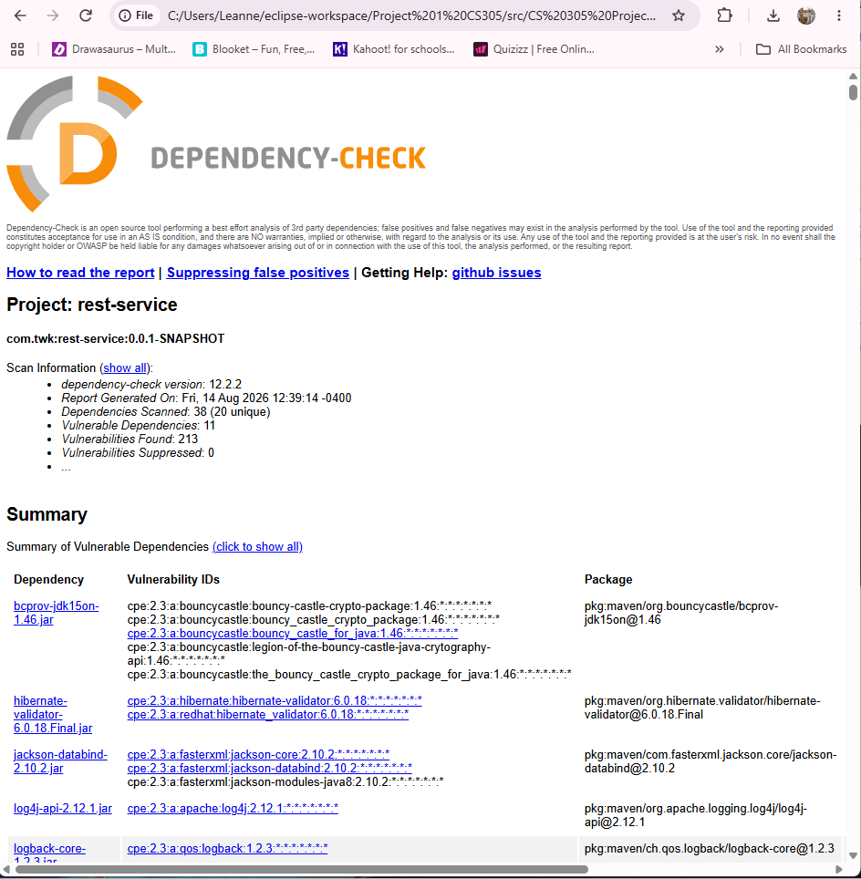
Figure 4. Dependency-Check report after refactoring, with suppression applied
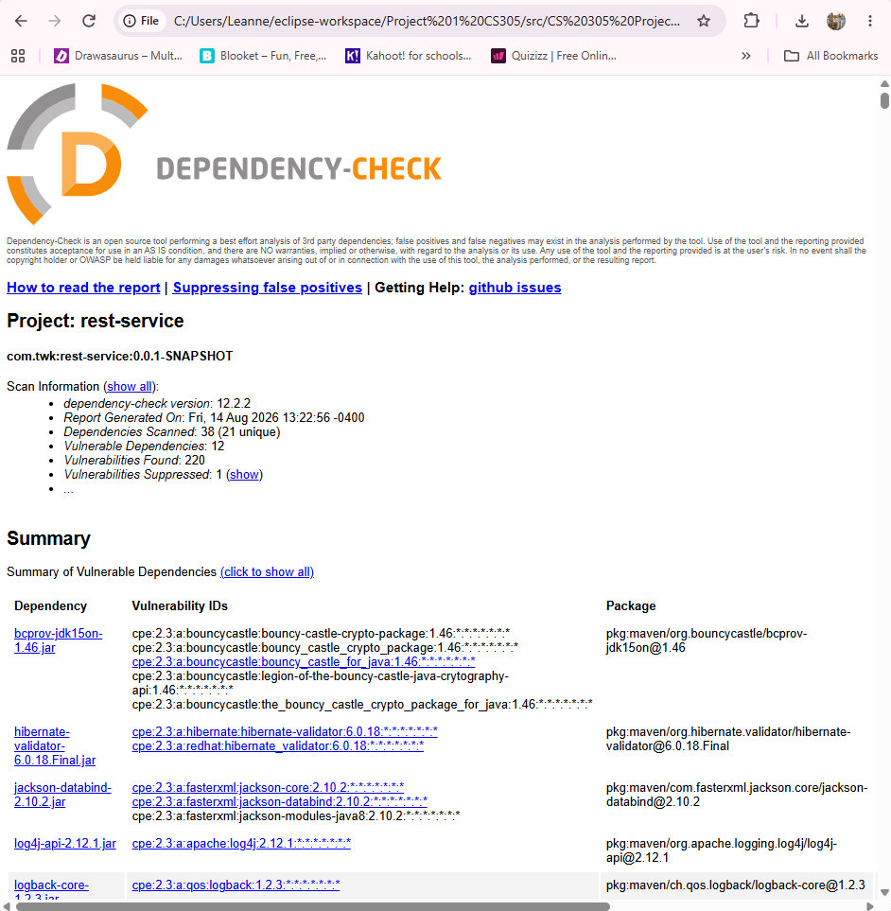

Functional Testing
Insert a screenshot below of the refactored code executed without errors.

Static analysis tools identify known vulnerabilities in known libraries, but they do not catch logic errors or insecure patterns in code that a developer has just written. I therefore reviewed the refactored code manually for syntactical, logical, and security defects.
On the syntactical level, I confirmed that the project compiles without errors or warnings, that all imports resolve, and that the controller is correctly annotated so that Spring registers the endpoint at startup. On the logical level, I verified that the checksum produced by the endpoint matches the value produced by an independent SHA-256 implementation for the same input string, which confirms the hexadecimal conversion is correct. A common defect in this kind of conversion is dropping leading zeros on byte values below sixteen, which produces a digest that is too short and silently wrong. Using a format specifier that pads to two characters avoids this.
On the security level, I checked that the character encoding is specified explicitly, that no sensitive values are written to logs or returned in responses, and that the endpoint does not accept user-supplied input, which removes injection as an attack surface for this particular endpoint. I also confirmed that the application does not fall back to serving plain HTTP once SSL is enabled.
[Insert screenshot here]

Summary

Working from the vulnerability assessment process flow diagram, the refactoring in this project addressed several of the seven areas of security assessment. Secure coding practices were applied in the implementation of the hash function, particularly around explicit encoding and correct byte conversion. Cryptography was addressed directly through the selection and deployment of SHA-256 and through the generation of an RSA 2048 key pair signed with SHA-256. Client and data storage was addressed by verifying data integrity through checksums. Dependency management, which is often the largest source of inherited risk in a modern application, was addressed through OWASP Dependency-Check scanning with documented suppression of the false positive that was identified.
My process for adding layers of security followed a deliberate order. I began by assessing the existing application to establish a baseline of what was already present and what was missing. I then implemented the cryptographic hash to satisfy the client's stated file verification requirement. With integrity handled, I secured the transport layer, since a checksum transmitted over an unencrypted channel can be modified alongside the data it is meant to protect. Finally I ran static analysis to confirm that the changes had not introduced new vulnerabilities, and reviewed the code manually to catch the class of defects that static analysis does not detect.
The ordering reflects the principle of defense in depth. No single one of these measures is sufficient on its own. Hashing without transport security can be defeated by an attacker who controls the channel. Transport security without integrity verification does not detect a file corrupted before transmission. Dependency scanning without manual review misses logic errors, and manual review without dependency scanning misses inherited vulnerabilities in libraries the developer never examined. Each layer covers a gap left by the others.

Industry Standard Best Practices

Several industry standard practices shaped this work. I selected algorithms based on current NIST guidance rather than on familiarity, which is why SHA-256 was used throughout and MD5 and SHA-1 were excluded. I avoided implementing cryptographic primitives myself and used the vetted implementations in the Java standard library, since hand-rolled cryptography is a well documented source of serious defects. I treated third-party dependencies as part of the application's attack surface rather than as trusted infrastructure. And I documented the suppression of a false positive with its justification rather than silently discarding the finding, so that the decision remains auditable.
Maintaining the application's existing security was as important as adding to it. The refactoring was additive. I did not modify or remove existing functionality, which limits the risk of introducing regressions in code that was already working correctly. I ran the dependency scan both before and after the changes so that any difference in findings could be attributed correctly.
For a company in Artemis Financial's position, the value of these practices extends well past the technical. The company holds financial and personal data for its clients, which places it under regulatory obligations and makes it an attractive target. A breach would carry direct costs in remediation and potential regulatory penalties, but the more serious damage would be to client trust, which is the actual product a financial planning firm sells. Security defects are also substantially cheaper to fix during development than after deployment. Building verification and encryption into the application now, rather than retrofitting them after an incident, is the less expensive path by a wide margin. Global Rain's position that security is everyone's responsibility reflects this. Security implemented as a review step at the end of development produces worse outcomes than security treated as a design consideration throughout.

References
National Institute of Standards and Technology. (2015). Secure hash standard (SHS) (FIPS PUB 180-4). U.S. Department of Commerce. https://doi.org/10.6028/NIST.FIPS.180-4
OWASP Foundation. (2026). OWASP Dependency-Check. https://owasp.org/www-project-dependency-check/

