Grazioso Salvare Rescue Dog Dashboard
README
Leanne Byrne
CS-340 Client/Server Development, Southern New Hampshire University
October 2026

About the Project
Grazioso Salvare is an international rescue animal training company that identifies shelter dogs who are good candidates for search-and-rescue training. This project is a full stack web application that connects to a MongoDB database of Austin Animal Center outcome records and presents the data through an interactive dashboard. Staff at Grazioso Salvare can filter available dogs by rescue type, browse and sort the matching records, see the breed mix of the current results, and locate a selected animal on a map.
The application follows the Model-View-Controller (MVC) design pattern. MongoDB is the model, the Dash layout and its widgets are the view, and Dash callbacks, which call the CRUD Python module developed in Project One, act as the controller.

Required Functionality
The dashboard includes the following components, as outlined in the Dashboard Specifications Document:
- Branding: the Grazioso Salvare logo and a unique identifier (developer name and course) at the top of the page.
- Interactive filtering options: radio buttons for Water Rescue, Mountain or Wilderness Rescue, Disaster or Individual Tracking, and Reset. Selecting a rescue type sends the matching query to MongoDB through the CRUD module. Reset returns every record.
- Interactive data table: displays the query results 10 rows per page, with native sorting by column, per-column text filtering, and single-row selection.
- Breed pie chart: shows the breed distribution of the records currently in the table. When there are more than 10 breeds (as in the unfiltered data), the top 10 are shown and the rest are grouped as Other so the chart stays readable.
- Geolocation map: a Dash Leaflet map that places a marker at the selected animal's location. Hovering over the marker shows the breed, and clicking it shows the animal's name. The first row is selected automatically whenever the filter changes.

Rescue Type Filter Criteria
Each filter uses the criteria from the Rescue Type and Preferred Dog Breeds table. All filters also require animal_type to be Dog.
Rescue Type | Preferred Breeds | Preferred Sex | Age (weeks)
Water | Labrador Retriever Mix, Chesapeake Bay Retriever, Newfoundland | Intact Female | 26 to 156
Mountain or Wilderness | German Shepherd, Alaskan Malamute, Old English Sheepdog, Siberian Husky, Rottweiler | Intact Male | 26 to 156
Disaster or Individual Tracking | Doberman Pinscher, German Shepherd, Golden Retriever, Bloodhound, Rottweiler | Intact Male | 20 to 300
Reset | All records (no filter) | Any | Any

Testing and Screenshots
The dashboard was tested in three ways. Unit testing confirmed that each CRUD module method worked on its own, including a read of the full collection. Integration testing confirmed that selecting each filter triggered the callback, ran the correct MongoDB query, refreshed the data table, and updated both charts. Regression testing repeated every filter after each new component was added, and confirmed that Reset still restored the original unfiltered view. The screenshots below show each required state. Every screenshot includes the Grazioso Salvare logo and the unique identifier.
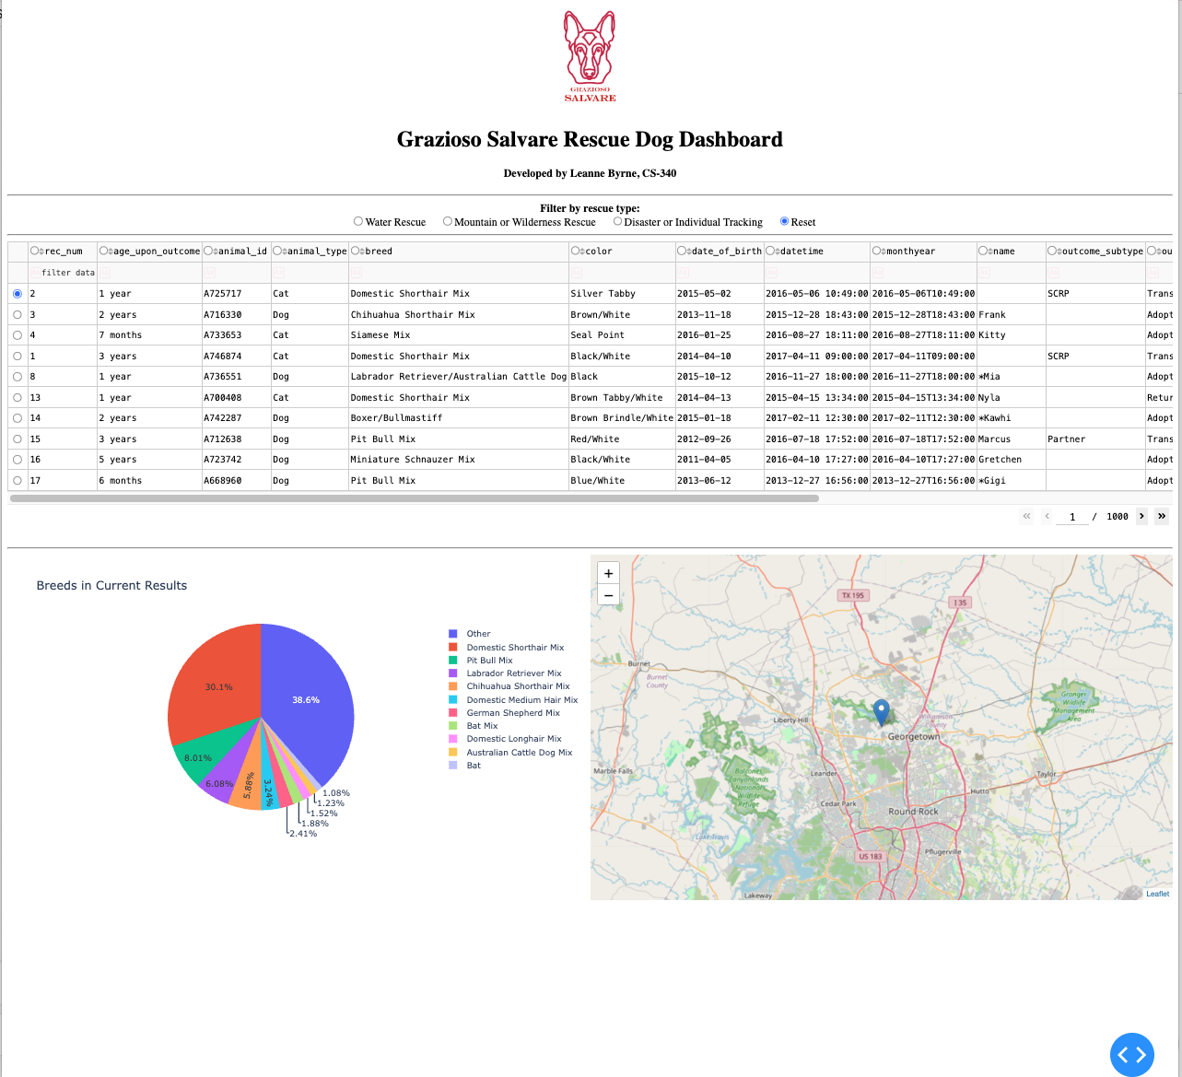
Figure 1. Starting state. All 10,000 records are shown across 1,000 pages, the pie chart shows the top 10 breeds plus Other, and the map marks the first record.
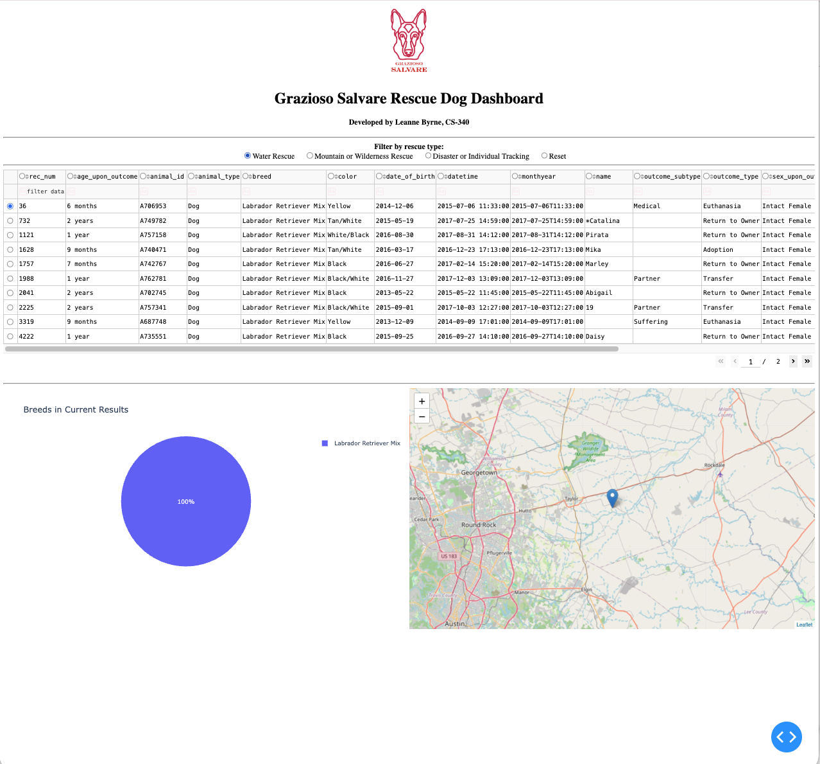
Figure 2. Water Rescue filter applied. The table narrows to two pages of intact female Labrador Retriever Mix dogs, and the chart and map update to match.
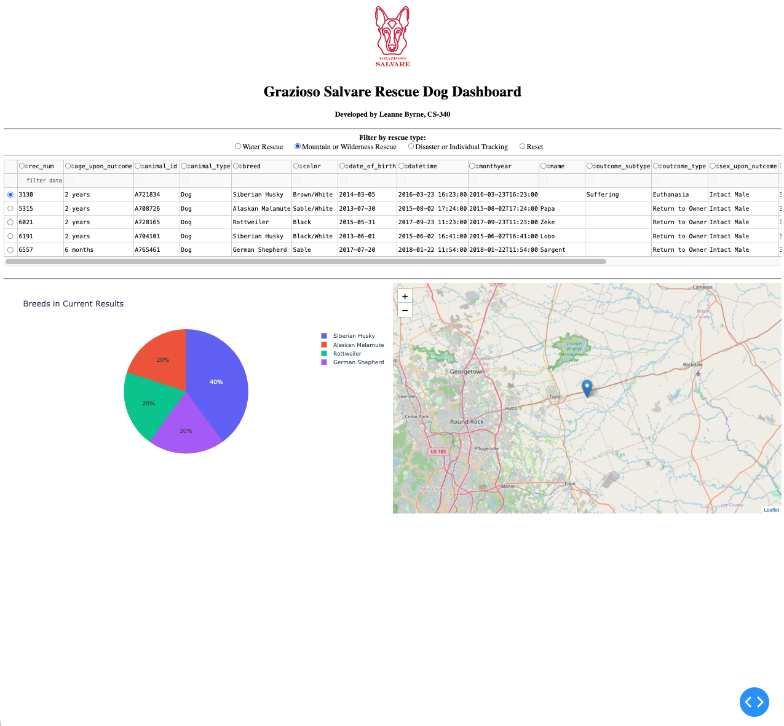
Figure 3. Mountain or Wilderness Rescue filter applied. Five intact male dogs match: two Siberian Huskies, an Alaskan Malamute, a Rottweiler, and a German Shepherd.
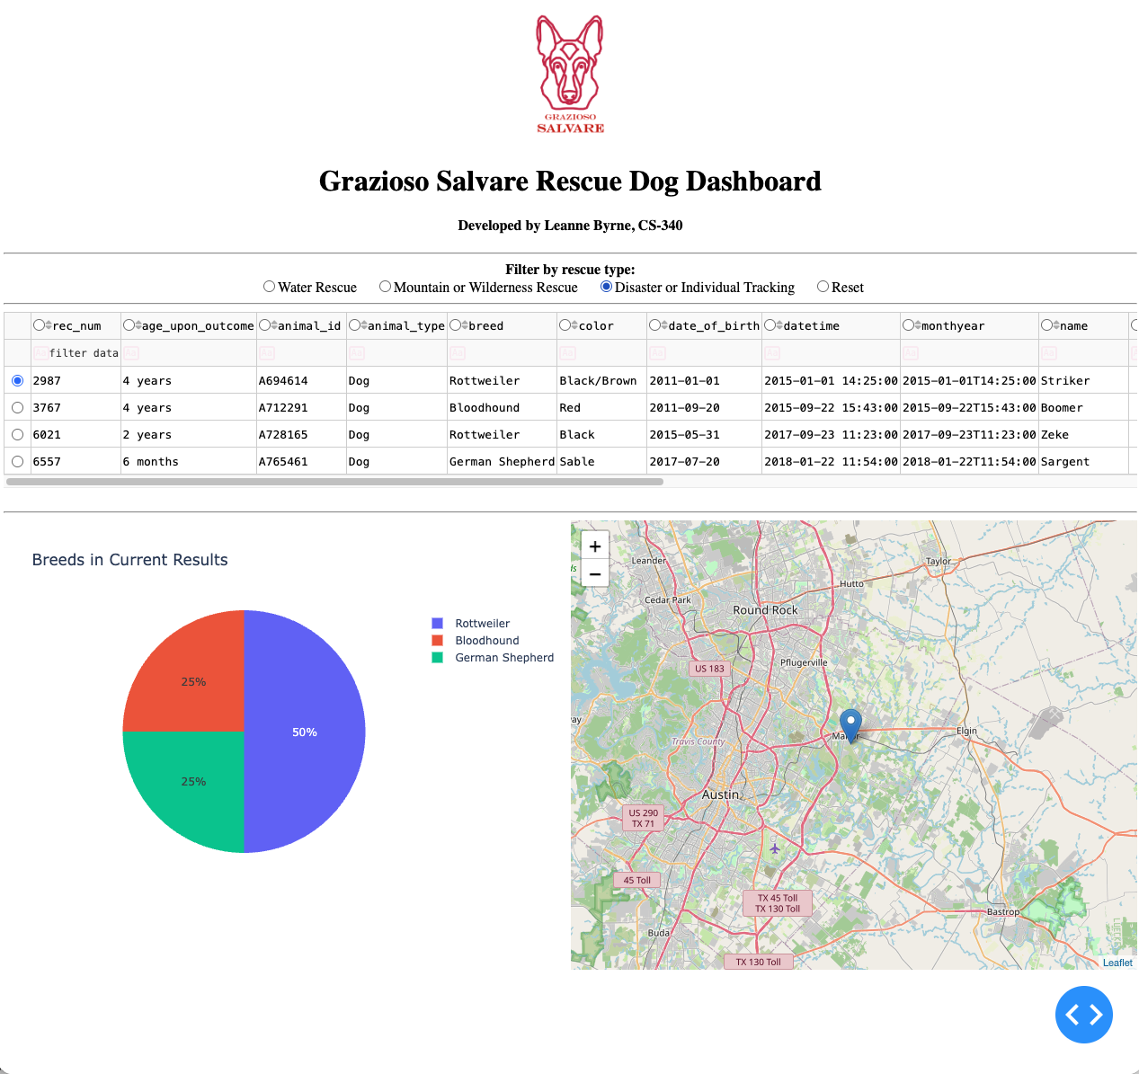
Figure 4. Disaster or Individual Tracking filter applied. Four intact male dogs match: two Rottweilers, a Bloodhound, and a German Shepherd. The map moves to the first result near Manor, Texas.
Figure 5. Reset applied after filtering. All widgets return to their original, unfiltered state.

Tools Used and Rationale

MongoDB (Model)
MongoDB 7.0 stores the Austin Animal Center Outcomes data in the aac database, animals collection. MongoDB was chosen as the model for several reasons:
- Document model that matches Python: each record is stored as a BSON document, which PyMongo returns as a Python dictionary. Queries are also written as dictionaries, so data moves between the database and Python code with no translation layer.
- Expressive queries: operators such as $in (for lists of preferred breeds) and $gte/$lte (for age ranges) let each rescue filter be written as a single query.
- Flexible schema: records do not need identical fields, which suits shelter data where values such as name are sometimes missing.
- Access control: a dedicated aacuser account with read and write access to the aac database keeps the application separate from administrative access.
- Scalability: MongoDB supports indexing, replication, and sharding, so the same design can grow if more shelters contribute data.

Python, PyMongo, and the CRUD Module
The CRUD Python module (CRUD_Python_Module.py) from Project One defines an AnimalShelter class that authenticates to MongoDB with PyMongo and provides create, read, update, and delete methods. The read method returns a list of documents, which the dashboard converts to a Pandas DataFrame. Using this module for every query keeps database logic out of the dashboard code and allows the same module to be reused by other applications.

Dash Framework (View and Controller)
Dash is an open source Python framework for building web dashboards, built on Flask, Plotly, and React. It provides both halves of the client-facing application:
- View: the app.layout section defines the page structure using Dash HTML Components and Dash Core Components (the logo, headings, RadioItems filter, DataTable, and chart containers).
- Controller: callbacks link components by their IDs. Each callback declares Input properties that trigger it and Output properties that it updates. In this project, the filter value triggers a query through the CRUD module and refreshes the table, and the table's current data and selected row drive the pie chart and map.
Dash was chosen because it lets the entire stack be written in Python, integrates directly with Pandas and Plotly, and runs inside Jupyter through JupyterDash, which made it straightforward to build and test each component incrementally in the Codio environment.

Supporting Libraries and Environment
- Pandas: converts MongoDB query results into DataFrames for the table and charts.
- Plotly Express: creates the breed pie chart.
- Dash Leaflet: renders the interactive geolocation map using the location_lat and location_long fields.
- Jupyter Lab in Codio: the development and testing environment.

Resources
- MongoDB Documentation: https://www.mongodb.com/docs/
- PyMongo Documentation: https://pymongo.readthedocs.io/
- Dash Documentation: https://dash.plotly.com/
- Dash Core Components: https://dash.plotly.com/dash-core-components
- Dash DataTable: https://dash.plotly.com/datatable
- Dash Leaflet: https://www.dash-leaflet.com/
- Plotly Pie Charts: https://plotly.com/python/pie-charts/
- Pandas Documentation: https://pandas.pydata.org/docs/
- Project Jupyter: https://jupyter.org/
- Codio: https://www.codio.com/
- Austin Animal Center Outcomes data set (City of Austin, 2020): https://doi.org/10.26000/025.000001

Reproducing the Project

Requirements
- MongoDB 7.0 or later, with the mongosh shell and mongoimport
- Python 3.11 or later
- Python packages: pymongo, pandas, dash, jupyter-dash, dash-leaflet, plotly
- Jupyter Lab
The Python packages can be installed with:
pip install pymongo pandas dash jupyter-dash dash-leaflet plotly

Setup Instructions
- Import the Austin Animal Center Outcomes CSV into a database named aac and a collection named animals:
mongoimport --db aac --collection animals --type csv --headerline --file <path to CSV file>

- Create the application user in mongosh (as an administrator) with read and write access to the aac database:
use admin
db.createUser({ user: "aacuser", pwd: "<password>", roles: [{ role: "readWrite", db: "aac" }] })

- Place ProjectTwoDashboard.ipynb, CRUD_Python_Module.py, and Grazioso Salvare Logo.png in the same folder.
- Open ProjectTwoDashboard.ipynb and set the username and password variables to the aacuser credentials. If MongoDB is not running on localhost port 27017, pass the correct host and port when creating the AnimalShelter object.
- Run the notebook cell. When the message "Dash app running on" appears, open the link to view the dashboard.
- Select a rescue type to filter the data, click a column header to sort, type in the filter row to search a column, and select a row to show that animal on the map. Select Reset to return to all records.

Steps Taken to Complete the Project
- Reviewed the Dashboard Specifications Document and the Rescue Type and Preferred Dog Breeds table.
- Verified that the Project One CRUD module still connected to MongoDB and that a read of the full collection returned all 10,000 records.
- Built the unfiltered data table first, then added pagination, sorting, column filtering, and single-row selection to make it easier for the client to use.
- Wrote one MongoDB query per rescue type as a Python dictionary and stored them together so the controller could look up the correct query by filter value.
- Added the RadioItems filter and a callback that runs the selected query through the CRUD module, refreshes the table, and selects the first result.
- Built the pie chart and map callbacks so both respond to the data currently shown in the table and to the selected row.
- Tested each filter and Reset after every change, then captured the five required screenshots.

Challenges and Solutions

Database authentication
When reconnecting to MongoDB at the start of the project, authentication failed. Because the notebook used getpass, the typed password was hidden, which made the cause hard to see. I verified the credentials directly in the terminal with mongosh, confirmed the correct password for aacuser, and then reconnected successfully. This also reinforced the difference between shell commands, which run in the terminal, and Python code, which runs in notebook cells.

Age range queries
Writing the age range with two separate age_upon_outcome_in_weeks keys does not work as intended, because a Python dictionary (and a JSON document) cannot hold duplicate keys. The second condition silently replaces the first, so only one bound is applied. I combined both operators under a single key, for example {"$gte": 26, "$lte": 156}, so both bounds are enforced.

ObjectId values in the data table
MongoDB returns an _id field of type ObjectId, which the Dash DataTable cannot display. I created a helper function that runs each query through the CRUD module and drops the _id column before the data reaches the table.

Fragile column positions in the map callback
The starter code located latitude, longitude, breed, and name by column position. Those positions shift if the column order changes. I replaced them with column names, added a fallback for animals with no name on record, and handled the case where a filter returns no results.

Readable pie chart
The unfiltered data contains hundreds of breeds, which made a pie chart unreadable. I limited the chart to the top 10 breeds and grouped the remainder as Other. Filtered results are small enough to show every breed.

Interpreting filter results
The Water Rescue filter returned only Labrador Retriever Mix dogs. I confirmed that this is accurate: the data set contains no intact female Chesapeake Bay Retrievers or Newfoundlands in the 26 to 156 week range. Similarly, two dogs appear in both the Mountain or Wilderness and Disaster or Individual Tracking results. This is expected, because German Shepherd and Rottweiler are preferred breeds for both rescue types and these dogs fall within both age ranges.

Choosing the filter control
The sample tutorial compared button click counts to decide which filter to apply, which requires extra clicks to switch filters and does not scale beyond two options. I used RadioItems instead, so the callback receives the selected value directly and each filter works with a single click.

Reference
Austin Animal Center. (2020). Austin Animal Center outcomes [Data set]. City of Austin, Texas Open Data Portal. https://doi.org/10.26000/025.000001

Contact
Leanne Byrne

