Hierarchy of Doctor

. Dr.Narendra Vaidya - Joint Replacement Surgeon

Chairman – Lokmanya Hospitals Pvt Ltd Poineer & Leading Robotic Assisted Joint Replacement surgeon
MBBS, DNB - Orthopedics/Orthopedic Surgery, MS - Orthopaedics, M.Ch - Orthopaedics
Orthopedic surgeon,



Rakesh Patil – Joint Replacement Surgeon
MBBS MS Ortho,DND Ortho
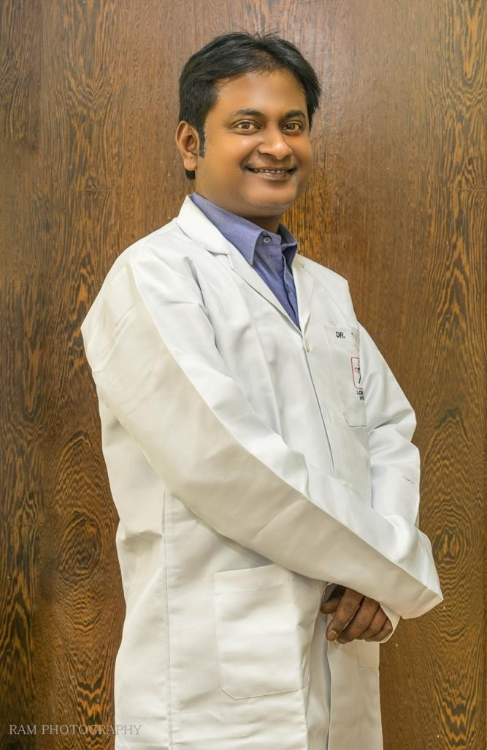
Experience : KNEE REPLACEMENT EXPERIENCE 5000+ Total Knee Replacement surgeries by Conventional technique 500+ Total Knee Replacement surgeries by Smith & Nephew Robotic Technology, NAVIO

Dr.Ashish Suryawanshi
MBBS MS – Orthopaedics ECFMG ( USA)
Orthopedic surgeon – Trauma Surgeon
15+ Years Experience Overall (10 years as specialist)

