Dr.Narendra Vaidya
Dr. Narendra Vaidya is widely regarded as one of India’s most respected and accomplished orthopedic surgeons. With over 30 years of experience, Dr. Vaidya’s expertise spans a range of orthopedic procedures, including primary and complex revision knee and hip replacements, as well as minimally invasive surgeries. His leadership as the Chairman of Lokmanya Hospitals has played a pivotal role in positioning the institution as a leader in orthopedic care.

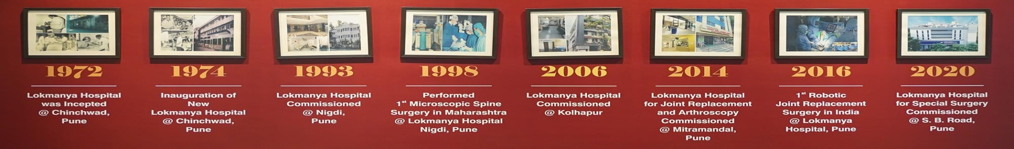
Our story grow from seeds to compassion :

Technique used for Knee replacement surgery:
Velys Robotic ,ROSA System , Cori Robotic , Navio System

Sequence of header menu :
- Home page
- About us
- Speciality
- Find a doctor
- Centre of Excellence
- Blog
- International Patient
- Careers
- Contact us

Message from our Chairman:
Over the past few decades, India’s healthcare system has gone through major changes due to the integration of new technology, upgraded facilities, and a renewed focus on delivering excellent medical services. As the need for top-notch healthcare services continues to rise, institutions are finding it increasingly challenging to create, enhance, and extend their services. Lokmanya Hospitals has not only tackled this challenge but has also established new benchmarks in the healthcare industry. By prioritizing medical excellence, innovation, and cost-effective care, Lokmanya Hospitals has become a highly reliable healthcare provider in India, gaining the trust of numerous patients, both locally and internationally
( Need to do GPT )

Why Choose Lokmanya Hospitals
(On the basis of this Make Draft for the About us)
350+ Bed
NABH Accreditation
50+ Years of Experience
1,50,000 + Successful Knee replacement
35000+ Joint Replacements

ROSA System

