**Worksheet: Ranque-Hilsch Vortex Tube**

**Name(s):** _____________________________________________________________________________________

Higher-pressure, room-temperature air is fed to a Ranque-Hilsch vortex tube, which splits the air into hot and cold streams at lower pressure. The fraction of the air that goes to the cold side (or hot side) affects how cold the low temperature side is (or how hot the high-temperature side is). The blue in the figure represents colder temperatures and the red represents hotter temperatures.

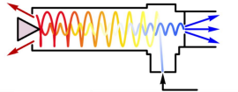

**Student Learning Objectives**

1. Use the ideal gas law to determine molar flow rates.

2. Apply the first law of thermodynamics to a steady-state system.

3. Apply the second law of thermodynamics to a steady-state system.

**Equipment**

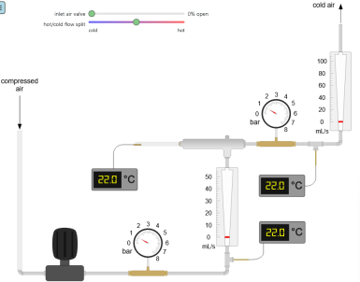

**Questions to answer before running the experiment:**

1. Is it physically possible to split a room-temperature stream into a hot and cold stream? 2. Does the total entropy of the system increase, decrease, or not change? Explain why.

3. What are advantages and disadvantages of using a vortex tube over a typical refrigeration system?

4. If more air flows to the hot side of the tube, do you expect the high temperature to increase or decrease?

**Running the experiment:**

1. Use the slider to open the valve to flow compressed air to the vortex tube and to adjust the flow rate split between the hot and cold sides.

2. Record the pressures, temperatures, and flow rates in the Table below. Note that the hot-side pressure is 1.0 bar.

3. Repeat these measurements for a range of feed pressures and for various openings of the valve on the high temperature outlet. Record values in the Table.

| Experiment # | Feed  temperature (°C) | Feed  pressure (bar) | Feed  flow rate (mL/s) | Cold-side  temperature (°C) | Cold-side pressure  (bar) | hot-side  temperature (°C) | Hot-side pressure (bar) | hot-side  flow rate  (mL/s) |
| --- | --- | --- | --- | --- | --- | --- | --- | --- |
| 1 |  |  |  |  |  |  | 1.0 |  |
| 2 |  |  |  |  |  |  | 1.0 |  |
| 3 |  |  |  |  |  |  | 1.0 |  |
| 4 |  |  |  |  |  |  | 1.0 |  |
| 5 |  |  |  |  |  |  | 1.0 |  |
| 6 |  |  |  |  |  |  | 1.0 |  |
| 7 |  |  |  |  |  |  | 1.0 |  |
| 8 |  |  |  |  |  |  | 1.0 |  |

**After the experiments:**

For each experiment, record the results of these calculations in the Table below.

Calculate the molar flow rates for the feed and the hot streams using the ideal gas law and record in Table below.

Calculate the cold stream molar flow rates from material balances and record in the Table. Calculate the two terms in the energy balance for the change in energy of the hot and cold streams and record in the Table.

Add the two terms together and record the results in the table. Do they add to zero? where Tf = feed temperature (K)

Tc = cold temperature (K)

Th = hot temperature (K)

Pf = feed pressure (bar)

Ph = hot side pressure (bar)

Pc = cold side pressure (bar)

CP = constant pressure heat capacity (J/(mol K))

| Experiment # | (mol/s) | (mol/s) | (mol/s) | (J/s) | (J/s) | Add 2 energy terms |
| --- | --- | --- | --- | --- | --- | --- |
| 1 |  |  |  |  |  |  |
| 2 |  |  |  |  |  |  |
| 3 |  |  |  |  |  |  |
| 4 |  |  |  |  |  |  |
| 5 |  |  |  |  |  |  |
| 6 |  |  |  |  |  |  |
| 7 |  |  |  |  |  |  |
| 8 |  |  |  |  |  |  |

Calculate the change in entropy for the hot and cold streams and enter in the table below.

| Experiment # | (mol/s) | (mol/s) | [J/(K s)] | [J/(K s)] | Add 2  entropy  terms |
| --- | --- | --- | --- | --- | --- |
| 1 |  |  |  |  |  |
| 2 |  |  |  |  |  |
| 3 |  |  |  |  |  |
| 4 |  |  |  |  |  |
| 5 |  |  |  |  |  |
| 6 |  |  |  |  |  |
| 7 |  |  |  |  |  |
| 8 |  |  |  |  |  |

Is the total entropy change positive?

**Questions to answer**

1. What is the entropy change of the surroundings? Why?

2. What experimental aspect was ignored in applying the first law to this system?

3. What safety precautions would you observe in carrying out this experiment in the laboratory?