**Name(s):**___________________________________________________________________________________________

**Fill in all sections – These are today’s notes**

**Student Learning Objectives**

1. Understand how velocity and pressure change as fluid passes through a venturi meter

2. Understand that diameter changes along a venturi have nonlinear effects on pressure and velocity

3. Describe how energy transformation (one form to another) occurs along the direction-of-flow axis

4. Calculate flow rates from venturi pressure difference (ΔP) data and compare to measured flow rates

5. Calculate the venturi coefficient for the hands-on system used in class

**DLM Schematic and Dimensions**

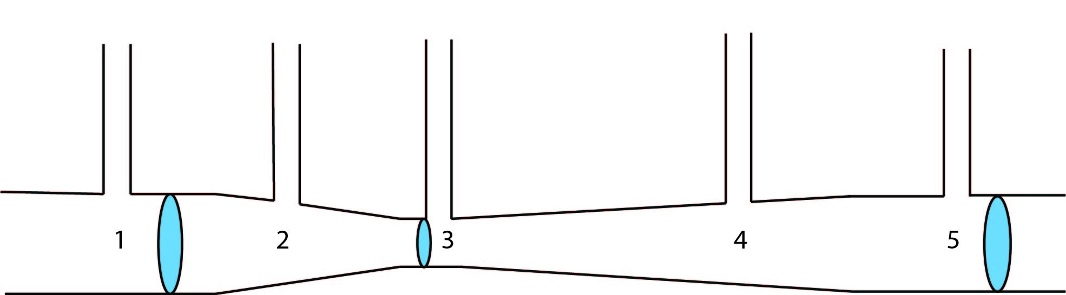

D1 = 1.27 cm

D3 = 0.406 cm

D5 = D1 = 1.27 cm

Flow

**Before beginning the experiment**

Graph the predicted velocity and pressure trends as water travels through the venturi meter from points 1 to 5. Explain your reasoning.

*Velocity:*

Velocity

Distance down venturi

*Pressure:*

Pressure

Distance down venturi

**Velocity and Pressure Trends in a Venturi Meter**

1. Start the pump. Adjust the valve position so that there is no water leaking from the top of the manometers.
2. Mark and measure the water height in manometers 1 to 5, measuring from the center of the horizontal tube. Plot the pressure trend below. Remember that pressure is proportional to water column height.

Pressure

Distance down venturi

1. Discuss the observed pressure trend. How does pressure vary with changes in pipe diameter?
2. The continuity equation for steady, one-dimensional flow between two points (i and j) appears below, where = fluid density*,*  = cross sectional area, and = average fluid velocity:

Simplify the continuity equation between the points listed below and complete the velocity and area relationship statements with symbols (>, <, or =).

* 1. Velocity at points 1 & 3:

Simplified continuity equation:

Velocity relationship: because

* 1. Velocity at points 1 & 5:

Simplified continuity equation:

Velocity relationship: because

1. Go to <https://labs.wsu.edu/educ-ate/tutorial-videos/> and watch the video *near the bottom:* “Venturi throat flow visualization”. Discuss the answer to question 4a in light of the video.
2. Describe the relationship between velocity and pipe diameter. Is it linear? Consider the continuity equation and the formula below for the cross-sectional area of a circular pipe:
3. Based on your answers to questions 4, 5, and 6 plot the velocity trend in the venturi meter.

Velocity

Distance down venturi

1. For the valve settings in Table 1, run a series of experiments. Measure and record the **volumetric flow rate** (with a beaker and cell phone timer) and the **manometer water heights.**

Table 1

|  |  |  |  |  |  |  |  |
| --- | --- | --- | --- | --- | --- | --- | --- |
| Valve setting | [mL] | Time [s] | h1 [cm] | h2 [cm] | h3 [cm] | h4 [cm] | h5 [cm] |
| Fully Open |  |  |  |  |  |  |  |
| Partially Closed Position (1) |  |  |  |  |  |  |  |
| Partially Closed Position (2) |  |  |  |  |  |  |  |

**Energy Balances Applied to the Venturi Meter**

1. The mechanical energy balance below gives the relationship between kinetic and potential energy, flow work, and frictional losses per unit mass between two arbitrary points, *i* and *j*:

|  |  |
| --- | --- |
| **Match these terms with their descriptions** | |
| **Term in mechanical energy balance** | **Description** |
|  | Kinetic energy |
|  | Flow work |
|  | Frictional loss |
|  | Potential energy |

Simplify the mechanical energy balance (i.e., cancel terms) for each case below.

* 1. Apply between points 1 & 3 (hint: frictional losses are minimal as fluid enters a nozzle):

Simplified equation:

* 1. Apply between points 1 & 5 (do ***not*** ignore frictional losses)

Simplified equation:

1. Based on simplified equations in questions 9a and 9b, why does the pressure change:

Between points 1 & 3?

Between points 1 & 5:

1. According to the mechanical energy balance, how does pressure vary with velocity? How does pressure vary with diameter (combine knowledge from questions 9a, 4a and 6).
2. Are the relationships between (a) pressure and velocity and (b) pressure and diameter linear? Why or why not?
3. An energy transition occurs when one form of energy is converted to another. For example, when a ball begins rolling down a hill *potential energy* is converted to *kinetic energy* as the ball accelerates and changes its vertical position.

What types of *energy transitions* occur in the venturi meter? How do kinetic energy and flow work, change between points 1 & 3 and points 1 & 5 and how do frictional losses affect these changes?

Between points 1 & 3:

Between points 1 & 5:

Between points 1 & 5:

**Homework Problems Due:**

1. What are the advantages and disadvantages of using a venturi meter compared to an orifice meter? Hint: You will need to do some reading in your textbook and/or review on-line information.
2. Derive the rearranged energy balance below for the venturi meter. Show your work. Hints:
3. Ignore frictional losses in the energy balance between points 1 and 3 in the venturi.
4. Use the continuity equation to describe point 1 velocity in terms of throat velocity .
5. Substitute .
6. Rearrange for and multiply your result by , the venturi coefficient.
7. When deriving the equation above, what was ignored that makes necessary; do some reading on this; it is not just because you ignore frictional losses, though that is part of it. Why is the correction factor so close to 1.0?
8. Calculate the volumetric flow rate for each valve setting in Table 1 using the data you collected for outlet volume and time to get the measured value, and the pressure drop between points 1 and 3 and equation in question 2 to get the calculated value. Use the literature value for the venturi coefficient (Cv) of 0.98.

|  |  |  |  |
| --- | --- | --- | --- |
| Valve setting | = V/t  [mL/s] | ∆P = *ρg*(h1 – h3)  [Pa] | [mL/s] |
| Fully Open |  |  |  |
| Partially Closed Position (1) |  |  |  |
| Partially Closed Position (2) |  |  |  |

Compare the measured flow rates to the calculated values and discuss possible reasons for differences between and

1. Calculate the venturi coefficient from your data and compare it to the literature value of 0.98.

Use the equation derived in question 2 above. Using the measured flow rate, pressure drop data, and diameter values, obtain Cv using the slope from a linearized plot. **Attach your plot to this assignment**.

Cv =

1. From your data, how much energy per unit mass is being lost due to friction and dissipation of turbulent eddies between points 1 and 5? Compare that to how much energy would be lost in a straight pipe, of the same diameter as the venturi entrance at point 1, with a length equal to the distance between points 1 and 5 (L1→5 = 9 cm). Show your work below.