**.Net 5 Quick Notes for Quick Reference**

1. Section 1: Introduction
   1. Introduction to the course
   2. Setting up the developer environment
   3. Getting help
   4. Course assets and source code.
2. Building a waling skeleton Part One – API
   1. Introduction
   2. Creating the .net API Project using the **dotnet CLI**
      1. Creating solution 🡺 dotnet new sln
      2. Creating new API 🡺 dotnet new webapi –o API
      3. Adding API to solution file 🡺 dotnet sln add API
3. Setting up VS code to work with C# (Installation of extensions to work with C#)
   1. C# Extension
   2. Nuget Package Reference
   3. Folder structure Icons
   4. Color braces …etc. (As per your requirement)
4. Getting to know the API Project files

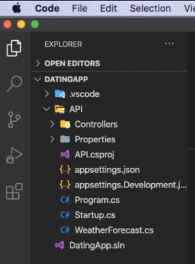

To run dot API , Command : 🡺 dotnet watch run or dotnet run