
LESSON NOTE | DETAILED EXPLANATORY NOTES
BIOTECHNOLOGY
RECOMBINANT DNA TECHNOLOGY
( Genetic Engineering )
GRADE 12 - BIOLOGY
■ ■ ■

What Is Recombinant DNA Technology?
In the last lesson you saw how a gene is expressed (DNA → RNA → protein). Recombinant DNA technology - also called genetic engineering - goes one step further: scientists cut out a useful gene from one organism and paste it into another, so the new organism makes a product it could not make before. “Recombinant” means DNA that has been re-combined from different sources.
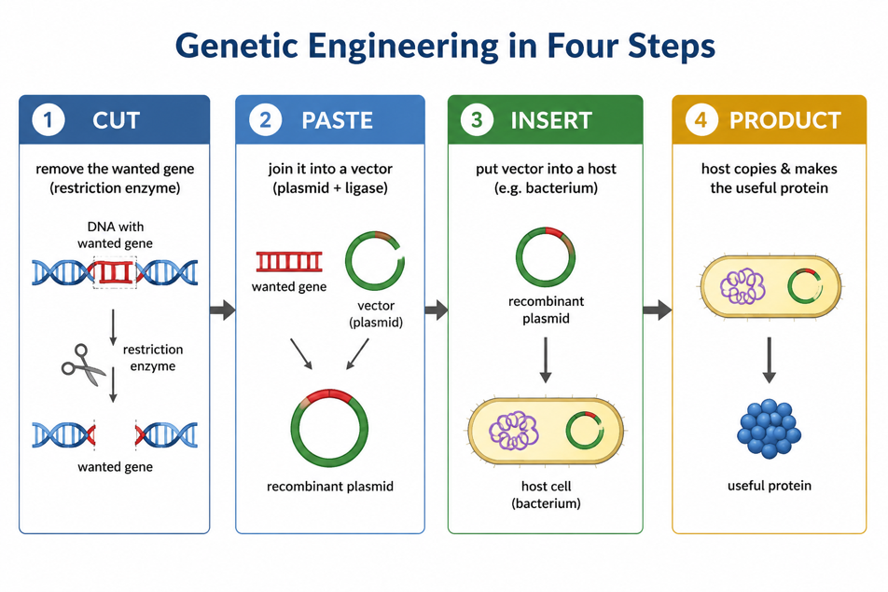
Figure 1: The four basic steps of genetic engineering - cut, paste, insert, produce.
Introduction
Recombinant DNA technology, also known as genetic engineering, is a key area of modern biology where scientists can extract, cut, and recombine DNA to create new genetic combinations. This allows specific genes to be cloned and used in a wide range of applications, from medicine and agriculture to industrial biotechnology. It builds directly on your understanding of DNA structure and the central dogma of molecular biology.

Key Learning Outcomes
- Define recombinant DNA technology / genetic engineering.
- Describe the tools: restriction enzymes, DNA ligase, vectors (plasmids) and host cells.
- Outline the steps of inserting a gene and cloning it.
- Explain the production of human insulin as a worked example.
- Give applications in medicine, agriculture and forensics.
- Discuss the social, ethical and environmental issues of genetic engineering.

The Molecular Tools
Genetic engineering needs a small set of “molecular tools”:
- Restriction enzymes: “molecular scissors” that cut DNA at specific recognition sequences, often leaving sticky ends.
- DNA ligase: “molecular glue” that joins pieces of DNA together.
- Vector (usually a plasmid): a small circular DNA from bacteria that carries the new gene into a host cell.
- Host cell: usually a bacterium, which copies the gene and makes its protein.

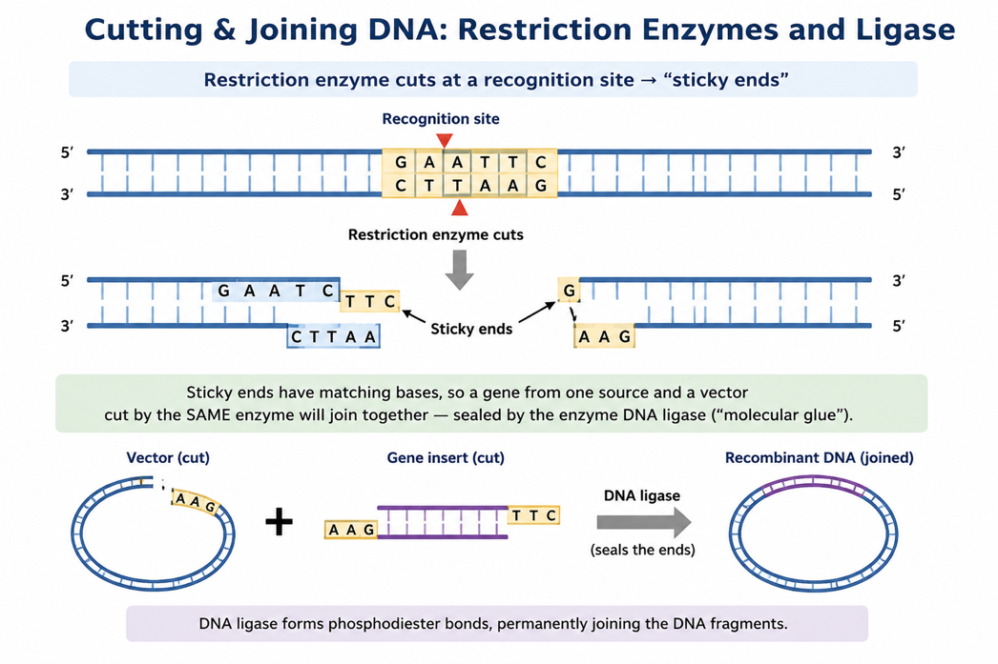

Figure 2: A restriction enzyme cuts DNA into sticky ends; ligase joins matching pieces.

Cloning a Gene with a Plasmid
To copy and use a gene, scientists put it into a plasmid vector:
- Cut the wanted gene and the plasmid with the SAME restriction enzyme (so the sticky ends match).
- Mix them with ligase - the gene joins the plasmid to form a recombinant plasmid.
- Put the recombinant plasmid into a bacterium (transformation).
- The bacterium divides, making millions of copies (gene cloning) and, if the gene is switched on, making the protein.
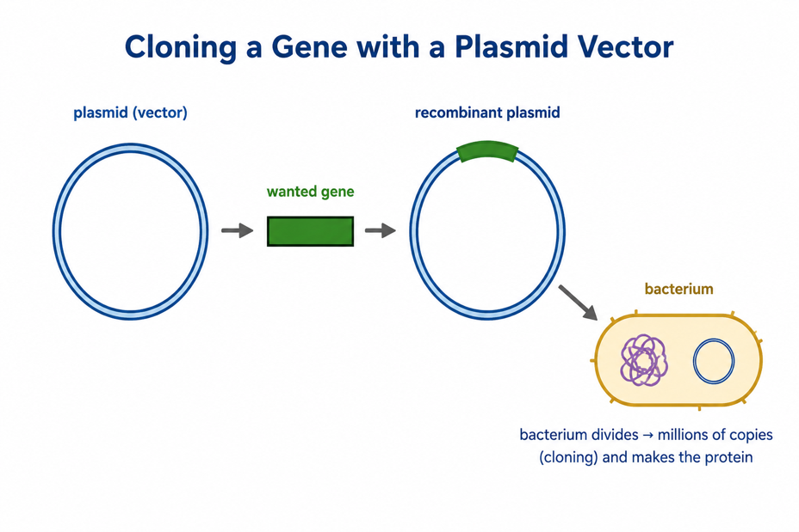
Figure 3: A wanted gene is inserted into a plasmid and cloned inside bacteria.

Worked Example - Human Insulin
People with diabetes need the hormone insulin. Genetic engineering lets bacteria make human insulin:
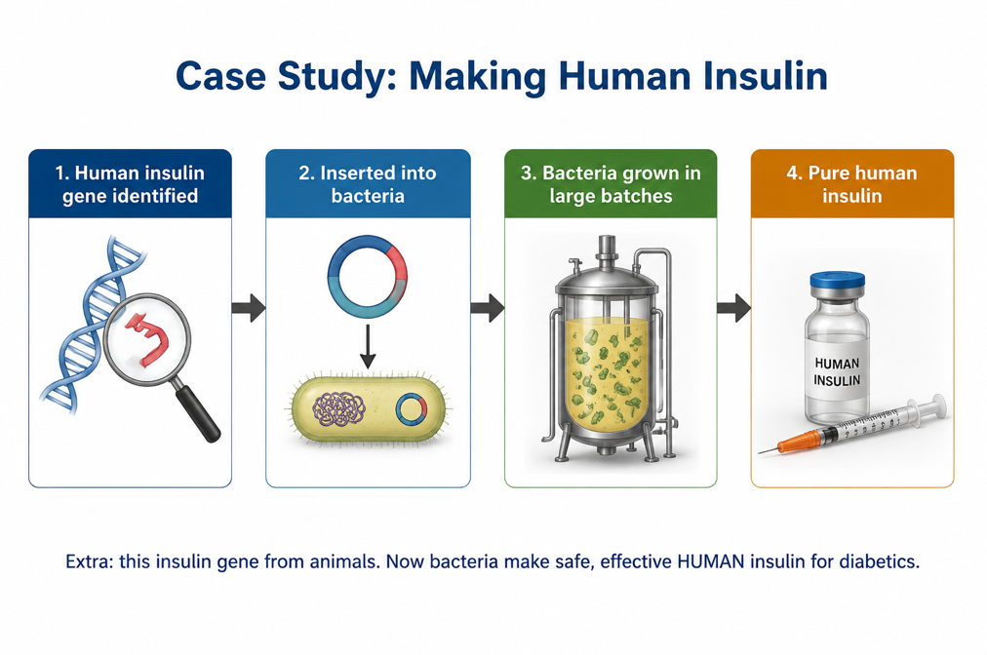

Figure 4: The human insulin gene is put into bacteria, which are grown to produce pure human insulin.
Before this, insulin was taken from the pancreases of pigs and cattle, which was costly and sometimes caused reactions. Engineered bacteria now make safe, identical, cheap human insulin - a clear benefit of the technology.

Applications
Recombinant DNA technology is used widely:
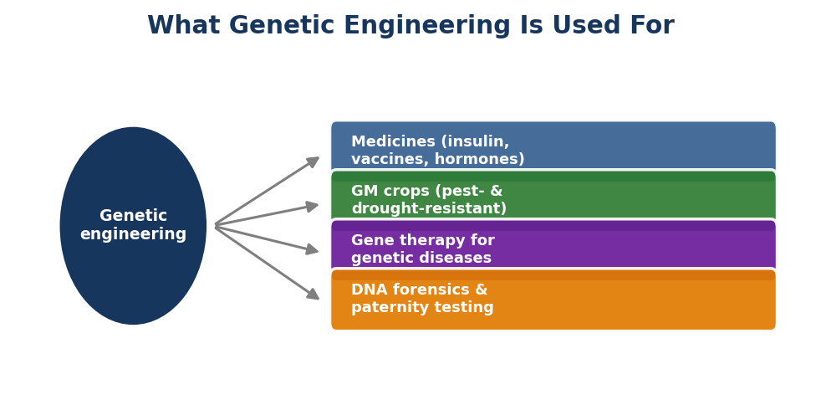
Figure 5: Some of the main uses of genetic engineering.
Field | Examples
Medicine | Insulin, growth hormone, vaccines (e.g. hepatitis B), gene therapy
Agriculture | GM crops resistant to pests, disease, drought; higher yields
Industry | Enzymes for detergents, food and biofuels
Forensics & research | DNA fingerprinting, studying gene function

Social, Ethical and Environmental Issues (SBC)
Genetic engineering is powerful, so it must be used responsibly.
Benefits | Concerns
Cheaper, safer medicines (e.g. insulin) | Long-term safety of some GM foods debated
Crops that resist pests & drought - food security | GM genes might spread to wild plants
Treating genetic diseases (gene therapy) | Ethics of changing human genes; ‘designer’ traits
New vaccines and faster research | Access, cost and who owns the technology

PNG spotlight - opportunity and responsibility
Genetic engineering offers PNG real benefits: affordable medicines and vaccines, and disease- and drought-resistant crops (coffee, cocoa, taro, sweet potato) to strengthen food security. But it must be guided by safety rules, fair access and respect for PNG’s biodiversity - the country should benefit from research done on its own plants and resources.

Key Vocabulary
- Recombinant DNA - DNA combined from two or more different sources.
- Genetic engineering - Changing an organism’s genes using molecular tools.
- Restriction enzyme - Protein that cuts DNA at a specific recognition sequence.
- Sticky ends - Short single-stranded ends that let cut DNA pieces join.
- DNA ligase - Enzyme that joins (glues) pieces of DNA together.
- Vector - A carrier (often a plasmid) that takes a gene into a host cell.
- Plasmid - A small circular piece of bacterial DNA used as a vector.
- Transformation - Getting a host cell to take up new DNA.
- Gene cloning - Making many identical copies of a gene.
- GM organism - An organism whose genes have been changed (genetically modified).
- Gene therapy - Treating disease by correcting faulty genes.
- Bioethics - Considering what is right and responsible in using biotechnology.

Check Yourself
- What does ‘recombinant DNA’ mean? Define genetic engineering.
- Name the four basic steps of genetic engineering.
- What do restriction enzymes and DNA ligase each do? What are sticky ends?
- What is a plasmid, and why is it used as a vector?
- Describe how a gene is cloned inside bacteria.
- Explain, step by step, how bacteria are used to make human insulin.
- Why is engineered human insulin better than insulin from animals?
- Give one application of genetic engineering in medicine, agriculture and forensics.
- List two benefits and two concerns of genetic engineering.
- How could genetic engineering help PNG, and what must be done responsibly?

References
- Department of Education, Papua New Guinea. STEM Biology Syllabus - Grade 12: Biotechnology (gene technology and applications).
- Department of Education, Papua New Guinea. Biology Syllabus, Grades 11 & 12 (SBC) - Strand 2 (Life), Unit 2: Genetics, benchmark 12.2.3.5 and Content Standard 12.2.2 (social, ethical & environmental implications).
- OpenStax Biology - Biotechnology: restriction enzymes, cloning vectors, recombinant DNA and applications.
- Genentech / history of recombinant human insulin (Humulin) - case study background.
- EduNeX Grade 12 Biology - Transcription & Translation (prerequisite lesson).

