Prepare：

1. One server which can run AzureAD command line with power shell
2. SharePoint Global Admin User

Guide:

Export

1. Run cmd with Administrator
2. Input command line go to the tool path:

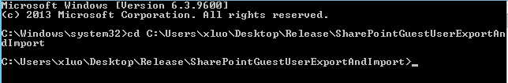

1. Input Export command line:

SharePointGuestUserExportAndImport.exe -o Export --output c: \ExportResult.csv



1. Input User name and password:

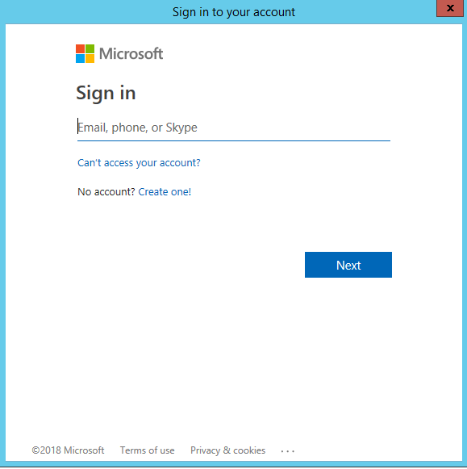

Import

1. Run cmd with Administrator
2. Input command line go to the tool path:



1. Input Import command line:

SharePointGuestUserExportAndImport.exe -o Import -f c:\ExportResult.csv --output c:\ImportResult.csv



1. Input User name and password:

