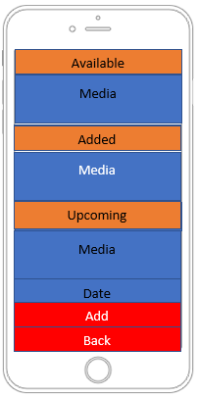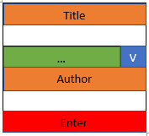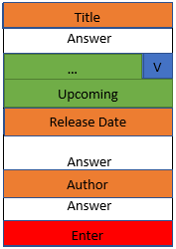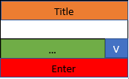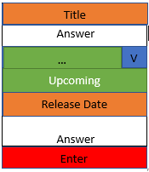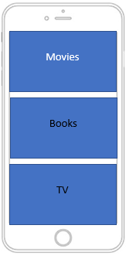

TV

Books

Movies

|  |  |
| --- | --- |
| Key | Colour |
| Button | Red |
| Label | Orange |
| Entry | White |
| DropBox | Green |
| Content | Blue  Release Date |

V

|  |
| --- |
| Title |
|  |
| … |
|  |
|  |
| Enter |