C++ Introduction

What is C++?
C++ is a cross-platform language that can be used to create high-performance applications.
C++ was developed by Bjarne Stroustrup, as an extension to the C language.
C++ gives programmers a high level of control over system resources and memory.
The language was updated 4 major times in 2011, 2014, 2017, and 2020 to C++11, C++14, C++17, C++20.

Why Use C++
C++ is one of the world's most popular programming languages.
C++ can be found in today's operating systems, Graphical User Interfaces, and embedded systems.
C++ is an object-oriented programming language which gives a clear structure to programs and allows code to be reused, lowering development costs.
C++ is portable and can be used to develop applications that can be adapted to multiple platforms.
C++ is fun and easy to learn!
As C++ is close to C, C# and Java, it makes it easy for programmers to switch to C++ or vice versa.

Similarities between C and C++
- Both the languages have a similar syntax.
- Code structure of both the languages are same.
- The compilation of both the languages is similar.
- They share the same basic syntax. Nearly all of C’s operators and keywords are also present in C++ and do the same thing.
- C++ has a slightly extended grammar than C, but the basic grammar is the same.
- Basic memory model of both is very close to the hardware.
- Same notions of stack, heap, file-scope and static variables are present in both the languages.

Difference between C and C++
C++ was developed as an extension of C, and both languages have almost the same syntax.
The main difference between C and C++ is that C++ support classes and objects, while C does not.

Introduction to C++ Programming Language
C++ is a general-purpose programming language that was developed as an enhancement of the C language to include object-oriented paradigm. It is an imperative and a compiled language.
- C++ is a high-level, general-purpose programming language designed for system and application programming. It was developed by Bjarne Stroustrup at Bell Labs in 1983 as an extension of the C programming language. C++ is an object-oriented, multi-paradigm language that supports procedural, functional, and generic programming styles.
- One of the key features of C++ is its ability to support low-level, system-level programming, making it suitable for developing operating systems, device drivers, and other system software. At the same time, C++ also provides a rich set of libraries and features for high-level application programming, making it a popular choice for developing desktop applications, video games, and other complex applications.
- C++ has a large, active community of developers and users, and a wealth of resources and tools available for learning and using the language. Some of the key features of C++ include:
- Object-Oriented Programming: C++ supports object-oriented programming, allowing developers to create classes and objects and to define methods and properties for these objects.
- Templates: C++ templates allow developers to write generic code that can work with any data type, making it easier to write reusable and flexible code.
- Standard Template Library (STL): The STL provides a wide range of containers and algorithms for working with data, making it easier to write efficient and effective code.
- Exception Handling: C++ provides robust exception handling capabilities, making it easier to write code that can handle errors and unexpected situations.
Overall, C++ is a powerful and versatile programming language that is widely used for a range of applications and is well-suited for both low-level system programming and high-level application development.
Features
- Object-Oriented Programming
- Machine Independent
- Simple
- High-Level Language
- Popular
- Case-sensitive
- Compiler Based
- Dynamic Memory Allocation
- Memory Management
- Multi-threading

Data Types in C++ are Mainly Divided into 3 Types:
1. Primitive Data Types: These data types are built-in or predefined data types and can be used directly by the user to declare variables. example: int, char, float, bool, etc. Primitive data types available in C++ are:
- Integer
- Character
- Boolean
- Floating Point
- Double Floating Point
- Valueless or Void
- Wide Character
2. Derived Data Types: Derived data types that are derived from the primitive or built-in datatypes are referred to as Derived Data Types. These can be of four types namely:
- Function
- Array
- Pointer
- Reference
3. Abstract or User-Defined Data Types: Abstract or User-Defined data types are defined by the user itself. Like, defining a class in C++ or a structure. C++ provides the following user-defined datatypes:
- Class
- Structure
- Union
- Enumeration
- Typedef defined Datatype
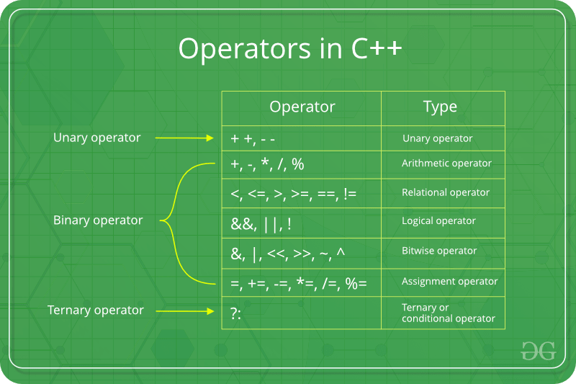
Operators

Bitwise Operators
These operators are used to perform bit-level operations on the operands. The operators are first converted to bit-level and then the calculation is performed on the operands. Mathematical operations such as addition, subtraction, multiplication, etc. can be performed at the bit level for faster processing.
Name | Symbol | Description | Example
Binary AND | & | Copies a bit to the evaluated result if it exists in both operands | int a = 2, b = 3;  (a & b); //returns 2
Binary OR | | | Copies a bit to the evaluated result if it exists in any of the operand | int a = 2, b = 3;  (a | b); //returns 3
Binary XOR | ^ | Copies the bit to the evaluated result if it is present in either of the operands but not both | int a = 2, b = 3;  (a ^ b); //returns 1
Left Shift | << | Shifts the value to left by the number of bits specified by the right operand. | int a = 2, b = 3;  (a << 1); //returns 4
Right Shift | >> | Shifts the value to right by the number of bits specified by the right operand. | int a = 2, b = 3;  (a >> 1); //returns 1
One’s Complement | ~ | Changes binary digits 1 to 0 and 0 to 1 | int b = 3;  (~b); //returns -4
Note: Only char and int data types can be used with Bitwise Operators.

Ternary or Conditional Operators(?:)
This operator returns the value based on the condition.
Expression1? Expression2: Expression3
The ternary operator ? determines the answer on the basis of the evaluation of Expression1. If it is true, then Expression2 gets evaluated and is used as the answer for the expression. If Expression1 is false, then Expression3 gets evaluated and is used as the answer for the expression.
This operator takes three operands, therefore it is known as a Ternary Operator.

Basic Input / Output in C++
C++ comes with libraries that provide us with many ways for performing input and output. In C++ input and output are performed in the form of a sequence of bytes or more commonly known as streams.
- Input Stream: If the direction of flow of bytes is from the device(for example, Keyboard) to the main memory then this process is called input.
- Output Stream: If the direction of flow of bytes is opposite, i.e. from main memory to device( display screen ) then this process is called output.
Header files available in C++ for Input/Output operations are:
- iostream: iostream stands for standard input-output stream. This header file contains definitions of objects like cin, cout, cerr, etc.
- iomanip: iomanip stands for input-output manipulators. The methods declared in these files are used for manipulating streams. This file contains definitions of setw, setprecision, etc.
- fstream: This header file mainly describes the file stream. This header file is used to handle the data being read from a file as input or data being written into the file as output.
- bits/stdc++: This header file includes every standard library. In programming contests, using this file is a good idea, when you want to reduce the time wasted in doing chores; especially when your rank is time sensitive. To know more about this header file refer this article.
In C++ after the header files, we often use ‘using namespace std;‘. The reason behind it is that all of the standard library definitions are inside the namespace std. As the library functions are not defined at global scope, so in order to use them we use namespace std. So, that we don’t need to write STD:: at every line (eg. STD::cout etc.).
The two instances cout in C++ and cin in C++ of iostream class are used very often for printing outputs and taking inputs respectively. These two are the most basic methods of taking input and printing output in C++. To use cin and cout in C++ one must include the header file iostream in the program.
This article mainly discusses the objects defined in the header file iostream like the cin and cout.
- Standard output stream (cout): Usually the standard output device is the display screen. The C++ cout statement is the instance of the ostream class. It is used to produce output on the standard output device which is usually the display screen. The data needed to be displayed on the screen is inserted in the standard output stream (cout) using the insertion operator(<<).
- standard input stream (cin): Usually the input device in a computer is the keyboard. C++ cin statement is the instance of the class istream and is used to read input from the standard input device which is usually a keyboard.
The extraction operator(>>) is used along with the object cin for reading inputs. The extraction operator extracts the data from the object cin which is entered using the keyboard.

Some other differences between endl and \n are:
endl | \n
It is a manipulator. | It is a character.
It doesn’t occupy any memory. | It occupies 1 byte memory as it is a character.
It is a keyword and would not specify any meaning when stored in a string. | It can be stored in a string and will still convey its specific meaning of line break.
We cannot write ‘endl’ in between double quotations. | We can write ‘\n’ in between double quotations like std::cout<<“\n”;
It is only supported by C++. | It is supported in both C and C++.
It keeps flushing the queue in the output buffer throughout the process. | It flushes the output buffer only once at the end of the program

C++ Break and Continue

C++ Break
You have already seen the break statement used in an earlier chapter of this tutorial. It was used to "jump out" of a switch statement.
The break statement can also be used to jump out of a loop.

C++ Continue
The continue statement breaks one iteration (in the loop), if a specified condition occurs, and continues with the next iteration in the loop.

C++ Type Modifiers
Modifiers are used in C++ to change or give extra meaning to already existing data types. It’s added to primitive data types as a prefix to change their meaning. A modifier is used to change the meaning of a basic type so that it better matches the requirements of different circumstances.
Following are the C++ data type modifiers:
- signed
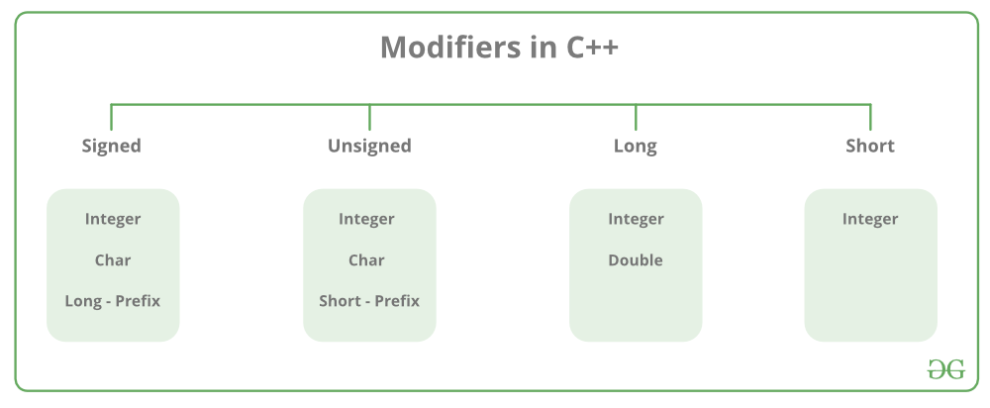
- unsigned
- short
- long

Type Conversion in C++
A type cast is basically a conversion from one type to another. There are two types of type conversion:
- Implicit Type Conversion Also known as ‘automatic type conversion’.
  - Done by the compiler on its own, without any external trigger from the user.
  - Generally takes place when in an expression more than one data type is present. In such condition type conversion (type promotion) takes place to avoid lose of data.
  - All the data types of the variables are upgraded to the data type of the variable with largest data type.
bool -> char -> short int -> int ->

unsigned int -> long -> unsigned ->

long long -> float -> double -> long double
  - It is possible for implicit conversions to lose information, signs can be lost (when signed is implicitly converted to unsigned), and overflow can occur (when long long is implicitly converted to float).
2. Explicit Type Conversion: This process is also called type casting and it is user-defined. Here the user can typecast the result to make it of a particular data type. In C++, it can be done by two ways:
- Converting by assignment: This is done by explicitly defining the required type in front of the expression in parenthesis. This can be also considered as forceful casting. Syntax:
(type) expression
where type indicates the data type to which the final result is converted.
- Conversion using Cast operator: A Cast operator is an unary operator which forces one data type to be converted into another data type. C++ supports four types of casting:
- Static Cast
- Dynamic Cast
- Const Cast
- Reinterpret Cast
Advantages of Type Conversion:
- This is done to take advantage of certain features of type hierarchies or type representations.
- It helps to compute expressions containing variables of different data types.

Casting Operators in C++
Casting operators are used for type casting in C++. They are used to convert one data type to another. C++ supports four types of casts:
- static_cast
- dynamic_cast
- const_cast
- reinterpret_cast

1. static_cast
The static_cast operator is the most commonly used casting operator in C++. It performs compile-time type conversion and is mainly used for explicit conversions that are considered safe by the compiler.

Syntax of static_cast
static_cast <new_type> (expression);
where,
- expression: Data to be converted.
- new_type: Desired type of expression
The static_cast can be used to convert between related types, such as numeric types or pointers in the same inheritance hierarchy.

2. dynamic_castdivBlock
The dynamic_cast operator is mainly used to perform downcasting (converting a pointer/reference of a base class to a derived class). It ensures type safety by performing a runtime check to verify the validity of the conversion.

Syntax of dynamic_cast
dynamic_cast <new_type> (expression);
If the conversion is not possible, dynamic_cast returns a null pointer (for pointer conversions) or throws a bad_cast exception (for reference conversions).

3. const_cast
The const_cast operator is used to modify the const or volatile qualifier of a variable. It allows programmers to temporarily remove the constancy of an object and make modifications. Caution must be exercised when using const_cast, as modifying a const object can lead to undefined behavior.

Syntax for const_cast
const_cast <new_type> (expression);

4. reinterpret_cast
The reinterpret_cast operator is used to convert the pointer to any other type of pointer. It does not perform any check whether the pointer converted is of the same type or not.

Syntax of reinterpret_cast
reinterpret_cast <new_type> (expression);

