**Assignment - 4**

**Problem Statement–**

To implement the A* algorithm and demonstrate its application in solving a shortest path problem.

**Objectives -**

1. To understand the working principles of the A* algorithm.
2. To apply A* to find the optimal path between two points on a grid.
3. To compare the performance of A* with other pathfinding algorithms like Dijkstra’s algorithm.
4. To analyze the advantages and limitations of using A* in real-world applications.

**Theory -**

1. **What is A* search algorithm?**

A search algorithm* is one of the most popular and efficient pathfinding and graph traversal algorithms. It finds the shortest path between a starting point and a goal by combining features of Dijkstra’s algorithm and Greedy Best-First Search. A* uses both the actual cost of the path from the start-sometimes known as g(n)-and an estimate of the cost to reach the goal from the current node, sometimes called the heuristic or h(n). This combination allows A* to explore fewer nodes than Dijkstra’s algorithm, while still guaranteeing the shortest path, provided the heuristic is admissible.

1. **Why A* search algorithm?**

A* is preferred in many applications because it is both optimal (it finds the least-cost path) and complete (it will find a solution if one exists). It is more efficient than uninformed search algorithms (like Dijkstra) because it uses a heuristic to estimate the remaining cost to the goal, guiding the search towards the most promising paths. Additionally, A* can handle a variety of complex problems, such as navigation, game development, and AI, making it a versatile and widely used algorithm.

1. **Steps for implementing A* search algorithm**

* Create an open list (priority queue) to store nodes that are yet to be explored.
* Create a closed list for nodes that have already been explored.
* Add the start node to the open list with g(n) = 0 and calculate f(n) = g(n) + h(n).
* Select the node from the open list with the lowest f(n). This is the most promising node.
* Move it to the closed list.
* If the current node is the goal node, the search ends. Reconstruct the path from the goal to the start.
* For each neighboring node, calculate g(n)(the cost from the start to this neighbor) and h(n) (heuristic cost to the goal).
* If the new f(n) is lower than a previously encountered value for this node, update its f(n) and add it to the open list.
* Continue expanding nodes until the goal is reached or the open list is empty (indicating no solution).

1. **Workflow diagram for A* search algorithm**

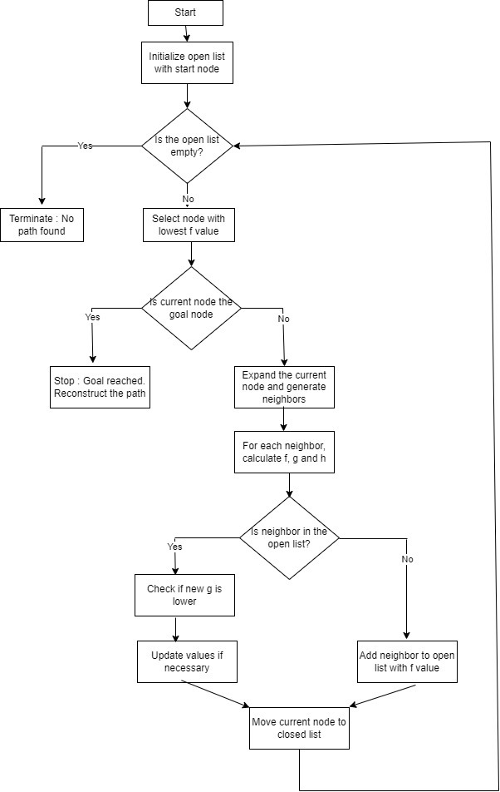

1. **Formula**

The A* algorithm evaluates nodes using the following formula:

f(n) = g(n) + h(n)

where, g(n) is the cost from the start node to the current node n.

h(n) is the heuristic estimate of the cost from n to the goal.

f(n) is the estimated total cost of the path through n.

1. **What is heuristics?**

A heuristic is a function that estimates the cost of the cheapest path from a given node to the goal. In the A* algorithm, the heuristic helps prioritize which nodes to explore, guiding the algorithm toward the goal efficiently. The heuristic should be admissible, meaning it never overestimates the actual cost.

Here, h(n) is a heuristic function.

1. **How to calculate exact heuristics?**

Exact heuristics involve perfect knowledge of the distance from the current node to the goal. This can be calculated if you know the exact path or cost, which is typically not the case in real-world problems unless you precompute the values.

1. **How to calculate approximate heuristics?**

Approximate heuristics are used when the exact cost is unknown. Some common ways to approximate the heuristic include:

* **Manhattan Distance**: For grid-based maps, calculated as the sum of the absolute differences of the x and y coordinates.
* **Euclidean Distance**: The straight-line distance between two points.
* **Chebyshev Distance**: Used in environments where diagonal moves are allowed, taking the maximum of the horizontal and vertical distances.

1. **Time complexity of A* algorithm**

The time complexity of A* is O(b^d), where b is the branching factor (the average number of child nodes per node) and d is the depth of the solution.

Considering a graph, it may take us to travel all the edge to reach the destination cell from the source cell [For example, consider a graph where source and destination nodes are connected by a series of edges, like – 0(source) –>1 –> 2 –> 3 (target)

So the worst case time complexity is O(E), where E is the number of edges in the graph.

1. **Space complexity of A* algorithm**

The space complexity is also O(b^d) because A* needs to store all generated nodes in memory. **This is one of the primary limitations of the algorithm.**

In the worst case we can have all the edges inside the open list, so required auxiliary space in the worst case is O(V), where V is the total number of vertices.

1. **Applications of A* algorithm**

* **Robotics and Autonomous Navigation:** Used for pathfinding and obstacle avoidance in robotic systems.
* **Game Development:** A* is used in games for NPC navigation and AI behavior, helping characters move efficiently in virtual environments.
* **GPS Navigation:** A* finds the optimal routes between locations, considering road networks and estimated travel times.
* **Logistics and Route Optimization:** Helps plan optimal paths for transportation and delivery services.
* **AI Systems:** Applied in decision-making processes for AI agents.

1. **Advantages of A* algorithm**

* **Optimal:** If the heuristic is admissible, A* will always find the least-cost path.
* **Complete:** It will find a solution if one exists, assuming the search space is finite.
* **Efficient:** A* is often more efficient than uninformed algorithms, thanks to its use of heuristics.
* **Flexible:** By adjusting the heuristic function, A* can be tailored to different types of search problems.

1. **Limitations of A* algorithm**

* **Memory Intensive:** A* must store all generated nodes, leading to high memory consumption, especially in large search spaces.
* **Computationally Expensive:** As A* explores a large number of nodes, it can become computationally expensive in complex problems.
* **Heuristic Dependency:** The performance of A* depends heavily on the quality of the heuristic. Poor heuristics can make A* behave like Dijkstra’s algorithm.

1. **Comparison between A* algorithm and other algorithms such as Dijkstra's algorithm**

|  |  |  |
| --- | --- | --- |
| **Aspect** | **Dijkstra’s Algorithm** | **A* Algorithm** |
| **Heuristic (h(n))** | h(n) = 0 for all nodes | Uses both g(n) and h(n) to guide the search |
| **Cost Consideration** | Considers only the cost so far (g(n)) | Combines g(n) and h(n) for more informed decision-making |
| **Efficiency** | Explores more nodes, especially in large search spaces | More efficient when a good heuristic is available |
| **Exploration** | Explores more nodes due to lack of heuristic | Explores fewer nodes with an admissible heuristic |
| **Optimality** | Guarantees the shortest path | Guarantees the shortest path if h(n) is admissible |

|  |  |  |
| --- | --- | --- |
| **Aspect** | **Greedy Best-First Search Algorithm** | **A* Algorithm** |
| **Heuristic (h(n))** | Uses only the heuristic h(n) | Combines both g(n) and h(n) |
| **Cost Consideration** | Does not consider actual cost (g(n)) | Balances between actual cost g(n) and heuristic h(n) |
| **Path Optimality** | Can lead to suboptimal paths | Finds the shortest path if h(n) is admissible |
| **Node Exploration** | Often explores fewer nodes but may not be efficient | Explores fewer nodes while ensuring the shortest path |
| **Search Strategy** | Focuses on reaching the goal quickly without guarantees | Efficiently balances cost and heuristic for optimal path |

1. **When to use A* algorithm and when to use other algorithms?**

* **Use A* Algorithm -**

1. When you need to find the shortest path efficiently and can define a good heuristic.
2. In pathfinding problems like navigation in robotics, games, or transportation networks.
3. When optimality is crucial, and you want to balance exploration and exploitation of the search space.

* **Use Other Algorithms -**

1. **Dijkstra’s Algorithm:** If no heuristic is available or if you need to find the shortest path in graphs where edge weights are non-negative and uniform, or when you need all-pairs shortest paths.
2. **Greedy Best-First Search:** When you prioritize speed over optimality and are only interested in finding a path quickly.
3. **Breadth-First Search:** When working with unweighted graphs where all edges have the same cost.

**Conclusion -**

The A algorithm is one of the most popular methods, gaining great power and versatility in pathfinding and traversing graphs to efficiently find the shortest paths between nodes through a combination of actual cost to reach the node (g(n)) and a heuristic estimate of cost to reach the goal (h(n)). This balanced approach is more efficient in large or complex environments where a carefully designed heuristic can drastically reduce the number of nodes that need to be explored in contrast with Dijkstra's, where exploration depends purely on g(n), or Greedy Best-First Search, where exploration relies purely on h(n). A* guarantees finding the best path as long as a heuristic is admissible, meaning it never overestimates the true cost. It is therefore very general in application from robotics to games route planning, and artificial intelligence. However, its performance significantly depends on the quality of the heuristic function; an ineffective heuristic can lead to unnecessary exploration and slower performance. In general, if an admissible heuristic is available, A* is preferred; otherwise, it balances exploration and optimality and removes the shortcomings found in both Dijkstra's and Greedy Best-First Search algorithms.