**Assignment No: - 4**

**Problem Statement:**

Implementing time series prediction using Recurrent Neural Networks (RNNs) for stock market analysis or weather forecasting.

**Objective:**

* To understand the architecture and functioning of Recurrent Neural Networks.
* To learn how to preprocess time series data for RNN training.
* To implement an RNN model using Keras and TensorFlow for time series prediction.
* To evaluate model performance using test data.
* To visualize predictions and compare them with actual values.

**S/W Packages and H/W apparatus used:**

* **Operating System:** Windows/Linux/MacOS
* **Kernel:** Python 3.x
* **Tools:** Jupyter Notebook, Anaconda, or Google Colab
* **Hardware:** CPU with minimum 4GB RAM; optional GPU for faster processing

**Libraries and packages used:**

* **TensorFlow**
* **Keras**
* **NumPy**
* **Pandas**
* **Matplotlib**

**Theory:**

**Definition:**

Recurrent Neural Networks (RNNs) are a class of artificial neural networks designed for processing sequential data. They have the capability to maintain information about previous inputs in their internal memory, making them particularly suitable for time series prediction tasks.

**Structure:**

Input Layer: Accepts sequences of data points (e.g., stock prices or weather measurements).

Recurrent Layers: Consist of RNN cells (e.g., LSTM or GRU) that process sequences, maintaining a hidden state to capture temporal dependencies.

Fully Connected Layer: Connects the output from the recurrent layers to the final prediction output.

Output Layer: Produces the predicted values for the next time step in the sequence.

**Activation Functions:**

Common activation functions used in RNNs include Tanh and Sigmoid, which help regulate the values flowing through the network and maintain stability during training.

**Memory Cells:**

RNNs utilize memory cells, such as Long Short-Term Memory (LSTM) or Gated Recurrent Unit (GRU) cells, to address issues like vanishing gradients and to retain long-term dependencies in sequential data.

**Methodology:**

1. **Data Acquisition:**

* Load historical stock market data (e.g., stock prices) or weather data (e.g., temperature, humidity) from reliable sources like Yahoo Finance or weather APIs.

1. **Data Preparation:**

* Process the dataset by selecting relevant features and normalizing values to a range between 0 and 1.

1. **Sequence Creation:**

* Create sequences from the time series data to prepare input and output pairs. For example, use the past 60-time steps to predict the next value.

1. **Model Architecture:**

* Create a sequential model using Keras.
* Add one or more recurrent layers (e.g., LSTM or GRU) with a specified number of units.
* Add a fully connected layer and an output layer for regression tasks.

1. **Model Compilation:**

* Compile the model using the Adam optimizer and Mean Squared Error (MSE) as the loss function.

1. **Model Training:**

* Fit the model on the training data while validating on a separate validation set. Track loss and performance metrics.

1. **Model Evaluation:**

* Evaluate the model on the test dataset to measure prediction accuracy.

1. **Prediction Visualization:**

* Plot predicted values against actual values over time to visually assess model performance.

**Advantages:**

* **Sequential Data Handling:** RNNs are specifically designed for sequential data, allowing them to capture temporal dependencies effectively.
* **Long-Term Memory:** With architectures like LSTM and GRU, RNNs can remember information over long sequences, making them ideal for time series tasks where past values influence future outcomes.
* **Flexibility:** RNNs can handle varying input lengths, making them versatile for different types of time series data.
* **Dynamic Computation:** They process sequences of varying lengths without the need for fixed-size input, adapting to the data's natural structure.

**Limitations:**

* **Computational Complexity:** Training RNNs can be computationally intensive, especially with long sequences and large datasets.
* **Vanishing Gradient Problem:** Traditional RNNs can struggle with long-term dependencies due to vanishing gradients, though this is mitigated with LSTM and GRU architectures.
* **Overfitting Risk:** RNNs are prone to overfitting, particularly with small datasets, necessitating regularization techniques.
* **Data Requirements:** Effective training requires a significant amount of historical data to capture the underlying patterns accurately.

**Applications:**

* **Stock Market Analysis:** RNNs are commonly used for predicting stock prices and trends based on historical price data.
* **Weather Forecasting:** They are employed to forecast weather conditions by analysing time series data from previous weather patterns.
* **Natural Language Processing:** RNNs are utilized in applications such as language modelling and text generation, where sequential data plays a crucial role.

**Working / Algorithm:**

**Step 1: Import Necessary Libraries**

* Import the required libraries for numerical operations, data manipulation, visualization, and machine learning. Use libraries like NumPy, Pandas, Matplotlib, and Keras for building the RNN model.

**Step 2: Load Dataset**

* Load the stock market dataset using Pandas. Ensure the dataset includes a 'Date' column for timestamps and a 'Close' column for closing stock prices.
* Convert the 'Date' column to a datetime format and set it as the index for the DataFrame.

**Step 3: Preprocess the Data**

* Extract the closing prices from the DataFrame and convert them into a NumPy array.
* Normalize the closing prices using MinMaxScaler to scale the data to a range between 0 and 1. This step is crucial for improving the performance of the RNN.

**Step 4: Create sequences for the RNN**

* Define a function to generate input-output sequences from the normalized data.
* Loop through the data to create sequences of a specified length (e.g., 60 time steps) for the input features and their corresponding labels (the next time step).

**Step 5: Split the data into train and test sets**

* Determine the index to split the data into training and testing datasets. Typically, 80% of the data is used for training and 20% for testing.
* Use the determined index to separate the features and labels into training and testing datasets.

**Step 6: Build the RNN model**

* Create a sequential model using Keras.
* Add a SimpleRNN layer with a specified number of units (e.g., 50) and an activation function (e.g., ReLU).
* Add a Dense layer for output, designed to predict the stock price.

**Step 7: Train the model**

* Compile the model using the Adam optimizer and Mean Squared Error (MSE) as the loss function.
* Fit the model on the training data, specifying the number of epochs (e.g., 10) and batch size (e.g., 32). Also, validate the model on the testing data during training.

**Step 8: Predict for the next 20 days**

* Initialize an empty list to store future predictions.
* Retrieve the most recent sequence of data from the normalized dataset to use for predictions.
* For a specified number of days (e.g., 20), reshape the recent sequence and predict the next stock price using the trained model. Append the predicted price to the list of future predictions and update the recent sequence accordingly.

**Step 9: Inverse transform the predicted prices to the original scale**

* Use the scaler object to inverse transform the list of predicted future prices to convert them back to the original scale of stock prices.

**Step 10: Compare with actual prices (next 20 days)**

* Extract the actual closing prices for the next 20 days from the normalized dataset for comparison.

**Step 11: Plot the results**

* Create a line plot to visualize the actual and predicted stock prices for the next 20 days. Label the axes and add a legend for clarity.

**Step 12: Print actual and predicted prices for the next 20 days**

* Loop through the predictions and print the actual vs. predicted prices for each of the next 20 days, providing a comparison of the model's predictions with real data.

**Diagram:**

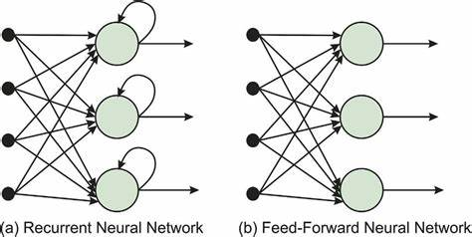 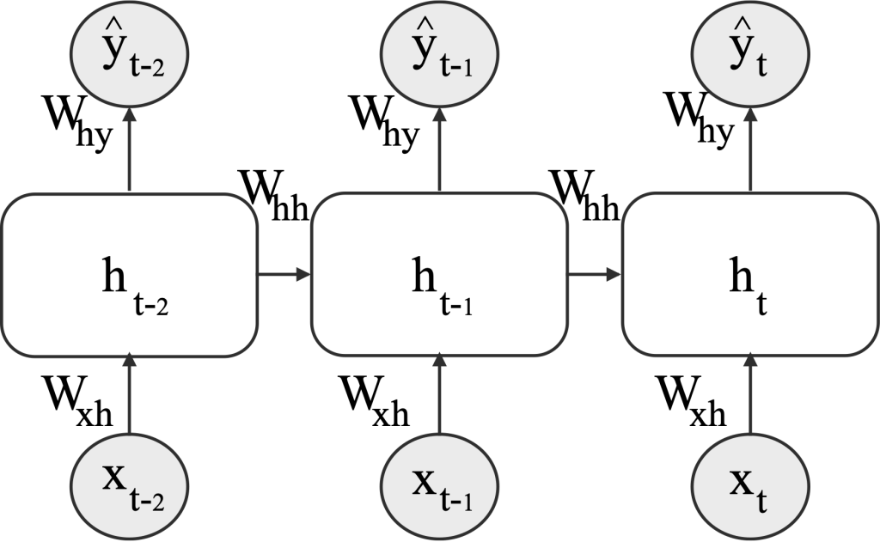

**Conclusion:**

In conclusion, Recurrent Neural Networks (RNNs) provide a powerful approach for time series prediction tasks, effectively capturing temporal patterns in data. Their ability to learn from historical information makes them well-suited for applications like stock market analysis and weather forecasting. While RNNs come with challenges, such as computational demands and the risk of overfitting, their adaptability and effectiveness make them a valuable tool for predictive modeling in various domains. With proper tuning and implementation, RNNs can yield accurate and insightful predictions based on sequential data.