Linux Commands Assignment

# 1. Creating and Renaming Files/Directories

# Create directory  
mkdir test_dir  
  
# Go inside directory  
cd test_dir  
  
# Create empty file  
touch example.txt  
  
# Rename file  
mv example.txt renamed_example.txt

Explanation: mkdir creates a directory, touch creates an empty file, and mv is used to move/rename files.

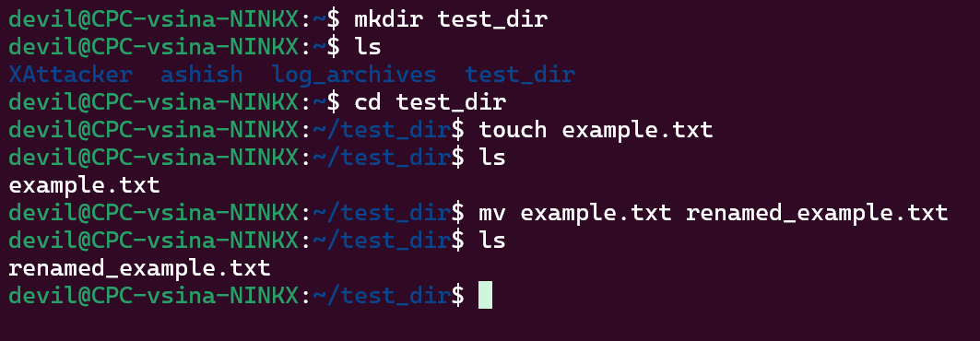

# 2. Viewing File Contents

# Display contents of /etc/passwd  
cat /etc/passwd  
  
# First 5 lines  
head -n 5 /etc/passwd  
  
# Last 5 lines  
tail -n 5 /etc/passwd

Explanation: cat prints file content, head shows top lines, and tail shows bottom lines.

# 3. Searching for Patterns

# Find lines containing 'root'  
grep "root" /etc/passwd

Explanation: grep searches text patterns inside files.

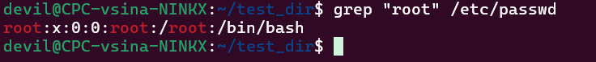

# 4. Zipping and Unzipping

# Compress directory  
zip -r test_dir.zip test_dir  
  
# Create new directory and unzip  
mkdir unzipped_dir  
unzip test_dir.zip -d unzipped_dir

Explanation: zip -r compresses recursively, and unzip -d extracts into a specific directory.

# 5. Downloading Files

wget https://example.com/sample.txt  
wget https://people.sc.fsu.edu/~jburkardt/data/csv/airtravel.csv

Explanation: wget downloads files from the internet.

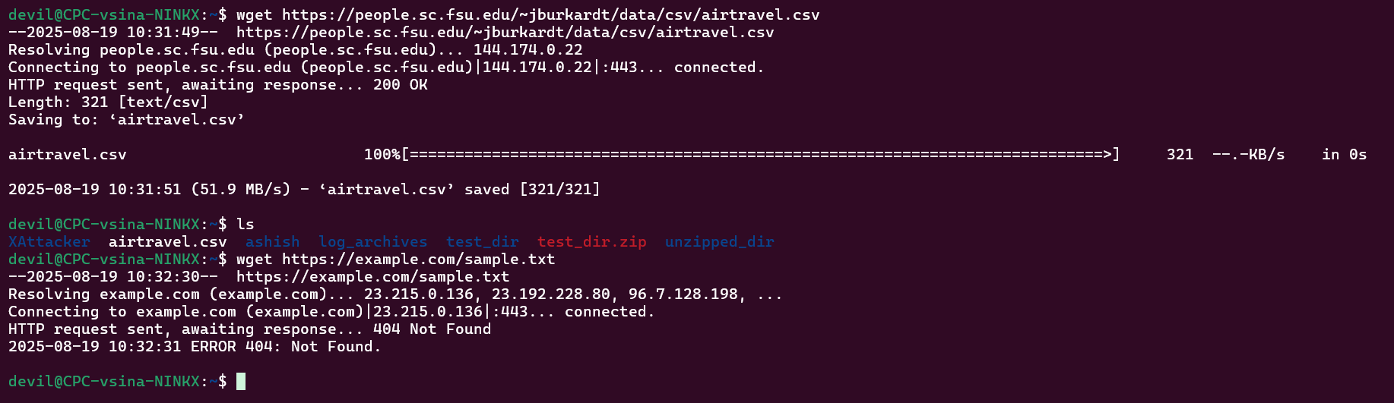

# 6. Changing Permissions

# Create file  
touch secure.txt  
  
# Make read-only for everyone  
chmod 444 secure.txt

Explanation: chmod 444 gives read-only permission to owner, group, and others.

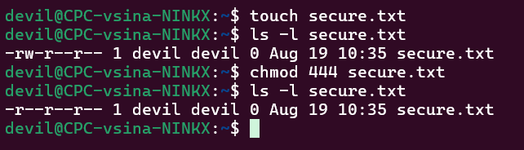

# 7. Working with Environment Variables

# Set environment variable  
export MY_VAR="Hello, Linux!"  
  
# Verify  
echo $MY_VAR

Explanation: export sets environment variables in shell, echo prints their value.

