2. Methodology
2.1 Hybrid text classification Model
2.1.1 Preprocessing
[1. output , explain ]
The language and vocabulary used in chat can vary from the original rules. To normalize the vocabulary used and to remove the most frequently occuring words and articles, preprocessing is applied on the text before training the model. The text is converted to lowercase , html tags are removed ,punctuations are removed , abbreviations are replaced with gramatically correct words, spelling correction is done on words. Stopwords are replaced. Stemming is done on the words to reduce the words to its root form.

2.1.2 Text Representation : bow, tfidf, word2vec
[2. output , explain ]
The Machine Learning and Deep Learning Models require the input data to be in numerical form. Text representation techniques used includes Bag Of Words, TFIDF and Word2Vec. In Bag Of Words representation, the chat text is represented as a vector. The vector elements refer to the number of times a word is occuring in the chat text . The length of the vector is equal to the vocabulary size of the corpus. Bag Of Words representation was unable to capture the ordering of words , it was overfitting and slow due to the huge size of the vocabulary. TFIDF is a method by which the word is represented such that if it occurs too many times in one document and rarely in the entire corpus , then the word is given more score. Sematic relationship of the words is not captured by TFIDF , therefore Word2Vec method is used. It also solves the problem of sparsity by using dense vectors.
[3. output , explain ]

2.1.3 Text classif ML model ensemble : GNB, MNB, BNB , SVC, KNC, DTC, LRC, RFC, ABC, BC, ETC, GBDT , XGB
[4. output , explain ] --
Word2Vec text representation is used to trian the models. The models include Gaussian Naive Bayes, Multinomial Naive Bayes, Bernaulli Naive Bayes , Support Vector Classifier, K Nearest Neighbors Classifier, Decision Tree Classifiers are trained . Ensemble learning techniques including voting ,bagging and stacking are applied on these models to enhance the overall accuracy.
(output of all classifiers)
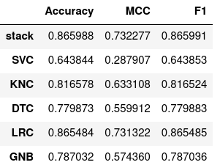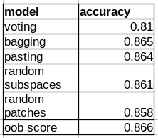

[5. output , explain ]
Ensemble learning models are also trained which include Random Forest Classifier , AdaBoost Classifier, Bagging Classifier, Extra Trees Classifier , Gradient Boosting Classifier , and XGBoost Classifiers are trained .
(output of all classifiers)
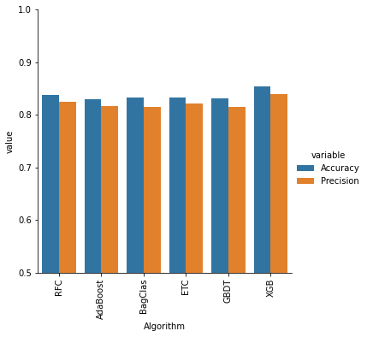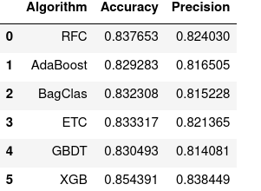

2.1.4 Text classif DL model ensemble : ANN, GRU , LSTM
[6. output , explain ]
Text classification can also be done using Deep Learning models . Artificial Neural Network , Gated Recurrent Unit and Long Short Term Memory Models are used to classify the text . The neural networks output a value ranging from 0 to 1 at the output layer . This value is a result of the sigmoid activation function . This value is used as a feature instead of 0 or 1 classification to improve accuracy of the further sales predcition models.
(accuracy of classifiers)
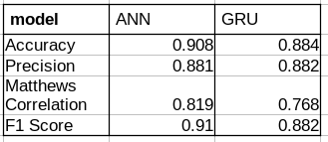
[7. output , explain ] --
Ensemble learning is done using ANN, GRU , LSTM models as the base estimators. Fusion , Voting , Bagging and Gradient Boosting ensemble learning techniques are tried on the model to improve the overall performance of the models.
(accuracy of ensemble model )

2.2 Hybrid Sales Prediction Model
- EDA : orderwise , prodwise , clientwise
- select models for ensemble learning based on hyperparameter tuning : multiple lr,polynomial, ridge, lasso , elasticNet, logistic, softmax , dtree, reg tree, random forest : orderwise, prodwise, clientwise
- IMDB Movie review for sentiment classif.
2.2.1 EDA : Orderwise , productwise, clientwise
Orderwise :

[1. output, explain]
[2. output, explain]
[3. output, explain]
[4. output, explain]

Most Orders are placed by Client0 , in the month of December, on Monday.
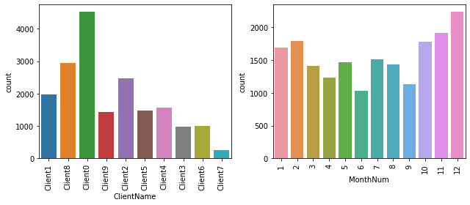
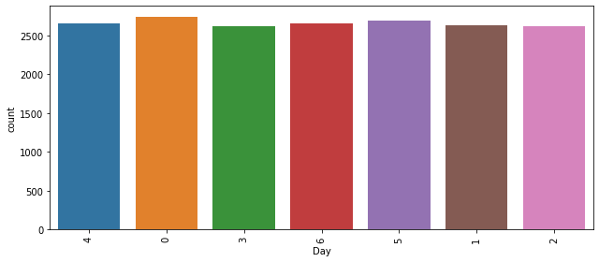

Distribution of Hour when the sales was done
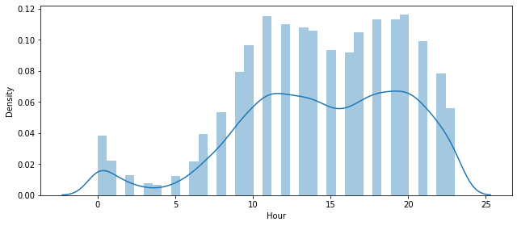
Distribution of Client’s Average Sentiment based on chats before Order was placed
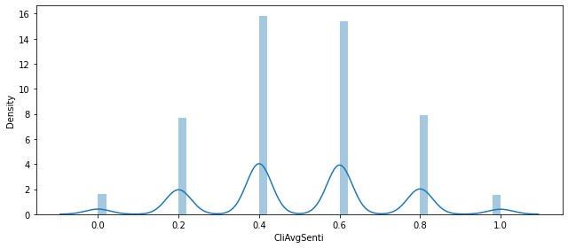

Distribution of Salesperson’s average sentiment based on chats before the order was placed.
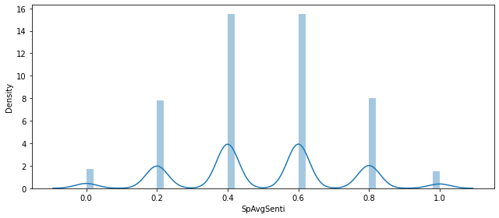
Distribution of Basket size of an order.
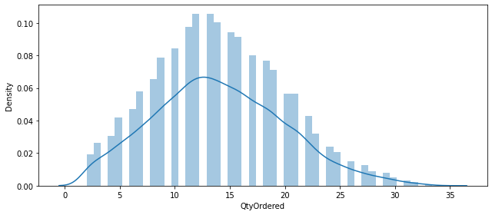
Distribution of Sales of Orders
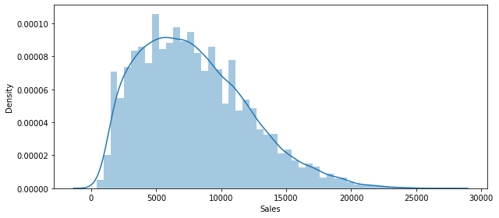

Sales and Quantity Ordered with Client Name and Day
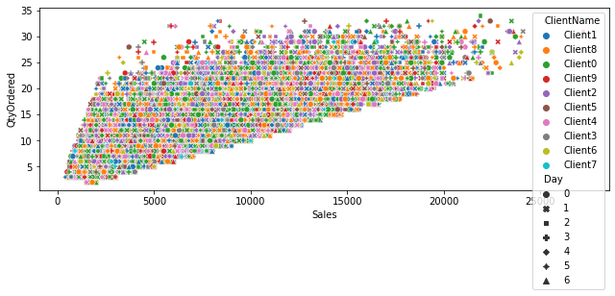

Sales and Hour of day with Client Name and Day
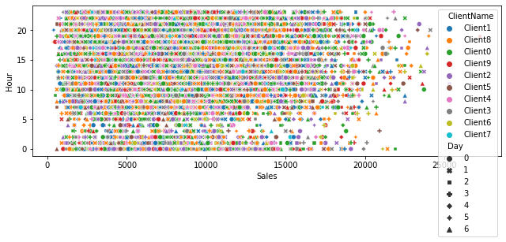

ClientName and Sales with MonthNum
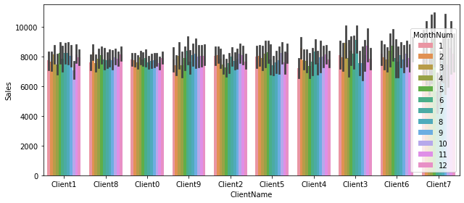

ClientName and Sales with Day
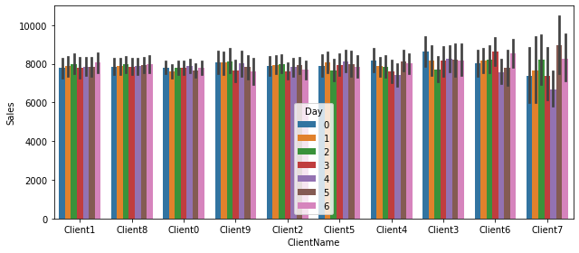

Productwise :
[1. output, explain]
[2. output, explain]
[3. output, explain]
[4. output, explain]

Clientwise :
[1. output, explain]
[2. output, explain]
[3. output, explain]
[4. output, explain]

2.2.2 Model training(hyperparameter tuning,normalization) : multiple lr,polynomial, ridge, lasso , elasticNet, logistic , softmax, dtree, reg tree, random forest : Orderwise , productwise, clientwise

- avg sampling done to get chats before order
Orderwise:
[5. output, explain]
[6. output, explain]
[7. output, explain]
[8. output, explain]
[9. output, explain]
[10. output, explain]
[11. output, explain]
[12. output, explain]
[13. output, explain]
[15. output, explain]

Productwise:
Predicting Sales :
[5. output, explain]
[6. output, explain]
[7. output, explain]
[8. output, explain]
[9. output, explain]
[10. output, explain]
[11. output, explain]
[12. output, explain]
[13. output, explain]
[15. output, explain]

Predicting Product Name :
[14. output, explain]
Predicting Client Name :
[14. output, explain]
Clientwise:
[5. output, explain]
[6. output, explain]
[7. output, explain]
[8. output, explain]
[9. output, explain]
[10. output, explain]
[11. output, explain]
[12. output, explain]
[13. output, explain]
[15. output, explain]

2.2.3 Ensemble model training : voting , bagging , random forest, ADA boosting , gradient boosting , stacking , blending : Orderwise , productwise, clientwise
Orderwise:
[16. output, explain]
[17. output, explain]
[18. output, explain]
[19. output, explain]
[20. output, explain]
[21. output, explain]

Productwise:
Predicting Sales :
[16. output, explain]
[17. output, explain]
[18. output, explain]
[19. output, explain]
[20. output, explain]
[21. output, explain]

Predicting Product Name :
[16. output, explain]
[17. output, explain]
[18. output, explain]
[19. output, explain]
[20. output, explain]
[21. output, explain]

Predicting Client Name :
[16. output, explain]
[17. output, explain]
[18. output, explain]
[19. output, explain]
[20. output, explain]
[21. output, explain]

Clientwise:
[16. output, explain]
[17. output, explain]
[18. output, explain]
[19. output, explain]
[20. output, explain]
[21. output, explain]

3. Experimental Design : already avail , own datasets

3.1 Prebuilt Dataset
IMDB movie reviews dataset is used to train the Machine Learning and Deep Learning Models. It has 50K movie reviews out of which 25K are positive and 25K are negative.
[4. output , explain ]
50.19% reviews are positive and 49.81% are negative.
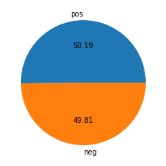
Distribution of number of characters and words in positive and negative reviews
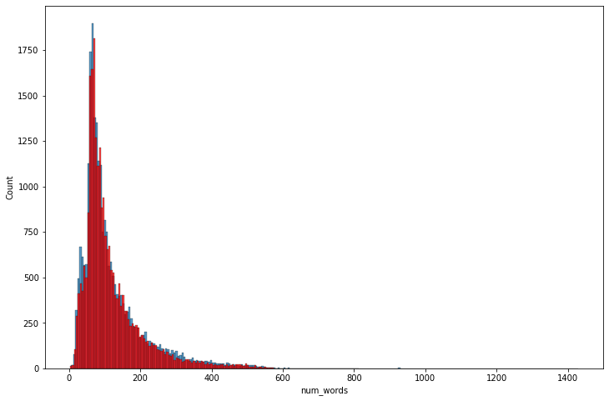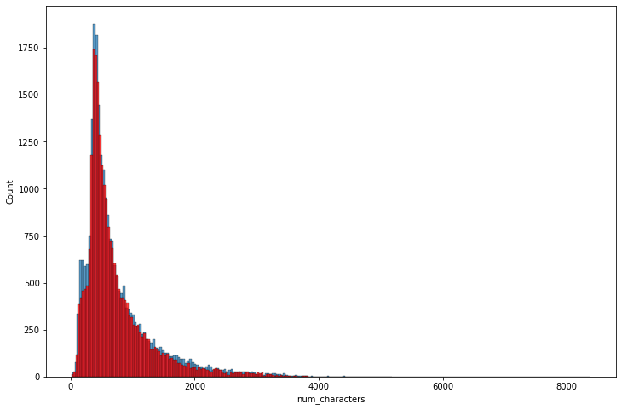

Pairplot analyzing the features number of characters, number of words and number of sentences.
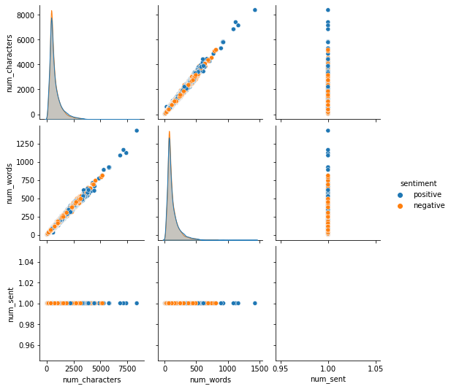’
Correlation matrix among the features number of characters, words , sentences and the target , sentiment .
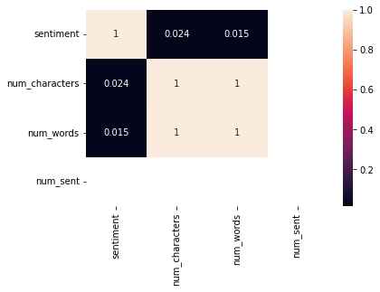
Word cloud for positive reviews , and negative reviews
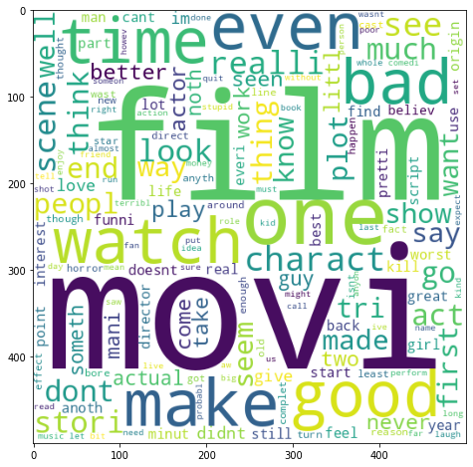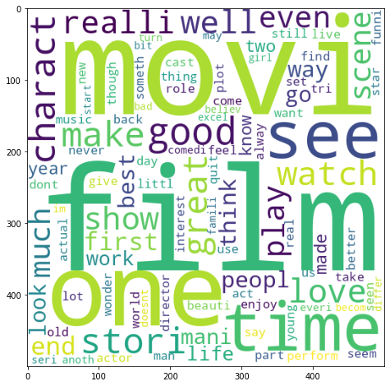

neg pos

Most occuring words in positive and negative reviews.

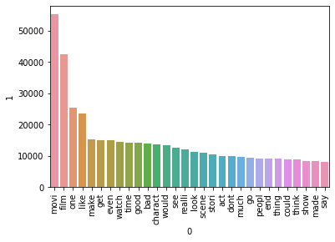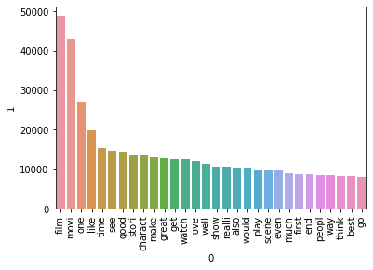
neg pos

3.2 Dataset Generation
To generate datasets for Orderwise, Productwise, Clientwise analysis, raw dataset is generated . For every month in a year, orders are generated with random amounts of product and quantity per order. Client name for an order is decided randomly.
[0. output, explain]
All months order sales data is aggregated and analyzed. Monthwise, Citywise, Clientwise, Productwise sales is plotted. December month , San Fransico(CA) , Client0 ,Prod15 had the most sales.
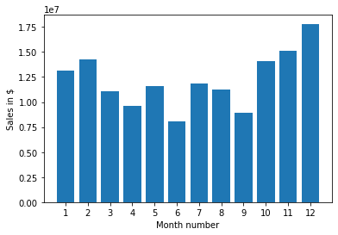

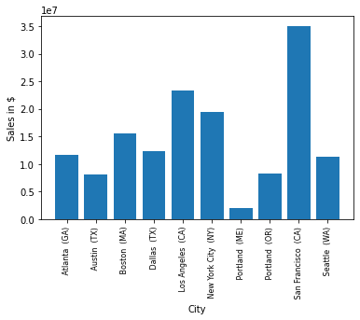
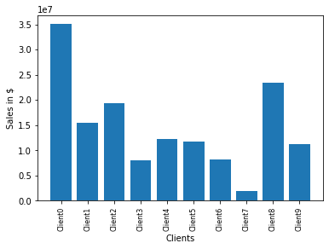

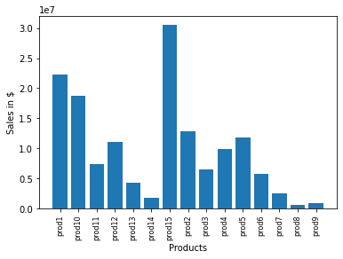
Hour of the day having the most sales is calculated and the sales peaked out at morning 11am and evening 8pm .
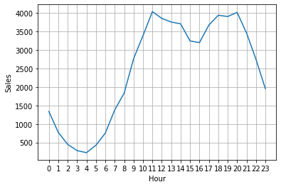
The Client and Salesperson chats are selected randomly from the Movie reviews dataset and concatenated into one chat , the average sentiment is calculated by calculating the mean of sentiments of selected chats. These chats are fed into the dataset for every order. They represent the chats made by Client and Salesperson before the order was made.
Orderwise data is grouped by using the OrderID. Every row contains the OrderID, Client name, Month number, Hour, Minute, Day , products sold in that order, Client’s Mean Sentiment , Salesperson’s Mean Sentiment and the total quantity of the products along with the total order amount. Sales column is the target column and can be predicted using regression techniques using other columns as feature columns.
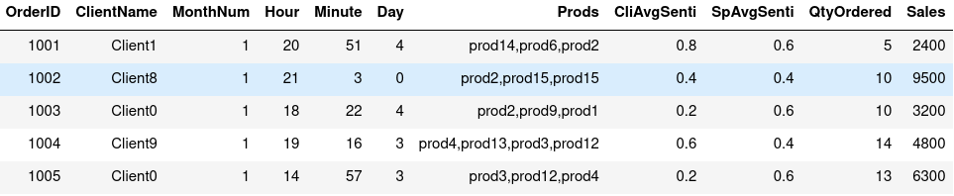
Productwise data is the entry of every product sold in every order. Every row contains the Product name, Client name , Month , OrderID, Order quantity , order total , Client’s Average Sentiment , Salesperson’s Average Sentiment , Hour, Minute of the time of sale, Day of the sale and the total product price.Product name and Client name are the target columns and can be predicted using classification techniques. Product Price is also a target colum and can be predicted using regression techniques using other columns as feature columns.
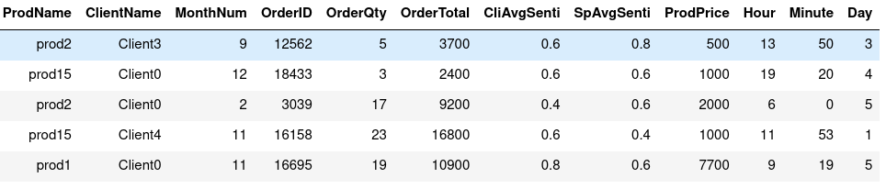
Clientwise data is generated by grouping the Client names with the Month , day of sale and the products basket. Every row contains the Client name, Month , Day , Products, Quantity Ordered and the Total order amount of those products. Sales is the target column and will be predicted using regression techniques.

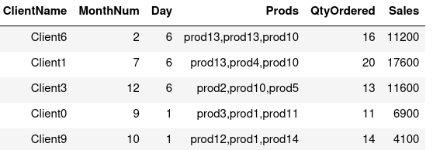

4. Performance Evaluation
4.1 : all metrics results for hybrid text model , sales model
4.2 : performance analysis hybrid text model , sales model
4.3 : discussion for sales, text model

5. Conclusion: sales hybrid , text hybrid model

1. Introduction
1.1 : Related works – all models rps [write 6.Ref here]
1.2 : Motivation – DLOM project
1.3 : Contribution – hybrid sales model using hybrid text classif
1.4 : Outline of proposed – hybrid sales model using hybrid text classif
1.5 : Organizatoni of paper

