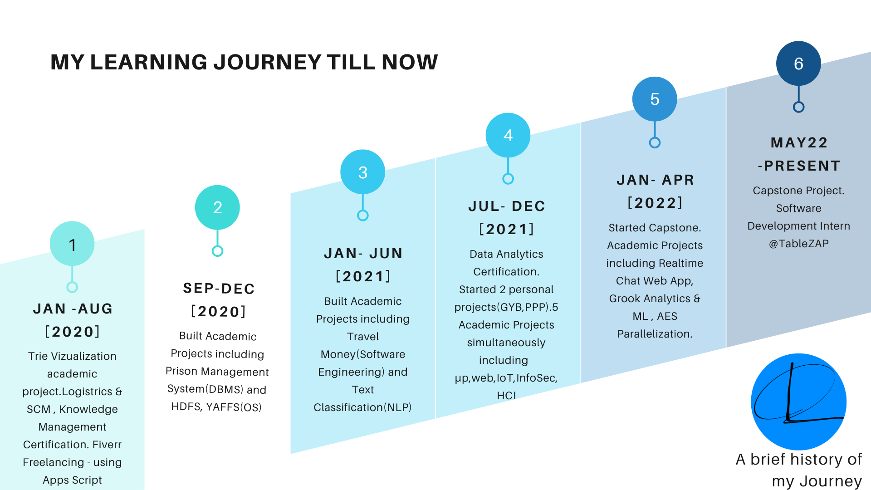
Information about what you learnt : [Text, list, title,link,code snippet]

Report doc upload:
Code write again :
Code run again :
Visualization video make :
Visualization ss take, explain in pitcher page

