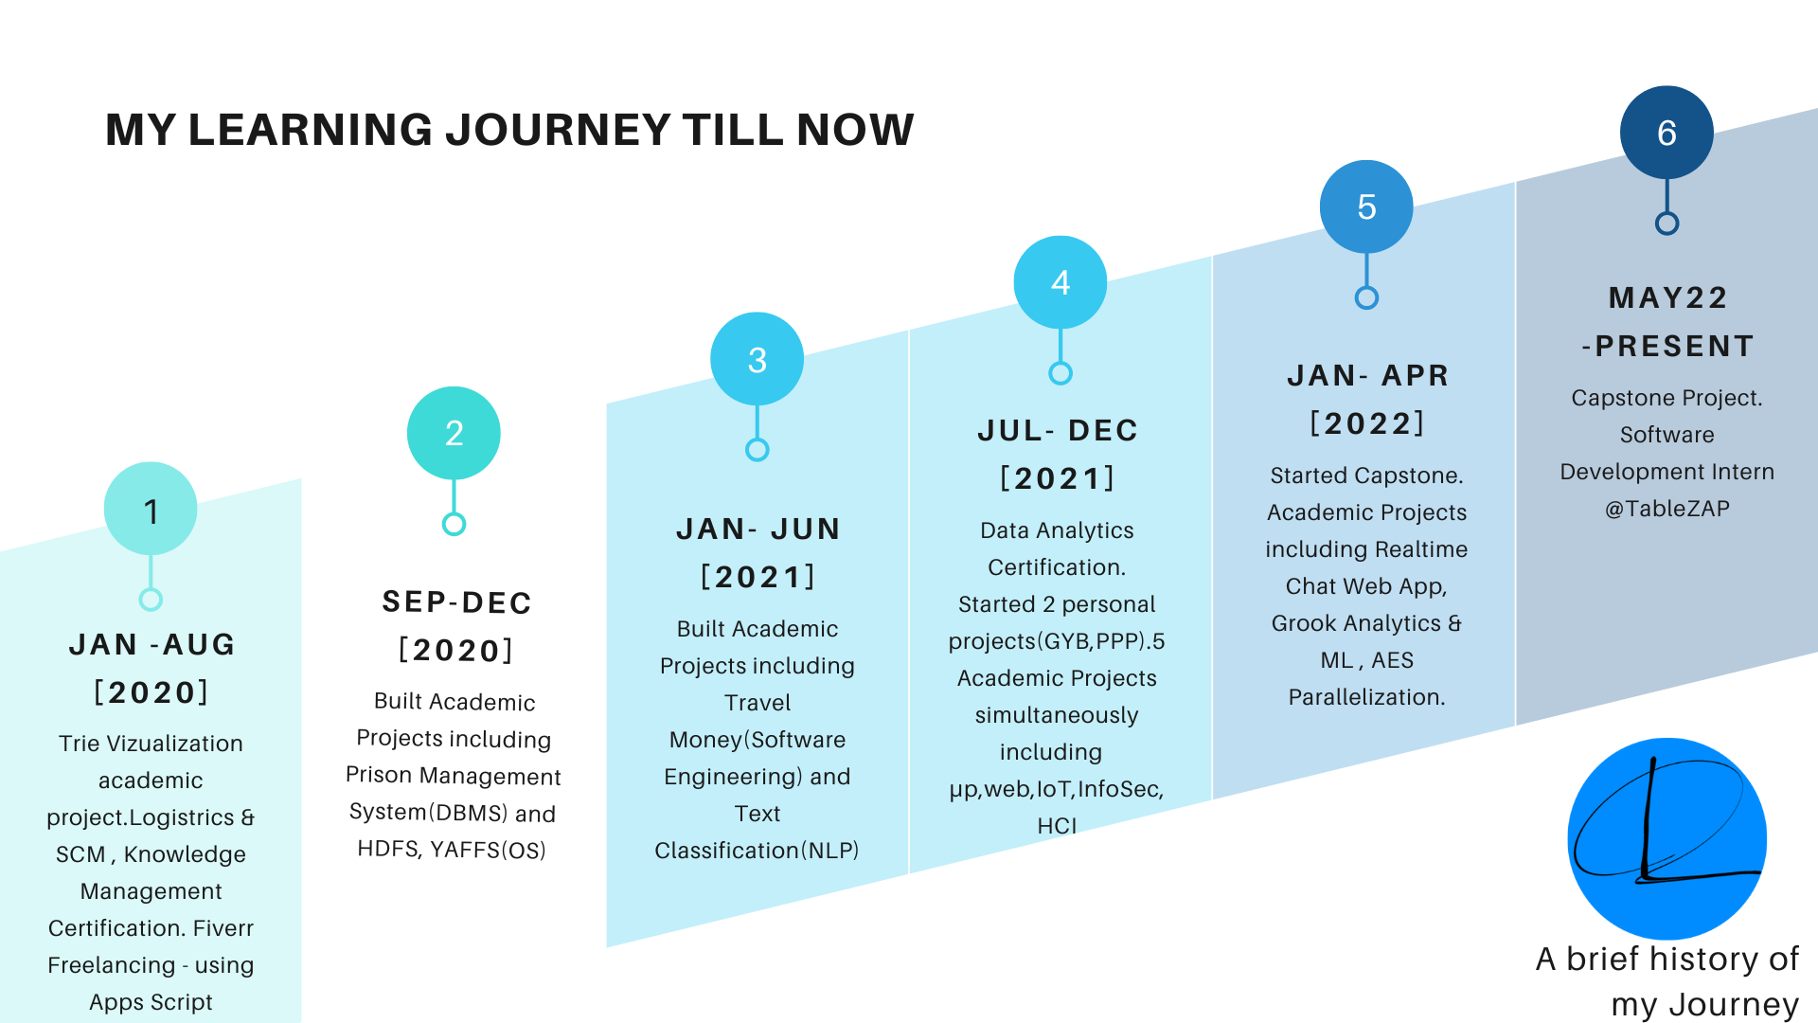
Information about what you learnt : [Text, list, title,link,code snippet]

[]

Information about what you learnt : [Text, list, title,link,code snippet]

