Mihir Achyuta
7/13/20
Game Theory
Week 1 Notes
1.1
- Game theory is strategic interactions between groups
  - A 2-player game is an interaction between 2 players in which both the players have a significant amount of power in their interactions to change a situation
1.2
- Agents are technically a person with their own self-interests and “feelings” (Selfish or helpful?)
- A utility function is how much an agent does or does not like a situation
  - It measures preferences across possibilities and how much of an impact uncertainty has
- Expected that agents act to maximize their utility (Decision theoretic rationality)

1.3
- Defining games
  - Who are people: governments, companies, employees?
  - What can players do: go to work or not, vote for one or the other?
  - What motivates the players: is profit good for them? What incentive is there?
- Normal form says what players get because of their actions
  - If players move simultaneously
- Extensive form includes timing of moves
  - Sequential moves like a tree (chess moves)
  - Keeps track of what each player knows and decides
    - Poker because the players see when they bet
- Normal form game
  - Players 1-n (finite), Action set a1-an, utility function u1-un
- 2 player games can be written as a matrix with player 1 being the row and player 2 being the column and payoffs inside the matrix cells
  - TCP Back off has compliance and noncompliance bits inside the matrix
- Large action game scenario could have millions of people
  - Their action set (decision set) would be to revolt or not
  - If the revolt has 2 million people or more then it succeeds then everyone benefits
    - But if its under 2 million people and u were in the revolt then your payoff goes down because you are punished by the government
    - If you didn’t participate in the revolt but it still failed then your payoff stays the same because you didn’t do anything
1.4
- One example of a game is prisoner’s dilemma where defecting in a neutral situation gives you the advantage
- If one defects and one cooperates then the defector wins always and it is better to both cooperate than to both defect
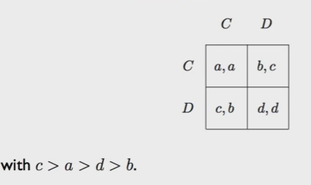
- This is a game of pure competition with exactly opposed interests which means only 2 players
  - A special case would be a zero sum game
  - AKA rock paper sciessors irl between 2 players
- A game of cooperation means that agents have the same interests.
  - Called noncooperative games like driving on a road
- A general game combines cooperation and competition like Battle of the Sexes

1.5-1.6
- The Keyne’s Beauty Contest Game involves a rising stock price that you want to sell right before it reaches it peak so essentially getting out of the market before the other investors do
  - We can create a Nash equilibrium to predict the agent’s decisions
- Each player inputs an integer and the 2/3d’s of the average integer wins the game and if there is a tie then it is decided by a random thing like rolling a die
- If the average play is X then the best strategy is (2/3)x and x is less than 100 then u cant be grater than 67 but then the best strategy si to do 2/3 of that and keep going and going
  - So the Nash Equilibrium of this game is for every player to pick 1 because if you go higher than 1 when everyone already picked 1 then you loose
- A nash equilibrium is a stable situation where every player makes the consistent decision to maximize their playoff based on the actions of others
  - No one has any incentive to deviate from the optimal action so that’s why the result is consistent
1.7
- Since no agent knows what the other agent will do the best idea is to look for stable action profiles

1.9
- Since no agent knows what the other agent will do the best idea is to look for stable action profiles

