Mihir Achyuta
7/13/20
Game Theory
Week 2 Notes
2.1
- An example of a mixed strategy is a randomized checkpoint system to stop terrorists
  - Any stop could be a checkpoint for an attacker leading to negative payoff
2.2
- Deterministic strategy is bad in matching pennies because it goes in a cycle
- You could confuse opponents by playing randomly
  - Strategy for agent is any probability distribution over actions
    - Pure strategy is 1 action with positive probability
    - Mixed strategy is more than 1 action with positive probability
- Every finite game has a Nash equilibrium
  - Finite game has a finite number of space to record so finite players, actions, moves
2.3
- Easy to get nash equilibrium when the support or set of pure strategies with positive probabilities can be guessed
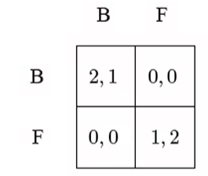
- 2P+0(1-p) = 0p + 1(1-p) => p = 1/3
- Mixed strategies could confuse your opponent or unsure about opponent actions
  - Description of what could happen in repeated play
2.4
- Some possible methods are a Linear Complementarity Formulation and a Support Enumeration Method to find a nash equilibrium

