Carseats

Learning Spoons R

2018-07-08

## Carseat 소개

library(ISLR)  
library(dplyr)  
library(ggplot2)  
str(Carseats)

## 'data.frame': 400 obs. of 11 variables:  
## $ Sales : num 9.5 11.22 10.06 7.4 4.15 ...  
## $ CompPrice : num 138 111 113 117 141 124 115 136 132 132 ...  
## $ Income : num 73 48 35 100 64 113 105 81 110 113 ...  
## $ Advertising: num 11 16 10 4 3 13 0 15 0 0 ...  
## $ Population : num 276 260 269 466 340 501 45 425 108 131 ...  
## $ Price : num 120 83 80 97 128 72 108 120 124 124 ...  
## $ ShelveLoc : Factor w/ 3 levels "Bad","Good","Medium": 1 2 3 3 1 1 3 2 3 3 ...  
## $ Age : num 42 65 59 55 38 78 71 67 76 76 ...  
## $ Education : num 17 10 12 14 13 16 15 10 10 17 ...  
## $ Urban : Factor w/ 2 levels "No","Yes": 2 2 2 2 2 1 2 2 1 1 ...  
## $ US : Factor w/ 2 levels "No","Yes": 2 2 2 2 1 2 1 2 1 2 ...

## Focus City

*소득*이 높고 **도시**의 평균 연령이 30대인 곳의 판매량을 알아보고 싶습니다.

아래에 해당 도시(400개)들의 변수를 표현합니다.

focusCity <- Carseats %>%   
 filter(Income > 100) %>%  
 filter(Age >= 30 & Age < 40) %>%  
 mutate(AdvPerCapita = Advertising/Population) %>%  
 select(Sales, Income, Age, Population, Education, AdvPerCapita) %>%  
 arrange(Sales)  
print(focusCity)

## Sales Income Age Population Education AdvPerCapita  
## 1 5.04 114 34 298 16 0.00000000  
## 2 5.32 116 39 170 16 0.00000000  
## 3 6.80 117 38 337 10 0.01483680  
## 4 7.49 119 35 178 13 0.03370787  
## 5 7.67 117 36 400 10 0.02000000  
## 6 8.55 111 36 480 16 0.04791667  
## 7 8.97 107 33 144 13 0.00000000  
## 8 9.03 102 35 123 16 0.10569106  
## 9 9.39 118 32 445 15 0.03146067  
## 10 9.58 104 37 353 17 0.06515581  
## 11 10.36 105 34 428 12 0.04205607  
## 12 10.59 120 30 262 10 0.05725191  
## 13 12.57 108 33 203 14 0.08374384

## Income vs Sales

doFacetWrap <- FALSE  
a <- ggplot(data = Carseats, aes(x = Income, y = Sales)) +   
 geom_point(aes(shape = Urban, color = US))  
if (doFacetWrap) {  
 a <- a + facet_wrap(~ floor(Age/10))  
}  
print(a)

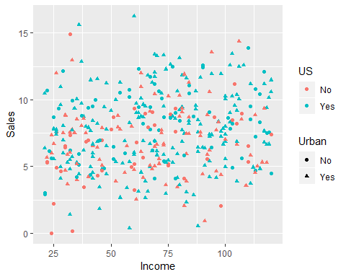

Your comment!

## Income vs Sales

doFacetWrap <- TRUE  
a <- ggplot(data = Carseats, aes(x = Income, y = Sales)) +   
 geom_point(aes(shape = Urban, color = US))  
if (doFacetWrap) {  
 a <- a + facet_wrap(~ floor(Age/10))  
}  
print(a)

