SOP LIBRARY
ISO-BASED OPERATIONAL DOCUMENT
Asset Issue & Return
Control assignment and return of company assets with traceable ownership and evidence.

Document parameters
Parameter | Details
Name of the document | SOP Library (ISO based) for Company ABC
Process document | Asset Issue & Return
Document ID | INV-SOP-002
Author | xxx
Departments | HR, Logistics, and Inventory
Processes included | Employee Onboarding, Asset Issue & Return, Inventory Management

1. Scope
Applies to approved asset issue requests and return events, including assets issued during employee onboarding and returned during separation. Process trigger: Approved asset request or onboarding requirement is received.

2. Key Terms
Term / abbreviation | Definition
HRIS | Human Resources Information System
ITSM | IT Service Management system
SOP | Standard Operating Procedure
CP | Control Point
Asset Register | Authoritative record of assigned assets

3. Process Details
The following table is the controlled written representation of the process, retained from the supplied source and formatted to match the SOP Library style.
Ref | Role | Activity / provision | System / record | Control / verification | Exception / decision
INV-ISS-01 | Requester / HR | Submit approved asset request | ITSM / HR onboarding request | Business need and approver captured | Incomplete request → return
INV-ISS-02 | Inventory Controller | Check availability and reserve asset | ERP / Asset Register | Available status and asset tag verified | No stock → raise exception
INV-ISS-03 | Asset Custodian | Prepare and hand over asset | Asset handover form | Serial/tag and recipient matched | Identity mismatch → stop
INV-ISS-04 | Employee | Acknowledge receipt and responsibility | E-signature / Asset Register | Acknowledgement captured | Missing signature → escalate
INV-ISS-05 | Inventory Controller | Update assignment and close request | Asset Register / ITSM | Status = Assigned; evidence linked | Mismatch → reconcile
INV-ISS-06 | HR / IT | Link assignment back to onboarding | HRIS / ITSM | Dependency closed | Open dependency → onboarding remains open

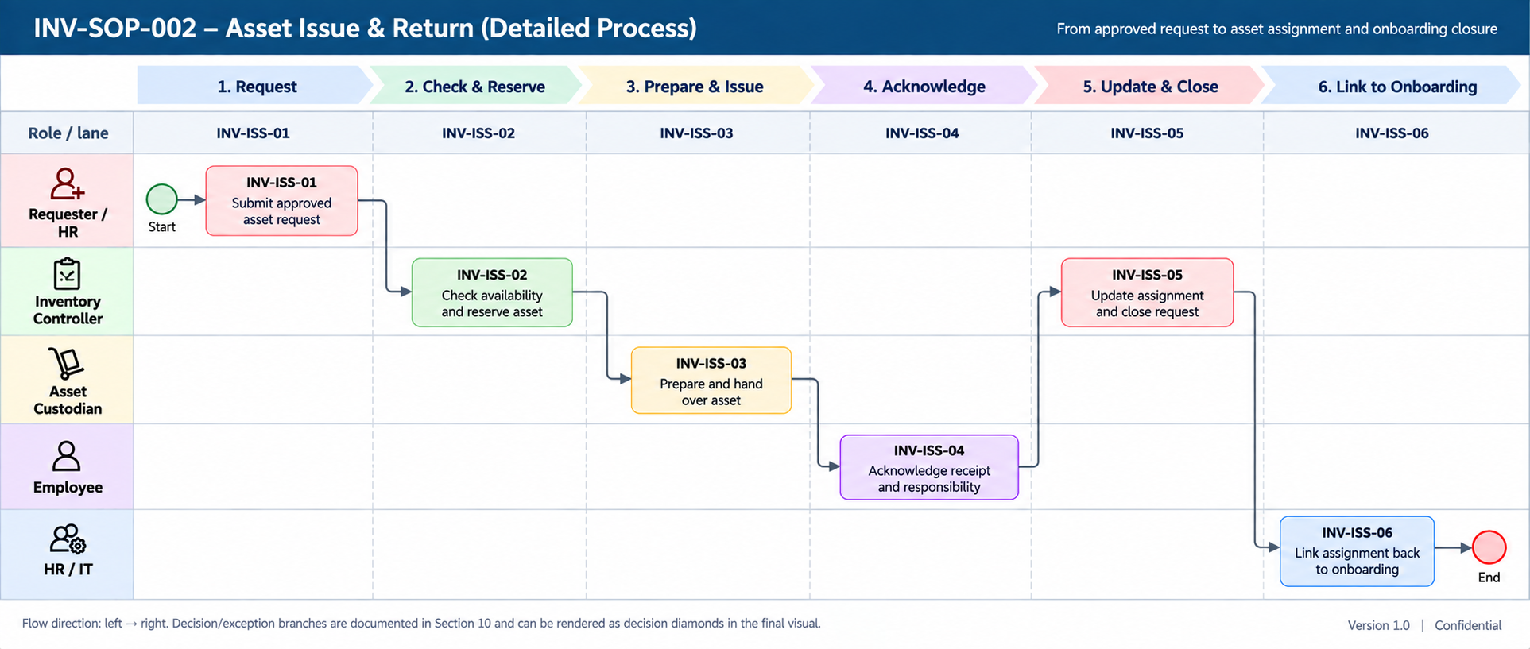

4. Reference
Reference | Linked process | Relationship
HR-SOP-001 | Employee Onboarding | Provides the employee/equipment requirement that can initiate asset issue.
INV-SOP-001 | Inventory Receiving & Put-away | Provides available stock for issue.

5. Annexures

Annexure A — Swimlane process reference
Role / lane | INV-ISS-01 | INV-ISS-02 | INV-ISS-03 | INV-ISS-04 | INV-ISS-05 | INV-ISS-06
Requester / HR | Submit approved asset request | — | — | — | — | —
Inventory Controller | — | Check availability and reserve asset | — | — | Update assignment and close request | —
Asset Custodian | — | — | Prepare and hand over asset | — | — | —
Employee | — | — | — | Acknowledge receipt and responsibility | — | —
HR / IT | — | — | — | — | — | Link assignment back to onboarding

Flow direction: left → right. Decision and exception branches are documented in the source process and can be rendered as decision diamonds in the final visual.

Annexure B — Cross-process reference
Reference | Linked process | Relationship
HR-SOP-001 | Employee Onboarding | Provides the employee/equipment requirement that can initiate asset issue.
INV-SOP-001 | Inventory Management | Provides available stock for issue.

Annexure C — Document control note
Version 0.1 — Demonstration. Status: Draft / Illustrative. Effective date, review date and approval are to be confirmed.

