SOP LIBRARY
ISO-BASED OPERATIONAL DOCUMENT
Employee Onboarding
Standardise onboarding from approved joiner to completed, evidenced employee setup.

Document parameters
Parameter | Details
Name of the document | SOP Library (ISO based) for Company ABC
Process document | Employee Onboarding
Document ID | HR-SOP-001
Author | xxx
Departments | HR, Logistics, and Inventory
Processes included | Employee Onboarding, Asset Issue & Return, Inventory Management

1. Scope
Applies from receipt of an approved joiner request through closure of mandatory onboarding activities, including the equipment/access dependency. Process trigger: Approved new-joiner request is received.

2. Key Terms
Term / abbreviation | Definition
HRIS | Human Resources Information System
ITSM | IT Service Management system
SOP | Standard Operating Procedure
CP | Control Point

3. Process Details
The following table is the controlled written representation of the process, retained from the supplied source and formatted to match the SOP Library style.
Ref | Role | Activity / provision | System / record | Control / verification | Exception / decision
HR-ONB-01 | HR | Receive approved joiner details | HRIS / recruitment record | Approval and mandatory data verified | Missing approval → return to HR
HR-ONB-02 | HR | Create employee record and onboarding checklist | HRIS | Mandatory fields complete | Data mismatch → correct
HR-ONB-03 | Hiring Manager | Confirm role, access and equipment needs | HRIS / request form | Manager approval captured | Late request → escalate
HR-ONB-04 | IT / Asset Custodian | Provision accounts and issue required equipment | ITSM / Asset Register | Asset tagged and assigned | Stock unavailable → INV-SOP-002 exception
HR-ONB-05 | Employee | Complete induction and acknowledge policies | LMS / e-signature | Required learning complete | Incomplete → reminder/escalation
HR-ONB-06 | HR | Close checklist and retain evidence | HRIS / repository | All mandatory controls complete | Open item → case remains open

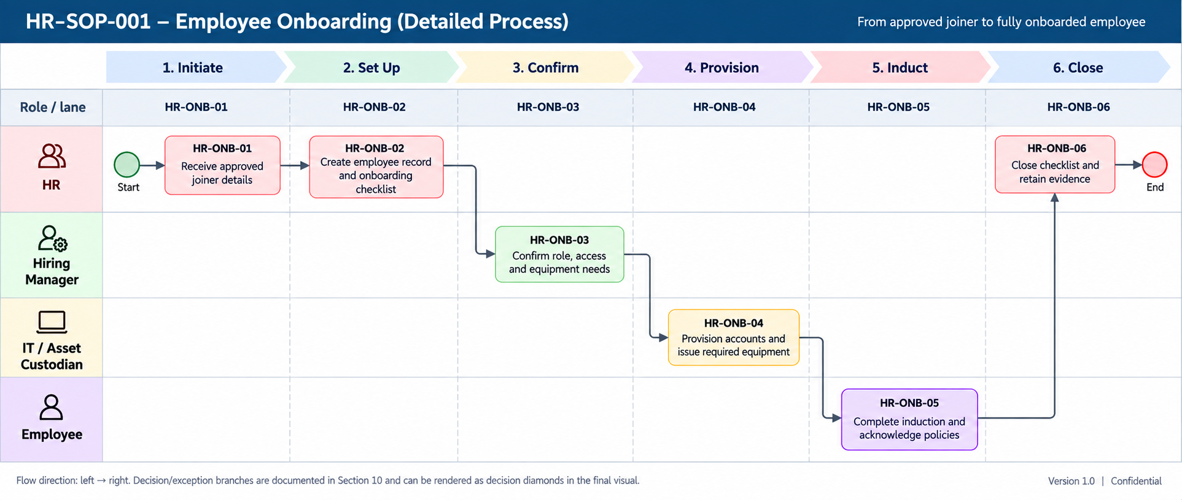

4. Reference
Reference | Linked process | Relationship
INV-SOP-002 | Asset Issue & Return | HR onboarding depends on controlled asset assignment.
INV-SOP-001 | Inventory Receiving & Put-away | Inventory availability ultimately depends on controlled receipt and put-away.

5. Annexures

Annexure A — Swimlane process reference
Role / lane | HR-ONB-01 | HR-ONB-02 | HR-ONB-03 | HR-ONB-04 | HR-ONB-05 | HR-ONB-06
HR | Receive approved joiner details | Create employee record and onboarding checklist | — | — | — | Close checklist and retain evidence
Hiring Manager | — | — | Confirm role, access and equipment needs | — | — | —
IT / Asset Custodian | — | — | — | Provision accounts and issue required equipment | — | —
Employee | — | — | — | — | Complete induction and acknowledge policies | —

Flow direction: left → right. Decision and exception branches are documented in the source process and can be rendered as decision diamonds in the final visual.

Annexure B — Cross-process reference
Reference | Linked process | Relationship
INV-SOP-002 | Asset Issue & Return | HR onboarding depends on controlled asset assignment.
INV-SOP-001 | Inventory Management | Inventory availability ultimately depends on controlled inventory management.

Annexure C — Document control note
Version 0.1 — Demonstration. Status: Draft / Illustrative. Effective date, review date and approval are to be confirmed.

