SOP LIBRARY
ISO-BASED OPERATIONAL DOCUMENT
Inventory Management
Control receipt, inspection, recording, put-away and availability of inventory.

Document parameters
Parameter | Details
Name of the document | SOP Library (ISO based) for Company ABC
Process document | Inventory Management
Document ID | INV-SOP-001
Author | xxx
Departments | HR, Logistics, and Inventory
Processes included | Employee Onboarding, Asset Issue & Return, Inventory Management

1. Scope
Applies from physical delivery at the designated receiving point through approved put-away and release of stock as available. Process trigger: Physical delivery arrives at the designated receiving point.

2. Key Terms
Term / abbreviation | Definition
HRIS | Human Resources Information System
ITSM | IT Service Management system
SOP | Standard Operating Procedure
CP | Control Point
GRN | Goods Receipt Note

3. Process Details
The following table is the controlled written representation of the process, retained from the supplied source and formatted to match the SOP Library style.
Ref | Role | Activity / provision | System / record | Control / verification | Exception / decision
INV-RCV-01 | Store / Inventory | Receive delivery against purchase order | ERP / GRN | PO and delivery note matched | Mismatch → discrepancy
INV-RCV-02 | Store | Inspect quantity and condition | Receiving checklist | Count and condition recorded | Damage/shortage → supplier exception
INV-RCV-03 | Inventory Controller | Record receipt and assign stock status | ERP / Inventory Register | Receipt approved | System variance → investigate
INV-RCV-04 | Store | Label, locate and update bin/location | Inventory Register | Location recorded | No bin → temporary location
INV-RCV-05 | Inventory Controller | Release stock as available | ERP | Status changed to Available | Quality hold → block issue

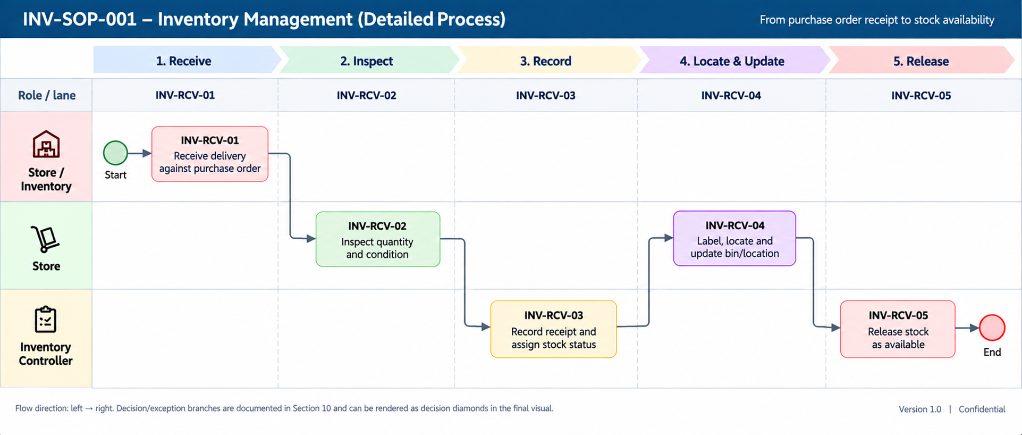

4. Reference

Reference | Linked process | Relationship
INV-SOP-002 | Asset Issue & Return | Available stock may be consumed by approved asset issues.

5. Annexures

Annexure A — Swimlane process reference
Role / lane | INV-RCV-01 | INV-RCV-02 | INV-RCV-03 | INV-RCV-04 | INV-RCV-05
Store / Inventory | Receive delivery against purchase order | — | — | — | —
Store | — | Inspect quantity and condition | — | Label, locate and update bin/location | —
Inventory Controller | — | — | Record receipt and assign stock status | — | Release stock as available

Flow direction: left → right. Decision and exception branches are documented in the source process and can be rendered as decision diamonds in the final visual.

Annexure B — Cross-process reference
Reference | Linked process | Relationship
INV-SOP-002 | Asset Issue & Return | Available stock may be consumed by approved asset issues.

Annexure C — Document control note
Version 0.1 — Demonstration. Status: Draft / Illustrative. Effective date, review date and approval are to be confirmed.

