SOP LIBRARY
ISO-BASED OPERATIONAL DOCUMENT
SOP Library (ISO based) for Company ABC

Document control | Details
Author | xxx
Departments | HR, Logistics, and Inventory
Processes included | Employee Onboarding; Asset Issue & Return; Inventory Management
Status | Demonstration
Version | 0.1

Structured as an ISO-style operational-document blueprint

1. Scope
This SOP Library provides a structured operational-document framework for Company ABC covering the three processes included in this showcase: Employee Onboarding, Asset Issue & Return, and Inventory Management. The library is intended to show how process activities, roles, systems, controls, exceptions and cross-process dependencies can be organized in a common document structure.
The supplied source describes this as an ISO-style operational-document blueprint and explicitly notes that it is not a claim of ISO certification or conformity assessment.

2. Departments
Department | Role in included processes
HR | Employee onboarding; requester / HR participation in asset issue and onboarding linkage
Logistics | Included as a department in the library scope; the supplied process tables do not separately assign a Logistics role.
Inventory | Inventory receiving, stock control, asset issue and return activities

3. Processes Included
Process ID | Process | Owner / function | Primary reference
HR-SOP-001 | Employee Onboarding | HR Operations | HR-ONB-01 to HR-ONB-06
INV-SOP-002 | Asset Issue & Return | Inventory Control | INV-ISS-01 to INV-ISS-06
INV-SOP-001 | Inventory Management / Receiving & Put-away | Inventory Control | INV-RCV-01 to INV-RCV-05

4. Key Terms
The source document does not provide formal definitions. The entries below therefore describe how each term is used within the supplied process tables rather than asserting formal ISO definitions.
Term | Use within this SOP Library
SOP | Standard Operating Procedure; the controlled process document represented by each process entry.
HRIS | System used for employee records, onboarding checklist and related HR evidence.
ITSM | System used for asset requests and service/request records.
ERP | System used for inventory receipt and stock-status records.
GRN | Goods receipt record referenced for inventory receiving.
PO | Purchase order against which a delivery is received and matched.
Asset Register | Record used to verify, assign and update asset status and ownership.
Inventory Register | Record used to maintain inventory location and stock information.
e-signature | Electronic acknowledgement used for employee receipt/responsibility and policy acknowledgement.

5. SOP Library Index
The supplied library shows a linked relationship between the processes: inventory receiving makes stock available; asset issue consumes available inventory; employee onboarding depends on asset issue for required equipment and closes the related dependency.
ID | Process | File / reference | Connection
HR-SOP-001 | Employee Onboarding | 01_HR_Onboarding_ISO_Style_SOP.docx | Triggers / depends on asset issue
INV-SOP-002 | Asset Issue & Return | 02_Inventory_Asset_Issue_ISO_Style_SOP.docx | Consumes available inventory
INV-SOP-001 | Inventory Management | 03_Inventory_Receiving_ISO_Style_SOP.docx | Manages available inventory

6. Process Details

6.1 Employee Onboarding
Ref | Role | Activity | System | Control | Exception
HR-ONB-01 | HR | Receive approved joiner details | HRIS / recruitment record | Approval and mandatory data verified | Missing approval → return to HR
HR-ONB-02 | HR | Create employee record and onboarding checklist | HRIS | Mandatory fields complete | Data mismatch → correct
HR-ONB-03 | Hiring Manager | Confirm role, access and equipment needs | HRIS / request form | Manager approval captured | Late request → escalate
HR-ONB-04 | IT / Asset Custodian | Provision accounts and issue required equipment | ITSM / Asset Register | Asset tagged and assigned | Stock unavailable → INV-SOP-002 exception
HR-ONB-05 | Employee | Complete induction and acknowledge policies | LMS / e-signature | Required learning complete | Incomplete → reminder/escalation
HR-ONB-06 | HR | Close checklist and retain evidence | HRIS / repository | All mandatory controls complete | Open item → case remains open

6.2 Asset Issue & Return
Ref | Role | Activity | System | Control | Exception
INV-ISS-01 | Requester / HR | Submit approved asset request | ITSM / HR onboarding request | Business need and approver captured | Incomplete request → return
INV-ISS-02 | Inventory Controller | Check availability and reserve asset | ERP / Asset Register | Available status and asset tag verified | No stock → raise exception
INV-ISS-03 | Asset Custodian | Prepare and hand over asset | Asset handover form | Serial/tag and recipient matched | Identity mismatch → stop
INV-ISS-04 | Employee | Acknowledge receipt and responsibility | E-signature / Asset Register | Acknowledgement captured | Missing signature → escalate
INV-ISS-05 | Inventory Controller | Update assignment and close request | Asset Register / ITSM | Status = Assigned; evidence linked | Mismatch → reconcile
INV-ISS-06 | HR / IT | Link assignment back to onboarding | HRIS / ITSM | Dependency closed | Open dependency → onboarding remains open

6.3 Inventory Management / Receiving & Put-away
Ref | Role | Activity | System | Control | Exception
INV-RCV-01 | Store / Inventory | Receive delivery against purchase order | ERP / GRN | PO and delivery note matched | Mismatch → discrepancy
INV-RCV-02 | Store | Inspect quantity and condition | Receiving checklist | Count and condition recorded | Damage/shortage → supplier exception
INV-RCV-03 | Inventory Controller | Record receipt and assign stock status | ERP / Inventory Register | Receipt approved | System variance → investigate
INV-RCV-04 | Store | Label, locate and update bin/location | Inventory Register | Location recorded | No bin → temporary location
INV-RCV-05 | Inventory Controller | Release stock as available | ERP | Status changed to Available | Quality hold → block issue

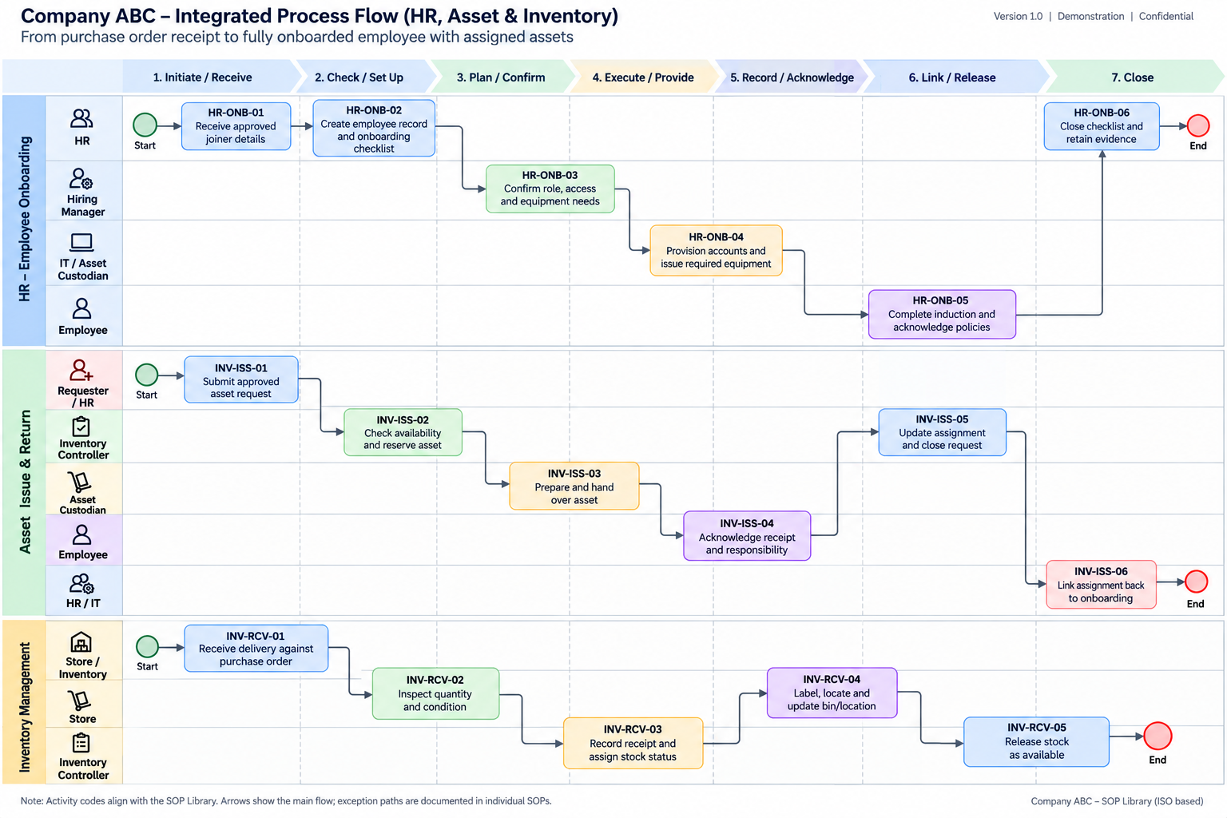

7. Annexures
The annexures below provide the supporting structure for the process library. The detailed swimlane diagrams can be maintained as visual process references alongside these controlled SOP tables.

Annexure A — Process relationship
Upstream process | Dependency / output | Downstream process
Inventory Management | Available stock | Asset Issue & Return
Asset Issue & Return | Assigned equipment / closed dependency | Employee Onboarding
Relationship shown in the supplied source: Inventory Receiving → available stock → Asset Issue → HR Onboarding closure.

Annexure B — Reference code structure
Prefix | Meaning in this library
HR-ONB | Employee onboarding activity
INV-ISS | Asset issue and return activity
INV-RCV | Inventory receiving and put-away activity

Annexure C — Document structure basis
The supplied source states that the ISO/IEC Directives Part 2 guide is used as the structural reference. It identifies document subdivisions including Title, Foreword, Introduction, Scope, Normative references, Terms and definitions, Symbols and abbreviated terms, clauses/subclauses, Figures, Tables, Annexes and Bibliography.
For this showcase, the structure has been simplified around the requested elements: Scope, Departments, Processes Included, Process Details, Key Terms and Annexures.

Annexure D — Document control note
Status: Demonstration. Version: 0.1. Author: xxx. This document is an ISO-style operational-document blueprint and does not represent ISO certification or a conformity assessment.

8. Portfolio Presentation Note
This SOP Library can be presented as an instructional-design / process-documentation portfolio artifact. The library demonstrates information architecture, controlled-document structure, process mapping, role-based workflow design, system references, controls, exceptions and cross-process dependencies.

