**Logo Quiz User Guide**

Logo quiz is written my Matthew Chi Hun Mo. Anyone who uses the software I prefer if wasn’t shared unless you have asked me first. Thanks for reading this user guide.

**Preface**

The content of this user guide is split into sections. Feel free to navigate around or read the whole content of this guide.

**Contents**

1. Introduction
2. Before you start
3. Start screen
4. Game screen
5. Hi scores screen
6. Feedback
7. Possible improvements to the game
8. Troubleshooting
9. FAQ
10. Where to find further help, and contact details
11. Introduction

Hi my name is Matthew Mo and this is my first project with Capita’s novus training graduate scheme. It is written in Java with JavaFX primarily and I really do hope you enjoy the game as much as I have enjoyed creating it!

1. Before you start

Make sure you have brushed up on various logos (HINT: the logos are mainly common ones, sports ones and region specific ones all around the UK). You will need an computer that can run the program with Java installed.

1. Start Screen

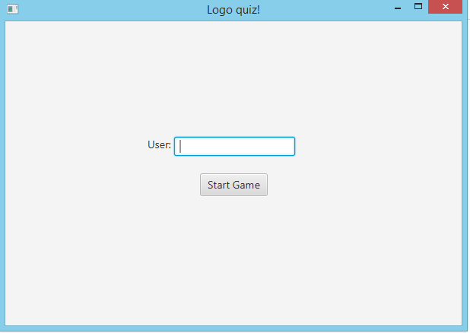As you can see you enter a user name here and click start to begin the name! Any user name is valid as long as you enter one so make sure you do!

1. Game Screen

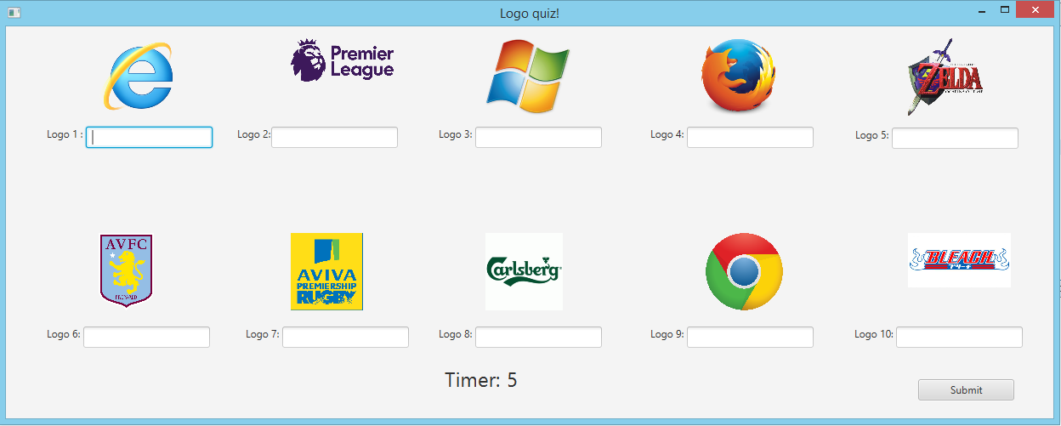

As you can see logos are displayed on the screen. Out of 30 logos 10 are randomly selected. The case of the words don’t matter here. Warning: you are being timed on this game so don’t take too long! When you have finished with the logos make sure to click submit.

1. Hi Scores screen

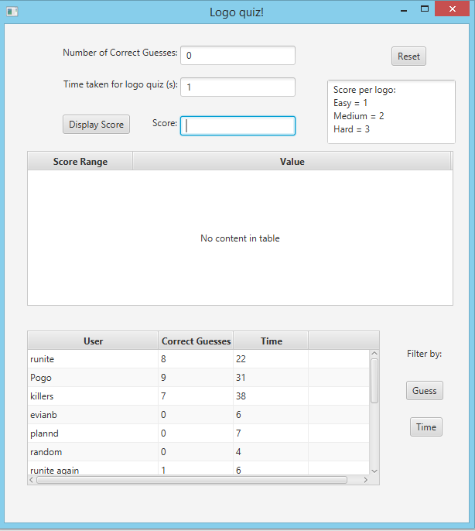

A hi scores screen at the end. It displays how many guesses you have scored right, the time taken for the quiz with previous users and how they did. If you’d like to see what score you got in terms of common and uncommon logos just click the display score button. There is some text reminding you of the score that different logos can have ranging from 1 to 3. The filter buttons at the side displays the variables chosen in ascending order.

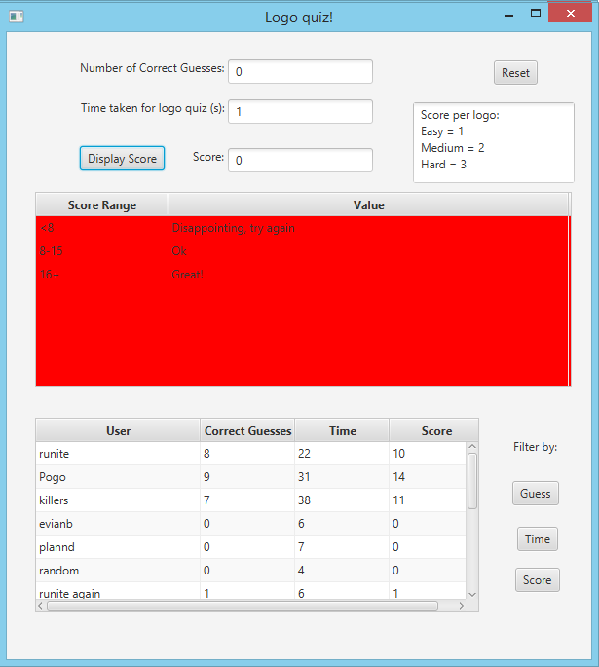

As you can see I scored 0 which is obviously disappointing. Table goes from red, amber to green depending on the score ranges.

Click the reset button if you’d like to play again.

1. Feedback

To give me feedback please email me at email address given below, good comments and constructive criticism much appreciated.

1. Possible improvements to the game

Styling with css would be nice to give the logo quiz more personality. Also storing and filtering data with SQL would be good, I currently have another version of the project that uses MySQL to retrieve and store data, however, the filtering functionality is currently broken.

1. Troubleshooting

Known problems: none

If you find any bugs or anything please let me know in contact details below

1. FAQ

Q: Can I play your quiz more than once?

A: Yes you can! The more times you play the better you will get! Just don’t forget to add in a user at the start and then play as much as you’d like!

Q: Some of your logos are too hard!

A: I’ve looked at this and decided the answer to this would be to give more common logos less points then logos that is harder to guess. Very important when it comes to random logos as this means each game is fair.

Q: Your score system is flawed! How can I get 16+ without trying a dozen times?

A: I wanted to give only really good comments to people that have excellent guessing deduction skills ☺

Q: What tools did you use to build your project?

* Source control (git)
* Java
* JavaFX
* FXML Views
* Scene Builder
* FXML Controllers
* Netbeans
* Github

Elaborations on the different technologies on the project sheet.

1. Where to find further help, and contact details

My email address is [matthew_mo@hotmail.co.uk](mailto:matthew_mo@hotmail.co.uk)

Feel free to email me and ask me questions or ask for help about this quiz.