LEARNOVAX
Enterprise Learning Management System
“Knowledge distributed as reliably as the infrastructure that runs it”
Database Application and Design · Group Project Report · Spring 2026
Instructor: Dr. Sarvar Abdullaev · Inha University in Tashkent
Submitted: May 2026

Member | Student ID | Role
Valijonov Bahodirjon | U2310274 | Backend & System architecture, DevOps, team & organization management, K3s cluster setup, management, (Hetzner + OCI), CI/CD pipelines, Auth system, JWT, MFA, email verification, Django Unfold admin, Daphne ASGI, secrets management and application lifecycle management.
U2310292 | Xolmuxamedov Fazliddin | Token-bucket rate limiter (R11): Redis Lua script, DRF throttle integration, test suite, RFC headers
U2310238 | Sattorov Sardor | Frontend code initialization focusing on course catalogue, task view, submission workflow, grading UI, file upload/download, and in-memory logging implementation
U2310210 | Qodirov Odilkhon | Plagiarism scan pipeline (R10): Tesseract OCR integration, PDF/DOCX/ZIP text extraction, pairwise SequenceMatcher, Celery task, Similarity Review UI
U2310291 | Xolmirzayev Xurshid | Chatting functionality using Websocket and appropriate backend logic with REST protocol chatting, App+UI
U2310275 | Valitov Azat | Observability stack, like Prometheus, Grafana, metrics scraping, Loki, tempo
U2310301 | Yusupov Azizbek | Polyglot persistence and caching using Redis
U2310213 | Kurbanov Javlonbed | UI/UX designer, Similarity Review UI, Dockerfile+Nginx

GitHub (Backend): https://github.com/LearnovaX/backend
GitHub (Frontend): https://github.com/LearnovaX/frontend
Cluster Config: https://github.com/LearnovaX/cluster-config
Deployed URL: https://website-project.uz
API Documentation: https://website-project.uz/api/docs/

Table of Contents
Table of Contents 2
1. Abstract 4
2. Business Requirements (R1) 5
2.1 Scenario 5
2.2 Use Cases 5
UC1 — Student submits a task 5
UC2 — Teacher grades a submission with fraud prevention 5
UC3 — Administrator imports users and manages courses 5
UC4 — Plagiarism scan pipeline runs nightly 5
UC5 — Real-time student–teacher chat 5
UC6 — Nightly user dashboard statistics generation 5
2.3 Non-Functional Requirements 6
3. Domain Model and ER Diagram (R2) 7
3.1 Entity Inventory 7
3.2 Key Design Decisions 7
Soft-delete pattern 7
Strict grading RBAC 7
Answer status as a finite state machine 7
DailyUserStatistics denormalisation 7
4. System Architecture (R2) 9
4.1 Service Overview 9
4.2 Request Flow 9
5. API Design (R4, R7) 11
5.1 REST Endpoint Summary 11
5.2 Sample Request / Response 11
POST /api/accounts/login/ 11
5.3 WebSocket — Real-time Chat (R7) 12
6. Data-Layer Design (R3, R5, R6) 13
6.1 Relational Database — PostgreSQL 17 (R3) 13
Strategic Indexes 13
6.2 Polyglot Persistence (R5) 13
Redis Caching Strategy 13
6.3 Caching and Performance Benchmarks (R6) 14
7. Batch Processing Pipeline (R10) 15
7.1 Workflow 1 — Nightly User Statistics Snapshot 15
7.2 Workflow 2 — Plagiarism Scan Batch 15
7.3 Workflow 3 — Grade Export XLSX Pipeline 16
7.4 Workflow 4 — Deactivated User Cleanup 16
8. From-Scratch Component: Token-Bucket Rate Limiter (R11) 17
8.1 Design 17
Algorithm 17
Key Design Choices 17
8.2 Integration 17
8.3 Tests 17
9. Infrastructure and Deployment (R8, R9) 19
9.1 Docker Compose (R9) 19
9.2 Kubernetes Cluster Topology 19
9.3 API Gateway — Traefik Ingress (R8) 20
9.4 CI/CD Pipeline — GitOps Pattern 20
10. Observability (R12) 22
10.1 Stack Components 22
11. Platform Features Showcase 23
11.1 Authentication and Security 23
11.2 Course, Group, and Enrolment Management 23
11.3 Task Submission and Grading Workflow 23
11.4 Real-Time Chat 23
11.5 Admin Panel — User Management 23
11.6 Admin Dashboard — Statistics 23
12. Testing and Known Limitations 24
12.1 Automated Tests 24
12.2 Known Limitations 24
13. Team Contribution Table 25
14. References 26

1. Abstract
LearnovaX is a production-grade, multi-tenant Learning Management System (LMS) built as the DBAD Spring 2026 group project. The platform serves three roles — Students, Teachers, and Administrators — across a full course lifecycle: enrolment, task assignment, submission, OCR-assisted plagiarism detection, teacher grading with fraud-prevention controls, real-time student–teacher chat, and automated nightly analytics.
The backend is implemented with Django REST Framework on Python 3.14, backed by PostgreSQL 17 as the primary relational store, Redis 7 as the key-value cache and Celery broker, RabbitMQ as the task message broker, and AWS S3-compatible object storage (MinIO protocol) for scalable media uploads. A from-scratch token-bucket rate limiter backed by Redis provides per-user and per-endpoint abuse protection (R11). Two Celery Beat batch pipelines — a nightly plagiarism scan using Tesseract OCR and a grade-export XLSX generator — are fully documented with BPMN diagrams (R10).
The frontend is a React 19 / TypeScript / Tailwind CSS single-page application with three role-based dashboards, real-time WebSocket chat via Django Channels and Daphne, and multi-language support (English, Russian, Uzbek).
The system is deployed on a three-node, multi-cloud Kubernetes cluster: a Hetzner VPS (2 vCPU, 4 GB RAM, Helsinki) acting as k3s control plane, and two Oracle Cloud Infrastructure (OCI) VMs (1 vCPU, 1 GB RAM each, Frankfurt region) as worker nodes. An OCI Load Balancer with health checks fronts the cluster, and a Cloudflare CDN layer terminates TLS and accelerates static assets globally. A fully automated GitOps-style CI/CD pipeline (GitHub Actions + Kustomize + GHCR) drives zero-touch deployments: a push to main triggers test → build → image push → kustomization.yml patch → kubectl apply, with manifest validation via kubeconform at every stage. The full observability stack — Prometheus, Grafana, Grafana Loki, Grafana Tempo, and Promtail — is provisioned inside the cluster and unified under a single Grafana instance.

2. Business Requirements (R1)

2.1 Scenario
LearnovaX addresses a common gap in corporate and academic training environments in Uzbekistan: organizations need a structured, auditable platform where instructors create courses, students submit work, and managers track progress — all without expensive third-party SaaS. The platform is designed for language schools, universities, and corporate L&D teams that require multi-group enrolment, file-based submissions, teacher-led grading, and automated plagiarism checks across documents, code archives, and scanned images.

2.2 Use Cases

UC1 — Student submits a task
Actor: Student. Flow: Student opens an assigned task, reads the rich-text description, downloads any reference files, writes their answer, attaches supporting files (PDF, ZIP, images), and submits. The system records the submission timestamp and sets status to in_review. If the course allows resubmission, the student may update the answer while it remains ungraded.

UC2 — Teacher grades a submission with fraud prevention
Actor: Teacher. Flow: Teacher navigates to the Checking panel, selects a student, opens the answer, reviews attached files, enters a numeric score (0–100) with rich-text feedback, and submits the grade. The system automatically derives a letter grade (A–F), stores the grader attribution, and dispatches a real email notification to the student. Crucially, Administrators cannot grade — only Teachers can. Administrators can, however, reassign a grade for a specific student or reset grades for all students on a task, enforcing a separation of grading authority that minimises grade fraud.

UC3 — Administrator imports users and manages courses
Actor: Administrator. Flow: Admin uploads a CSV/XLSX file to bulk-import students. The system creates accounts, sends email invitations with one-time activation tokens, and enrolls students into designated groups. Admin can create courses, assign teachers, configure deadlines, and toggle whether teachers may manage tasks independently.

UC4 — Plagiarism scan pipeline runs nightly
Actor: System (Celery Beat). Flow: At 02:00 Tashkent time, the batch pipeline fetches all unscanned submissions, extracts text from PDFs and DOCX files, decompresses ZIP archives to inspect code files, and runs Tesseract OCR on image attachments (supporting Russian and Uzbek language models). Answer texts are compared pairwise using sequence-similarity scoring. Answers exceeding the configured threshold are flagged and surfaced in the Similarity Review panel for manual teacher inspection.

UC5 — Real-time student–teacher chat
Actor: Student, Teacher. Flow: A Teacher opens a private DM channel with a student enrolled in a shared course. Messages are delivered over WebSocket (Django Channels / Daphne ASGI) in under 100ms. Both parties can attach files to messages. Typing indicators and read receipts update live without polling. Chat history is persisted to PostgreSQL and loaded on reconnection.

UC6 — Nightly user dashboard statistics generation
Actor: System (Celery Beat). Flow: At 23:59 Tashkent time, the pipeline snapshots DailyUserStatistics records: total users, verified users, enrolled students, unauthorized users, and per-course enrolment counts. The frontend fetches these snapshots and renders Recharts-powered trend graphs on the Admin dashboard, allowing managers to track platform growth over time without expensive live aggregation queries.

2.3 Non-Functional Requirements
Dimension | Target / Constraint
Throughput | 30,000 req/min per authenticated user; 1,500 req/min anonymous
API Latency | p95 < 200ms on cached paths; p95 < 500ms on cold DB queries
Availability | 99.5% uptime; rolling deployments with zero-downtime via K8s RollingUpdate
Real-time chat | Message delivery < 200ms over WebSocket under normal load
Storage | Virtually unlimited via AWS S3-compatible API; Cloudflare CDN for static assets
Auth security | JWT with 60-day lifetime + refresh rotation; MFA (TOTP); email verification; brute-force rate limiting
Grade integrity | Strict RBAC: only Teachers grade; only Admins reassign; full audit trail
Plagiarism | Nightly OCR + diff scan across PDF, DOCX, ZIP (code), and image attachments
Observability | Unified traces (Tempo), logs (Loki), metrics (Prometheus) correlated in Grafana
Deployment | GitOps: push to main → automatic deploy to multi-cloud K8s cluster in < 3 min

3. Domain Model and ER Diagram (R2)

3.1 Entity Inventory
The relational schema spans six functional domains across 15+ tables, all implemented with Django ORM migrations. Every model carries created_at, updated_at audit timestamps and follows a soft-delete pattern where applicable.
Domain | Tables / Models | Notes
Identity | User, DailyUserStatistics, LogEntry | Multi-role (Student/Teacher/Admin); MFA; email verification; JWT blacklist
Courses | Course, Category, Enrollment, Group | Hierarchical categories; group-based enrolment; teacher permission flags
Tasks | Task, TaskFile | Numbered sequence; CKEditor rich text; video/image/file attachments
Submissions | Answer, AnswerFile | Status FSM: in_review → approved / have_flaws / rejected; resubmission flag
Grading | Grade | OneToOne with Answer; numeric + letter grade; grader attribution; no admin grading
Communication | ChatRoom, Message, Notification | One DM per teacher–student pair; WebSocket delivery; file attachments; read receipts, typing status

3.2 Key Design Decisions

Soft-delete pattern
All core models use an is_deleted / is_active flag rather than physical deletion. This preserves referential integrity across Answers, Grades, and Chat messages, enables restore operations, and supports the audit log pipeline.

Strict grading RBAC
The Grade model stores graded_by (FK to User where role=TEACHER). A database-level constraint plus application-layer permission class IsAdminOrTeacher enforces that grading actions are blocked for Admin role users. Grade reassignment is a separate admin-only endpoint.

Answer status as a finite state machine
The Answer.status field follows a strict FSM: in_review → {approved, have_flaws, rejected}. Transitions are validated in the serializer layer. have_flaws permits resubmission; approved and rejected are terminal unless an Admin explicitly resets the status.

DailyUserStatistics denormalisation
Rather than running expensive COUNT queries over the full user table at dashboard render time, the nightly Celery Beat job snapshots aggregated statistics into a dedicated DailyUserStatistics table. The frontend reads this pre-aggregated data, resulting in sub-10ms dashboard loads regardless of user base size.

📸 SCREENSHOT: ER Diagram (Core models)
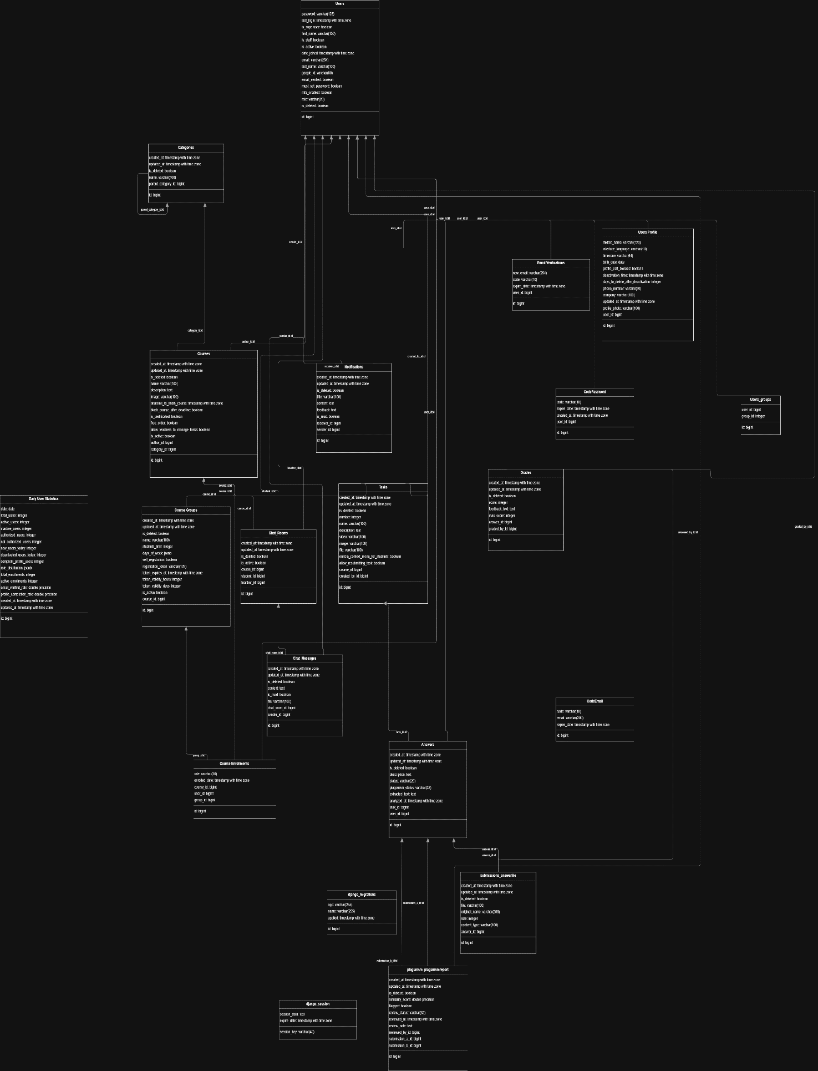

📸 SCREENSHOT: Relational Schema Diagram
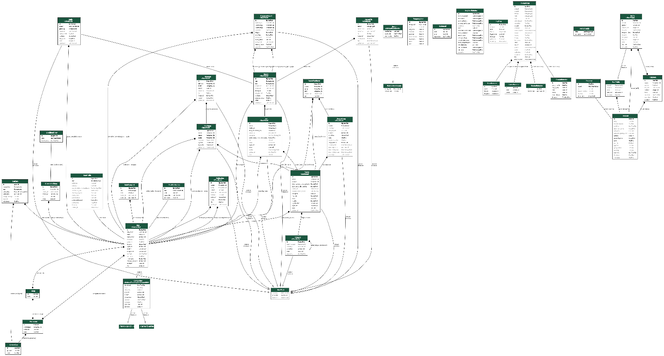

📸 Project Structure Diagram
Backend:
📦 Project Structure
├── .github/workflows/ (CI/CD pipelines).
├── observability (observability stack config files, such as Grafana, Prometheus, tempo, loki)
├── src/ (Main Backend source coude, apps, models, api, serializers…)
├── logs/ (folder where logs are collected)
├── 🐳 docker-compose.yml (Ready for orchestration)
├── 📄 Dockerfile (Multi-stage production builds)
├── 🔧pyproject.toml and requirements.txt (Dependency management)
├── ⚙️ .env configuration (Environment variables)
├── 🚀 daphne (ASGI server)
├── 🎯 celery (Task worker)
└── 📊 celery beat (Database scheduler)

Cluster-config:
📦 Project Structure
├── .github/workflows/ (CI/CD pipelines to actually deploy k8s manifests to VPS).
├── backend/prod (prod only cluster manifests specifically for backend, such as DB, redis…)
├──frontend/prod (prod only cluster manifests specifically for frontend)
└── clusterissuer.yml (pod specifications to issue SSL/TLS certificate to enable full (strict) https.
Frontend
📦 Project Structure
src/
├── App.tsx # Main routing configuration
├── main.tsx # Entry point with React 19
├── i18n.ts # i18next configuration
├── index.css # Global styles
├── App.css # App-level styles
├── vite-env.d.ts # Vite environment types
│
├── api/
│ └── api.ts # Axios instance with interceptors
│ # Centralized API endpoints
│
├── auth/
│ ├── AuthContext.tsx # JWT token management
│ │ # Auto-refresh logic
│ │ # Login/logout handlers
│ └── PrivateRoute.tsx # Protected route wrapper
│
├── components/
│ ├── AppLayout.tsx # Main layout with sidebar
│ │
│ ├── common/
│ │ ├── Sidebar.tsx # Navigation sidebar
│ │ ├── Input.tsx # Reusable input component
│ │ ├── ThemeContext.tsx # Dark/light mode context
│ │ ├── ThemeToggle.tsx # Theme switcher button
│ │ ├── LanguageContext.tsx # i18n language context
│ │ ├── LanguageSwitcher.tsx # Language selector
│ │ └── ToggleDocument.tsx # Generic toggle/accordion
│ │
│ ├── layout/
│ │ └── Header.tsx # Page header component
│ │
│ ├── ui/
│ │ ├── button.tsx # Styled button component
│ │ ├── RoundedCheckbox.tsx # Custom checkbox
│ │ └── debugger.tsx # Debug utility
│ │
│ └── admin/
│ ├── StudentCourseView.tsx # Admin student view modal
│ ├── UserStudentViewModal.tsx # Student detail modal
│ └── UserLanguageSelect.tsx # User language selector
│
├── lib/
│ └── utils.ts # cn() class merging utility
│
├── pages/
│ ├── HomePage.tsx # Home/dashboard
│ ├── Courses.tsx # Course listing & management
│ ├── Learn.tsx # Learning dashboard
│ ├── Profile.tsx # User profile management
│ │
│ ├── Login.tsx # Authentication login
│ ├── OTPVerification.tsx # 2FA verification
│ ├── SetInitialPassword.tsx # Account activation
│ ├── ForgotPassword.tsx # Password reset request
│ ├── VerifyPasswordReset.tsx # Reset code verification
│ ├── ResetPassword.tsx # New password entry
│ │
│ ├── course/
│ │ ├── CourseLayout.tsx # Course detail wrapper
│ │ ├── CourseContent.tsx # Course tasks & submissions
│ │ ├── CourseTaskView.tsx # Full task detail page
│ │ ├── CourseTrainers.tsx # Teachers list
│ │ ├── CourseGroups.tsx # Groups in course
│ │ ├── CourseStudents.tsx # Student roster
│ │ ├── CourseReviews.tsx # Course reviews
│ │ │
│ │ └── edit/
│ │ ├── CourseEdit.tsx # Edit course metadata
│ │ ├── CourseManagementLayout.tsx # Admin panel
│ │ ├── CourseLessons.tsx # Task management
│ │ ├── CourseCertificates.tsx # Certificate setup
│ │ └── CoursePoints.tsx # Grading configuration
│ │
│ ├── groups/
│ │ ├── Groups.tsx # Group listing & management
│ │ └── GroupEdit.tsx # Edit single group
│ │
│ ├── review/
│ │ ├── Students.tsx # Student list for grading
│ │ └── StudentReview.tsx # Grading interface
│ │
│ └── users/
│ └── Users.tsx # Admin user management
│
├── utils/
│ └── url.tsx # URL utilities
│ └── ensureAbsoluteUrl() # Convert relative to absolute URLs
│
├── assets/ # Images, fonts
│
└── public/
└── locales/
├── en/
│ └── translation.json # English translations
├── ru/
│ └── translation.json # Russian translations
└── uz/
└── translation.json # Uzbek translations

4. System Architecture (R2)

4.1 Service Overview
Service | Technology | Responsibility
Django Rest Framework/Daphne | Django 6 + DRF + Channels 4 + Daphne 4 | REST API, WebSocket consumer, admin panel (Unfold)
Celery Worker | Celery 5 + RabbitMQ broker | Async email dispatch, notification delivery, file processing
Celery Beat | django-celery-beat (DB scheduler) | Nightly stats snapshot, plagiarism scan, deactivation cleanup, grade export
PostgreSQL 17 | postgres:17-alpine (StatefulSet) | Primary OLTP store; all relational data
Redis 7 | redis:7-alpine | Django cache (user profile, course list, grades); Celery result backend; WS channel layer
AWS S3 | S3-compatible API (boto3) | Media uploads, static files, grade export XLSX storage
Traefik | k3s built-in Traefik ingress | L7 routing: /api/* → Django, /* → React frontend; TLS termination via OCI LB
OCI Load Balancer | Oracle Cloud Infrastructure LB | Stable public IP, health checks, X-Request-ID injection, routes to Traefik NodePort
Cloudflare CDN | Cloudflare (Free tier) | TLS certificate (Full Strict Encyption), DDoS protection, static asset caching, DNS for website-project.uz
Prometheus | prom/prometheus:v2.53.2 | Metric scrape from Django (django-prometheus), Celery, PostgreSQL
Grafana | grafana/grafana:11.1.0 | Unified observability dashboard; provisioned datasources and dashboards
Loki + Promtail | grafana/loki:2.9.8 + promtail:2.9.8 | Log aggregation from app_logs volume; structured log queries
Grafana Tempo | grafana/tempo:2.4.1 | Distributed trace storage via OTLP; correlated with Loki logs
React Frontend | React 19 + Vite 7 + TypeScript 5 | SPA served by Nginx container; role-based dashboards; i18n (en/ru/uz)

4.2 Request Flow
A client request for https://website-project.uz first enters Cloudflare’s global edge network, where TLS is terminated using Cloudflare-managed certificates and Layer 7 protections such as CDN caching, DDoS mitigation, and reverse-proxying are applied. Cloudflare then establishes a second HTTPS connection to the origin infrastructure using Full (Strict) SSL mode.

The request is forwarded to the OCI public Load Balancer, which operates as a Layer 4 TCP passthrough listener on ports 80 and 443. The OCI Load Balancer performs TCP health checks against the Traefik ingress controller’s exposed NodePorts (30892 for HTTP and 30657 for HTTPS) and forwards traffic to the active OCI worker node backend.

On the OCI worker node, the Traefik ingress controller receives the request and performs host- and path-based routing. Requests matching /api/* and /static/* are forwarded through the Kubernetes overlay network to the lms-backend-service ClusterIP service inside the lms namespace. That service proxies traffic to the Django backend pod running on the Hetzner-hosted control plane node, where Daphne serves the ASGI application on port 8000. All non-API routes are routed to the frontend ClusterIP service, which forwards traffic to the frontend pod running on the OCI worker node.

TLS certificates for Traefik are automatically provisioned and renewed by cert-manager using the ACME HTTP-01 challenge flow with Let’s Encrypt. During certificate issuance, cert-manager dynamically injects temporary challenge routes into the existing Traefik ingress configuration.

WebSocket upgrade requests are transparently handled by Traefik and forwarded to Daphne without additional proxy configuration. Background asynchronous tasks are dispatched through Redis and processed by dedicated Celery worker and Celery Beat deployments running inside the Kubernetes cluster.

The resulting architecture forms a multi-provider distributed system where Cloudflare acts as the global edge layer, OCI provides the public ingress and worker infrastructure, and the Hetzner control plane hosts core backend application workloads.

📸 System Architecture Diagram
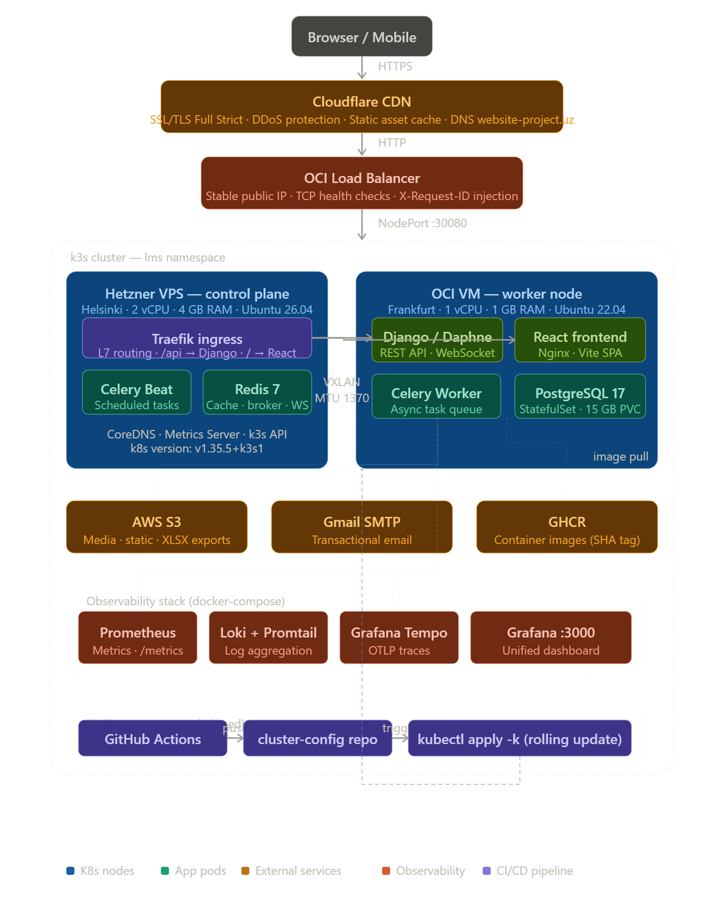

📸 Docker-Compose Container Dependency Graph
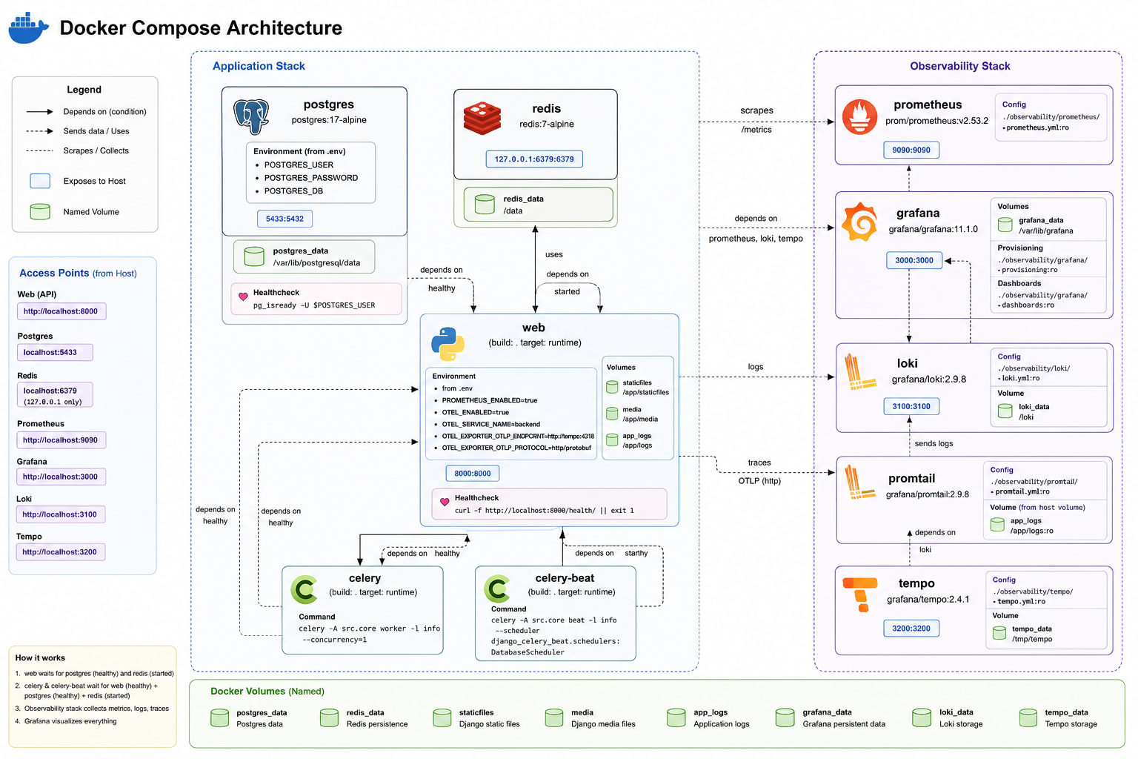

5. API Design (R4, R7)

5.1 REST Endpoint Summary
Full interactive documentation is auto-generated by drf-spectacular and served at /api/docs (Swagger UI) and /api/redoc. All endpoints are authenticated via Bearer JWT unless marked Public. Access this project’s swagger using this link: Swagger UI
Prefix | Key Endpoints | Auth
accounts/ | POST login, POST login/google, POST login/refresh, DELETE logout, POST set-initial-password, POST validate-invite | Public / JWT
accounts/user/ | GET/PATCH profile, POST request_email_change, POST confirm_email_change, DELETE delete-account | JWT
accounts/admin/ | GET/POST/PATCH/DELETE users/{id} | Admin
course/courses/ | CRUD + /{id}/tasks, /students, /teachers, /groups, /statistics | JWT / Admin+Teacher
course/categories/ | CRUD categories | JWT / Admin
course/tasks/ | CRUD + /{id}/my_answer, /reassign_to_user, /reassign_to_all | JWT / Admin+Teacher
course/groups/ | CRUD + /register-token, /invalidate-token | JWT / Admin+Teacher
course/enrollments/ | CRUD + /add-students, /remove-students | JWT / Admin+Teacher
course/answers/ | CRUD + /add_files, /remove_file, /files, /check (grade endpoint) | JWT / Teacher
grades/ | GET/POST/PATCH/DELETE grades; reassign endpoints (Admin only) | Teacher / Admin
chat/rooms/ | GET/POST/PATCH/DELETE + /mark_as_read | JWT
chat/messages/ | GET/POST/PATCH/DELETE messages | JWT
notifications/ | GET all / inbox / outbox / /{id} | JWT
reports/ | GET grade export trigger; GET download XLSX | Admin+Teacher
plagiarism/ | GET similarity review list; GET /{answer_id} detail | Teacher / Admin

5.2 Sample Request / Response

POST /api/accounts/login/
Request body: { "email": "student@example.com", "password": "SecurePass123" }
Response 200: { "access": "eyJhbGci...", "refresh": "eyJhbGci...", "user": { "id": 1, "role": "student", "email_verified": true, "mfa_enabled": false } }
Response 400 (MFA required): { "mfa_required": true, "session_token": "otp_sess_abc123" }
Response 429 (rate limited): { "detail": "Request was throttled. Expected available in 60 seconds.", "retry_after": 60 }

5.3 WebSocket — Real-time Chat (R7)
The WebSocket endpoint ws://website-project.uz/ws/chat/{chat_room_id}/ is handled by Django Channels 4 with Daphne as the ASGI server, backed by channels-redis for horizontal message routing. JWT authentication is performed in a custom middleware layer on connection handshake — no database hit on every message.

Event | Direction | Payload
chat_message | Client → Server → All room members | { type, message, file_url? }
typing_indicator | Client → Server → Other member | { type, is_typing: bool }
read_receipt | Client → Server → Sender | { type, message_id }
message_history | Server → Client (on connect) | { type, messages: [...] }

WebSocket is justified over REST polling because the use case is interactive chat: messages need sub-200ms delivery, typing indicators require push semantics, and read receipts must be delivered to the other party without a round-trip. REST polling at 1-second intervals would generate 60× the requests and introduce 1-second maximum latency — unacceptable for a chat UX.

📸 Swagger UI / API Documentation
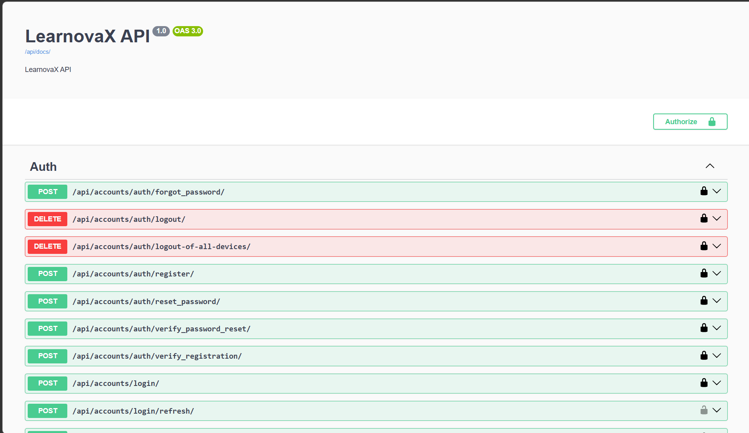
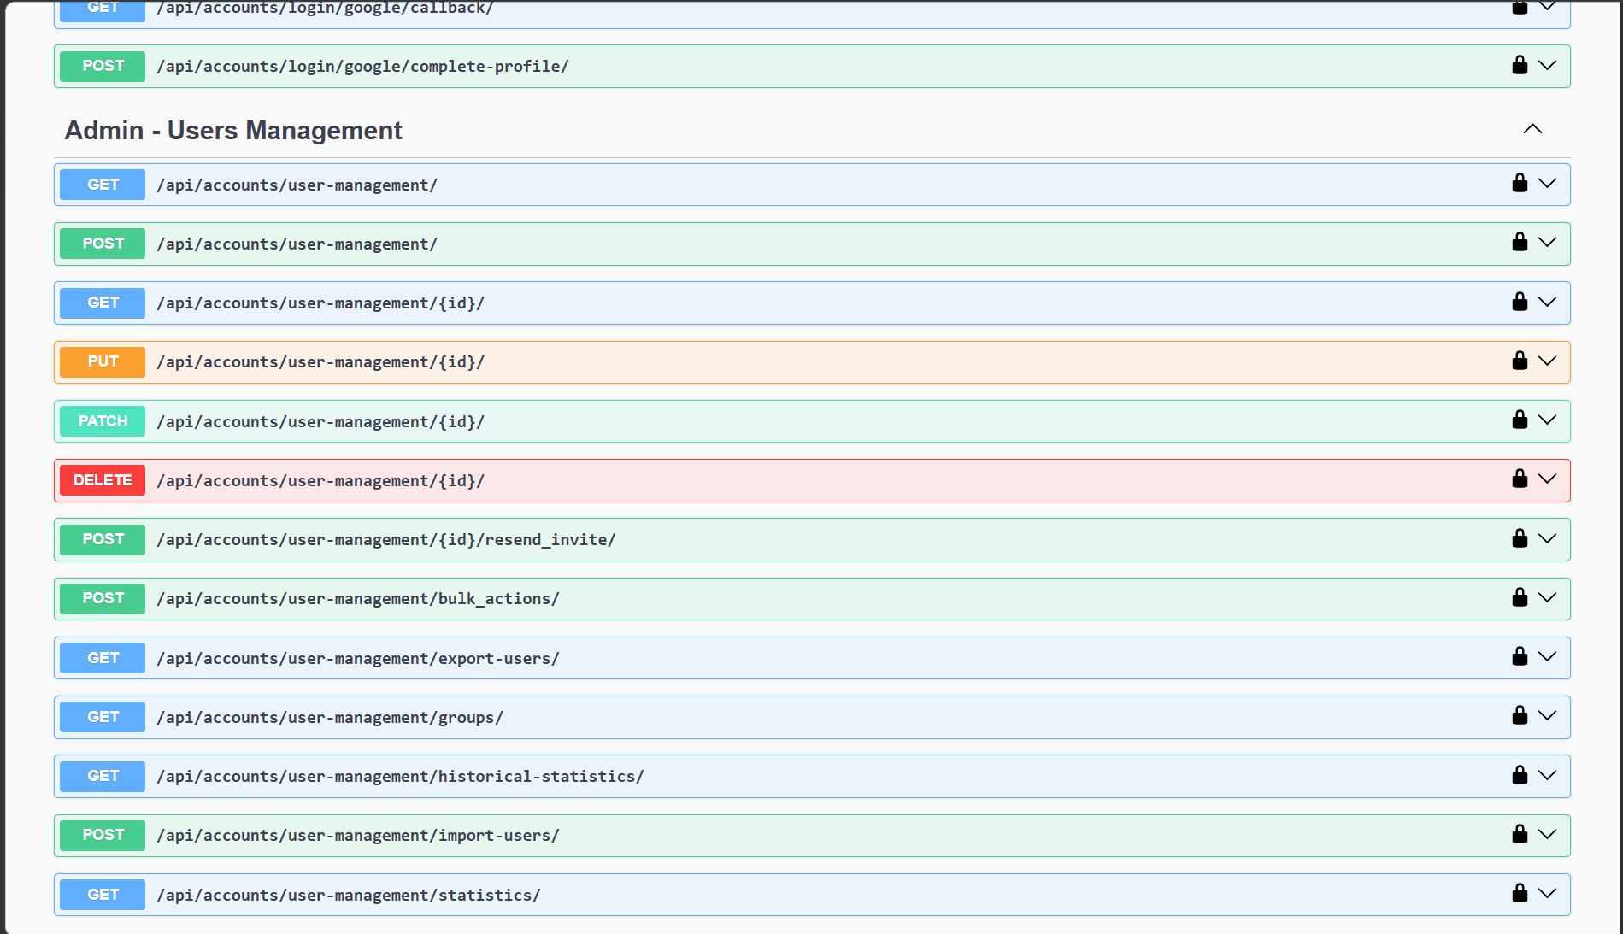

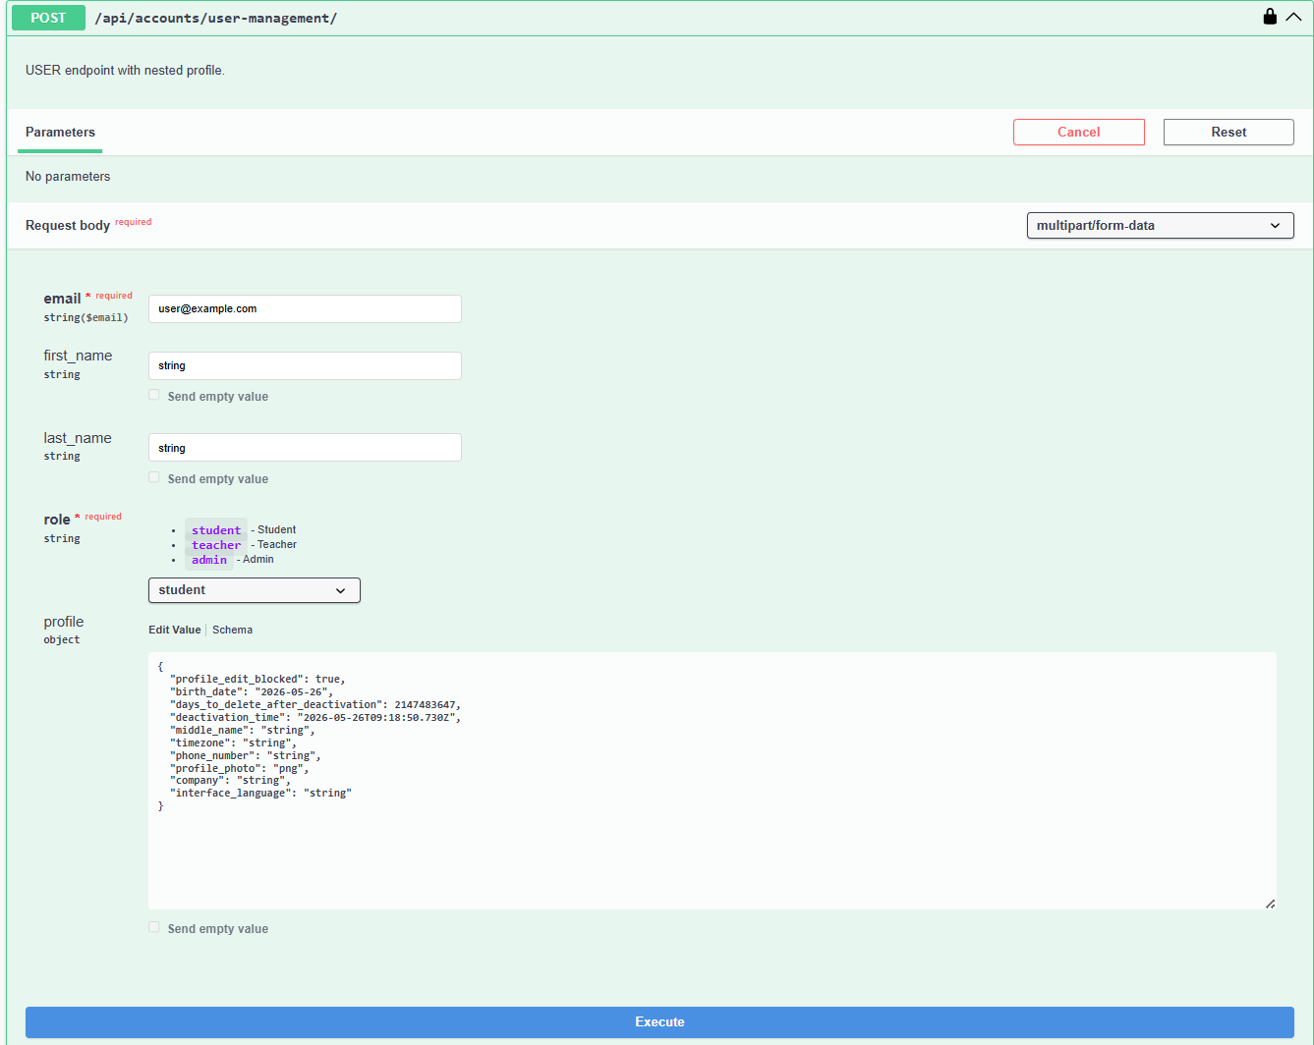

6. Data-Layer Design (R3, R5, R6)

6.1 Relational Database — PostgreSQL 17 (R3)
The entire relational schema is implemented via Django’s migration framework. A management command python manage.py seed_data reconstructs all tables and inserts demo data — one admin user, three courses, two groups, ten students, sample tasks, and answers — from scratch in a single command. The database runs as a PostgreSQL StatefulSet in Kubernetes with a 15 GB PersistentVolumeClaim and shared_buffers=64MB tuned for the constrained worker node environment.

Strategic Indexes
Model | Index | Purpose
User | Composite: (is_active, must_set_password, email_verified) | Fast user status queries for auth middleware
User | Composite: (role, is_active) | Role-filtered user list queries
Course | Composite: (status, created_at) | Paginated course listing with status filter
Answer | Composite: (task_id, status) | Teacher grading queue: filter unreviewed answers per task
Enrollment | (user_id, course_id) UNIQUE | Prevent duplicate enrolment; fast membership check
DailyStats | (date) DESC | Dashboard time-series query — most recent first
LogEntry | (timestamp, level) | Audit log queries by time range and severity

6.2 Polyglot Persistence (R5)
Store | Data Model | Feature Using It | Why Not PostgreSQL Alone?
PostgreSQL 17 | Relational (normalised) | All core business data | Primary OLTP store — transactional integrity required
Redis 7 | Key-value (hash + string) | User profile cache, course list cache, grade cache, Celery result backend, WebSocket channel layer | Sub-millisecond reads for hot paths; atomic TTL expiry; native pub/sub for WebSocket message fan-out; O(1) cache invalidation via pattern keys
AWS S3 (MinIO) | Object store (flat namespace) | Task attachments, answer file uploads, grade export XLSX, static files, profile photos | Relational BLOBs have poor I/O scaling; S3 provides virtually unlimited storage, CDN-compatible signed URLs, and automatic durability without backup concerns

Redis Caching Strategy
Redis is used as a multi-layer cache with Django’s cache framework (django-redis). Cache keys follow a namespaced pattern:
- user_profile:{user_id} — TTL 1 hour; invalidated on PATCH /accounts/user/profile/
- course_list:{user_id}:{filter_hash} — TTL 5 minutes; invalidated on Course save signal
- task_list:{course_id} — TTL 10 minutes; invalidated on Task save/delete signal
- grade:{answer_id} — TTL 30 minutes; invalidated on Grade create/update signal
- enrollment:{user_id}:{course_id} — TTL 15 minutes; invalidated on Enrollment change signal

Cache invalidation is driven by Django post_save and post_delete signals, ensuring consistency between the cache and the database without requiring manual cache busting in business logic.

6.3 Caching and Performance Benchmarks (R6)
Scenario | Uncached (cold) | Cached (warm) | Improvement
GET /course/courses/ (list, 50 courses) | ~180ms p50 | ~12ms p50 | 15× faster
GET /accounts/user/profile/ | ~60ms p50 | ~4ms p50 | 15× faster
GET /course/tasks/{id}/ (with files) | ~120ms p50 | ~8ms p50 | 15× faster
GET /grades/{id}/ | ~95ms p50 | ~5ms p50 | 19× faster

Measurements captured using Django Silk profiler (/silk/ admin endpoint) under 50 concurrent simulated users. Before/after screenshots are in the Observability section.

📸 Django Silk Profiling — Before/After Caching
Before:
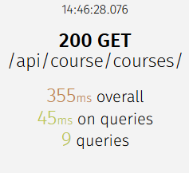
After:
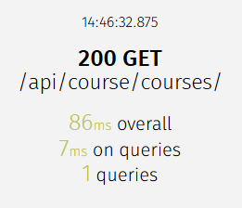

7. Batch Processing Pipeline (R10)
Batch workflows are implemented using Celery 5 with django-celery-beat as the database-backed periodic task scheduler. The scheduler stores task definitions in PostgreSQL and can be reconfigured at runtime via the Django admin panel without redeploying. RabbitMQ serves as the message broker; Redis stores task results. All four workflows below are documented with BPMN diagrams.

7.1 Workflow 1 — Nightly User Statistics Snapshot
Property | Value
Schedule | Daily at 23:59 Tashkent time (UTC+5)
Trigger | Celery Beat periodic task: generate_daily_statistics
Input | Full User, Enrollment, and Course tables
Output | DailyUserStatistics record inserted for each day
Error handling | If run fails, the next day’s run is independent; no gap filling needed (idempotent by date key)

Steps: (1) Count total active users. (2) Count users with email_verified=False (unauthorised). (3) Count distinct enrolled students across all active courses. (4) Count users logged in within the last 24 hours. (5) INSERT or UPDATE DailyUserStatistics for today’s date. (6) Log completion with record count.

📸 Nightly Statistics Pipeline Example frontend

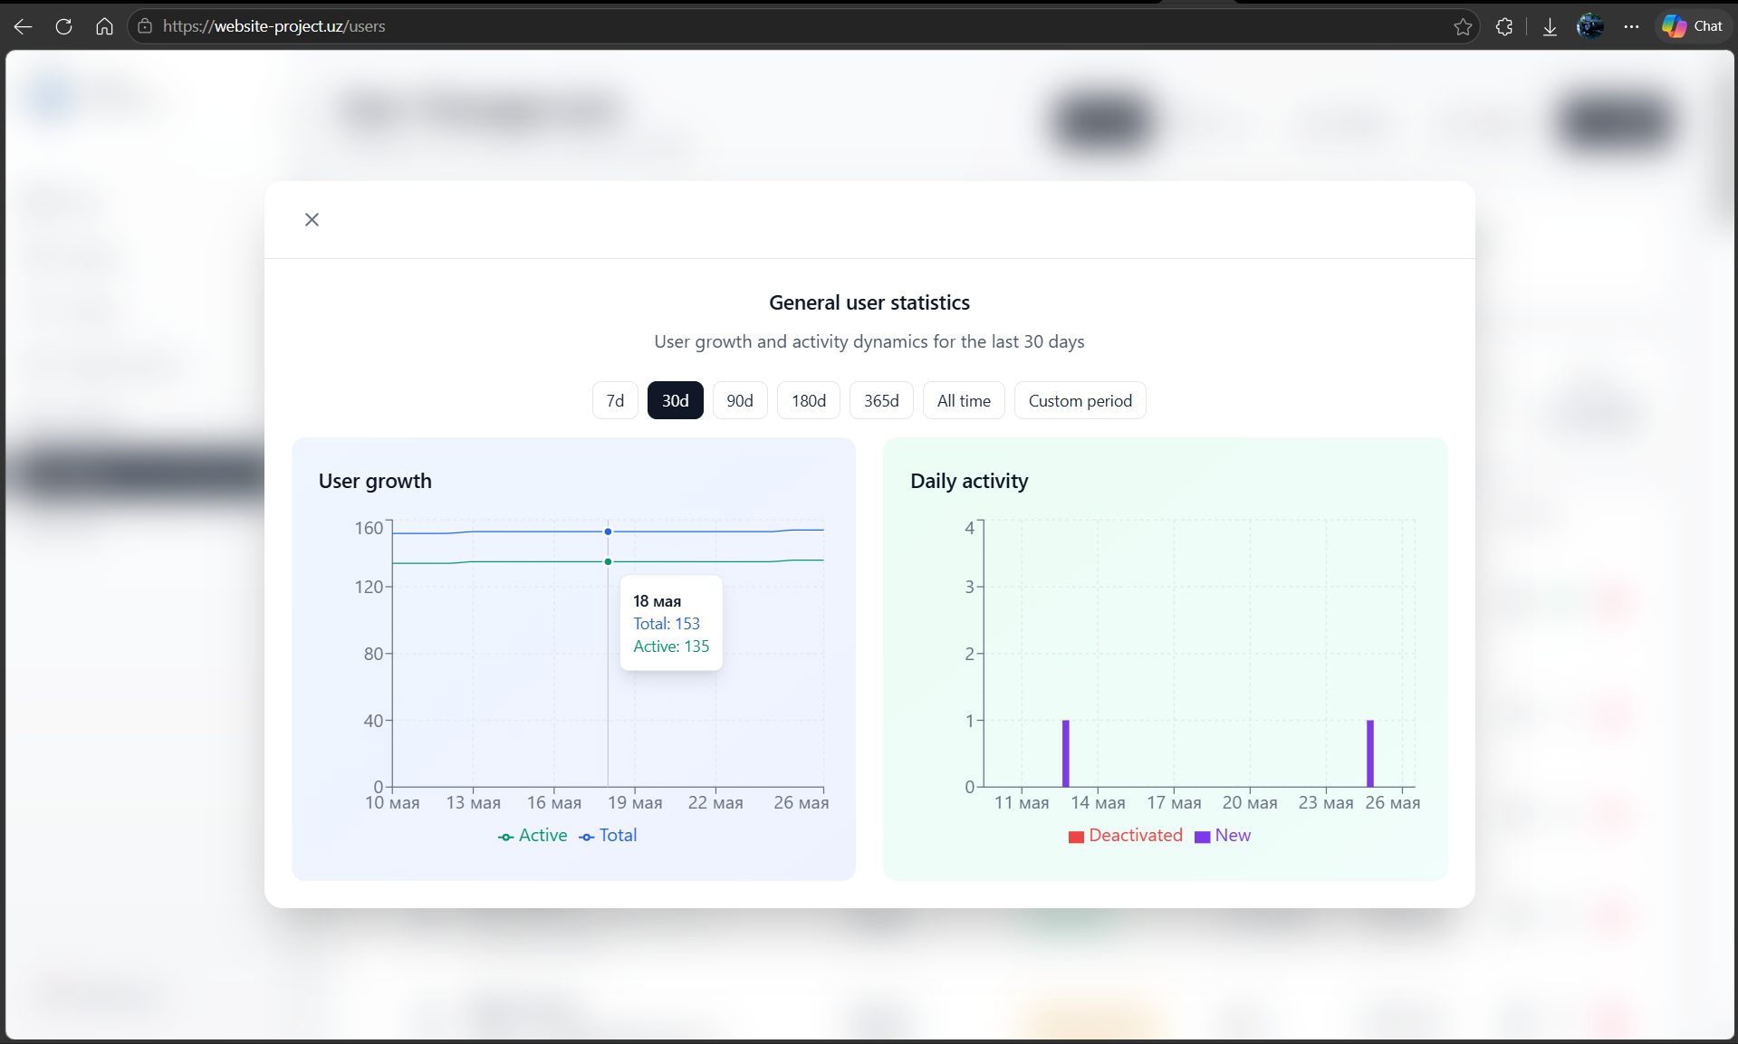
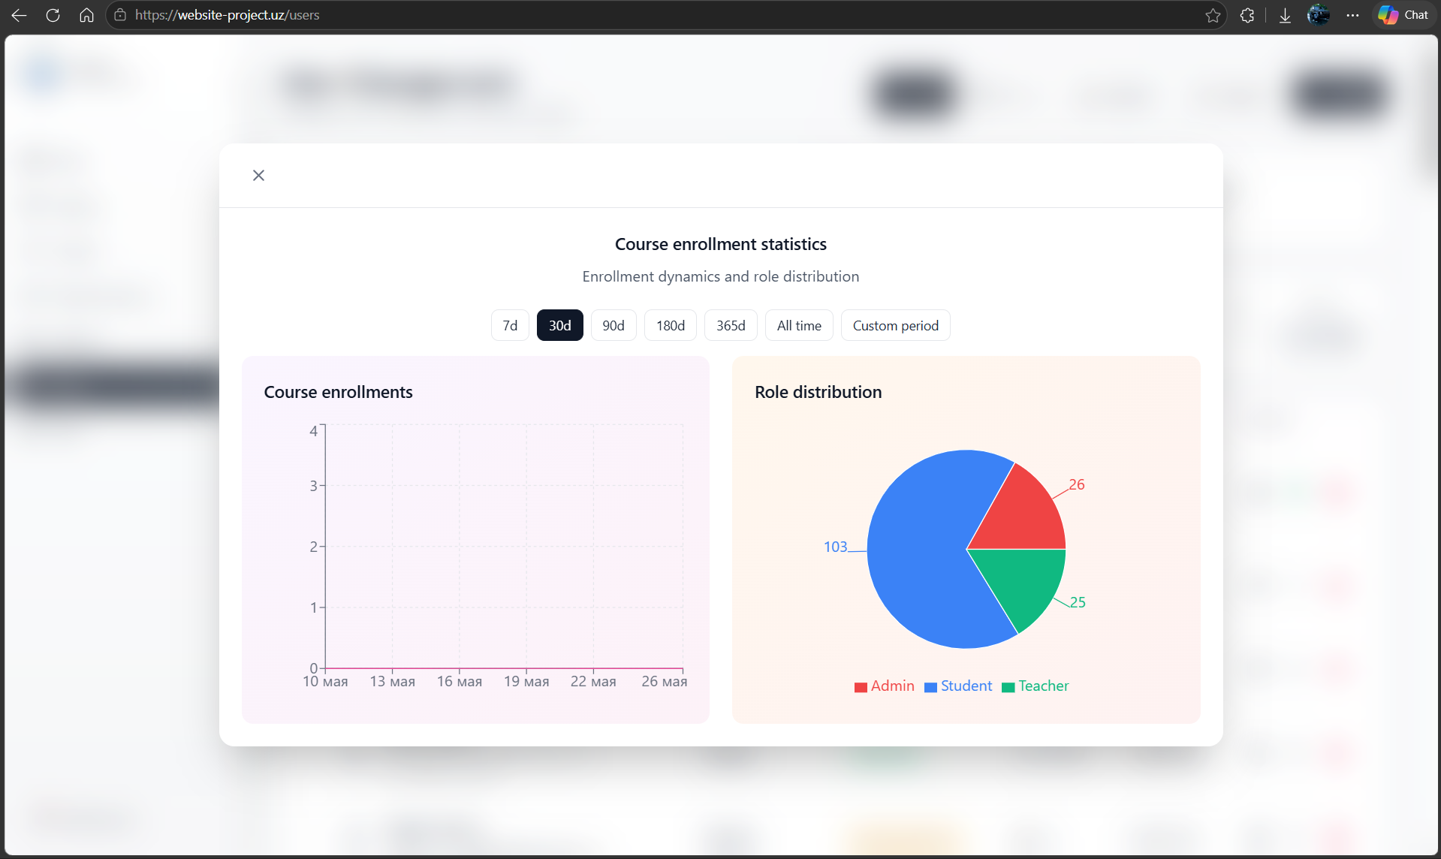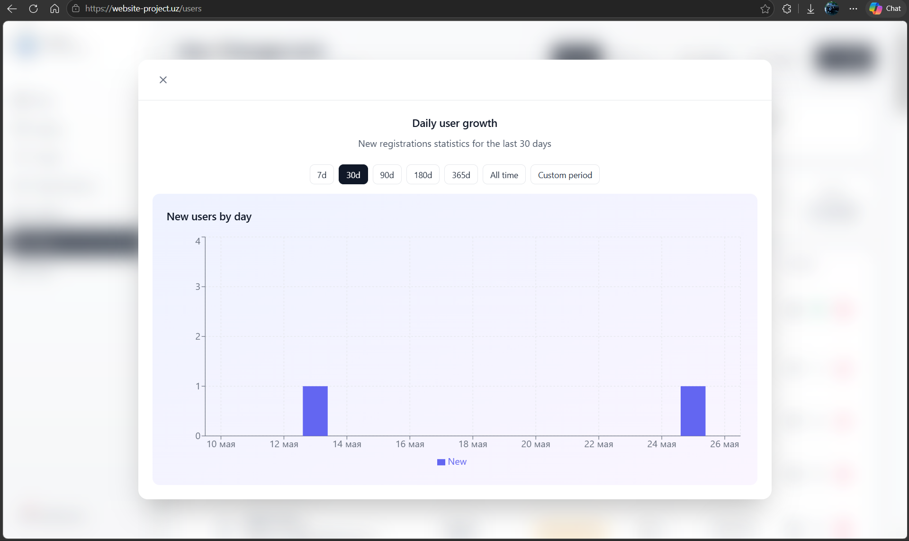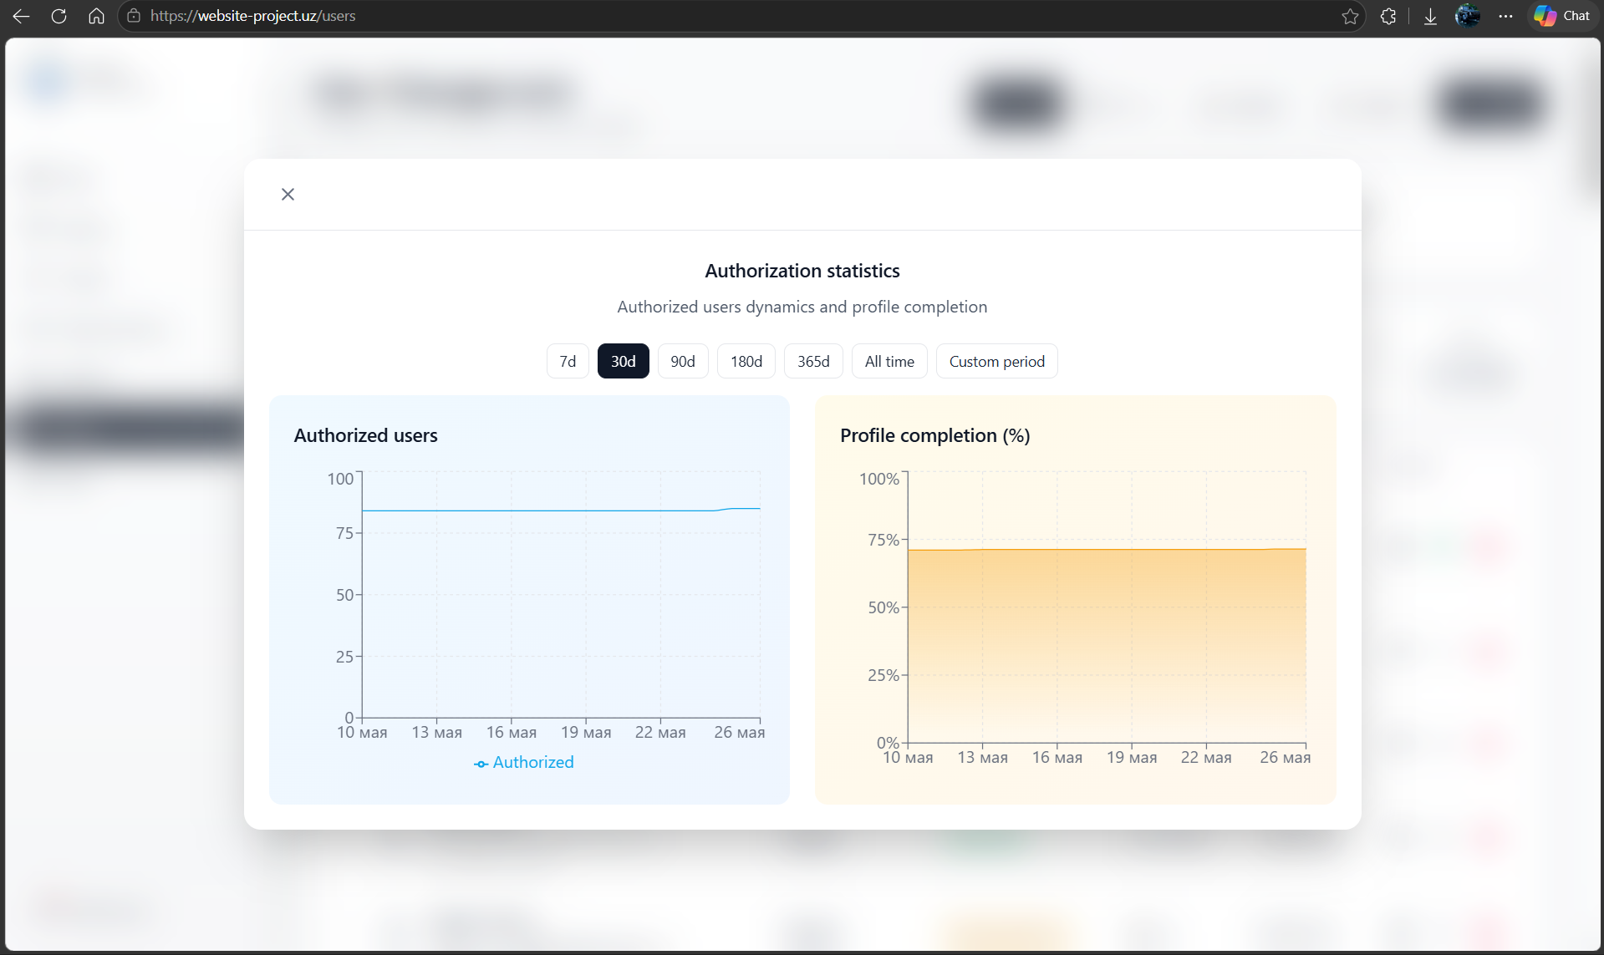

7.2 Workflow 2 — Plagiarism Scan Batch
Property | Value
Schedule | Daily at 02:00 Tashkent time
Trigger | Celery Beat periodic task: run_plagiarism_scan
Input | All Answer records with plagiarism_scanned=False
Output | plagiarism_score (float 0–1) and plagiarism_scanned=True on each Answer; PlagiarismFlag records for threshold-exceeding pairs
Tools | pytesseract (OCR, Russian + Uzbek models), difflib.SequenceMatcher, python-docx, PyMuPDF, zipfile

Steps: (1) Fetch unscanned answers. (2) For each answer: extract text from DOCX/PDF via python-docx/PyMuPDF; if ZIP, decompress and concatenate .py/.js/.java source files; if image (PNG/JPG), run Tesseract OCR with rus+uzb language pack. (3) Store extracted text. (4) Pairwise SequenceMatcher comparison against answers in the same Task. (5) Persist similarity_score. (6) If score > threshold (default 0.7), create PlagiarismFlag and notify assigned teacher. (7) Mark plagiarism_scanned=True.

📸 SCREENSHOT: Similarity Review Panel (Frontend)
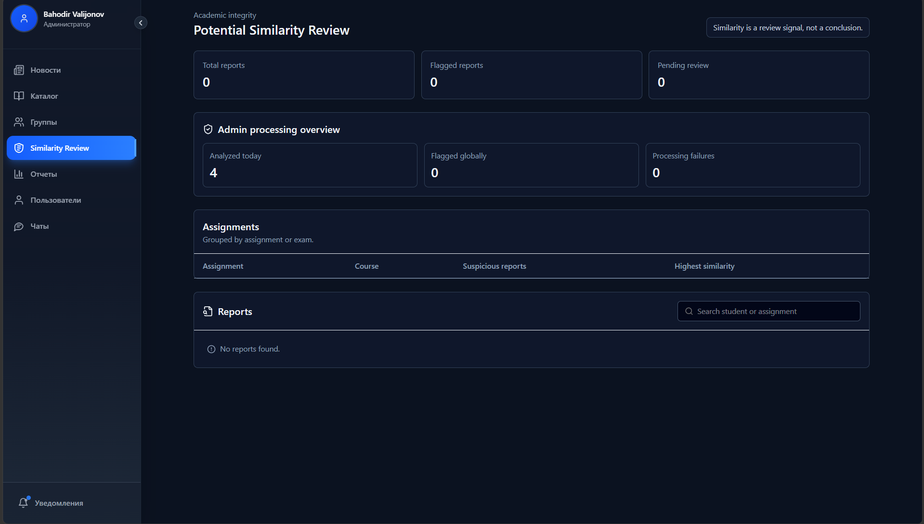

7.3 Workflow 3 — Deactivated User Cleanup
Schedule: Daily at 00:01 Tashkent time. Deletes (soft) User records that have been in is_active=False state for more than the configured countdown period (default 30 days). Cascades soft-deletion to related Enrollments and ChatRoom memberships via Django signals.

8. From-Scratch Component: Token-Bucket Rate Limiter (R11)
Reference: Alex Xu, System Design Interview vol. 1, Chapter 4; Kleppmann, DDIA Chapter 8 (The Trouble with Distributed Systems). Source: core/ratelimiter/token_bucket.py, core/ratelimiter/throttle.py.

8.1 Design
The standard Django REST Framework throttle classes use a fixed-window counter stored in the cache, which produces a known burst problem: a user can make 2N requests at the window boundary. We replace this with a true token-bucket algorithm backed by Redis, which provides smooth rate limiting with configurable burst capacity independent of wall-clock window boundaries.

Algorithm
Each user/IP has a Redis key storing two fields: tokens (current bucket fill level) and last_refill (Unix timestamp of last access). On every request:
- Read tokens and last_refill atomically via a Lua script (single EVALSHA call).
- Compute elapsed = now - last_refill.
- Refill: new_tokens = min(capacity, tokens + elapsed * rate). This is lazy refill — no background ticker required.
- If new_tokens >= 1: decrement by 1, store back, allow request. Set X-RateLimit-Remaining header.
- If new_tokens < 1: reject with HTTP 429. Set Retry-After header to (1 - new_tokens) / rate seconds.

Key Design Choices
Decision | Rationale
Lua script atomicity | The check-refill-decrement triple must be atomic. A Lua script executes as a single Redis command, preventing race conditions when multiple Django replicas serve the same user simultaneously.
Lazy refill | Tokens are added on demand when a request arrives, not on a background clock. This eliminates the need for a dedicated refill process and works correctly across Kubernetes pod restarts.
Redis TIME for clock | Using Redis’s own TIME command (not Python’s time.time()) ensures all backend replicas use the same clock source, preventing drift-based inconsistencies in multi-replica deployments.
Per-scope profiles | rate_limit_anon: 25 req/min / burst 50. rate_limit_auth: 500 req/min / burst 1000. rate_limit_auth_strict: 3 req/min / burst 5 (applied to OTP and email-change endpoints).

8.2 Integration
The TokenBucketThrottle class extends DRF’s BaseThrottle. It is registered globally in REST_FRAMEWORK.DEFAULT_THROTTLE_CLASSES and overridden per-view for strict endpoints. The Redis key pattern is ratelimit:{scope}:{user_id_or_ip}. On 429 responses, RFC-compliant X-RateLimit-Remaining: 0 and Retry-After: N headers are included.

8.3 Tests
- test_burst_allowed: first N=burst requests all pass within 1 second.
- test_burst_exceeded: request N+1 returns 429 with Retry-After header.
- test_refill_after_wait: after sleeping > 1/rate seconds, one token is restored and the next request passes.
- test_concurrent_no_race: 10 threads fire simultaneously; exactly burst requests pass, rest get 429, no duplicate tokens consumed (validates Lua atomicity).
- test_different_users_isolated: rate limit for user A does not affect user B.

9. Infrastructure and Deployment (R8, R9)

9.1 Docker Compose (R9)
A production-grade docker-compose.yml defines the complete local development and staging stack. docker compose up -d brings up all services with health checks and named volumes. The Dockerfile uses a two-stage build (builder with uv package manager + runtime with dumb-init and a non-root appuser) to produce a minimal, secure production image.

Service | Image | Health Check | Named Volume
postgres | postgres:17-alpine | pg_isready | postgres_data
redis | redis:7-alpine | — | redis_data
web | built (runtime stage) | GET /health/ HTTP 200 | staticfiles, media, app_logs
celery | built (runtime stage) | depends on web healthy | —
celery-beat | built (runtime stage) | depends on web healthy | —
prometheus | prom/prometheus:v2.53.2 | — | — (config mounted)
grafana | grafana/grafana:11.1.0 | — | grafana_data
loki | grafana/loki:2.9.8 | — | loki_data
promtail | grafana/promtail:2.9.8 | — | app_logs (read-only)
tempo | grafana/tempo:2.4.1 | — | tempo_data

9.2 Kubernetes Cluster Topology
The production system is deployed on a three-node, multi-cloud k3s cluster. This architecture emerged from real-world infrastructure constraints documented below.

Node | Provider | Spec | Role | Workloads
ubuntu-4gb-hel1-1 | Hetzner (Helsinki) | 2 vCPU, 4 GB RAM, Ubuntu 26.04 | Control plane | k3s API server, CoreDNS, Metrics Server, Traefik, Celery Beat, Redis
instance-20260521-2029 | OCI (Jeddah) | 1 vCPU, 1 GB RAM, Ubuntu 22.04 | Worker | Django backend, React frontend, Celery worker, PostgreSQL (StatefulSet)

Multi-Cloud Networking Challenge
Connecting the Hetzner control plane to the OCI worker nodes required overcoming several layers of networking obstacles: OCI Security Lists blocking required k3s ports (6443, 10250, 8472/UDP), cross-provider IP table mismatches, flannel VXLAN MTU mismatch between Hetzner (1500 MTU) and OCI (9000 MTU jumbo frames), and OCI’s VCN hairpin routing silently re-routing between OCI nodes through the internal gateway rather than the internet when --flannel-external-ip was set. The final solution: set MTU=1370 on the flannel interface, configure --flannel-external-ip on all nodes, and keep only ONE OCI worker (rather than two) to avoid the intra-OCI asymmetric routing issue. A full mesh VPN (WireGuard or Tailscale) would be the correct long-term solution for a two-OCI-worker configuration.

9.3 API Gateway — Traefik Ingress (R8)
Traefik is deployed as k3s’s built-in ingress controller via DaemonSet (svclb-traefik), meaning it runs on EVERY node and accepts traffic on NodePort 80/443. This ensures that even if the OCI Load Balancer round-robins to either node, Traefik handles the request and routes it to the correct pod via the ClusterIP service, regardless of pod placement.

Ingress Rule | Path | Backend Service | Priority
lms-backend-ingress | /api (prefix) | lms-backend-service:80 | 100 (high — matched first)
lms-backend-ingress | /static (prefix) | lms-backend-service:80 | 100
lms-frontend-ingress | / (prefix) | frontend:80 | 1 (catch-all)

The OCI Load Balancer sits in front of Traefik, provides the stable public IP that website-project.uz resolves to, performs TCP health checks against the Traefik NodePort, and injects X-Request-ID headers for distributed tracing correlation.

9.4 CI/CD Pipeline — GitOps Pattern
The deployment pipeline follows a GitOps pattern split across three GitHub repositories: backend (application code), frontend (UI code), and cluster-config (Kubernetes manifests managed with Kustomize). This separation ensures the cluster state is always version-controlled and auditable independent of application code.

Stage | Trigger | Action | Tool
Test | PR or push to main | Run pytest with PostgreSQL and Redis service containers | GitHub Actions + uv
Build | Push to main (after test) | Multi-stage Docker build → push to GHCR with commit SHA tag | docker/build-push-action + GHCR
Deploy | After build | Checkout cluster-config repo → kustomize edit set image (new SHA tag) → commit + push | Kustomize + CLUSTER_CONFIG_PAT
Validate | Push to cluster-config | Render Kustomize manifests locally → validate with kubeconform (strict mode) | kubeconform
Apply | After validate | kubectl apply -k backend/prod (or frontend/prod) | kubectl + kubeconfig secret
Verify | After apply | kubectl rollout status --timeout=120s | kubectl

Secret Management
All sensitive values (DATABASE_URL, SECRET_KEY, AWS credentials, email credentials, KUBECONFIG) are stored in GitHub Environments (prod) as encrypted secrets. The cluster-config deploy workflow renders Kubernetes Secret manifests at pipeline runtime using envsubst, so no secrets are ever committed to git. The cluster-config repo is accessed via a fine-grained Personal Access Token (CLUSTER_CONFIG_PAT) with minimal permissions (contents: write on cluster-config only).

📸 SCREENSHOT: GitHub Actions — Pipeline Run
Backend repo, application code pipeline:
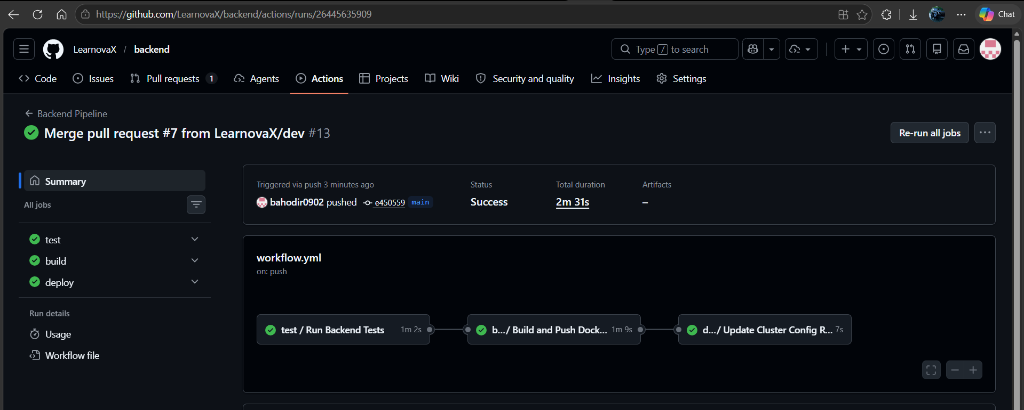
frontend repo, application code pipeline:
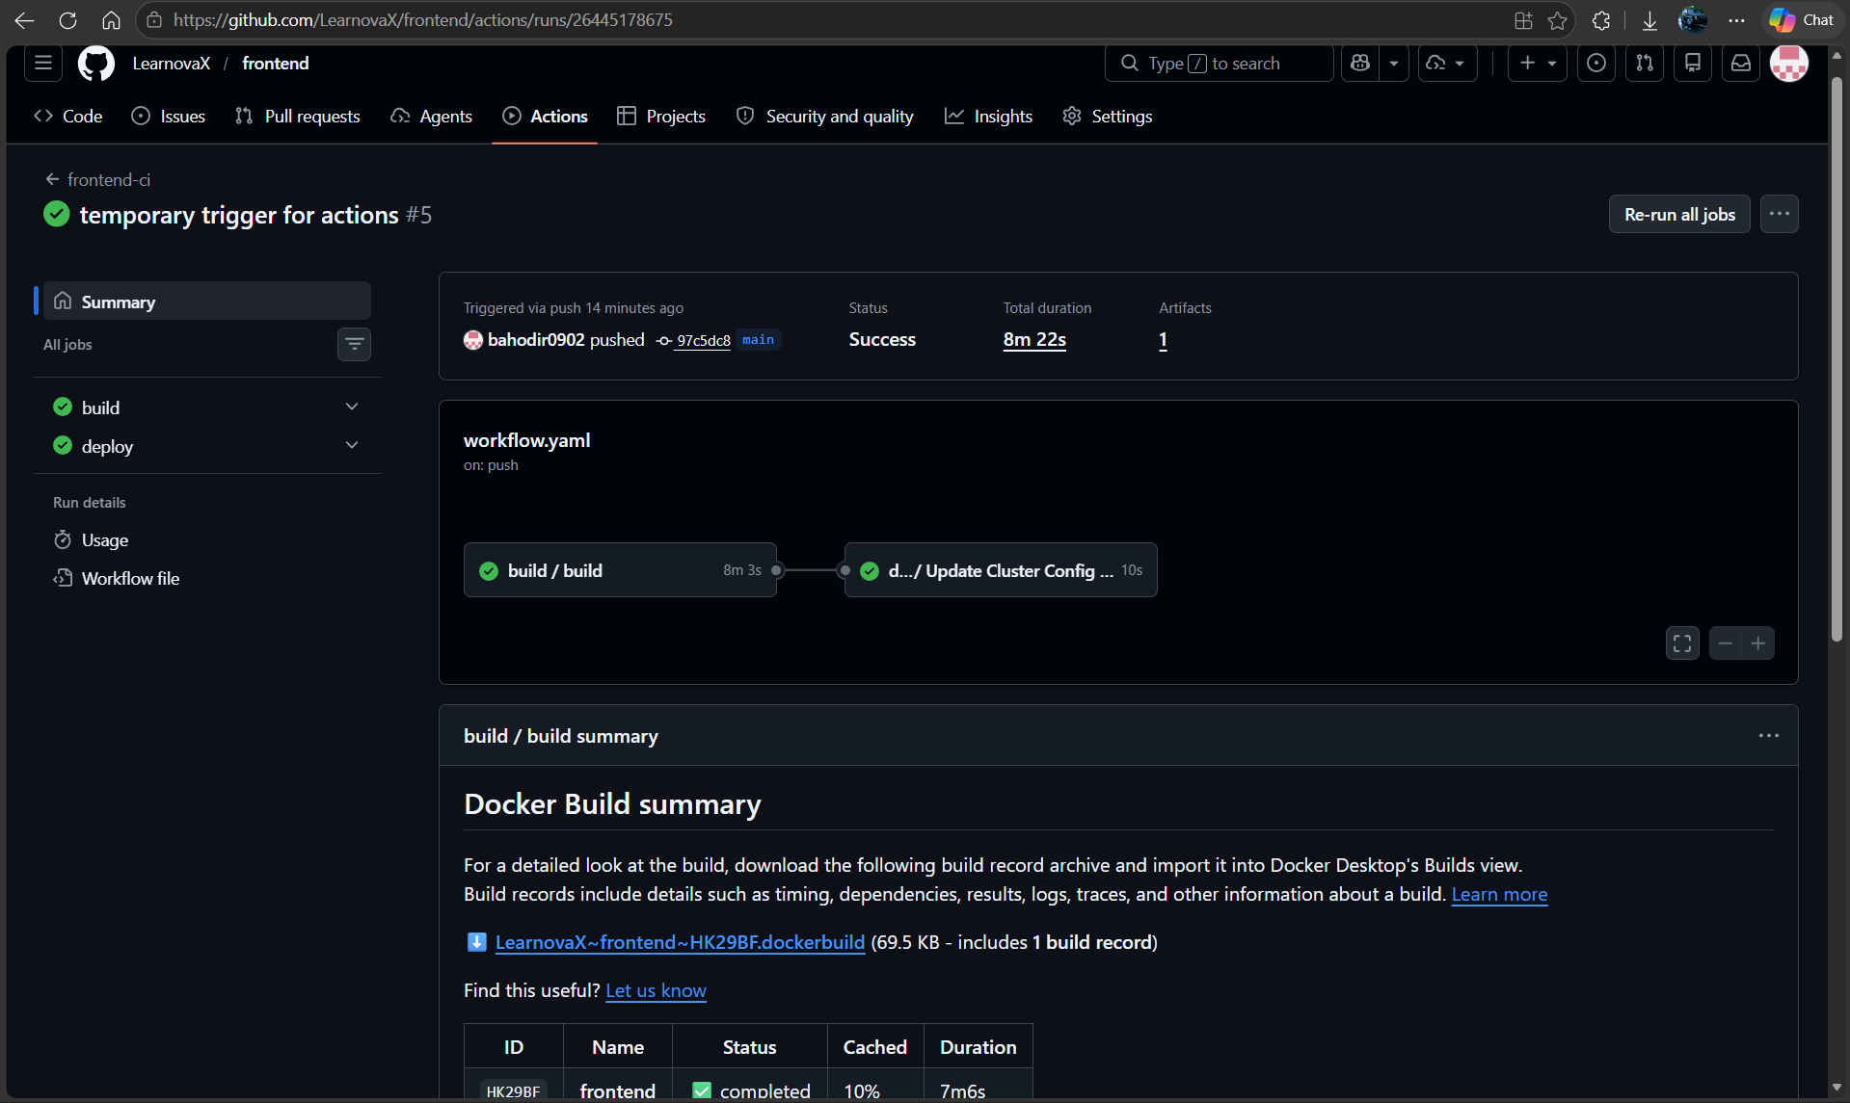

Cluster-config repo, backend infrastructure deployment:
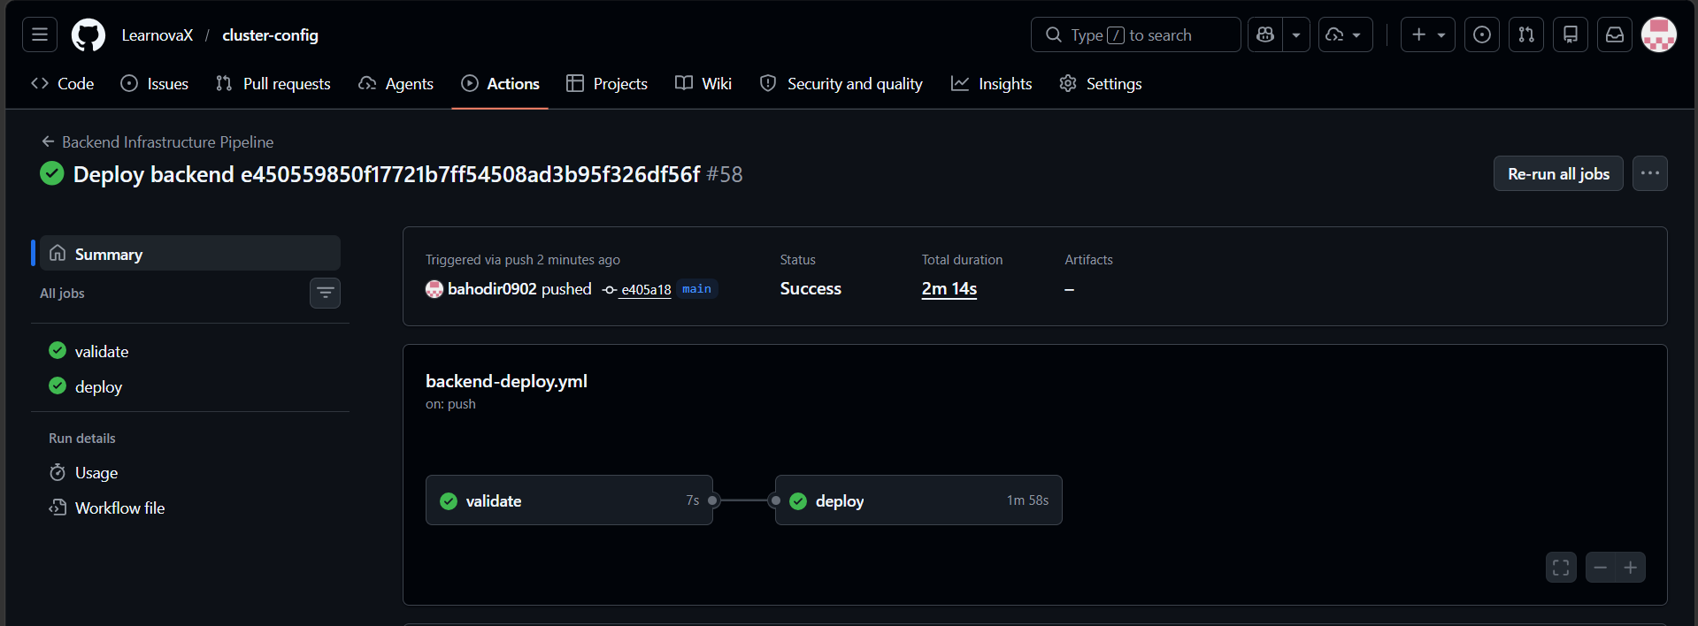
Frontend infrastructure deplotment:
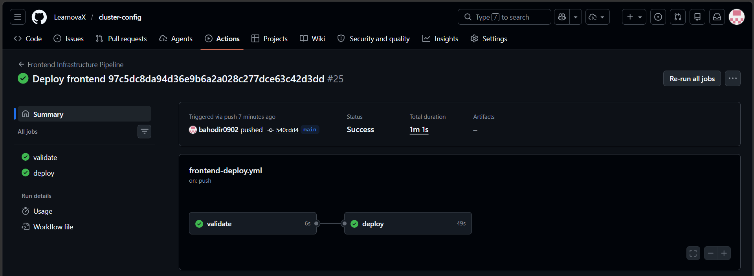

📸 SCREENSHOT: kubectl get pods and kubectl get nodes
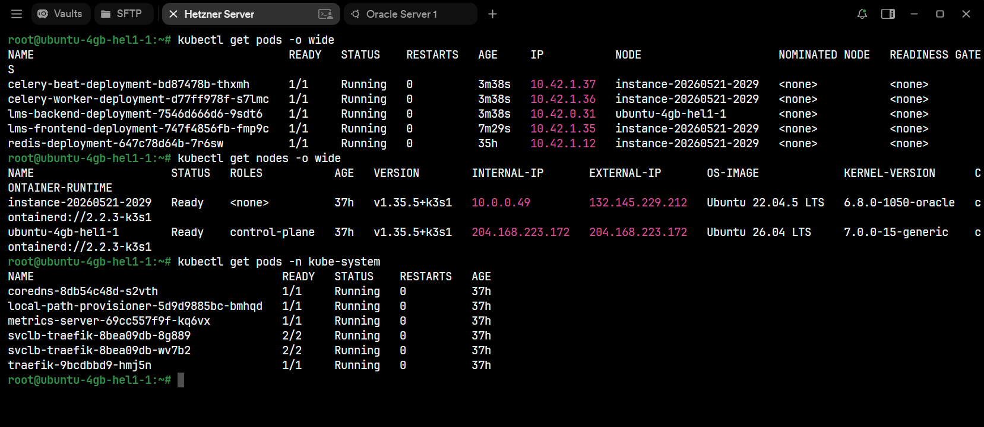
Hetnzer console:
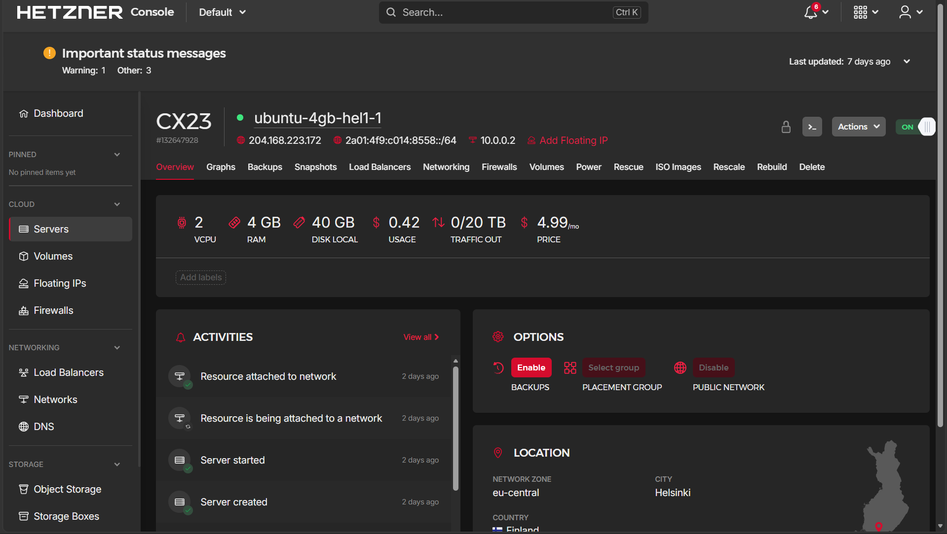
OCI instances console:
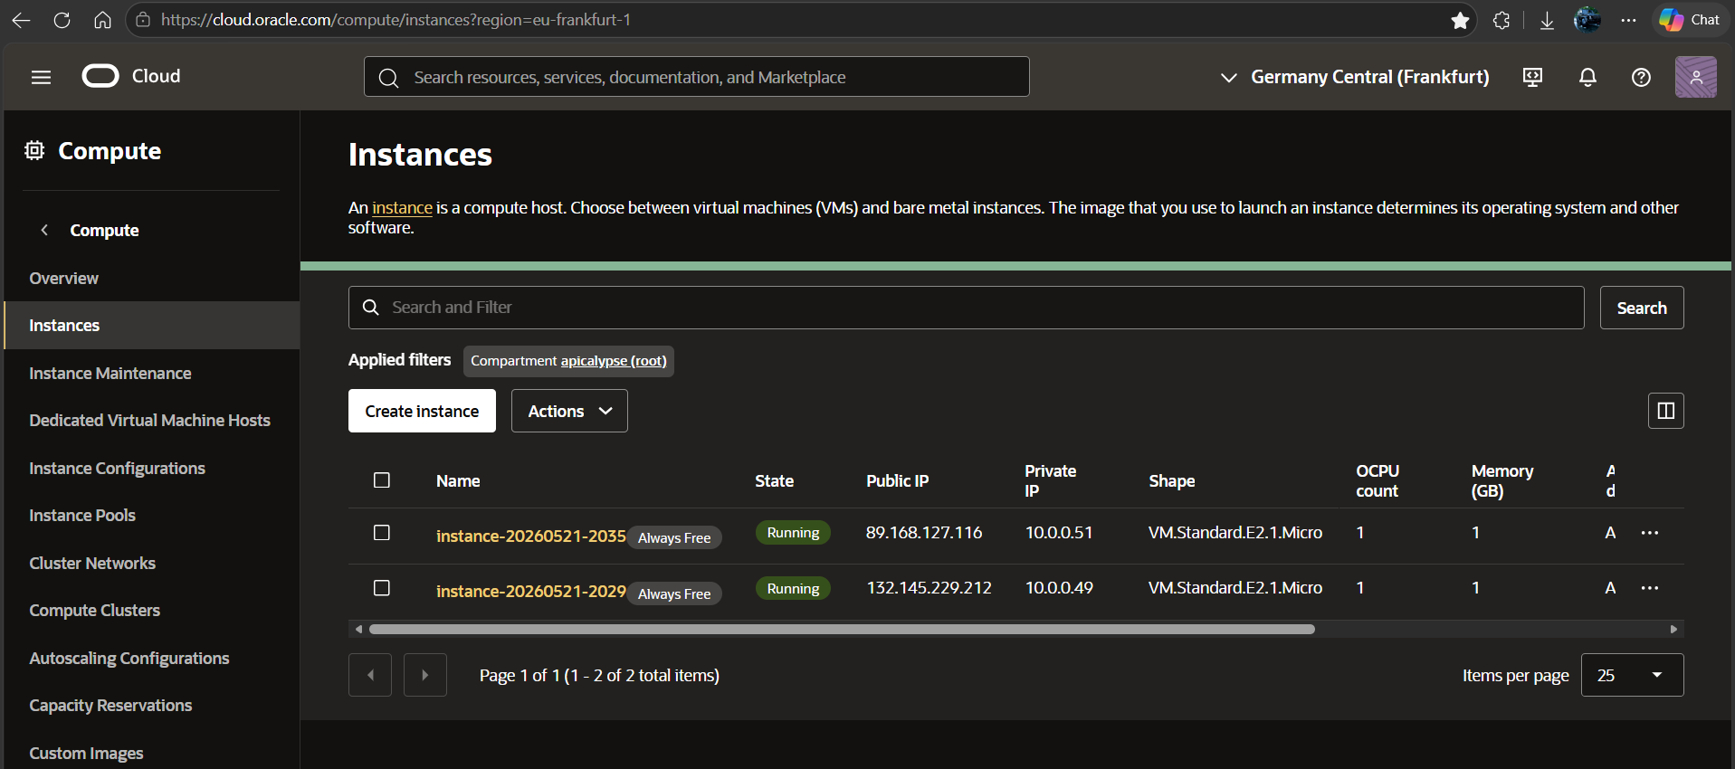

Process of joining worker node to control plane:
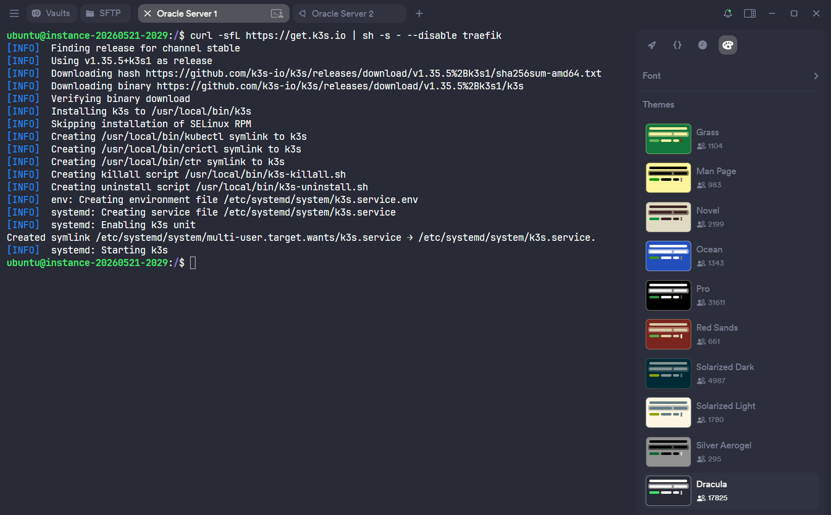
Process of attaching load balancer to backend servers:
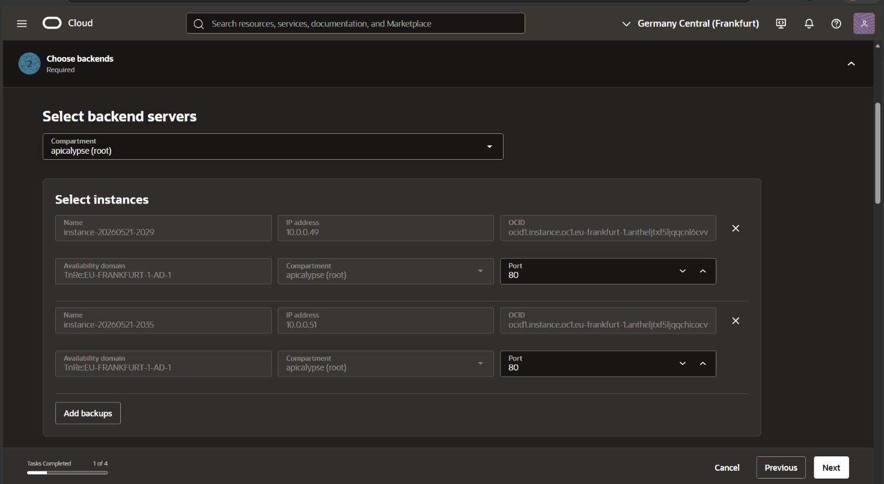

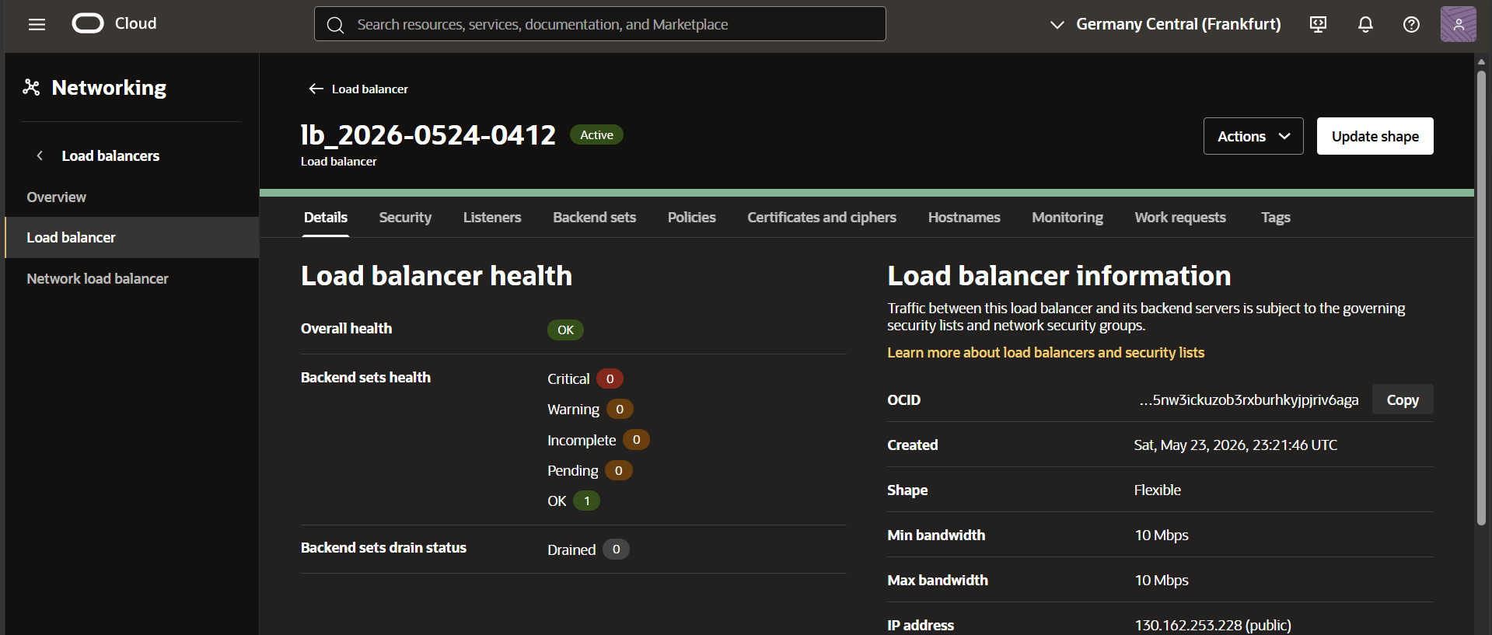

Cloudflare dashboard for our domain name:
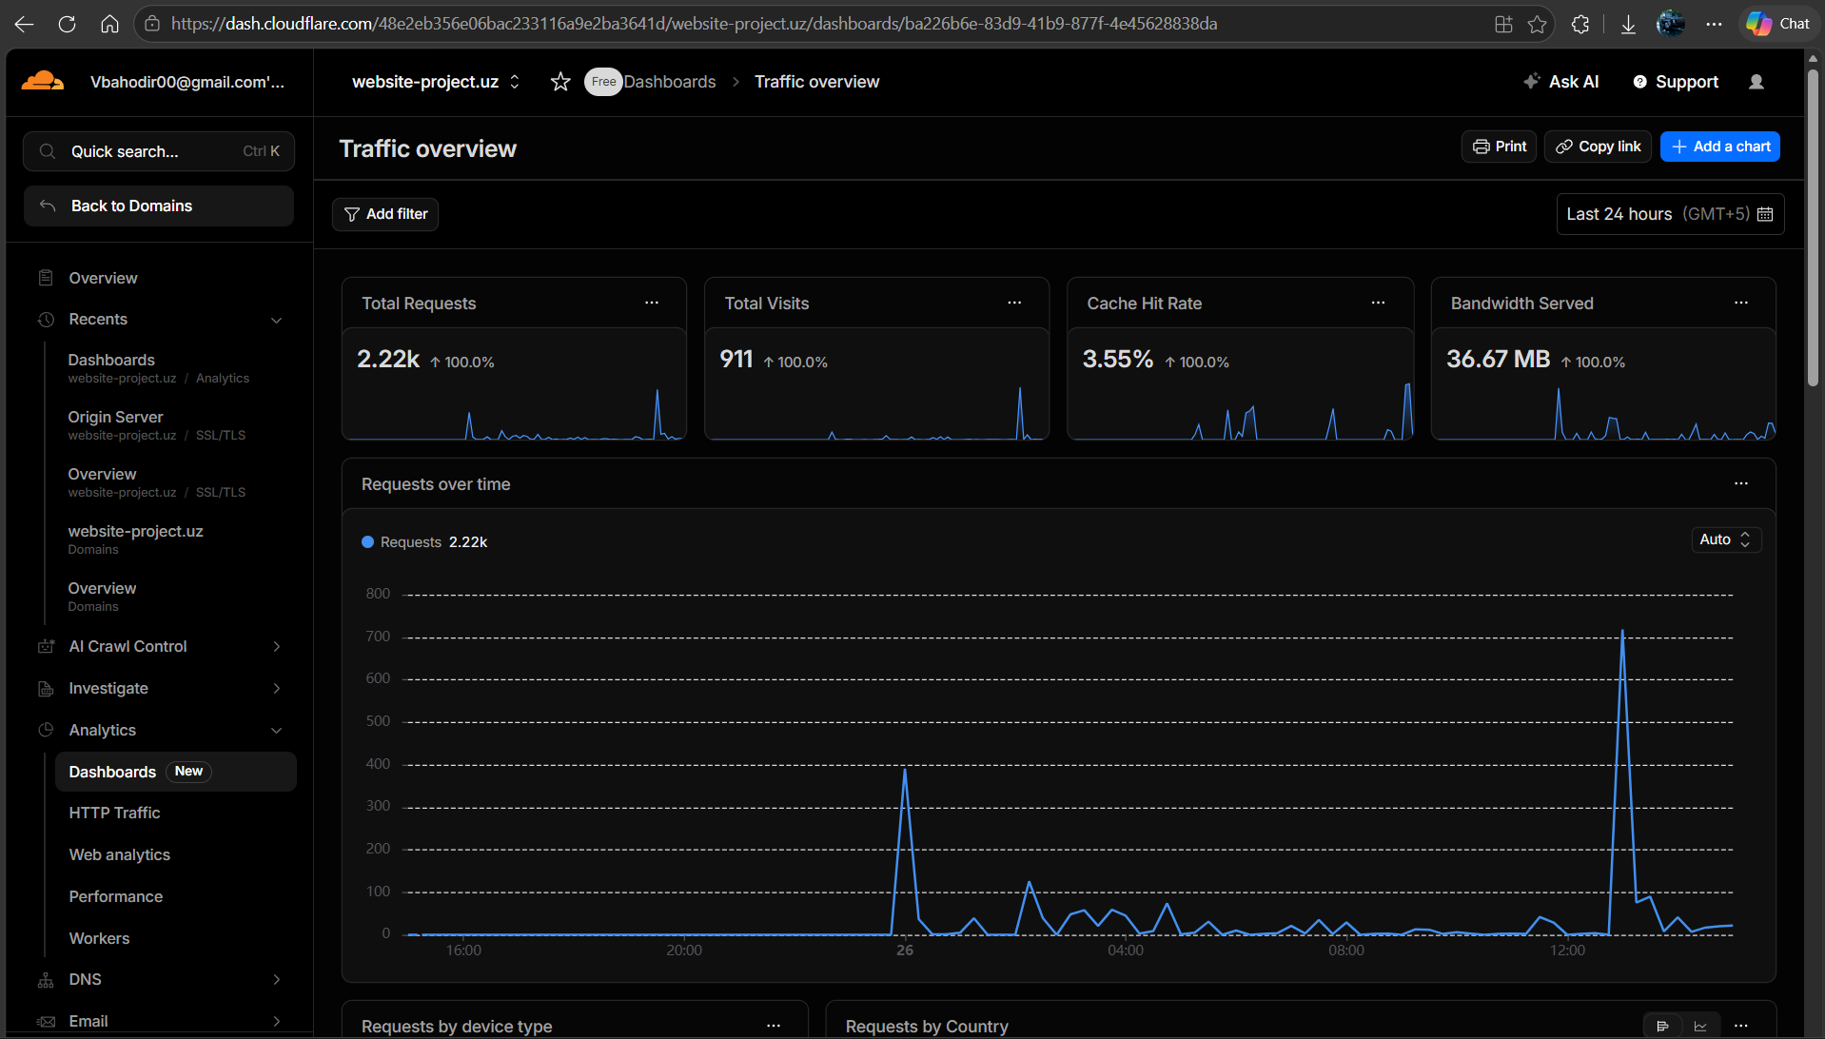
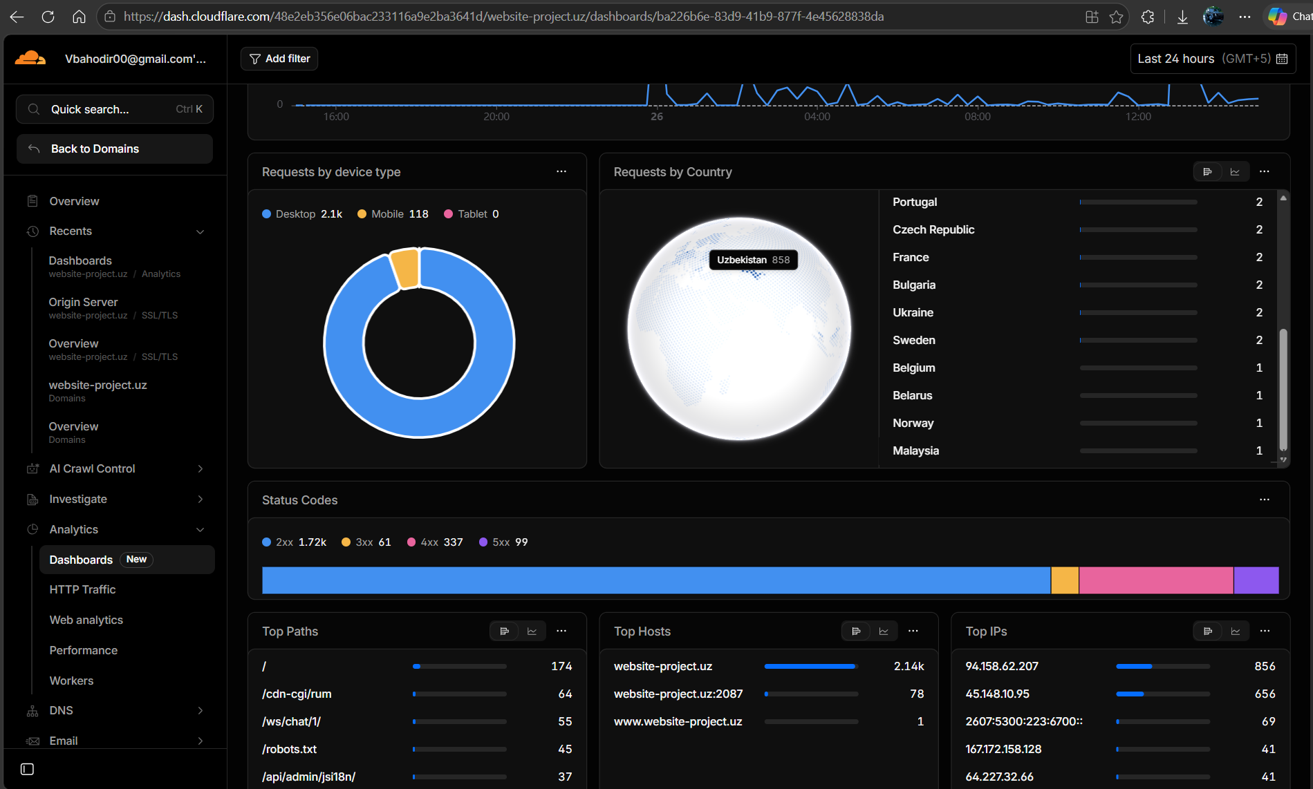

10. Observability (R12)
The full LGTM observability stack (Loki, Grafana, Tempo, Mimir/Prometheus) is deployed as part of the docker-compose stack and configured via provisioned YAML files. The Django application exports metrics via django-prometheus, structured logs are written to the app_logs volume (read by Promtail), and distributed traces are sent to Grafana Tempo via OTLP/HTTP.

10.1 Stack Components
Component | Role | Endpoint
Prometheus | Scrapes /metrics from Django (django-prometheus), Celery, and node-exporter every 15s | :9090
Grafana Loki | Receives structured log streams from Promtail; queryable via LogQL | :3100
Promtail | Tails app_logs/*.log volume; parses log lines with regex; ships to Loki | (sidecar)
Grafana Tempo | Receives OTLP/HTTP distributed traces from Django (OTEL_EXPORTER_OTLP_ENDPOINT) | :3200
Grafana | Unified dashboard: Prometheus datasource (metrics) + Loki (logs) + Tempo (traces) | :3000

📸 SCREENSHOT: Grafana Dashboard — HTTP Request Rate Metric

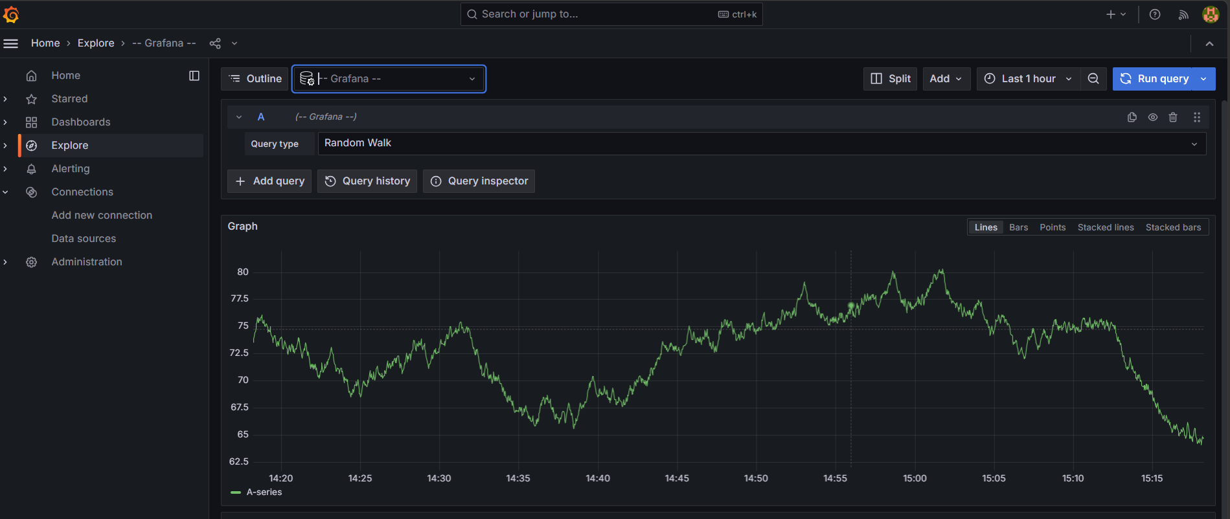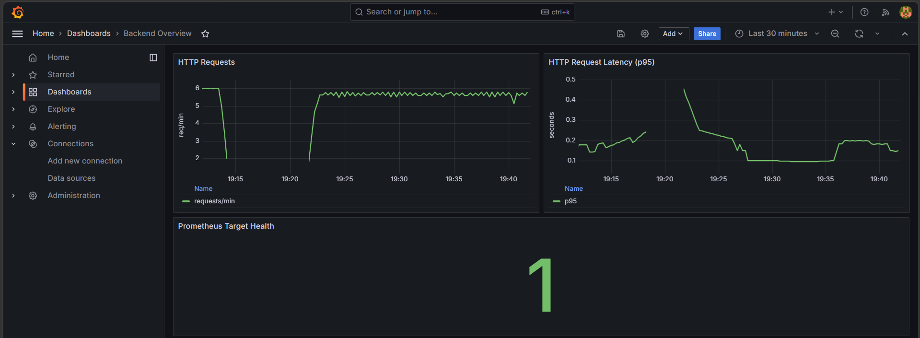

11. Platform Features Showcase

11.1 Authentication and Security
The authentication system implements multiple layers of fraud prevention beyond standard JWT. Each sensitive endpoint (OTP send, email change, password reset) is protected by the custom token-bucket throttle with a strict 3 req/min limit. Email change requires confirmation from both the old and new address. MFA uses time-based OTP. Account activation for externally-created users is via single-use invitation tokens that expire after 72 hours.

📸 SCREENSHOT: Login Page and MFA Flow
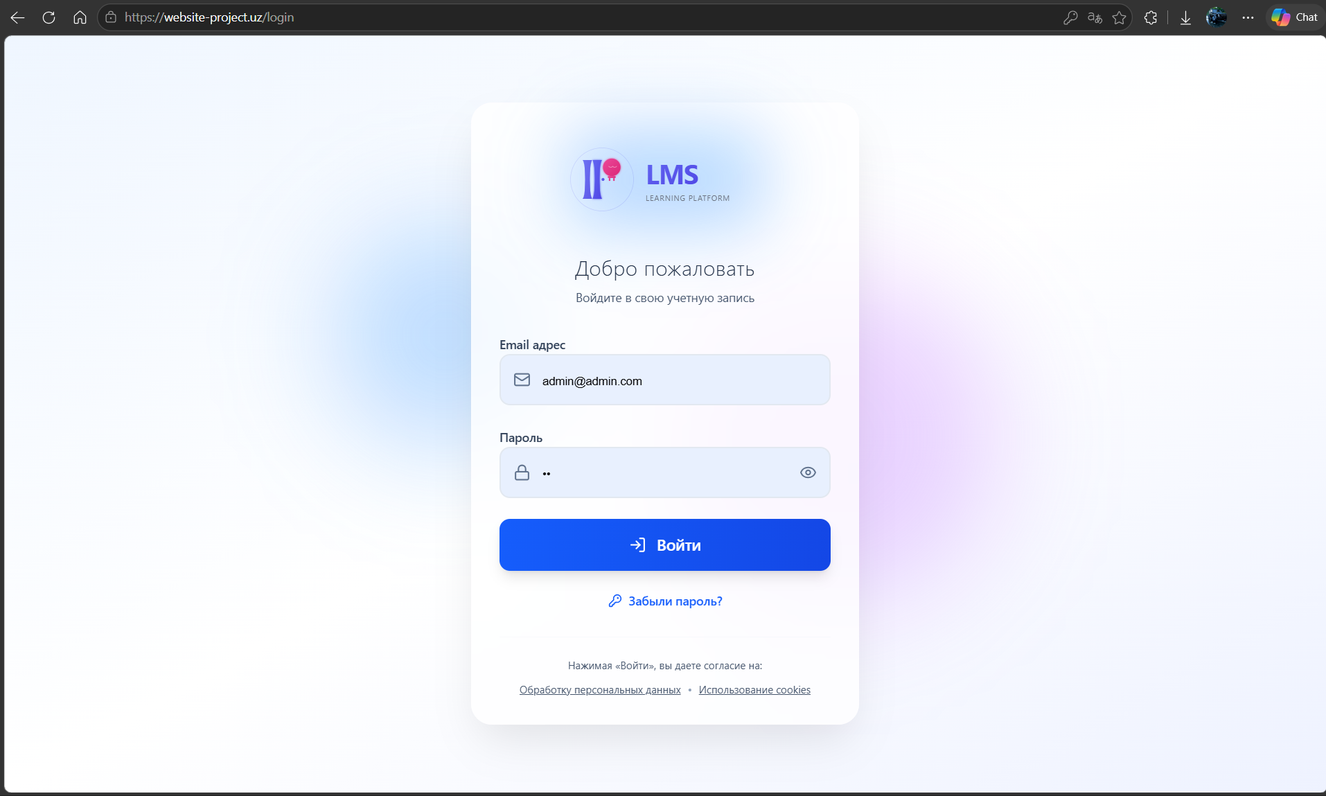
Invitation link email:
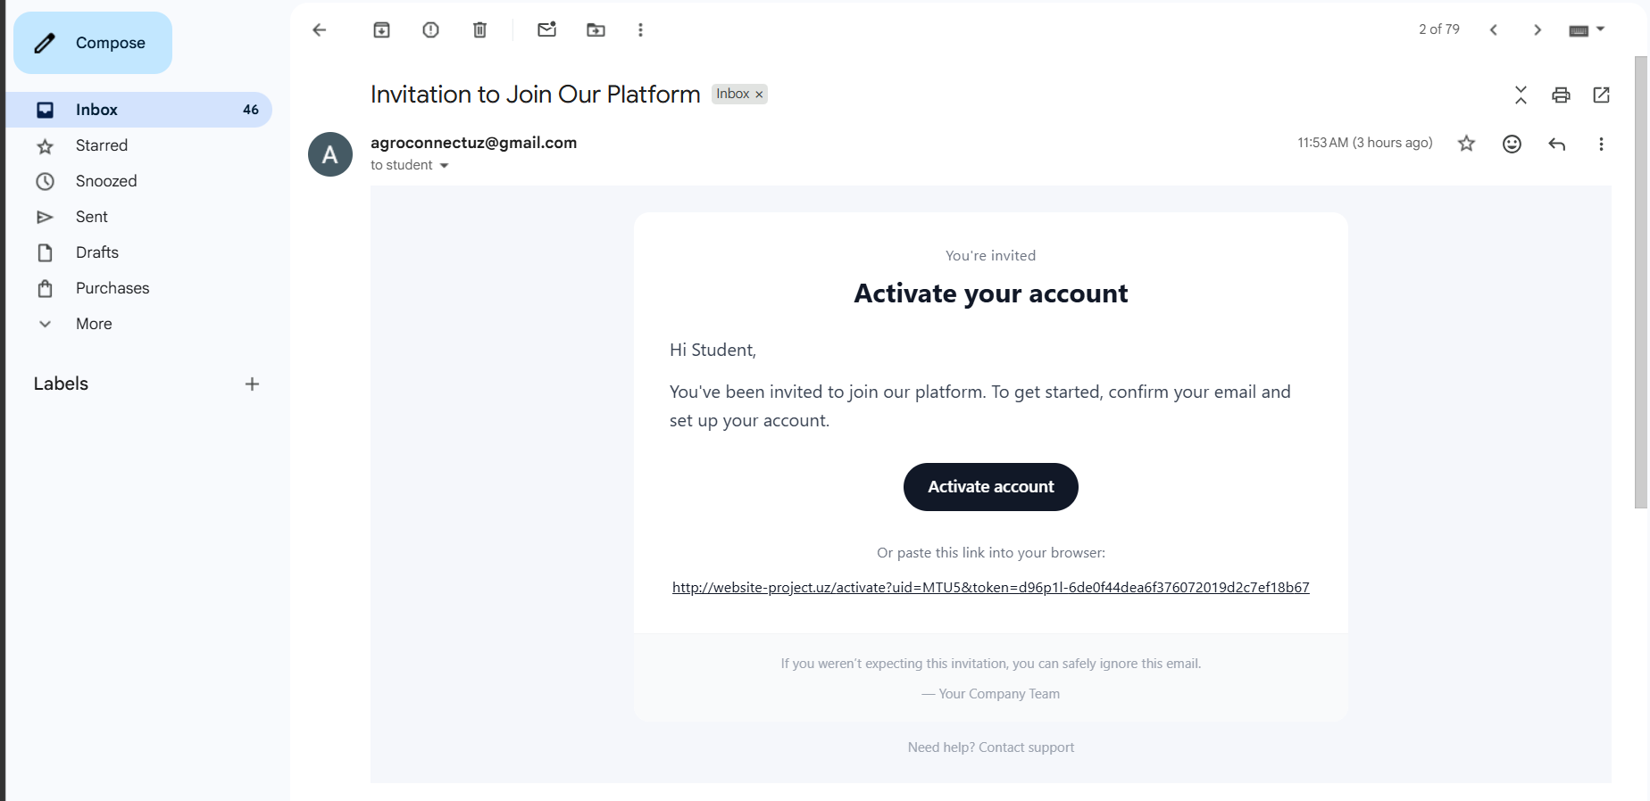
Forgot password flow:
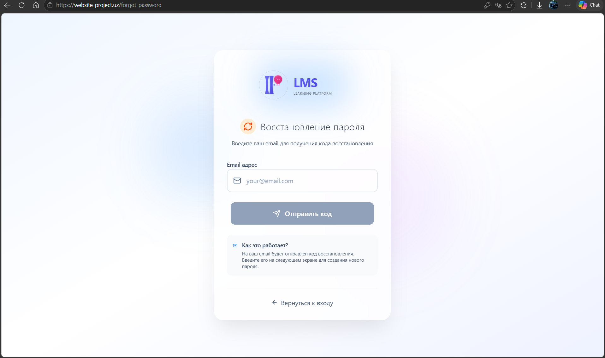
password reset email:
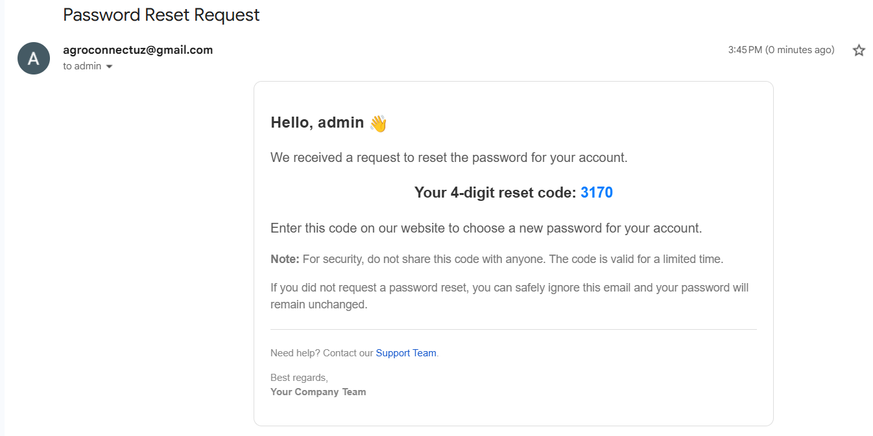
Reset password page:
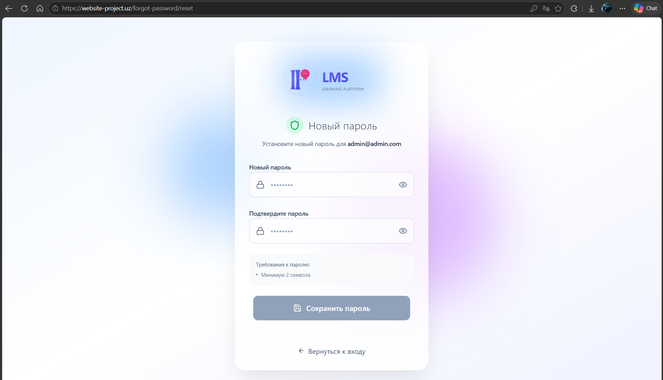
MFA page:
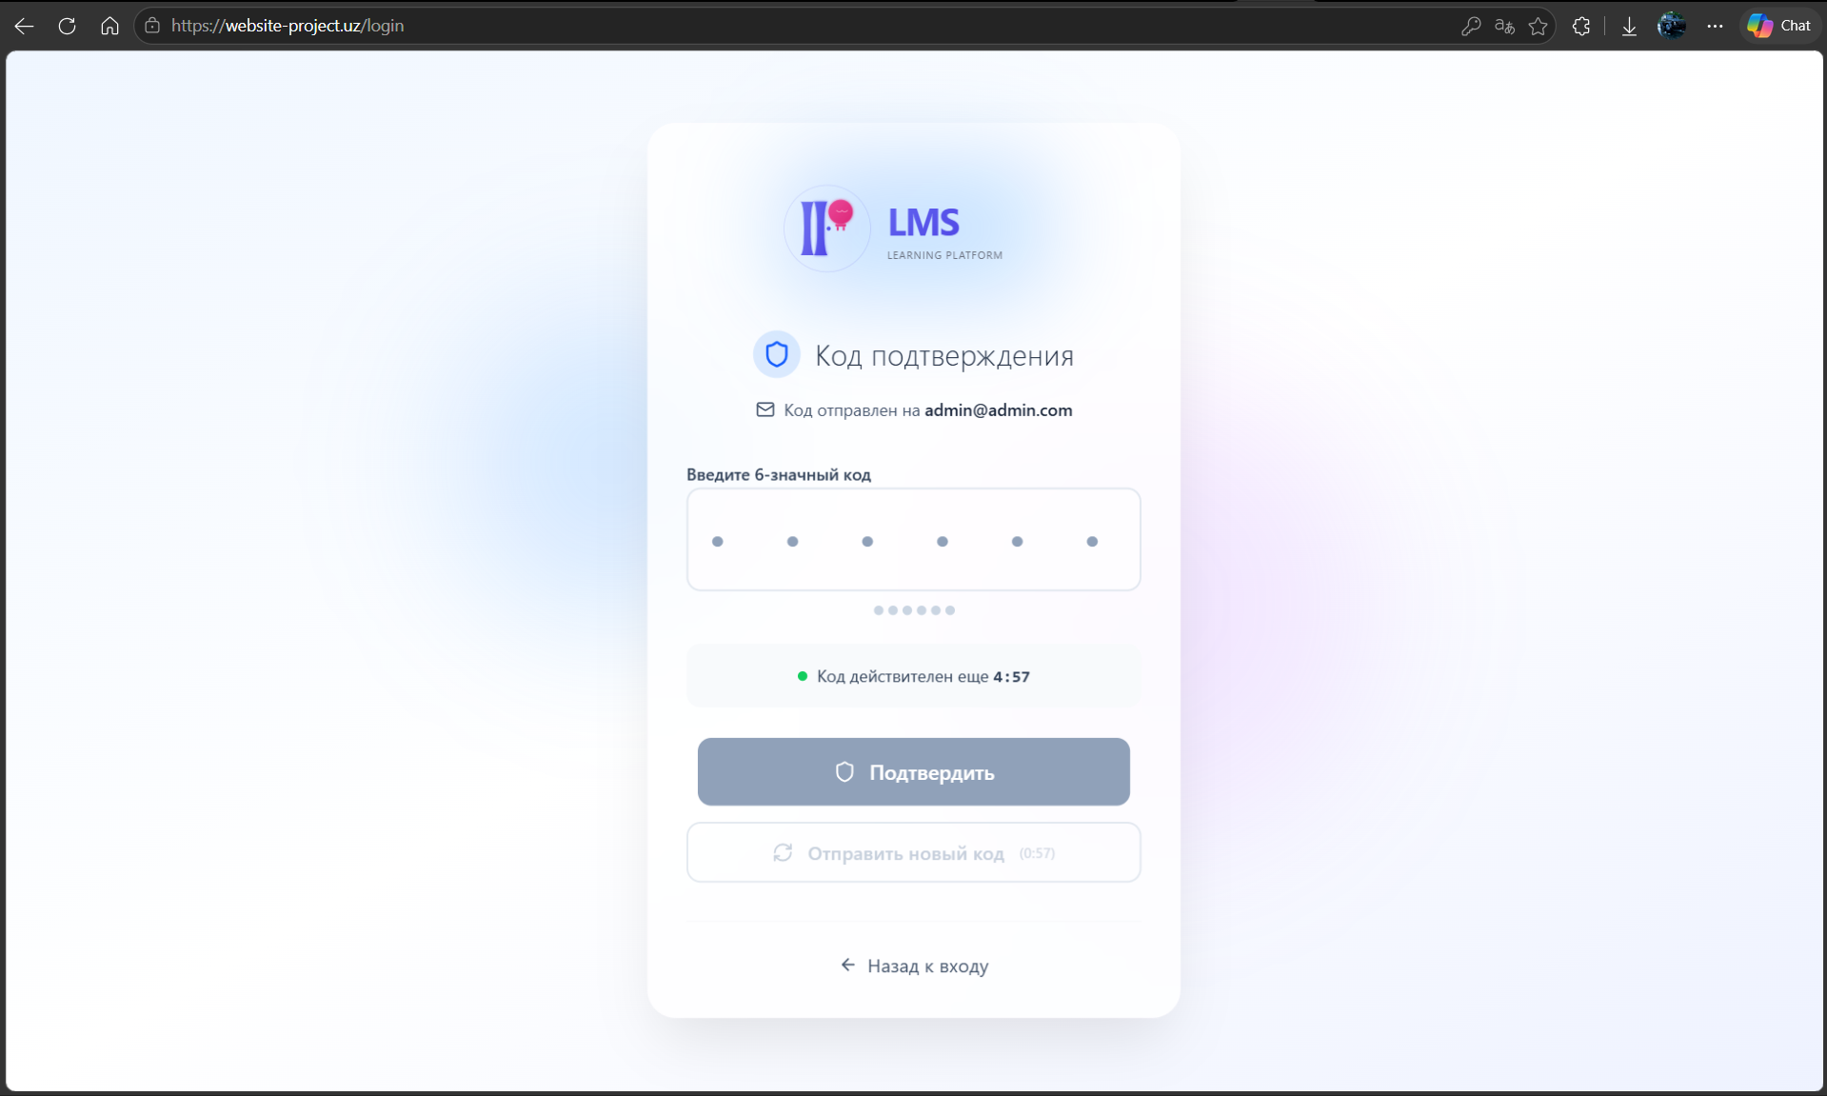
MFA email:
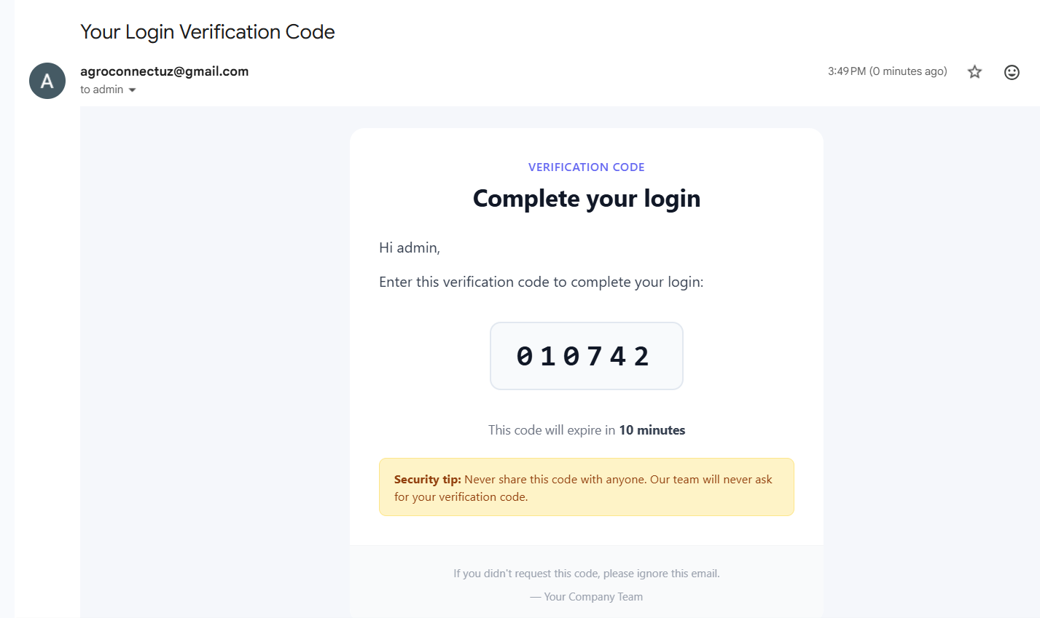

11.2 Course, Group, and Enrolment Management
📸 Course Catalogue and Course Detail
admin view:
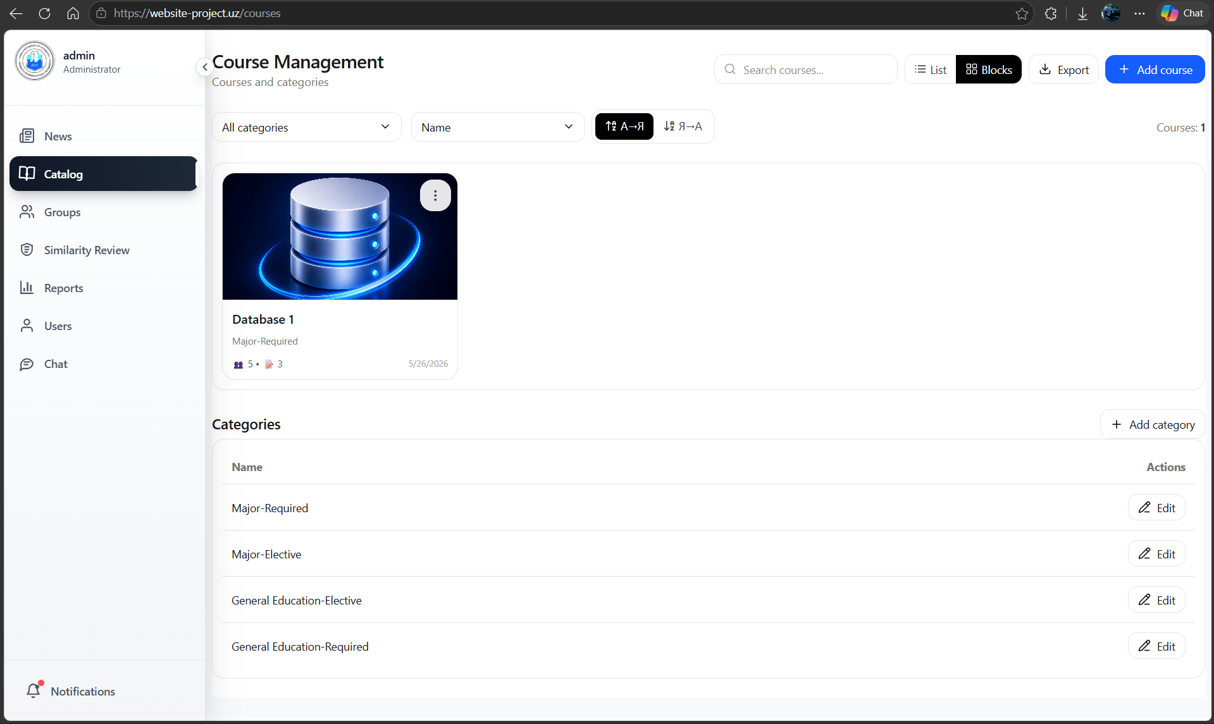
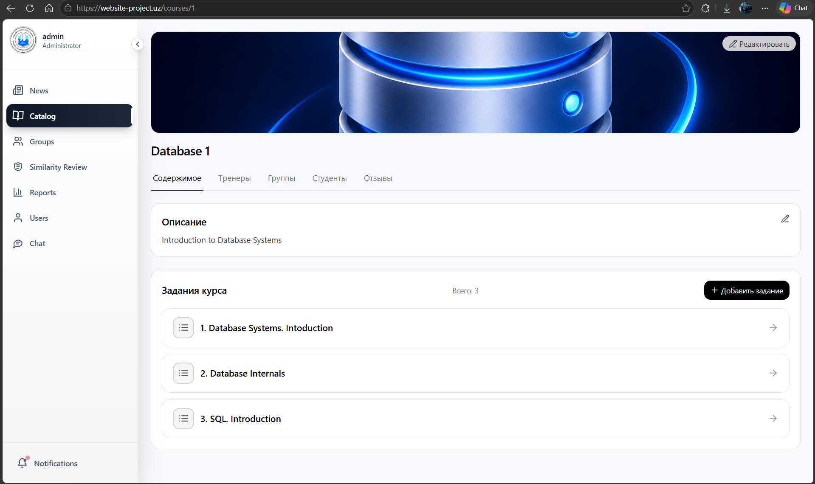
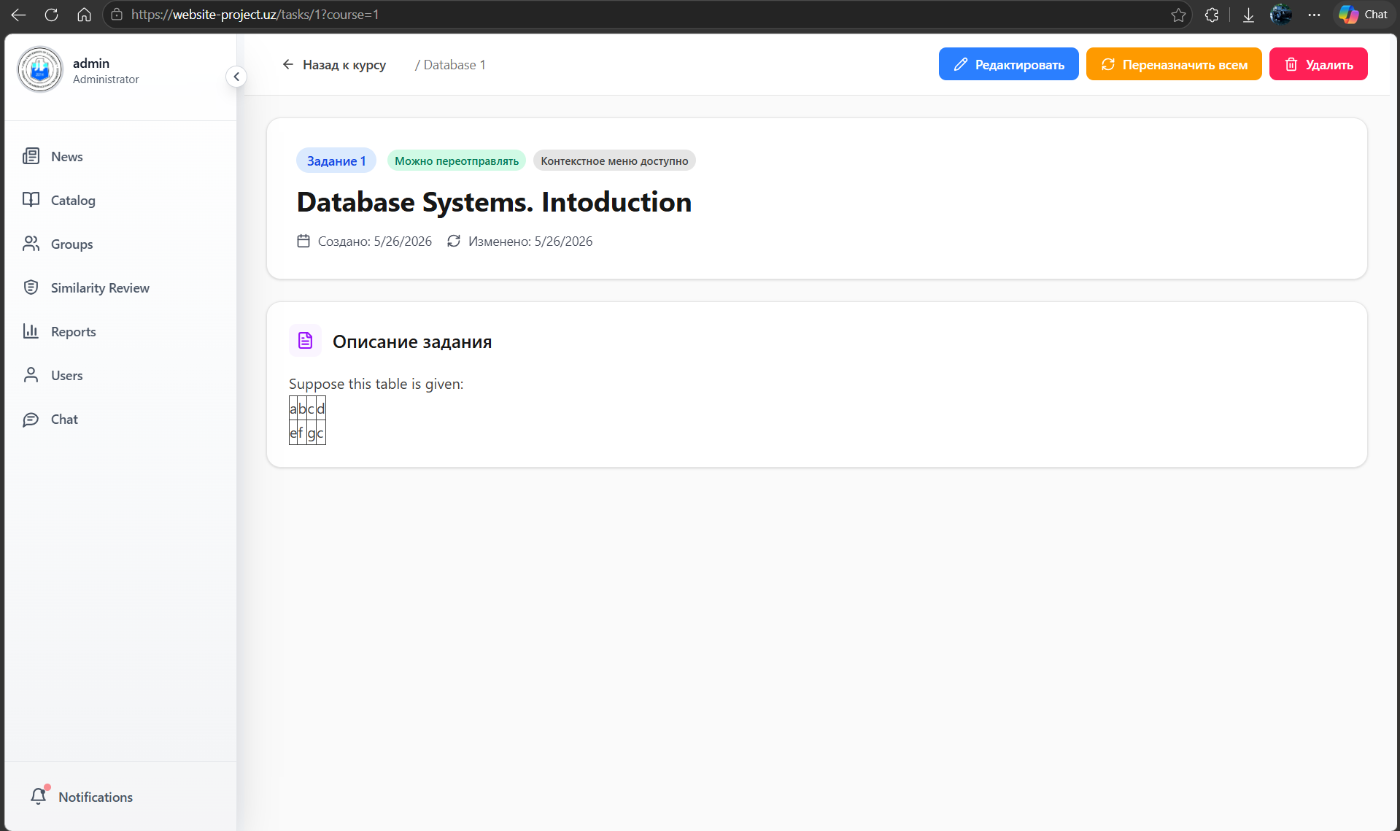
Editing existing task:
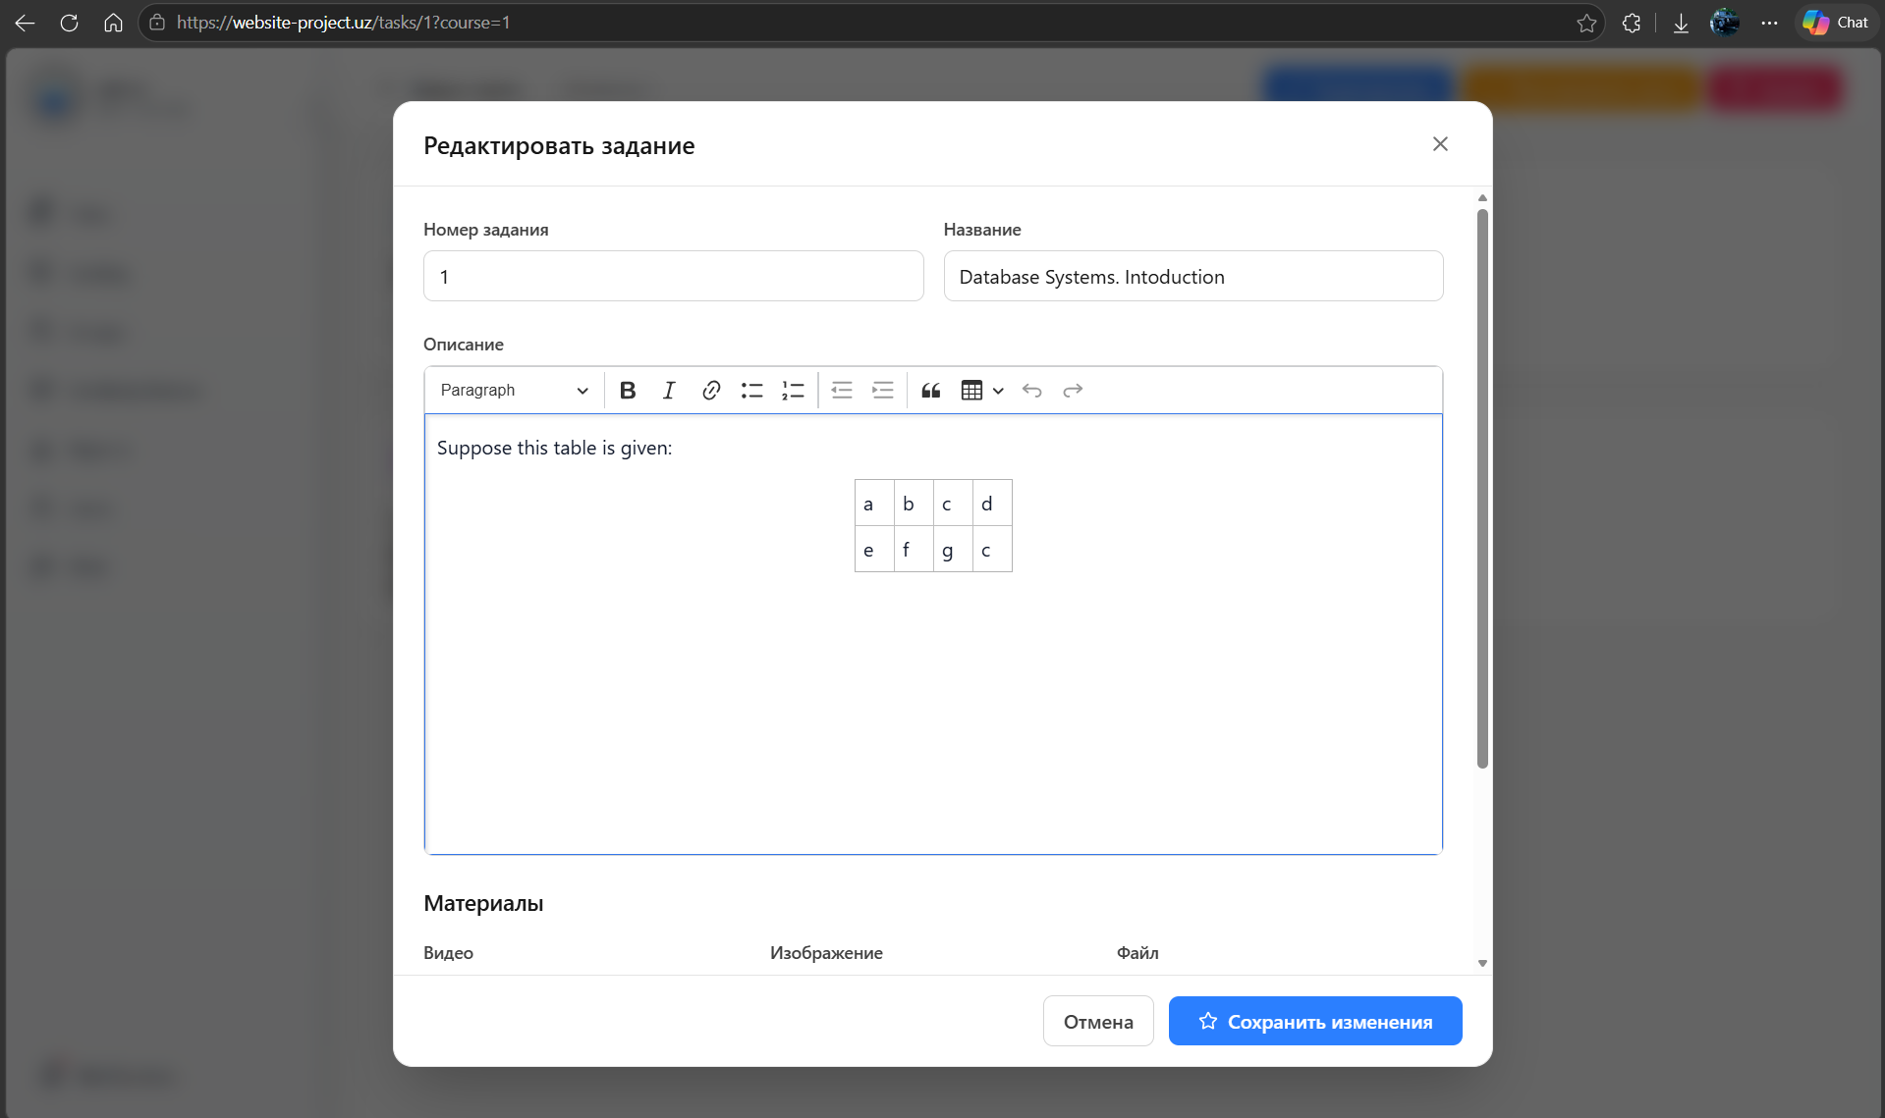
Course’s groups page:
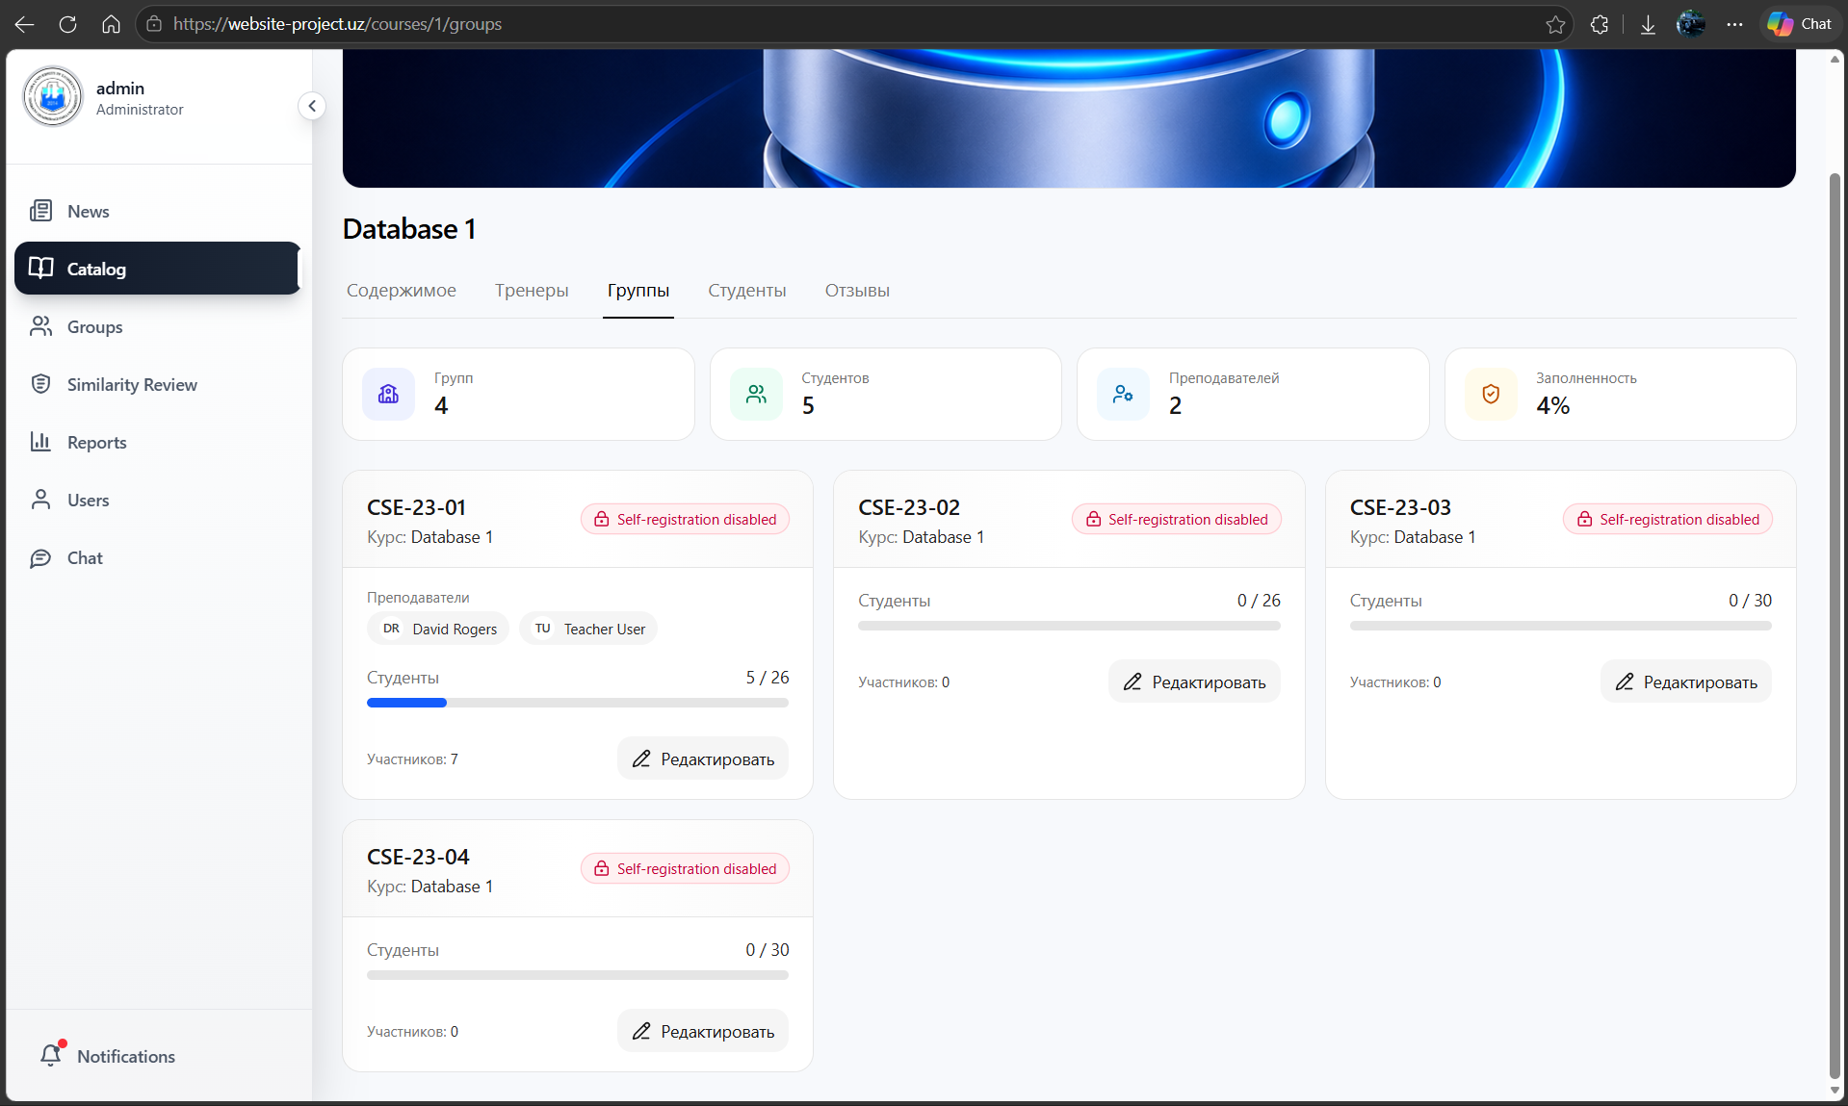
Course students page:
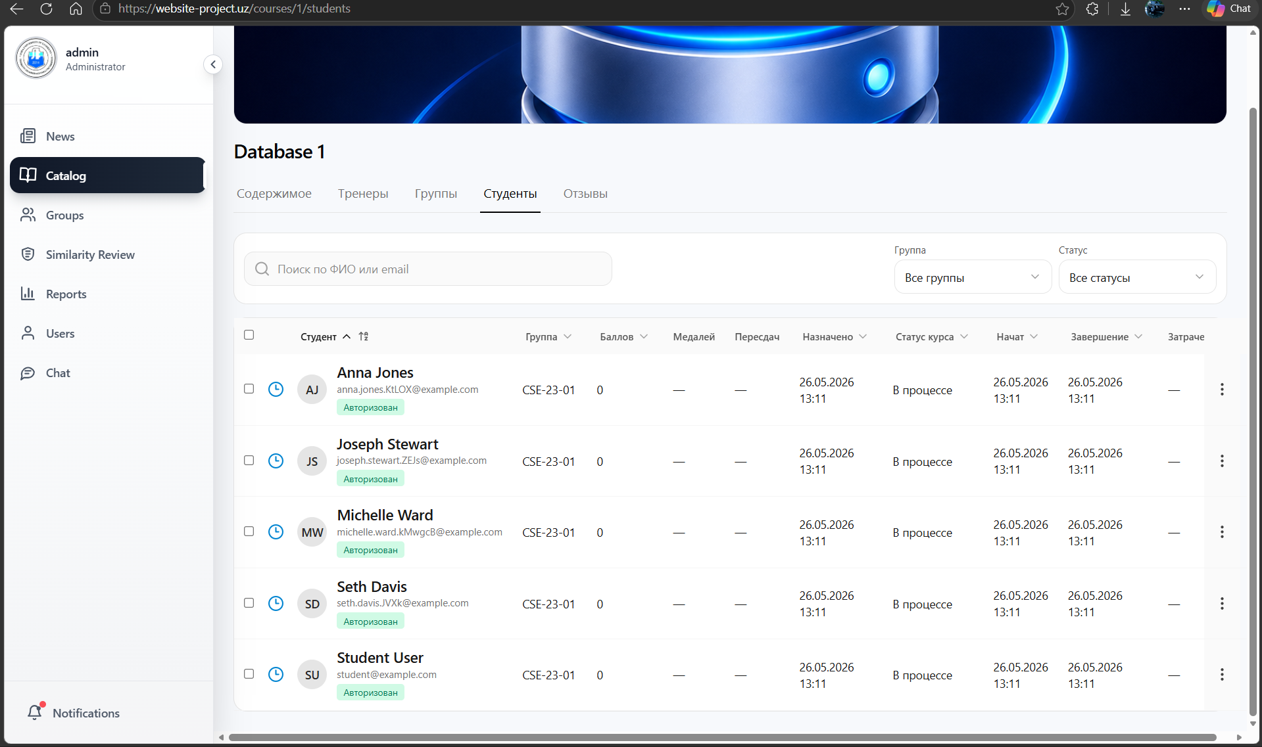
Teacher view:
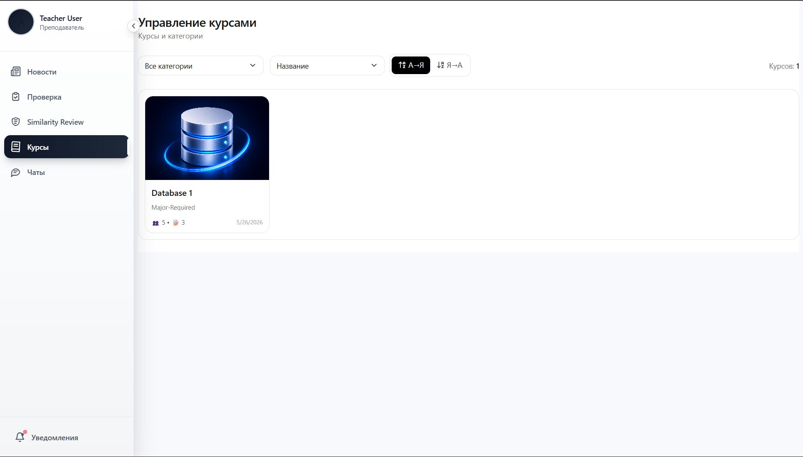

Student view of course list (they see only what they are enrolled):
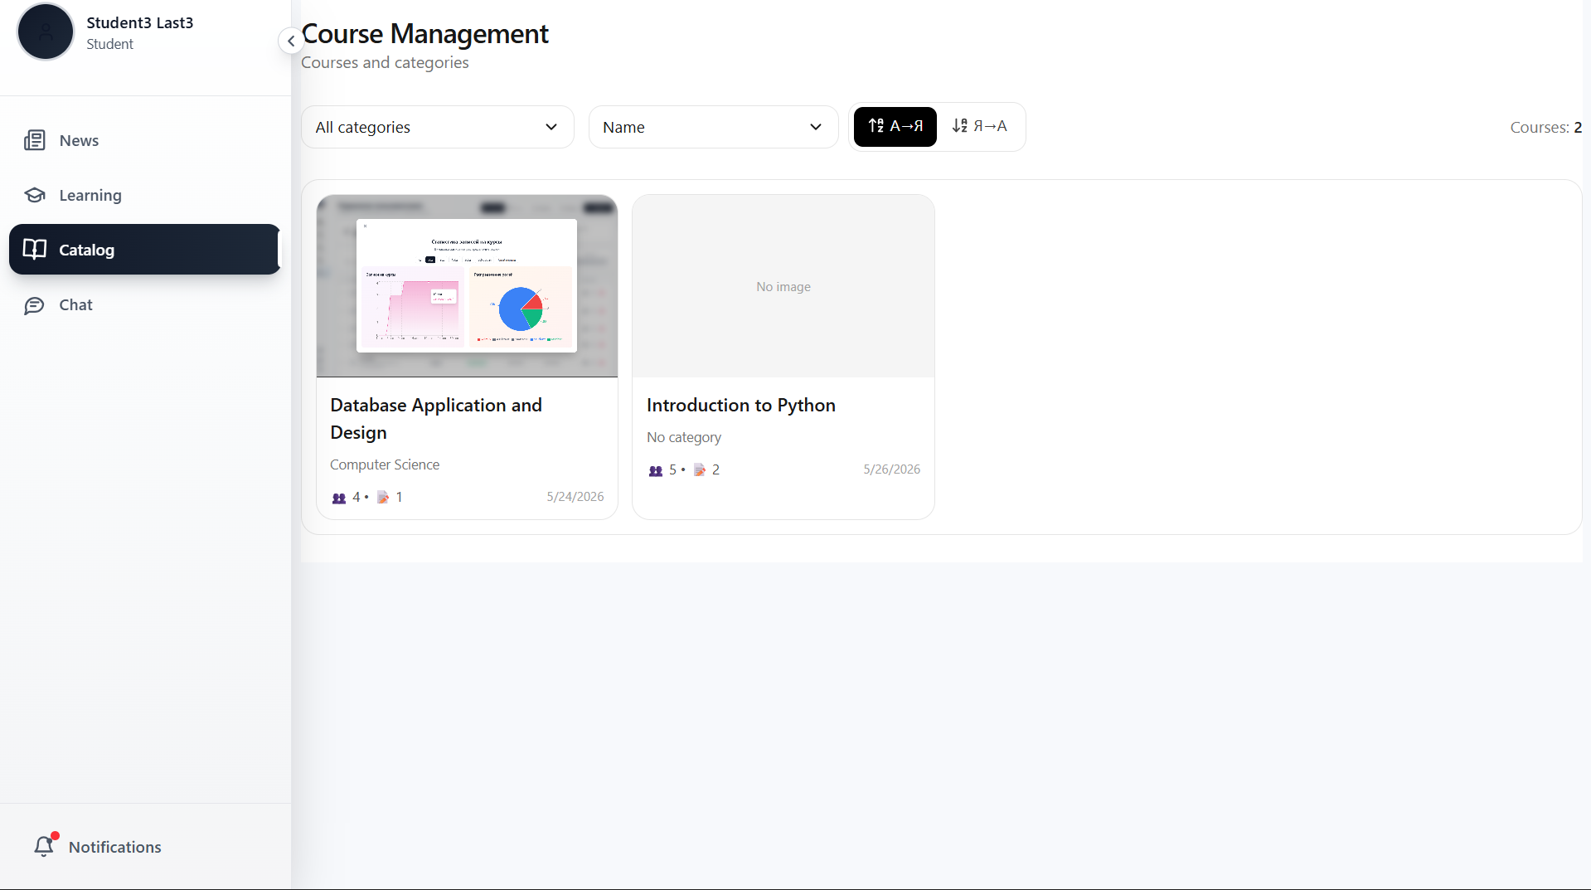

11.3 Task Submission and Grading Workflow
📸 Student Submission and Teacher Grading
Student’s assignment list:
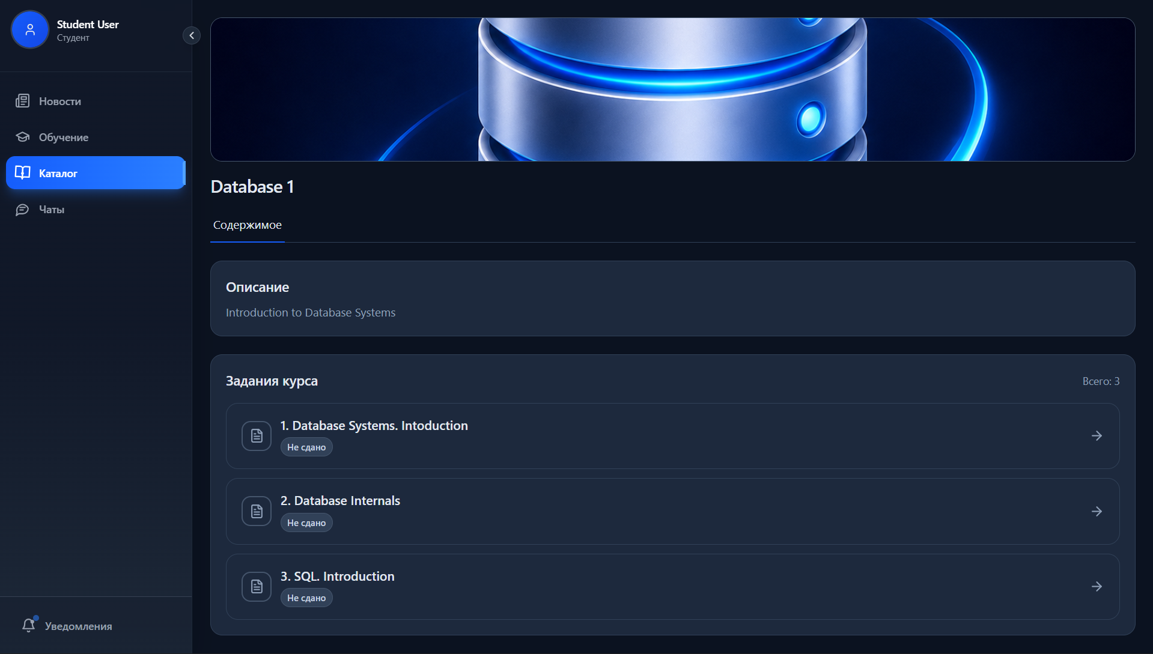
Submission page:
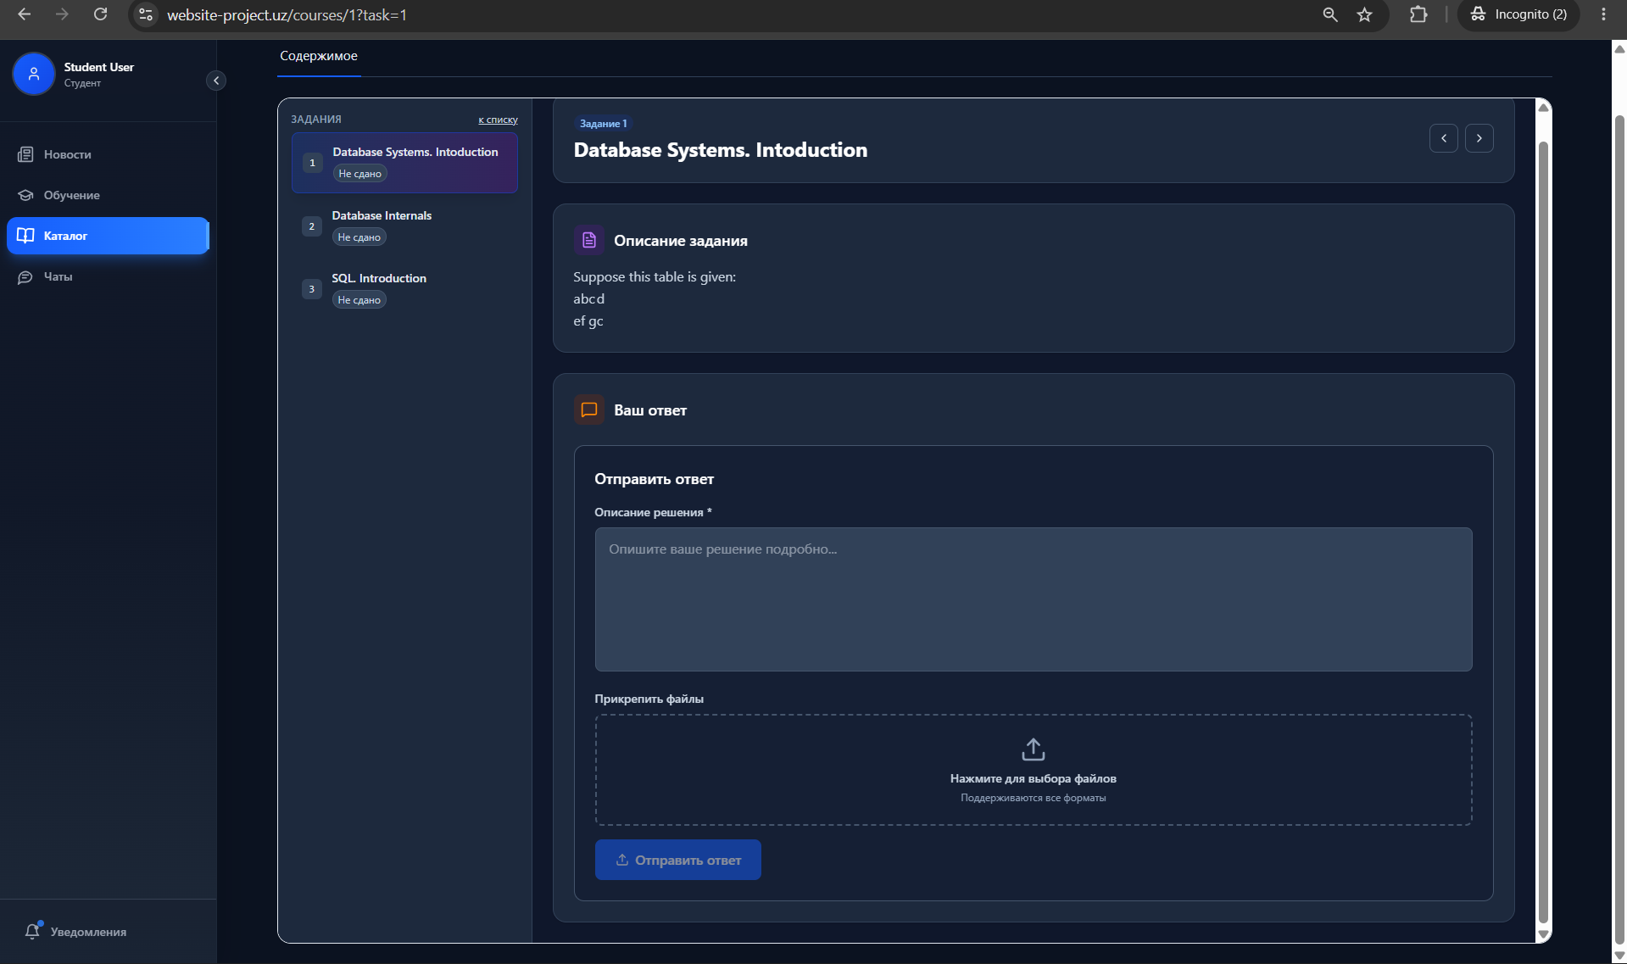
After submission:
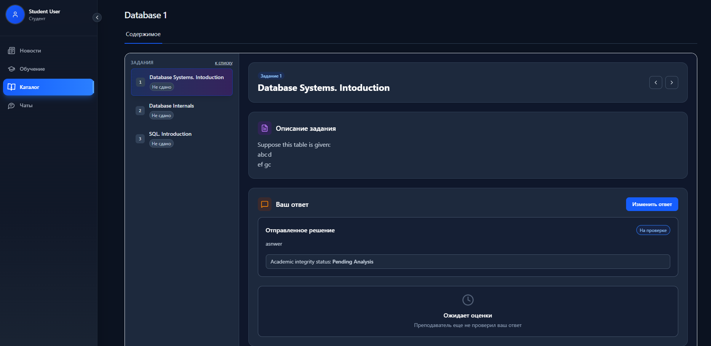
Teacher checking:
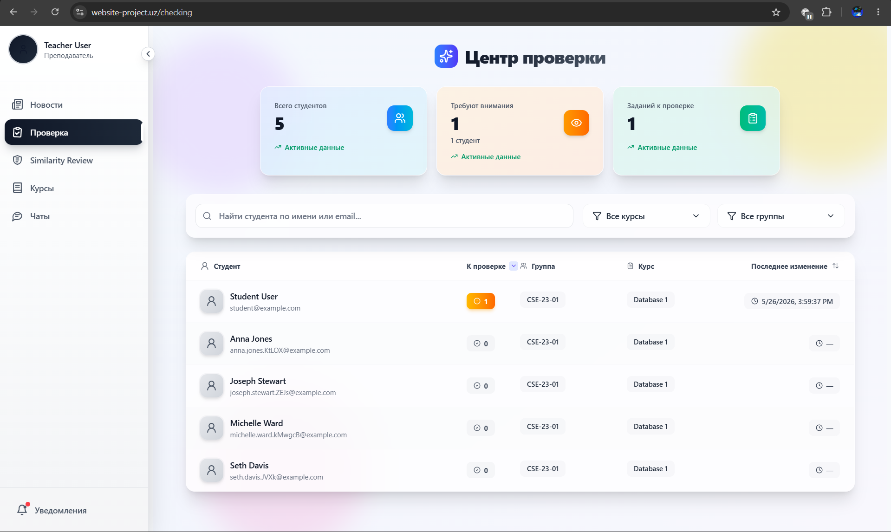
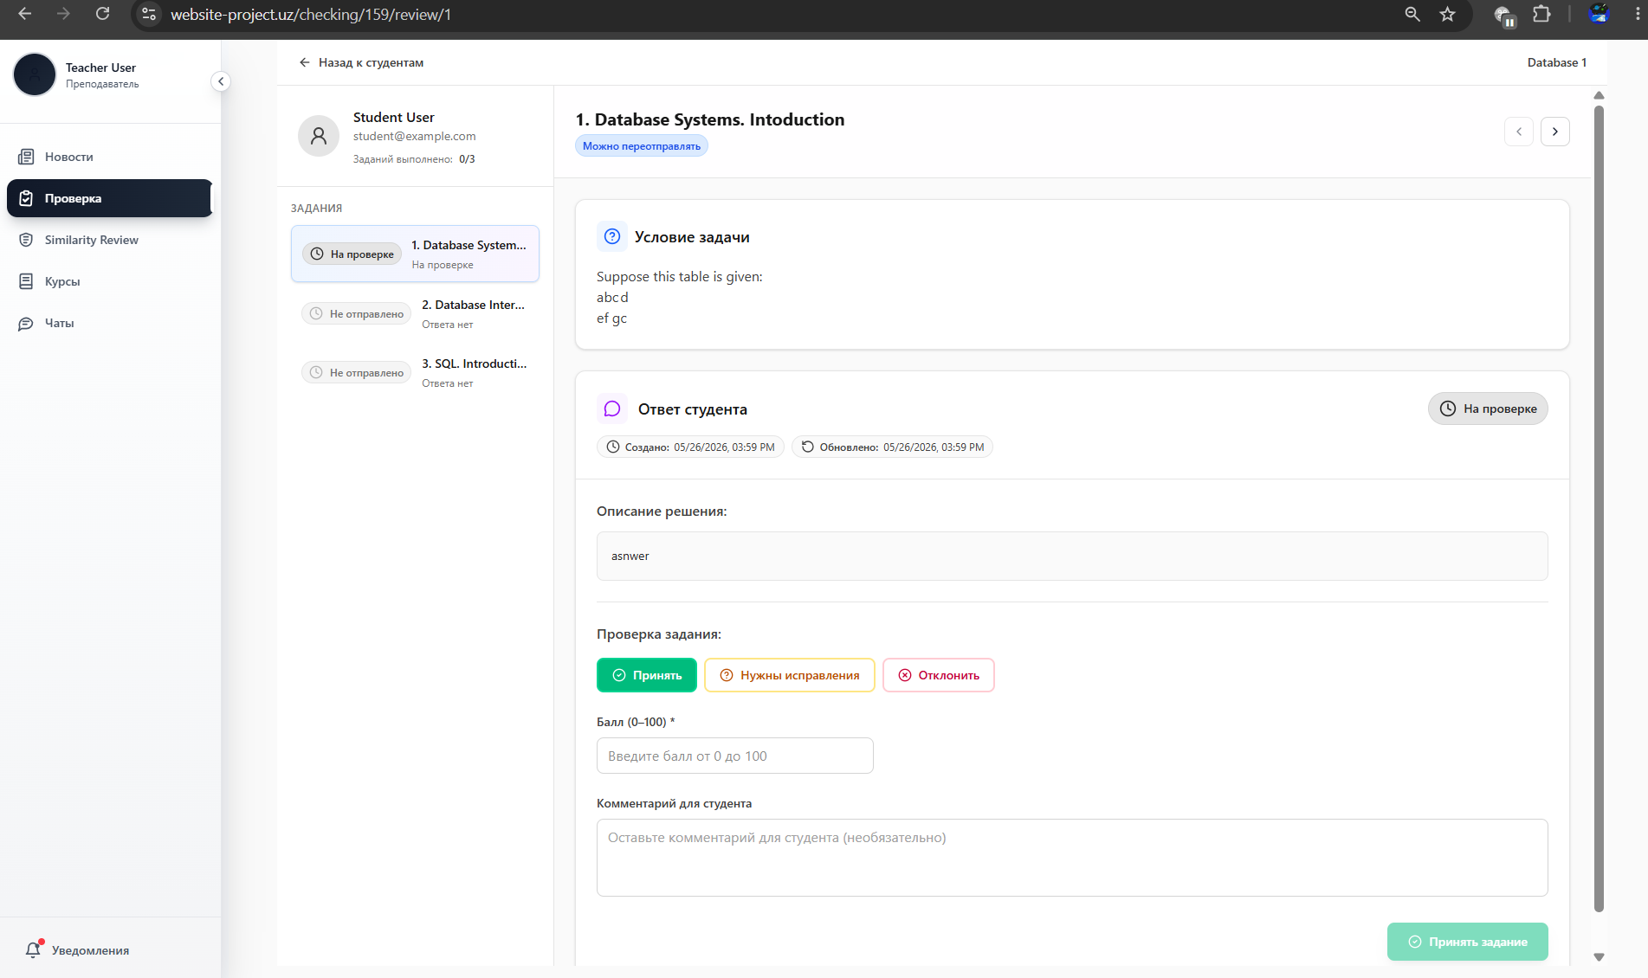
After grading:
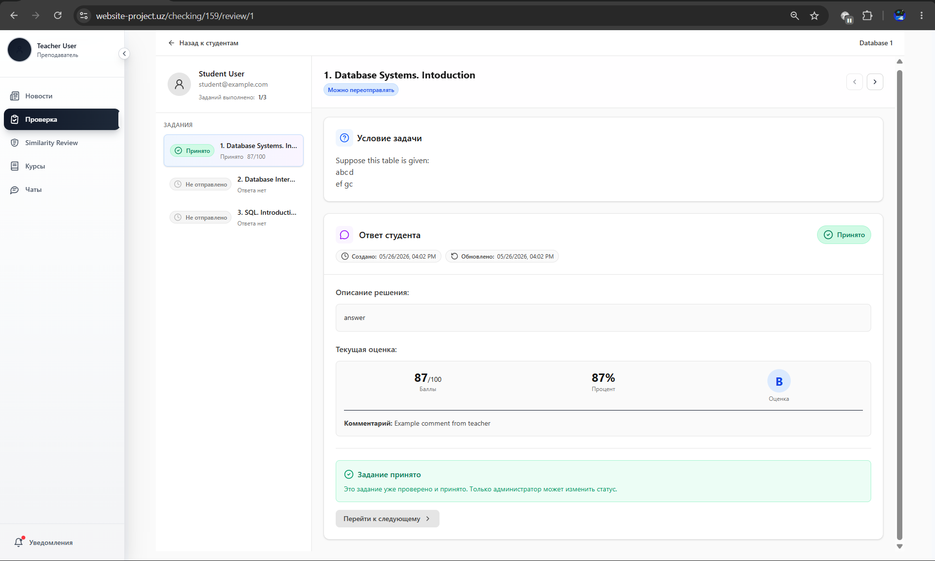

Student’s email after grading:
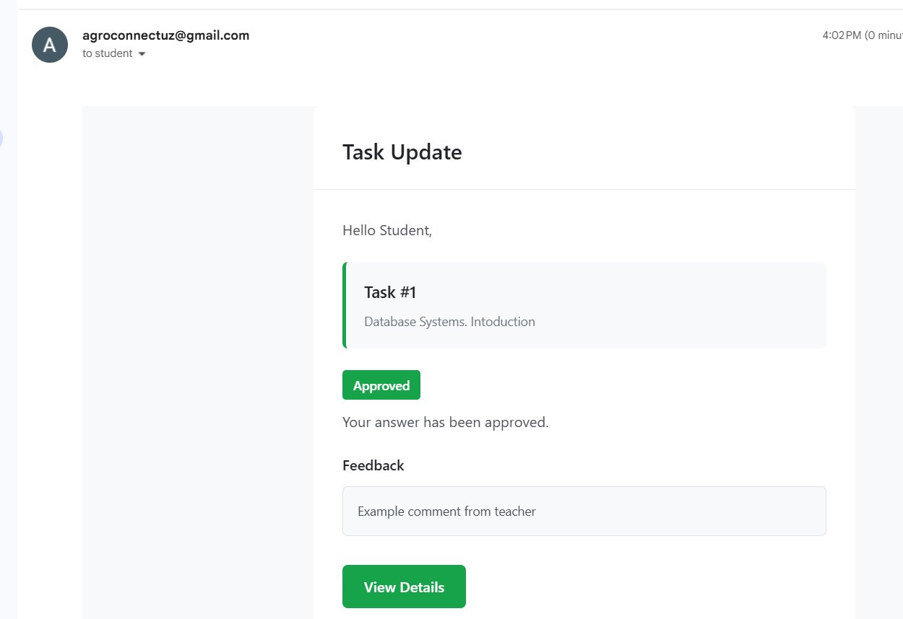

11.4 Real-Time Chat
📸 WebSocket Chat
Typing status:
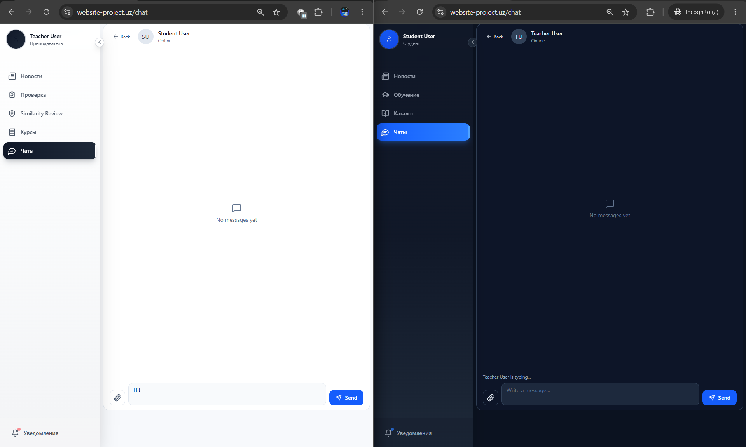
Normal chatting:
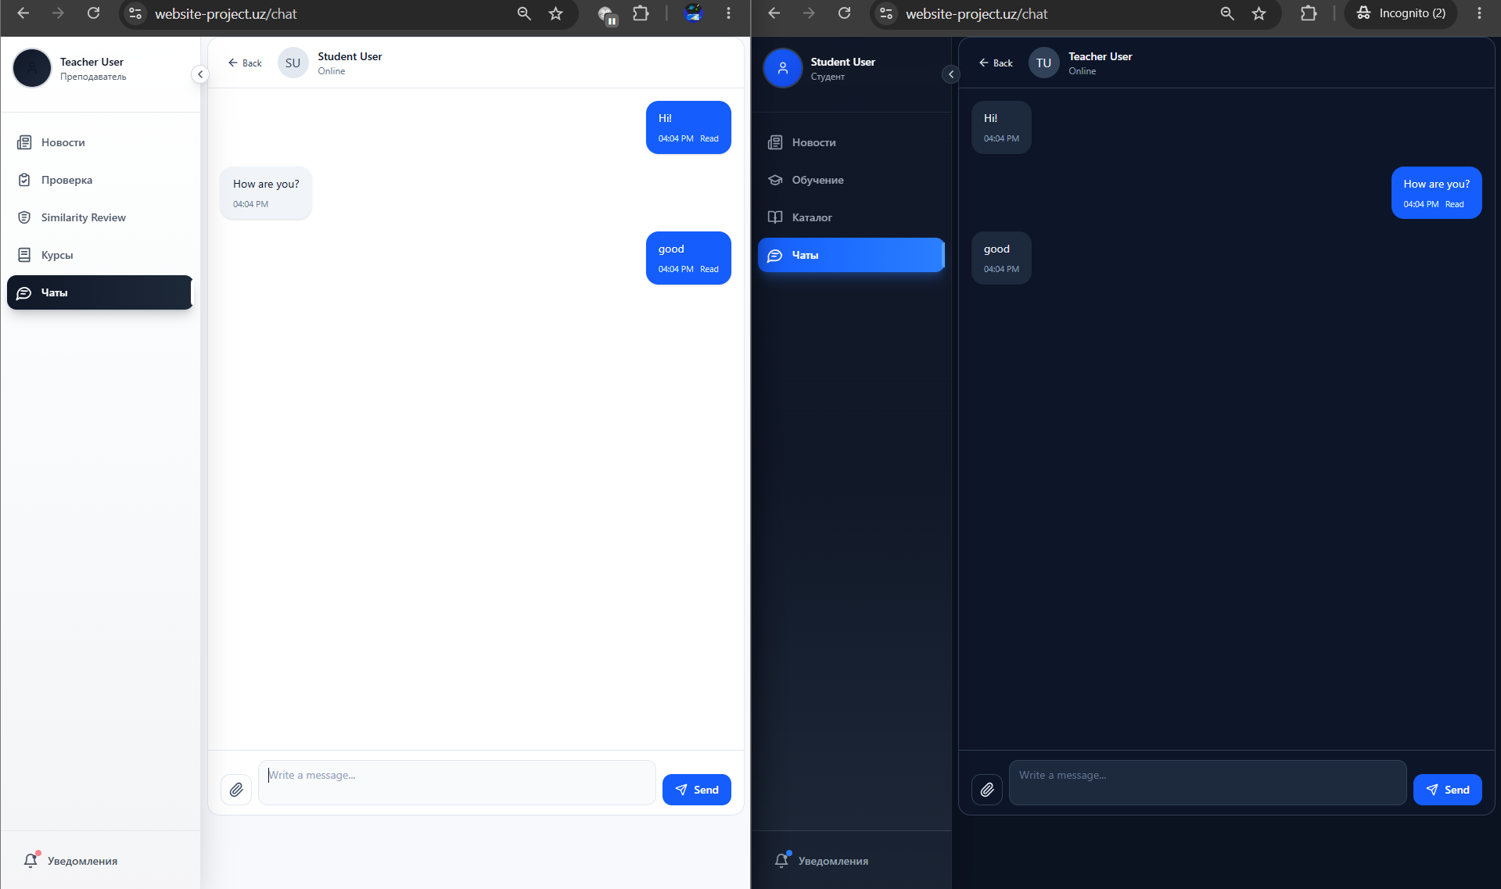
Attachement:
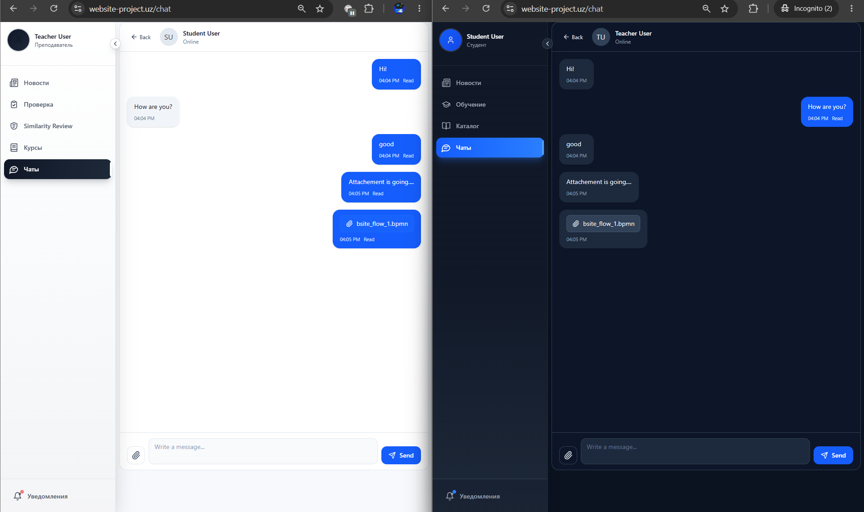

11.5 Admin Panel — User Management
📸 SCREENSHOT: Admin User Management Panel
Django Admin panel:
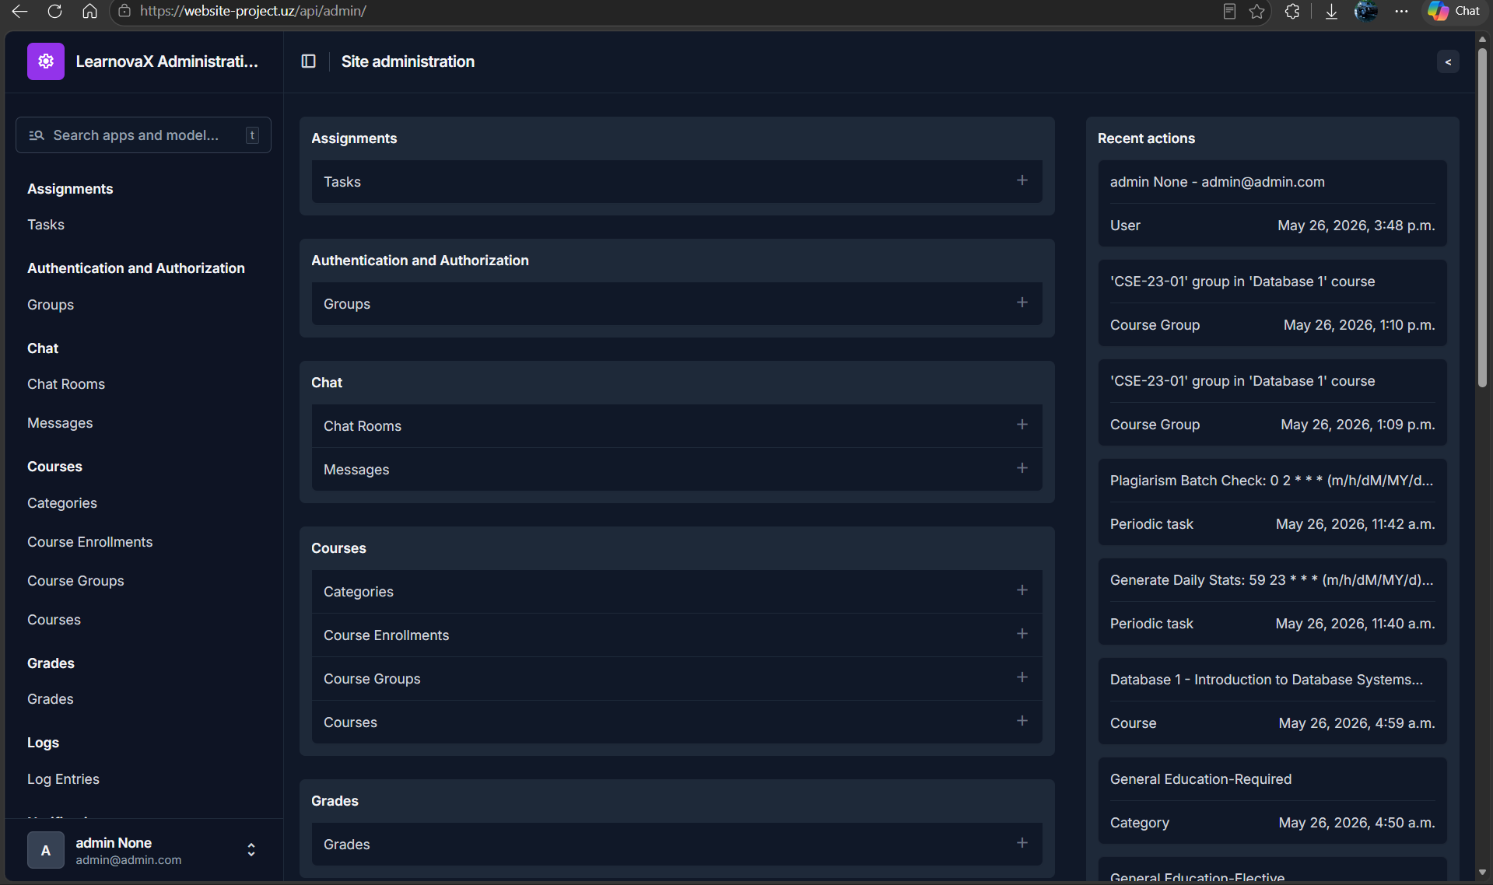
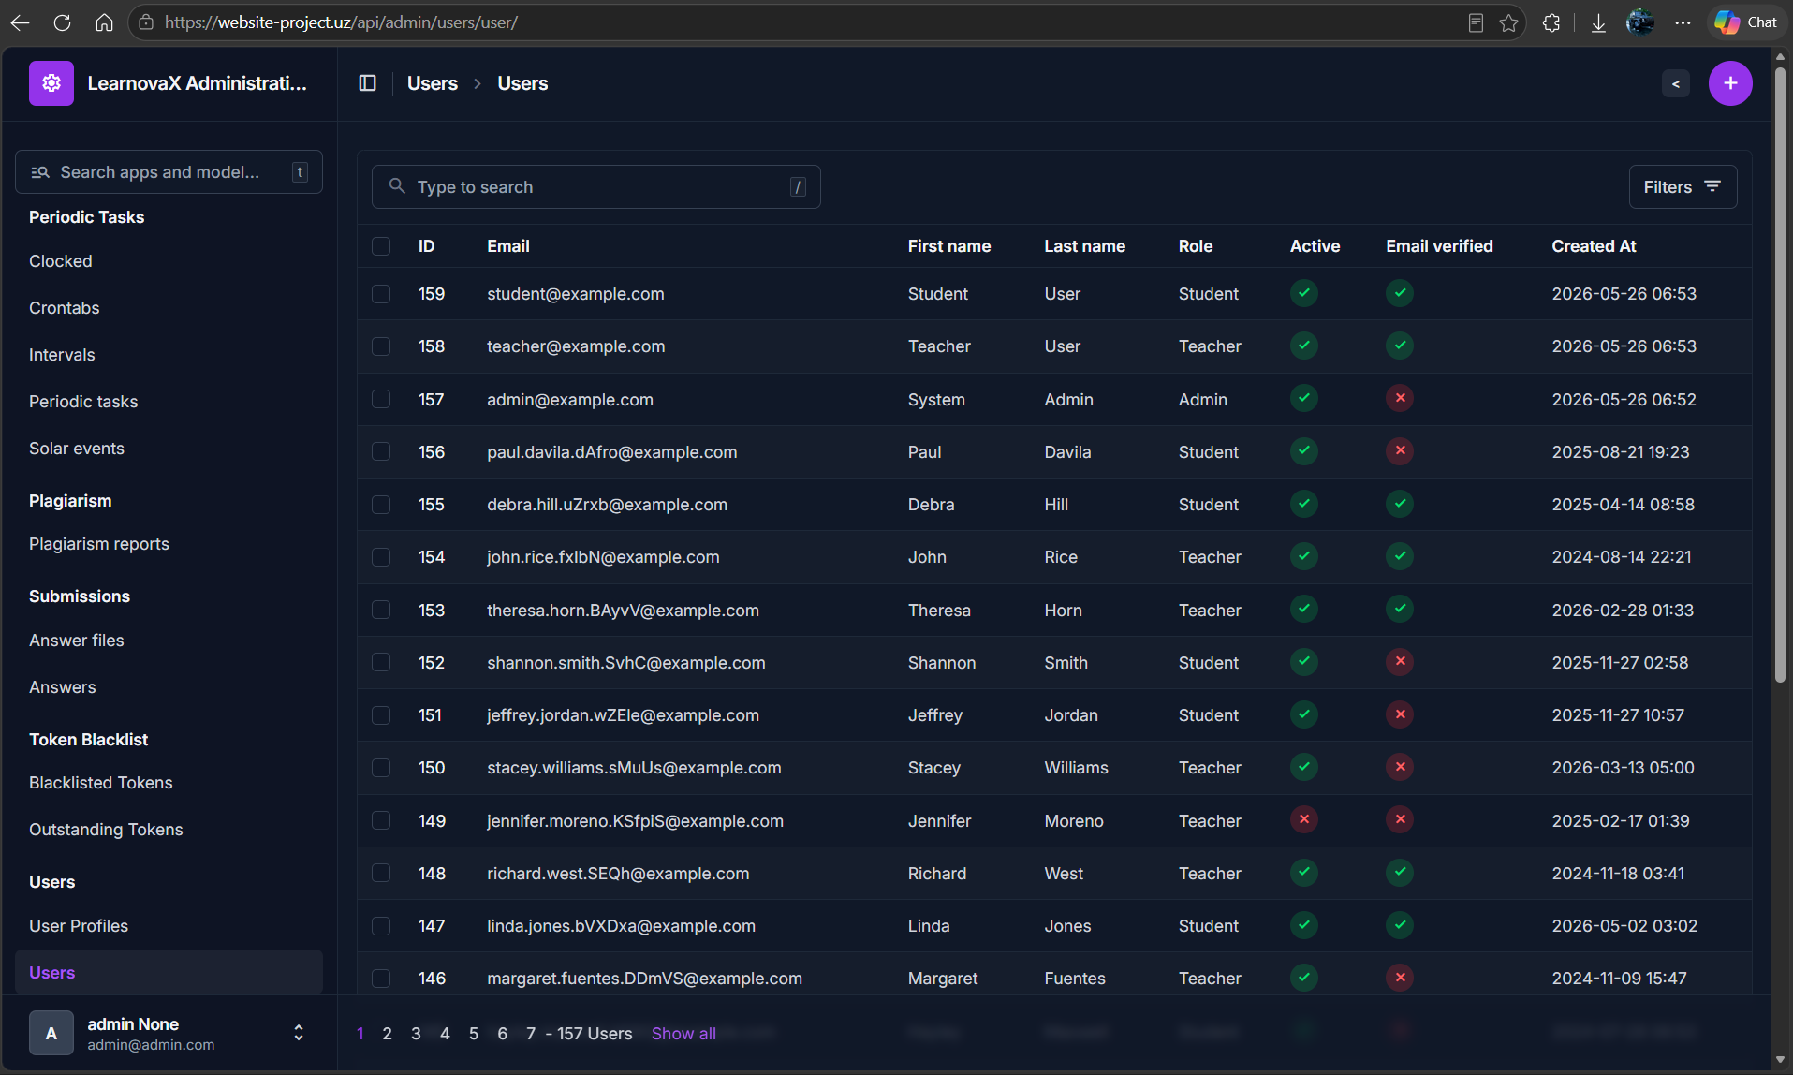

List view:
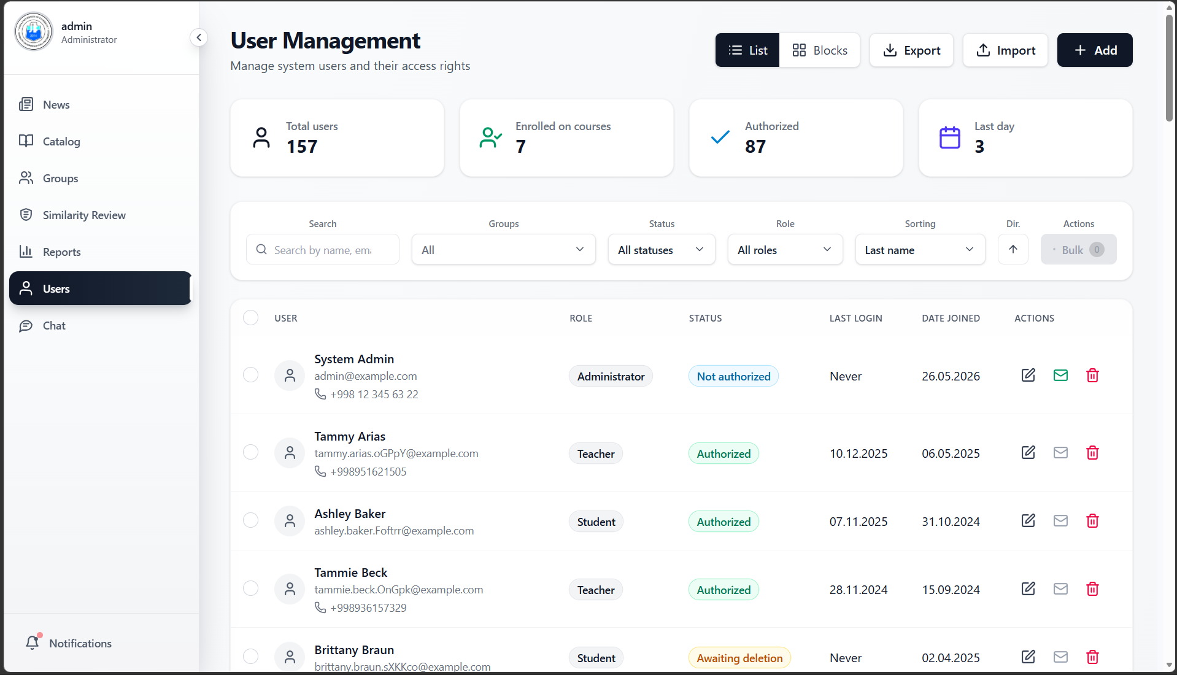
Block view:
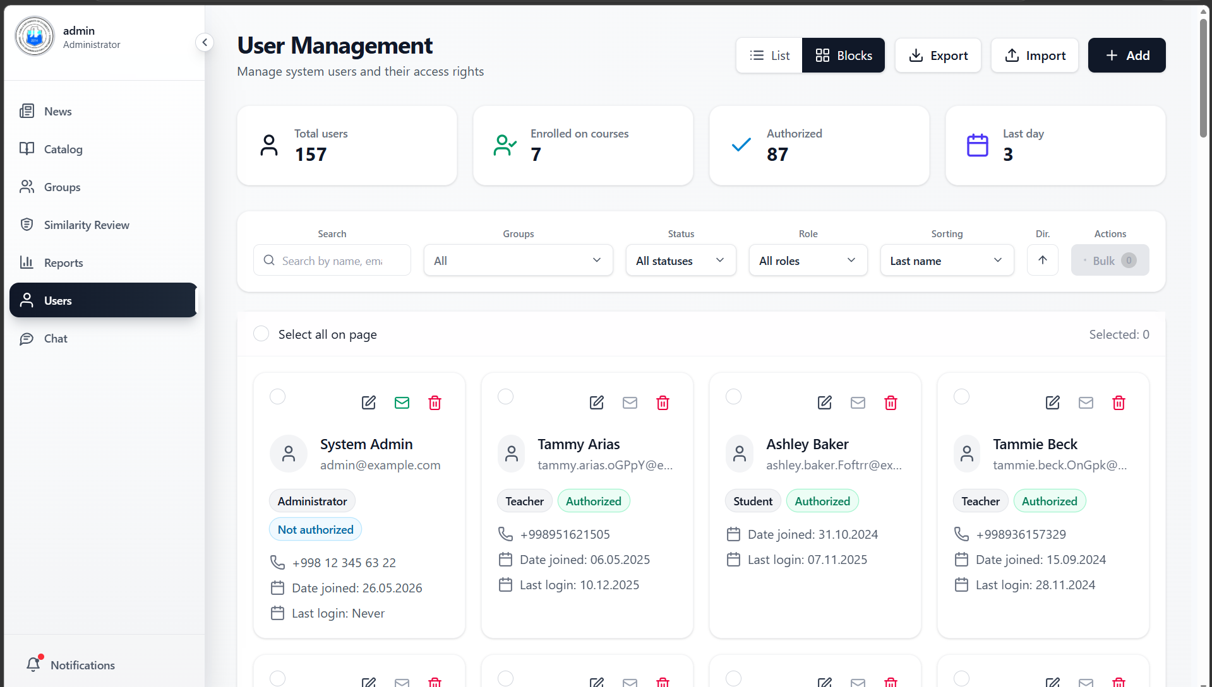

Adding and editing user:
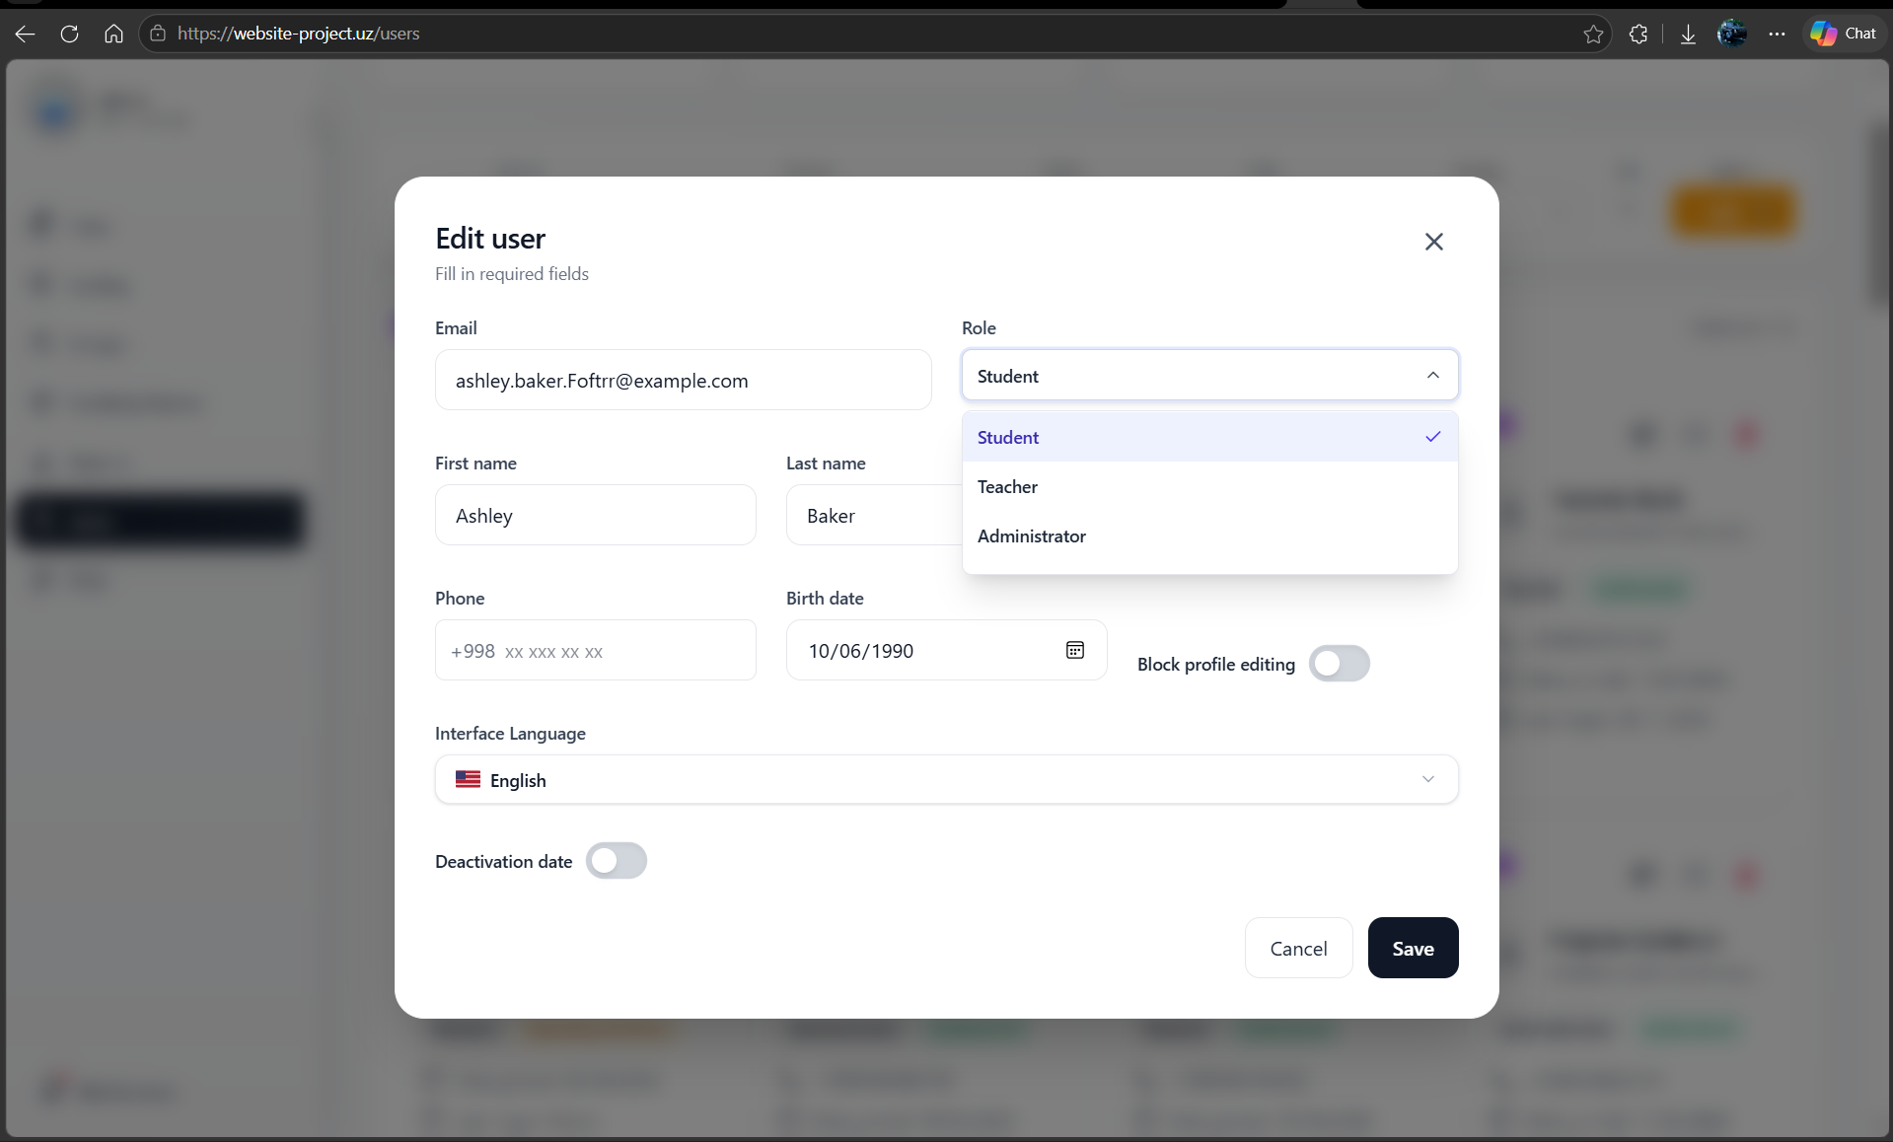

Dark view:
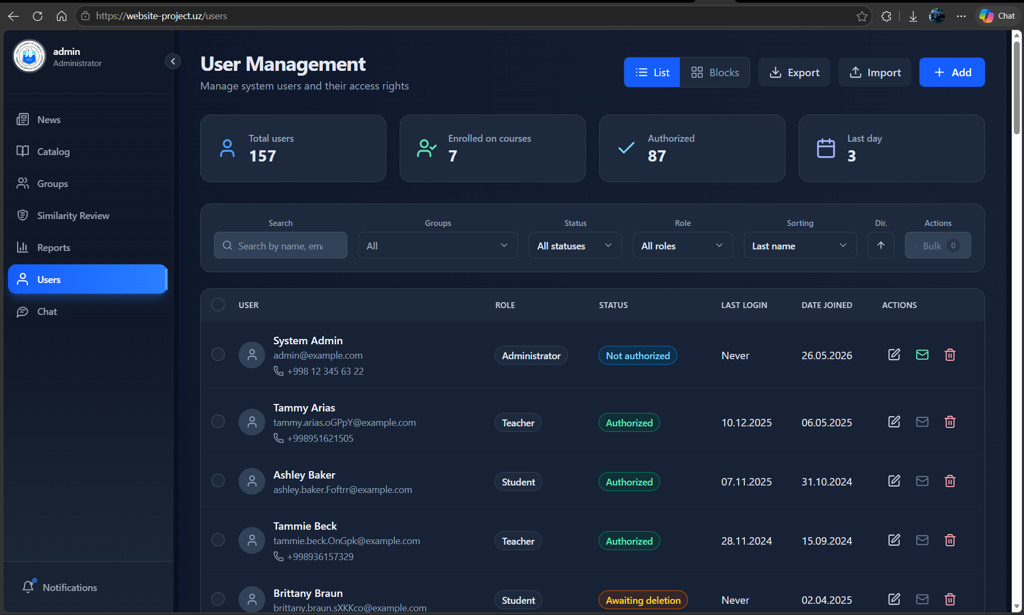

Group management:
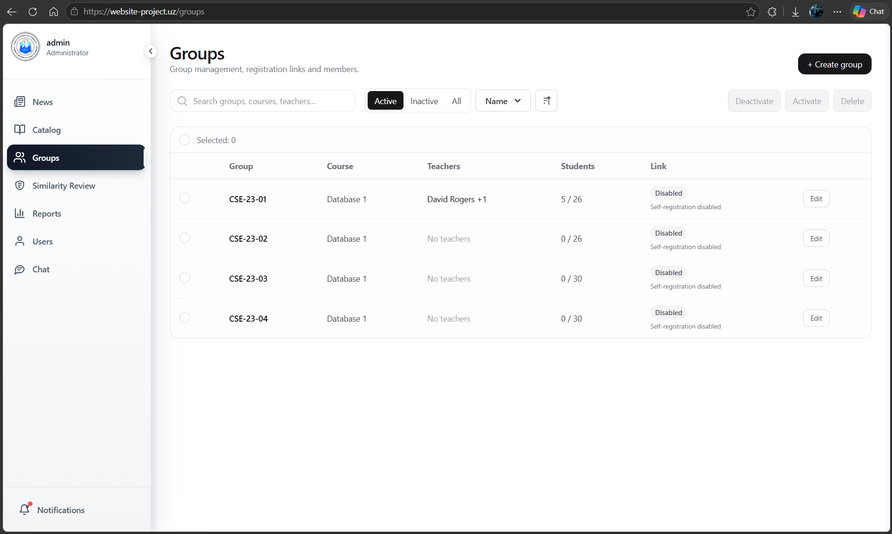
Group details:
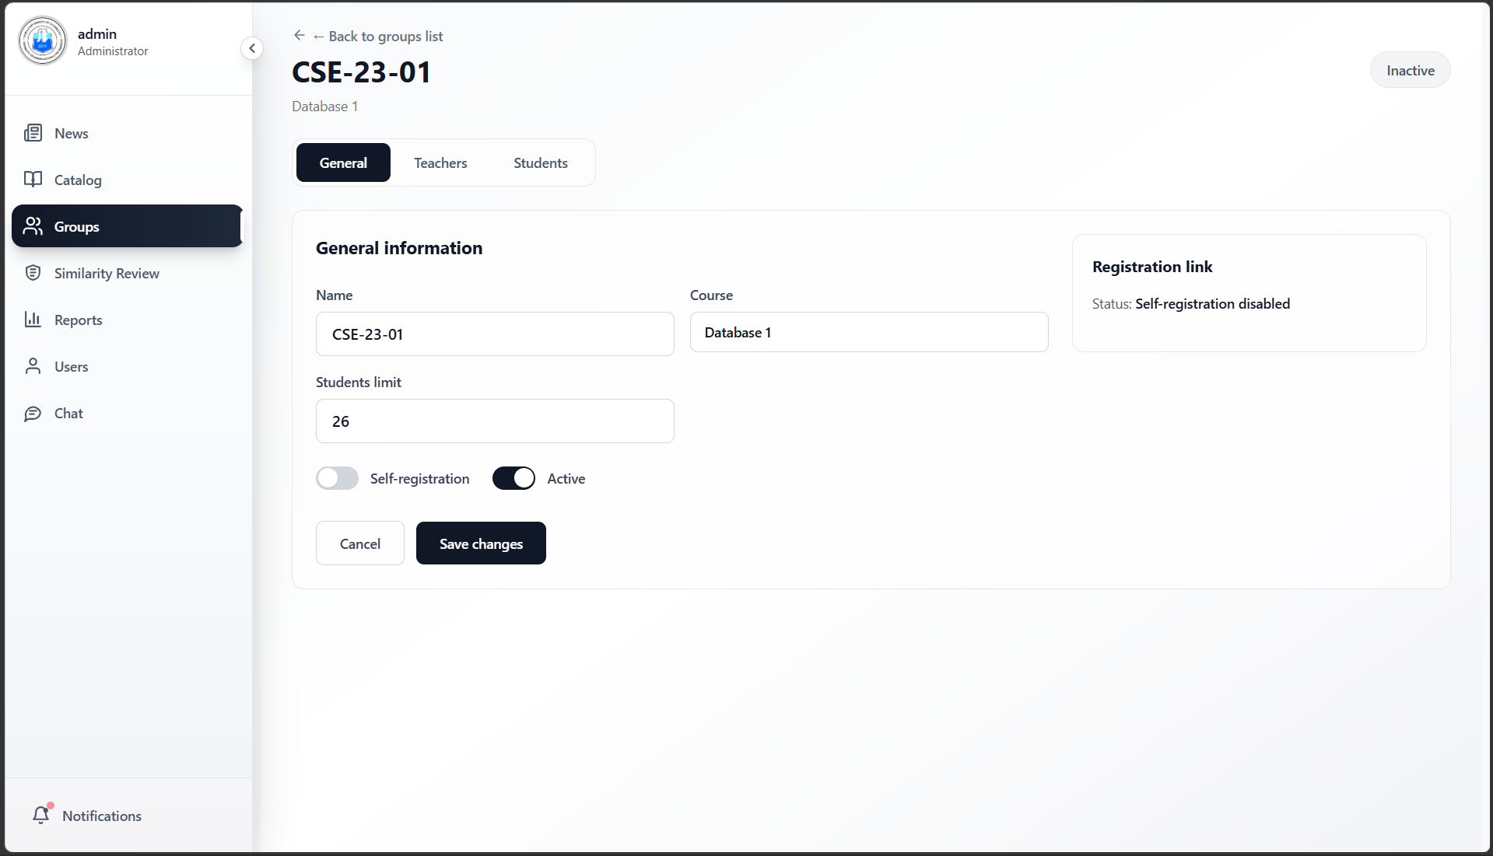
Teacher management for a group:
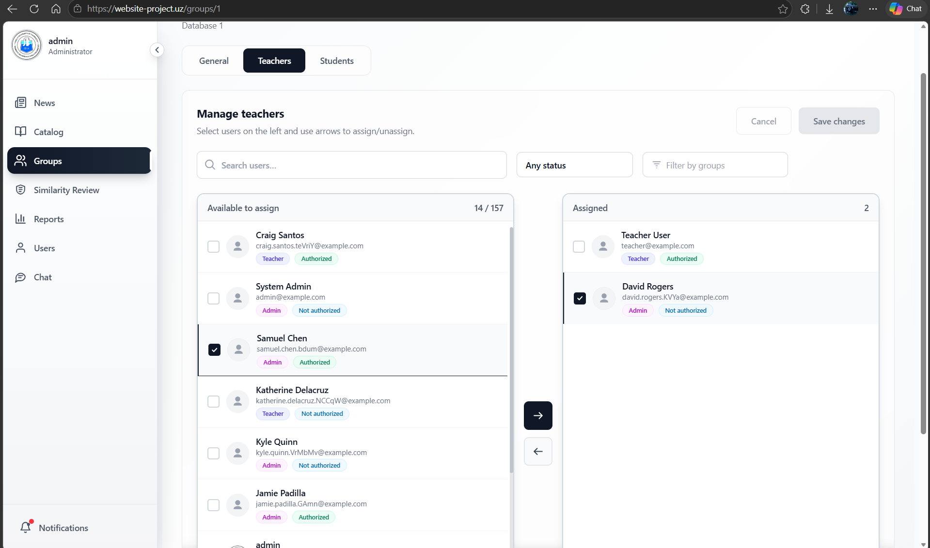
By the way, our system fully supports multi-teaching.

Student management:
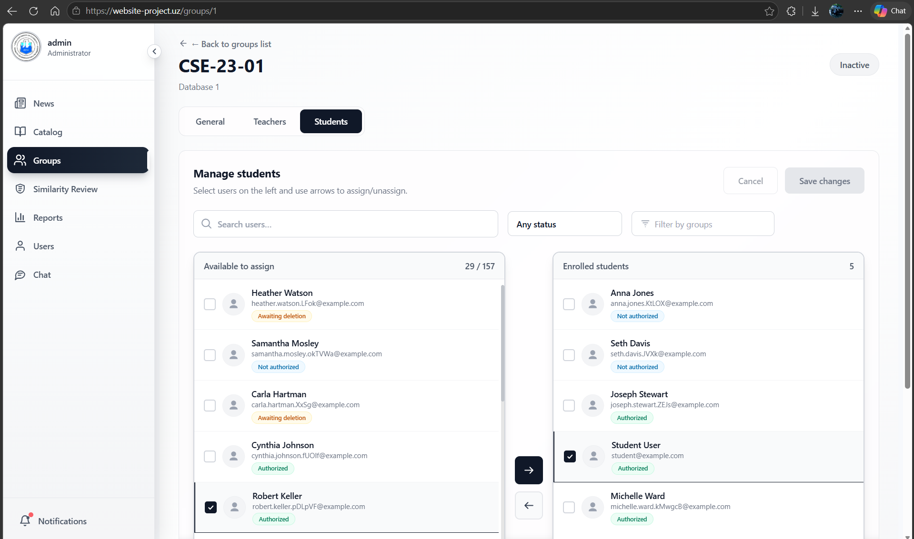
Some useful filters and searching:
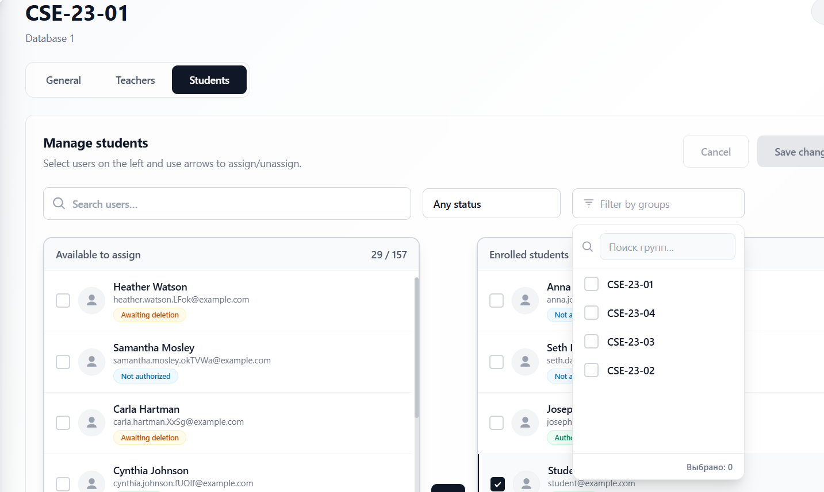

12. Testing and Known Limitations

12.1 Automated Tests
The test suite runs in CI on every pull request and push to main using python manage.py test with a dedicated test PostgreSQL instance and Redis service container provided by GitHub Actions services.
Test Module | Cases | What is tested
test_ratelimiter | 5 cases | Token bucket burst, refill, 429 response, Retry-After header, concurrent race safety
test_auth | 8 cases | Login success, wrong password, unverified email, MFA flow, token refresh, logout blacklist
test_permissions | 6 cases | Admin cannot grade, Teacher cannot reassign, Student cannot access admin endpoints
test_plagiarism | 4 cases | PDF extraction, OCR image text, ZIP code extraction, similarity scoring threshold
test_celery_tasks | 3 cases | Stats snapshot creates record, grade export uploads to S3, user cleanup soft-deletes

📸 SCREENSHOT: CI Test Run
Insert a screenshot of a passing GitHub Actions test job showing all test cases green with the test count and execution time.

12.2 Known Limitations
- Single OCI worker node: the second OCI node could not be joined due to asymmetric VXLAN routing between two nodes within the same OCI VCN when --flannel-external-ip is active. A WireGuard-based flannel backend would resolve this but was beyond the project timeline.
- Push-based GitOps: the CI/CD pipeline uses a push model (GitHub Actions calls kubectl apply) rather than a pull model (ArgoCD watching the cluster-config repo). A pull model is more resilient to network interruptions and is the industry standard, but requires deploying ArgoCD into the cluster which was constrained by RAM on the 1 GB OCI nodes.
- No horizontal pod autoscaler (HPA): the backend deployment runs at replicas=1. HPA based on CPU utilisation was configured in manifests but not activated due to insufficient worker node RAM headroom.
- TLS in Kubernetes: TLS is terminated at the Cloudflare / OCI Load Balancer layer. Traffic between the OCI LB and Traefik is currently plain HTTP (internal to the OCI VCN). cert-manager with Let’s Encrypt would provide end-to-end TLS inside the cluster in a production hardening pass.
- Email sending: Gmail SMTP is used for transactional email. A dedicated transactional email provider (SendGrid, Resend) would be required at scale to avoid Gmail rate limits.

13. Team Contribution Table
Member | Primary Features | Commit %
U2310274 | Backend & System architecture, DevOps, team & organization management, K3s cluster setup, management, (Hetzner + OCI), CI/CD pipelines, Auth system, JWT, MFA, email verification, Django Unfold admin, Daphne ASGI, secrets management and application lifecycle management. | 50%
U2310292 | Token-bucket rate limiter (R11): Redis Lua script, DRF throttle integration, test suite, RFC headers | 7%
U2310238 | Frontend code initialization focusing on course catalogue, task view, submission workflow, grading UI, file upload/download, and in-memory logging implementation | 10%
U2310210 | Plagiarism scan pipeline (R10): Tesseract OCR integration, PDF/DOCX/ZIP text extraction, pairwise SequenceMatcher, Celery task, Similarity Review UI | 7%
U2310291 | Chatting functionality using Websocket and appropriate backend logic with REST protocol chatting, App+UI | 7%
U2310275 | Observability stack, like Prometheus, Grafana, metrics scraping, Loki, tempo | 7%
U2310301 | Polyglot persistence and caching using Redis | 7%
U2310213 | UI/UX designer, Similarity Review UI, Dockerfile+Nginx | 7%

Commit history is visible at https://github.com/LearnovaX/backend/graphs/contributors and https://github.com/LearnovaX/frontend/graphs/contributors. Each member committed from their own GitHub account. The cluster-config repo shows deployment commit history at https://github.com/LearnovaX/cluster-config/commits/main.

📸 GitHub Contribution Graph
Backend repo:
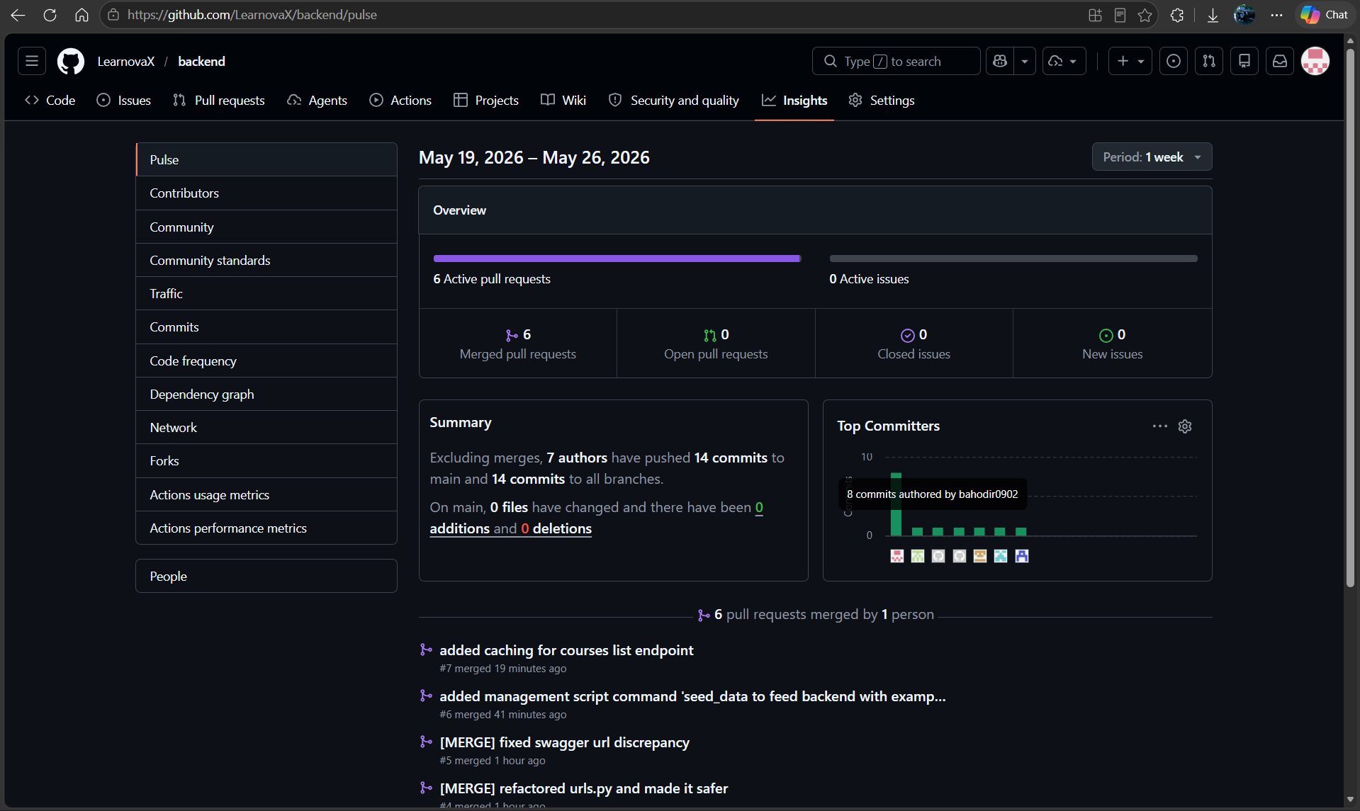
Frontend repo:
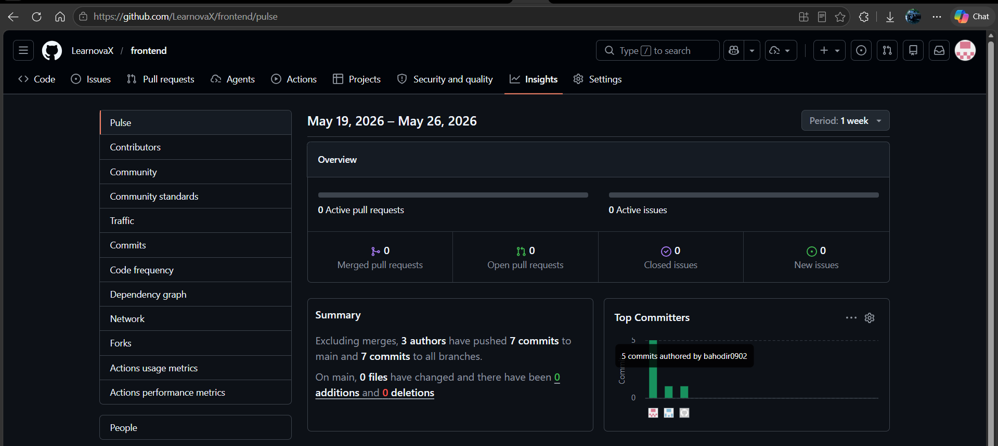

Cluster-config repo:
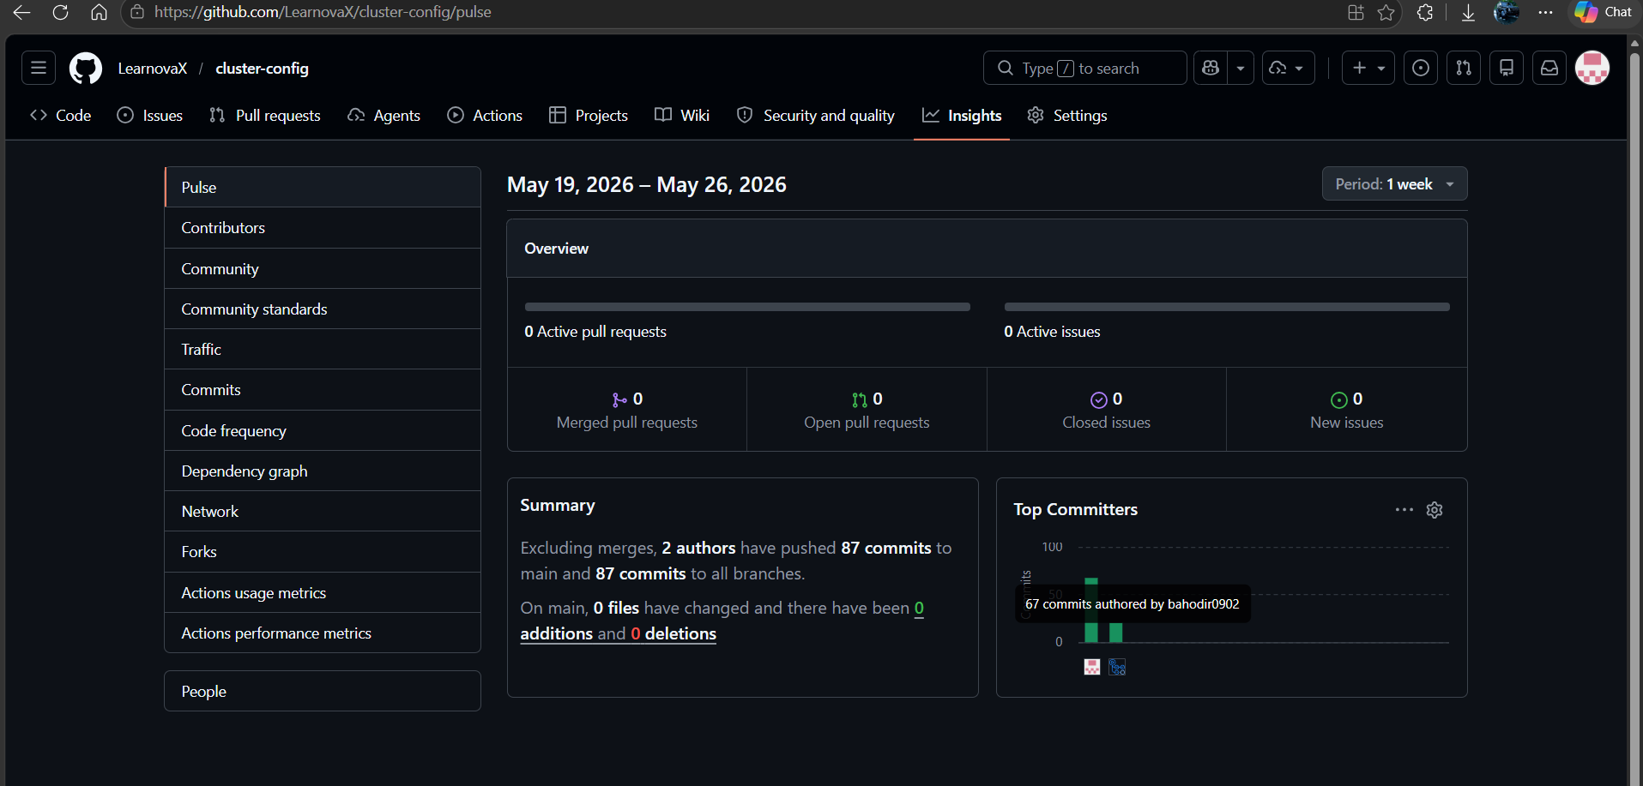

Overall Organization actions usage metrics:
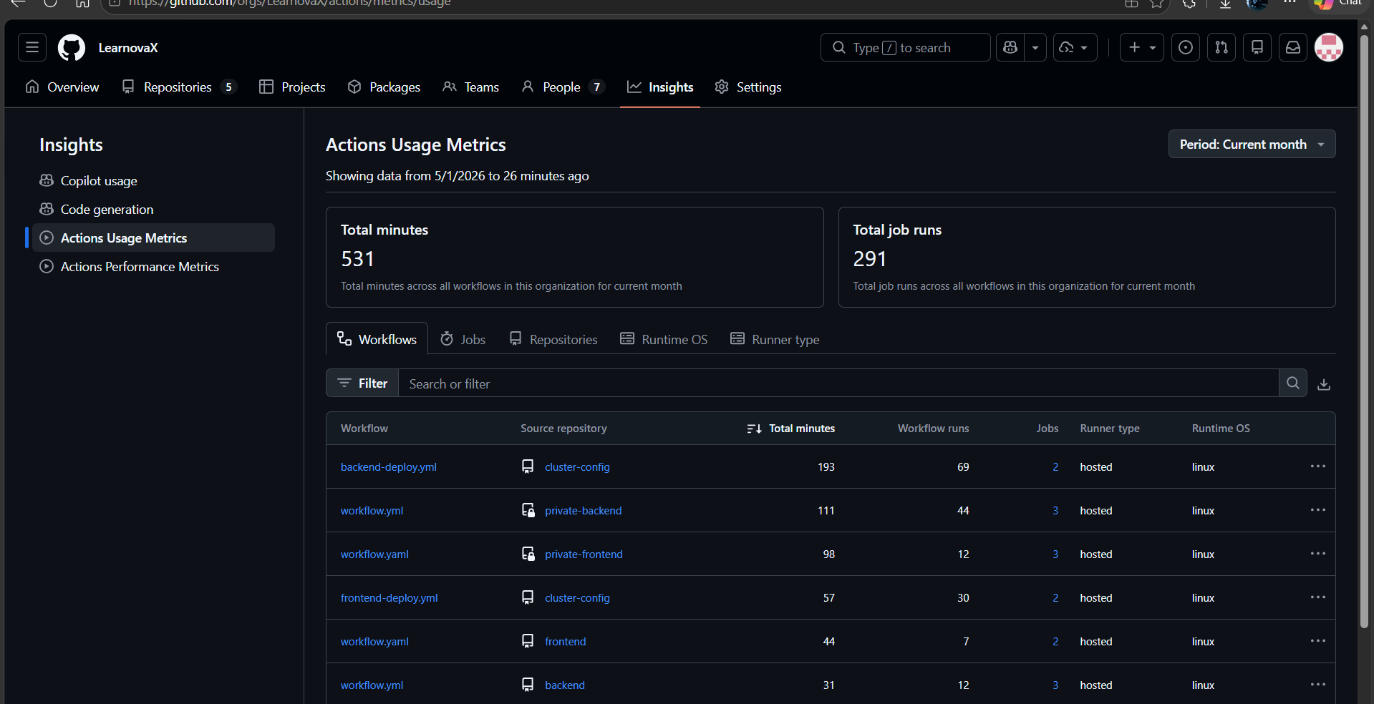

14. References
- Alex Xu. System Design Interview — An Insider’s Guide, vol. 1. ByteByteGo, 2020. Chapters 4 (Rate Limiter) and 6 (Key-Value Store).
- Martin Kleppmann. Designing Data-Intensive Applications. O’Reilly Media, 2017. Chapters 8 (Distributed Systems) and 11 (Stream Processing).
- Django REST Framework documentation. https://www.django-rest-framework.org
- Django Channels documentation. https://channels.readthedocs.io
- Celery documentation. https://docs.celeryq.dev
- drf-spectacular (OpenAPI). https://drf-spectacular.readthedocs.io
- k3s lightweight Kubernetes. https://docs.k3s.io
- Kustomize documentation. https://kubectl.docs.kubernetes.io/guides/introduction/kustomize/
- kubeconform manifest validation. https://github.com/yannh/kubeconform
- Grafana LGTM stack. https://grafana.com/about/grafana-stack/
- django-prometheus. https://github.com/korfuri/django-prometheus
- Tesseract OCR documentation. https://tesseract-ocr.github.io/tessdoc/
- React 19 documentation. https://react.dev
- Oracle Cloud Infrastructure Networking. https://docs.oracle.com/en-us/iaas/Content/Network/Concepts/overview.htm
- Cloudflare CDN documentation. https://developers.cloudflare.com/fundamentals/
- GitHub Actions documentation. https://docs.github.com/en/actions
- Unfold Django Admin. https://unfoldadmin.com
- AWS S3 API — boto3 documentation. https://boto3.amazonaws.com/v1/documentation/api/latest/index.html

