**A1**

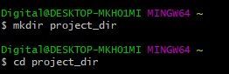

**C:\Users\Digital\Downloads\git\2.jpg**

**C:\Users\Digital\Downloads\git\3.jpg**

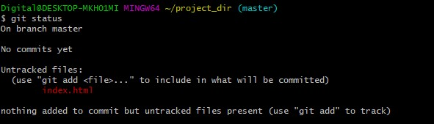

**C:\Users\Digital\Downloads\git\5.jpg**

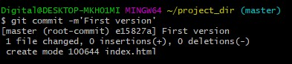

**C:\Users\Digital\Downloads\git\7.jpg**

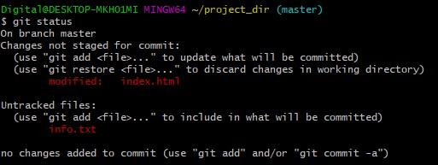

**C:\Users\Digital\Downloads\git\9.jpg**

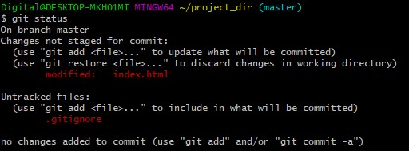

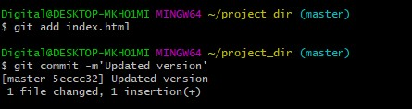

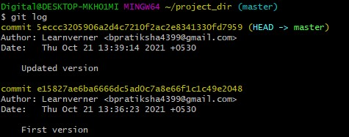

**C:\Users\Digital\Downloads\git\14.jpg**

**C:\Users\Digital\Downloads\git\15.jpg**

**C:\Users\Digital\Downloads\git\16.jpg**

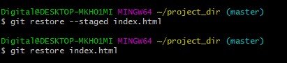

**C:\Users\Digital\Downloads\git\18.jpg**

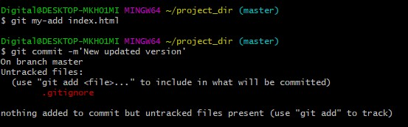

**C:\Users\Digital\Downloads\git\20.jpg**

**A2**

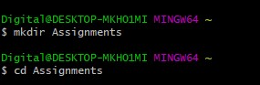

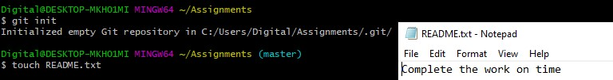

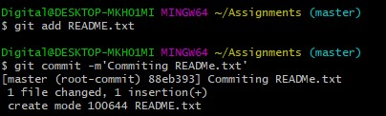

**C:\Users\Digital\Downloads\git2\25.jpg**

**C:\Users\Digital\Downloads\git2\26.jpg**

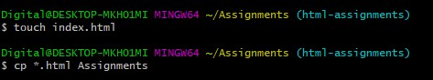

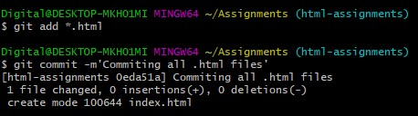

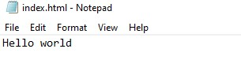

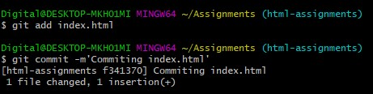

**C:\Users\Digital\Downloads\git2\31.jpg**

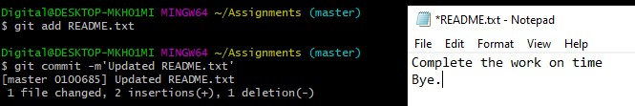

**C:\Users\Digital\Downloads\git2\33.jpg**

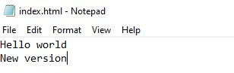

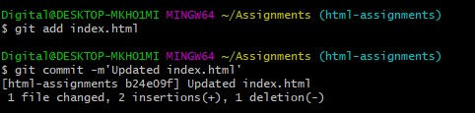

**C:\Users\Digital\Downloads\git2\36.jpg**

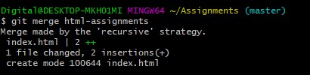

**C:\Users\Digital\Downloads\git2\38.jpg**

**A3**

**C:\Users\Digital\Downloads\git3\1.jpg**

**C:\Users\Digital\Downloads\git3\2.jpg**

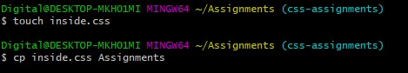

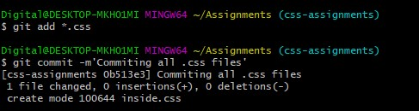

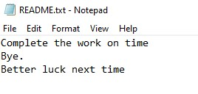

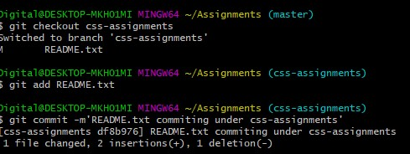

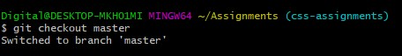

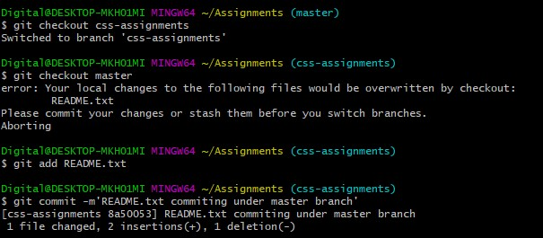

**C:\Users\Digital\Downloads\git3\9.jpg**

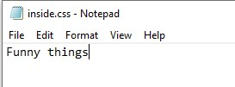

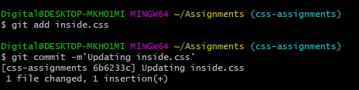

**C:\Users\Digital\Downloads\git3\12.jpg**

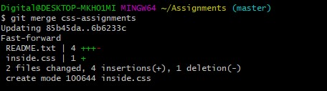

**C:\Users\Digital\Downloads\git3\14.jpg**

**A4**

**C:\Users\Digital\Downloads\git4\1.jpg**

**C:\Users\Digital\Downloads\git4\2.jpg**

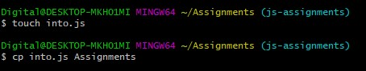

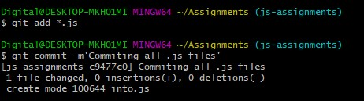

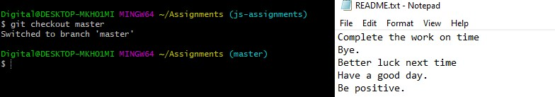

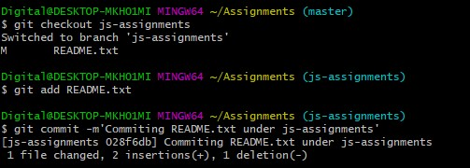

**C:\Users\Digital\Downloads\git4\7.jpg**

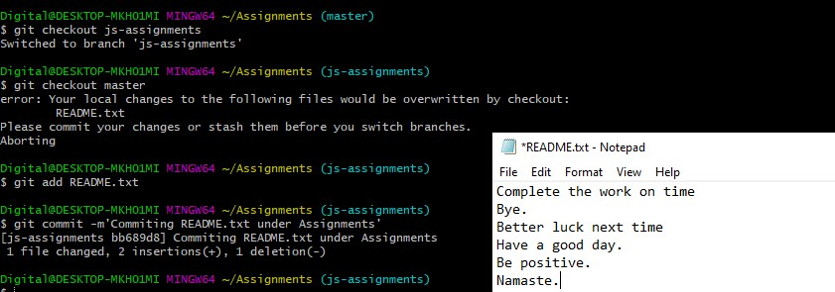

**C:\Users\Digital\Downloads\git4\9.jpg**

**C:\Users\Digital\Downloads\git4\12.jpg**

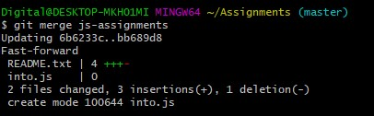

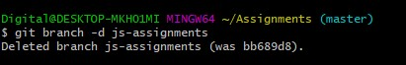

**SECTION 3**

