Pierce, Austin D

Pellissippi State Community College

CITC-2320 PC7 HOHOHO Company Infrastructure Documentation

GitHub link: <https://github.com/LeatherBandit/ServerFinal>

## Windows Server 2019 Installation

1. **Create a new virtual machine in VMware workstation.** 
   1. Select “Create a New Virtual Machine” in VMware workstation.
   2. Select “Custom (advanced)” for installation.  
      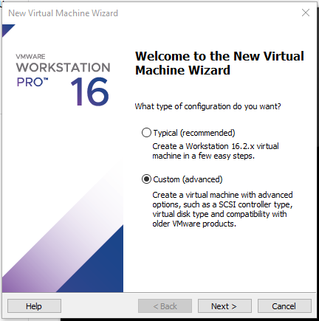
   3. Ensure “Workstation 16.2.x” is selected next to Hardware.  
      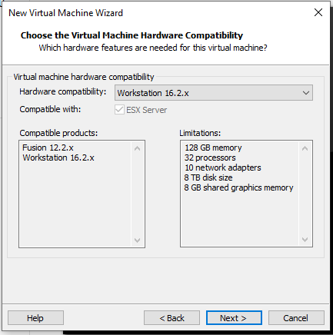
   4. Select “I will install the operating system later”  
      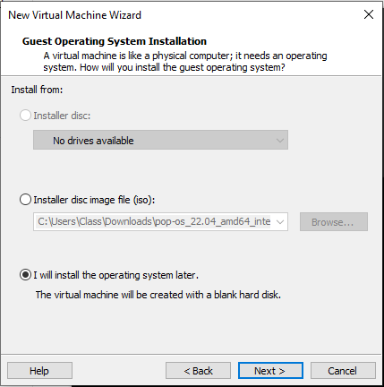
   5. Click the “Other” radio button. Select other on the version drop-down as well.  
      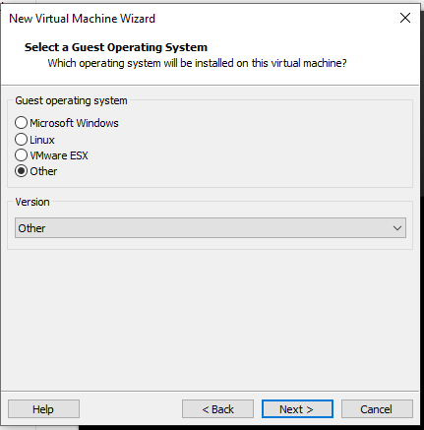
   6. Name it per company standard. “HHH-04 Windows Server 2019”
   7. Number of processors “2”, Number of cores per processor “4”.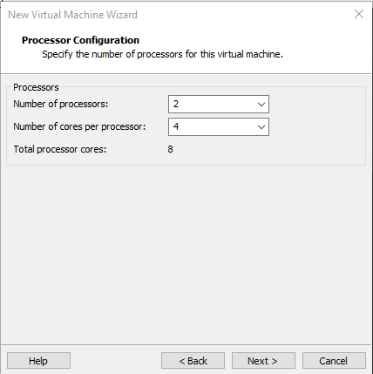
   8. Input “4096” MB for ram allocation.  
      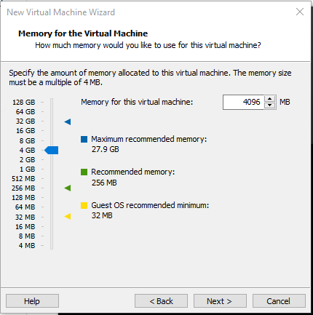
   9. Use default of “NAT” for the Network Type.
   10. Use default of “LSI Logic SAS”.
   11. Use default of “NVMe” or your recommended default.
   12. Use default of “create a new virtual disk”
   13. Input at least “50GB” for the drive capacity.  
       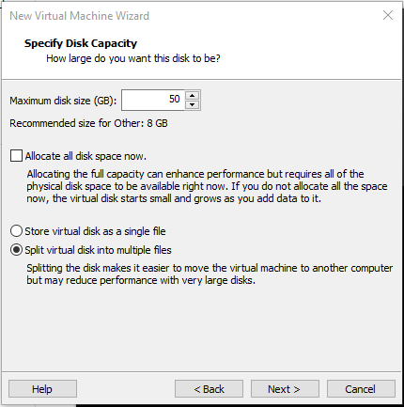
   14. Use default name for the disk file.
   15. Review and finish.  
       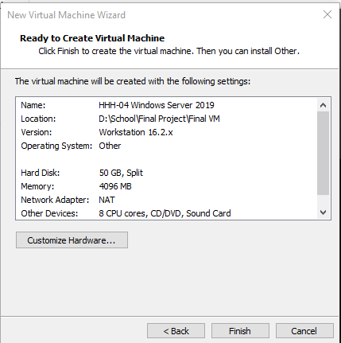
   16. On the Home screen: Select your new virtual machine’s CD/DVD item.
   17. Under connection: Select “use ISO image file”.
   18. Browse for your downloaded copy of “Windows Server 2016 Eval Edition” and select it  
       Graphical user interface, application

       Description automatically generated

## Initial Server Configuration Tasks

1. **Complete initial windows setup tasks as guided by the operating system.**
2. **Be sure to install Guest additions CD per VMware instructions.** 
   1. This can be done manually via the VMware tools .iso file. Click VM in top of VMware workstation client and select “Install Guest additions”.
   2. Select “Install VMware Tools”
   3. Press “WinKey + R” and type “D:\setup.exe”. This will start the tool installation.
   4. Select the installation manager from the task bar.
   5. Follow steps in the installation manager to complete the VMware tools installation.
   6. If this completes properly, your virtual machine should resize to fit the full display.
   7. Restart after the installation is complete.
   8. After restart sign in again.
3. Change password policy to allow for 2-character password. (Not recommended for production environments.)
   1. Open “Local Group Policy Editor” through the windows search feature.  
      Graphical user interface, text, application

      Description automatically generated
   2. Break out the tree until you’ve found “Password Policy” – (Computer Configuration > Windows Settings > Security Settings > Password Policy)  
      Graphical user interface, text, application, chat or text message

      Description automatically generated
   3. Select “Minimum password length” and change the value to “0” characters. Apply changes.  
      Graphical user interface, text, application, email

      Description automatically generated
   4. Select “Password must meet complexity requirements Properties” and disable this option. Apply changes.  
      Graphical user interface, text, application, email

      Description automatically generated
   5. Change the Administrator password to pw. Press “Win Key + R” and type lusrmgr.msc. Hit enter.  
      Graphical user interface, application

      Description automatically generated
   6. Double click the “User” tree.  
      Graphical user interface, text, application, email

      Description automatically generated
   7. Right click “Administrator” and select “Set Password”. On the next prompt click “Proceed”.  
      Graphical user interface, text, application, email

      Description automatically generated
   8. Set password as “pw” and select “ok”  
      Graphical user interface, text, application, email

      Description automatically generated
4. Create Admin account to avoid using “Administrator”
   1. With “lusrmgr.msc” still open, right click in the center section, and select “New User”.  
      Graphical user interface, application, Word

      Description automatically generated
   2. Fill out the basic information for our “HOADM” local admin account as follows:  
      Graphical user interface, text, application, email

      Description automatically generated
   3. Select “Create” to finalize, and verify the user has been created in the view pane.  
      Graphical user interface, text, application

      Description automatically generated
   4. Right click the new user and select properties. Navigate to “Member Of” tab.  
      Graphical user interface, text, application, email

      Description automatically generated
   5. Select “Add” and type in “Administrators” into the text box, hit enter.  
      Graphical user interface, text, application, email

      Description automatically generated
   6. Apply changes and switch users to the new admin account.  
      Graphical user interface, text, application, Word

      Description automatically generated
   7. Login to the “HO Admin” account.  
      A picture containing text, nature

      Description automatically generated
   8. Open cmd by searching in windows. Enter “whoami” into the command line. This will verify your signed in user.  
      Text

      Description automatically generated
5. **Set the time zone.**
   1. From “Server Manager” select “Local Server”  
      Graphical user interface, application

      Description automatically generated
   2. Select “Time Zone”  
      Graphical user interface, text, application

      Description automatically generated
   3. Select “Change time zone”  
      Graphical user interface, text, application, email

      Description automatically generated
   4. Set proper time zone and apply changes with the “OK” button.
6. **Set machine name and workgroup:**
   1. From the same “Local Server” tab select “Computer name”.  
      Graphical user interface, text, application

      Description automatically generated
   2. Set an appropriate description for this server.  
      Graphical user interface, text, application

      Description automatically generated
   3. Select Change to modify the name and workgroup. Note the workgroup does not need to be changed since this will be promoted to a domain controller but for the sake of clarity go ahead and set it appropriately.  
      Graphical user interface, text, application, email

      Description automatically generated
   4. Apply Changes and restart machine when prompted.   
      Graphical user interface, text, application

      Description automatically generated
7. **Collect Logs from event viewer:**
   1. Open event view by searching for “event viewer” in the windows search tool.  
      Waterfall chart

      Description automatically generated with medium confidence
   2. In the forest on the left side of the screen click the drop-down arrow for “Windows Logs”.  
      Graphical user interface

      Description automatically generated with medium confidence
   3. For each log section “Application, Security, System” repeat steps “d – e”.
   4. Select the log section “Application for example”. Select “clear log…”  
      Graphical user interface

      Description automatically generated with low confidence
   5. In the pop-up window select the option “Save and Clear”. Save the files in “Documents” as “APP-LOG-FULL-2022-DEC-01-406” (Section-LOG-FULL-MONTH-DAY-HOUR).  
      Graphical user interface, text, application, email

      Description automatically generated
8. Set Static IP Address:
   1. Open CMD by searching “CMD” in windows. Type “ipconfig” in the command line.  
      Text

      Description automatically generated
   2. Under “IPv4 Address” document the information listed. In the command line type “ncpa.cpl” to open network adapter properties.  
      Graphical user interface

      Description automatically generated
   3. On the “Network Connections” right click Eth0 and select properties.   
      Graphical user interface, application

      Description automatically generated
   4. Select “Internet Protocol Version 4 (TCP/IPv4)” and click properties.  
      Graphical user interface

      Description automatically generated
   5. Click “Use the following IP address” fill in the information from our previous documentation  
      Graphical user interface, text, application

      Description automatically generated
   6. The DNS settings will be the same as your default gateway. You can set the secondary to Google DNS for redundancy.   
      Graphical user interface, text, application

      Description automatically generated
   7. Save and close. Back in the command line run “ipconfig /all”. Verify DHCP enabled is listed as “No”  
      Text

      Description automatically generated
9. Configure Power Scheme:
   1. Search for “Power” in windows search.   
      Graphical user interface, application

      Description automatically generated
   2. Select “Additional Power Settings.  
      Graphical user interface

      Description automatically generated with low confidence
   3. Select “Create a power plan”  
      Graphical user interface, text, application

      Description automatically generated
   4. Name Power Plan appropriately.  
      Graphical user interface, text, application, email

      Description automatically generated
   5. Configure display timeout for 60 minutes, and sleep to never. Create to finalize.   
      Graphical user interface, application

      Description automatically generated
10. Defragment C drive.
    1. In windows search type “Defragment”.   
       Graphical user interface, text

       Description automatically generated
    2. Select “Optimize” to “Defragment or trim” depending on the type of drive.  
       Graphical user interface, text, application

       Description automatically generated
    3. Shut the machine down to perform the defragmentation from the VMware side as well. Select “Edit virtual machine settings”, and select your Hard disk.   
       Graphical user interface, application

       Description automatically generated
    4. Select the “defragment” option.   
       Graphical user interface, application

       Description automatically generated
11. Custom Keyboard Settings:
    1. Search for “Edit Language and keyboard options”  
       Graphical user interface, text, application, email

       Description automatically generated
    2. Add a language. Select the most appropriate language for your employees. Spanish in this case.   
       Table

       Description automatically generated
    3. Install the language features required. Speech and handwriting are not required in this case.   
       Graphical user interface, text, application

       Description automatically generated
    4. Complete the language installation and order as necessary.   
       Graphical user interface, text, application, email

       Description automatically generated
12. Configure NO memory dump.
    1. Open control panel by searching for “control panel” in the windows search tool. Navigate to “System and Security” > “System” > “Advanced System Settings"  
       Graphical user interface, text, application, email

       Description automatically generated
    2. Select “Settings” for startup and recovery.  
       Graphical user interface, application

       Description automatically generated
    3. Change automatic memory dump to “none” from the drop-down menu.  
       Graphical user interface, text, application, email

       Description automatically generated

## Promotion to Domain Controller.

1. Snapshot before promotion.
   1. Out of an abundance of caution we will save our progress by creating a snapshot of the machine’s state.
   2. In the VMware menu, select VM > Snapshot > Take snapshot.  
      Graphical user interface, text, application, email

      Description automatically generated
   3. Create a descriptive title and clear description. Select Take Snapshot. In the VM tab once again, select Snapshot > Snapshot Manager.  
      Graphical user interface, application

      Description automatically generated
   4. Select the snapshot we just created to verify successful creation.  
      Graphical user interface, application

      Description automatically generated
2. Capture logs before DC promotion.
   1. Repeat Event log capture workflow as detailed in Step 7. Of the initial configuration guide.
   2. Create “HOHOHO LOGS” folder and capture logs for users and groups.
      1. In a command prompt type the following command.   
         “mkdir "%USERPROFILE%\Documents\HOHOHO LOGS"   
         Text, logo

         Description automatically generated
      2. Followed by:  
         cd "%USERPROFILE%\Documents\HOHOHO LOGS"  
         
      3. Next we will capture local users followed by verifying the file was successfully created.  
         net user > HOHOHO-USRS1-B4DC.txt  
         type HOHOHO-USRS1-B4DC.txt  
         Text

         Description automatically generated
      4. We will do the same process for groups.   
         net localgroup > HOHOHO-GRPS1-B4DC.txt  
         Text

         Description automatically generated
3. Promote server to Domain Controller.
   1. In the “Server Manager” under local server. Select “Manage” in the top right. Select “Add roles and Features”.  
      Graphical user interface, application

      Description automatically generated
   2. Use the default settings until the “Select Server Roles” page. Select “Active Directory Domain Services”. Select “Add Features”  
      Graphical user interface, text, application, email

      Description automatically generated
   3. Click next on each the next prompts until the “Confirm Installation Selections”. Restart the server automatically. Finish the installation.  
      Graphical user interface, text, application

      Description automatically generated
   4. Back on the server manager, click the notification icon in the upper right-hand corner. Select “Promote this server to a domain controller”.  
      Graphical user interface, text, application, email

      Description automatically generated
   5. Select “Add a new forest” and add the Domain name.  
      Graphical user interface, text, application, email

      Description automatically generated
   6. Create a secure password for the “DSRM” as it can be used to restore your domain.  
      Graphical user interface, application

      Description automatically generated
   7. Leave defaults until the Prerequisites Check page. Verify your settings and install.  
      Graphical user interface, text, application, email

      Description automatically generated
   8. Reboot:  
      Graphical user interface, text, application, email

      Description automatically generated

## Create additional drives

1. In VMware, click the “VM” tab. Select settings.   
   Graphical user interface

   Description automatically generated
2. Select Add. Add Hard Disk. Leave the default disk type.  
   Graphical user interface, text, application, email

   Description automatically generated
3. Create a “new virtual disk”. Select the appropriate size. 2GB in this case. Leave the default value of split into multiple files.   
   Graphical user interface, text, application, email

   Description automatically generated
4. Leave disk file as default.  
   Graphical user interface, text, application, email

   Description automatically generated
5. Repeat steps 2-4 for the following devices.
   1. F Drive: 2GB
   2. H Drive: 3GB
   3. N Drive: 1GB
   4. S Drive: 2GB
   5. P Drive: 2GB  
      Graphical user interface

      Description automatically generated
6. We need to now initialize each in windows.
   1. Search disk management in windows search.  
      Graphical user interface, text, application

      Description automatically generated
   2. For the pop-up window we can select GPT and both disks, and select ok.  
      Graphical user interface, table

      Description automatically generated
   3. We need to ensure each disk is online by right clicking the “Disk x” box and selecting “online”.  
      Graphical user interface, application

      Description automatically generated
   4. We will also need to initialize each disk with the GPT partition style.  
      Graphical user interface, application

      Description automatically generated
   5. For each disk we will need to create simple volumes that encompass the entire available space for each. Select the unallocated space and start a “new simple volume”  
      Graphical user interface, text, application

      Description automatically generated
   6. Leave defaults for each prompt until the Drive letter assignment. Ensure you assign the correct drive letter for each volume.  
      Graphical user interface, text, application

      Description automatically generated
   7. Next we will leave the defaults for File system type as it is already NTFS. Label volume appropriately.   
      Graphical user interface, text, application

      Description automatically generated
   8. Finalize settings. And repeat for each drive.  
      Graphical user interface, application

      Description automatically generated
   9. Review disks.   
      Table

      Description automatically generated

## Create folder structure