Leatile Mogende
Bida25-127

WMD assignment 2026

Q1
a. The principal objective of a website is to provide relevant, useful, and engaging content to its audience while aligning with the mission, values and vision of the organization’s broader goals(Columbia sites 2026). Our website was designed to clearly communicate and deliver clear helpful information about the services we provide at MLS, Increase our digital presence to increase brand awareness and reach every corner of Botswana and generate leads that can be helpful in bringing in new clientele. Also accessibility was one of the key priorities when developing this website. We wanted to make it easy for our clients to access our services from their convenient location without the need to physically come to our office.

b. A target audience is a defined group characterized by shared demographics, behaviors , needs, and interests (SiteCove Learning Center 2026). MLS’s target audience is people of the age of 18-35. These are the people who are disadvantaged by the system when it comes to access to services like loans, so we took advantage of this gap to provide our services to people within this demographic who fits our eligibility criteria.
Location- we target people who stay in urban/suburban areas because they have access to internet infrastructure that allows them to use our website smoothly, and also most universities and workplaces are in urban/suburban areas and one of our requirements are that we only provide our services to people with a source of income and people in this demographic fit perfectly.
Technical Aptitude- most user with the age of 18-35 have smart phones and they have strong digital presence, so they are familiar with navigating websites and mobile browsing. So we targeted them because its easier to reach them through digital platforms and it will not be difficult for them understand and interact with your website since they have digital background.

c. The website I am designing falls under the category of service based site. It will display the services that MLS provides, an interactive form that users can use to apply for our services and display text that will educate the user about MLS and who we are.

2.
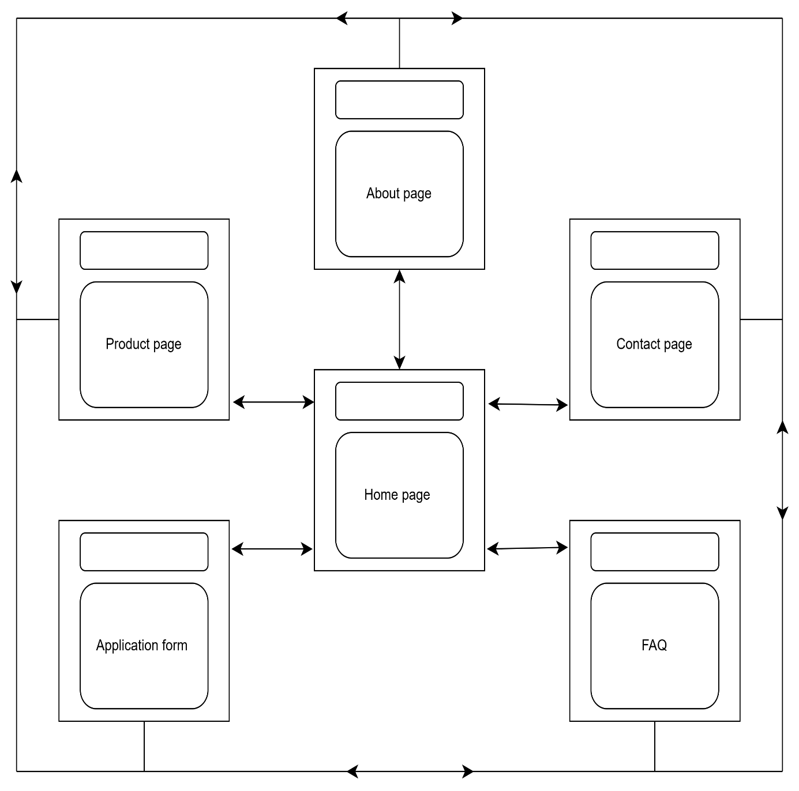

The home page has the navigation bar that that has links of Product page, about page, contact page, FAQ, and Application form which enables the user to move from one page to the other. All pages have the navigation bar so the user can jump from any page in the website to the other without any hierarchical process.

Home page wire frame
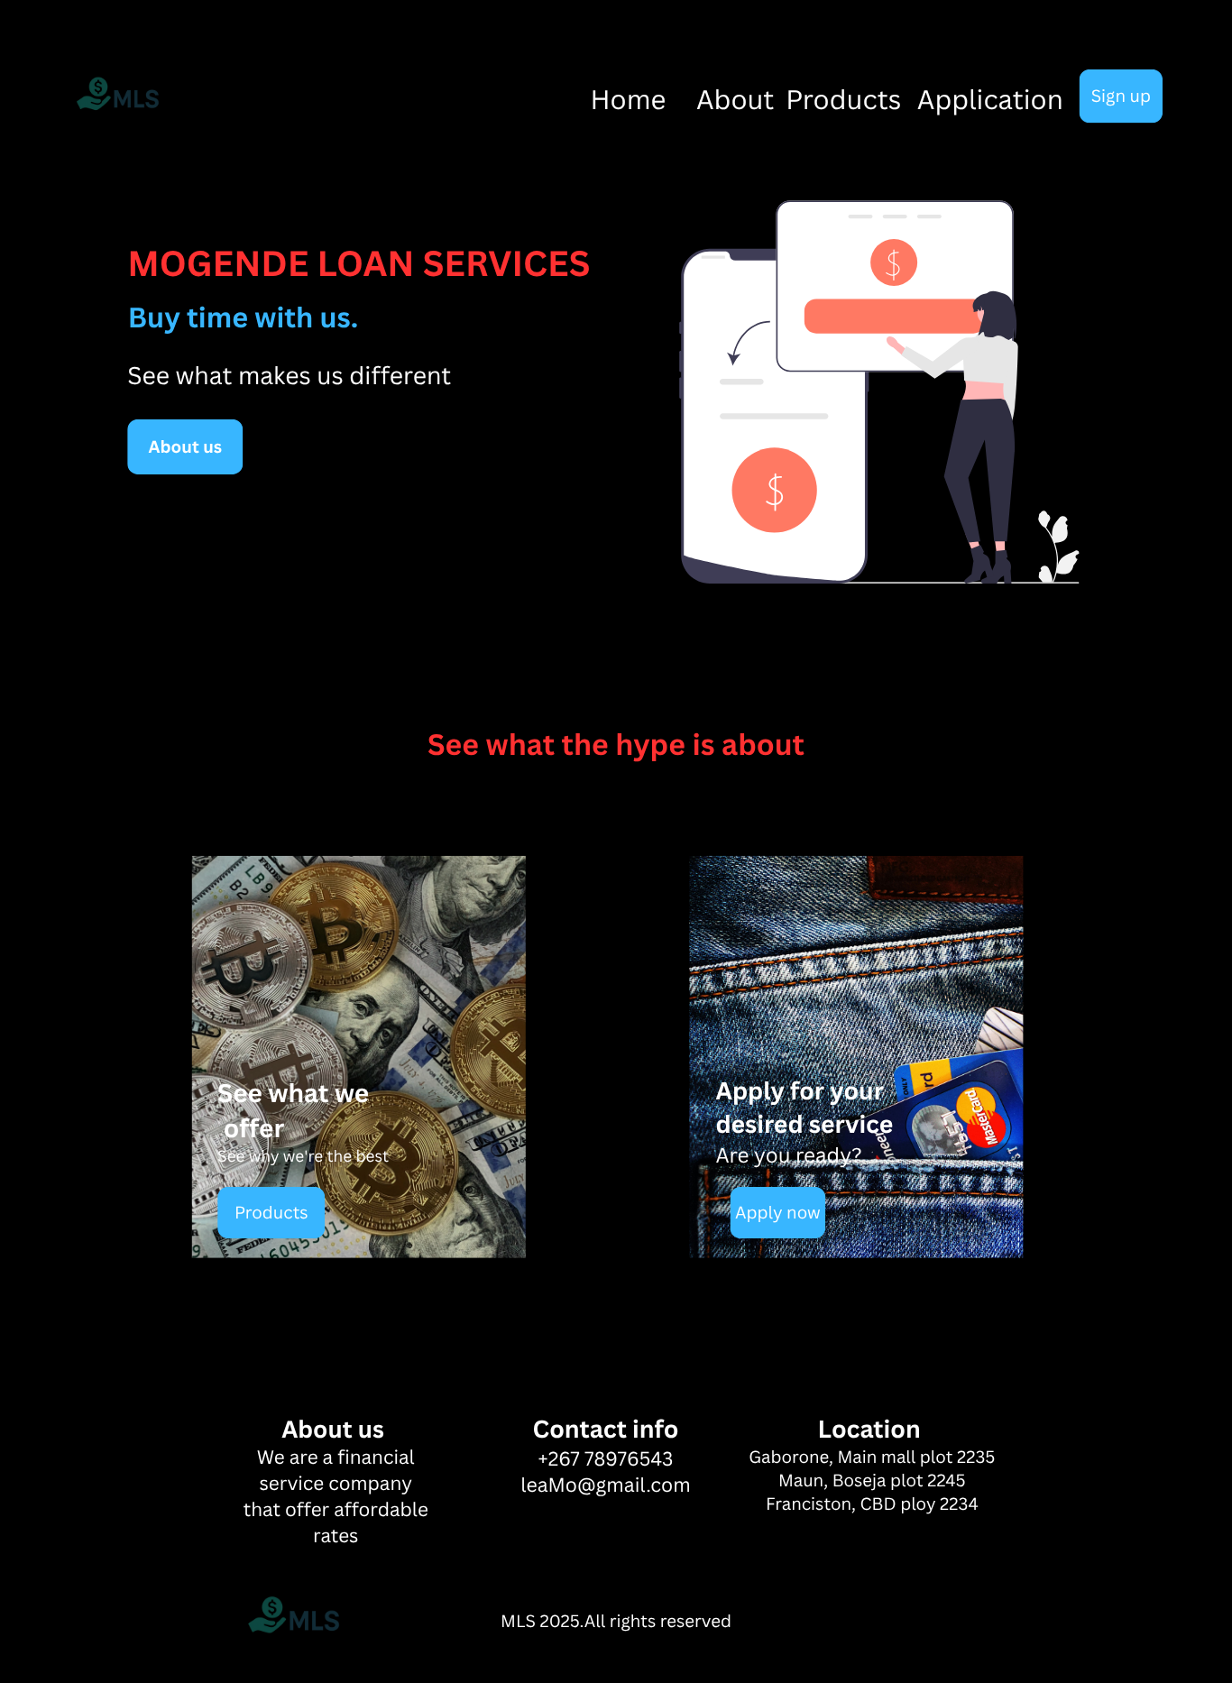
This is how contents of the website will be displayed in the home page.
Reference list:
Columbia Sites 2026, Define Website Goals, Columbia University, viewed 20 March 2026, https:// Define Website Goals | Columbia Sites
SiteCove Learning Center 2026, defining target audience and personas, SiteCode Learning Center, viewed 20 March 2026, Defining Target Audience and Personas | SiteCove Learning Center

