Lecture Analysis

- Basics of SMTP
SMTP, or Simple Mail Transfer Protocol, is an application-layer protocol designed for sending and receiving emails over the internet. By default, it operates on port 25, though ports 465 and 587 are frequently used in modern deployments to support encrypted or authenticated communications. Because SMTP is a text-based protocol, transmissions are unencrypted by default, which makes them vulnerable to interception and forensic inspection. This characteristic is especially relevant in investigations, as unprotected email exchanges can easily be reconstructed from captured network traffic. It is also important to distinguish SMTP from IMAP: while SMTP manages the transfer of outgoing messages, IMAP is primarily responsible for retrieving and managing messages on the client side.

- SSL/TLS
SSL and TLS play a central role in strengthening the security of email communication. TLS, the successor to SSL, is the standard protocol that ensures safe data transmission over the internet, while SSL itself is now obsolete. These cryptographic protocols serve three essential functions: they authenticate the identities of the client and server, they encrypt data to prevent unauthorized access during transmission, and they preserve data integrity by detecting tampering. In practical email systems, these protections are implemented either through SMTPS, which applies TLS from the beginning of the connection, or STARTTLS, which initiates a plaintext session and then upgrades it to a secure one. Such mechanisms illustrate how encryption can both secure communications and complicate forensic analysis.

- Forensics Analysis
Forensic investigation of SMTP traffic relies heavily on packet analysis tools such as Wireshark, which allow the recovery of meaningful evidence from captured network data. By analyzing .pcap files, investigators can determine when an email was sent, identify the software client responsible, and reconstruct entire messages from fragmented TCP streams. The analysis also extends to metadata, including sender and receiver IP addresses, MAC addresses, and port information, all of which can help establish the communication context. Moreover, SMTP authentication details are often encoded in Base64, and decoding these sequences can reveal plaintext usernames and passwords that may serve as critical evidence in an investigation.

- Base64 Encoding
Base64 encoding is another essential concept in the forensic examination of email traffic. It is a method of representing binary data in a text format, ensuring compatibility with systems that handle only textual information. In email communication, Base64 is commonly used to encode attachments, images, or even user credentials during authentication. For investigators, the significance of Base64 lies in the fact that it is not a security measure but a simple encoding scheme that can be easily reversed. By decoding Base64 data, one can quickly recover sensitive information, such as login details or embedded message content, which provides a valuable window into the activity taking place within SMTP traffic.

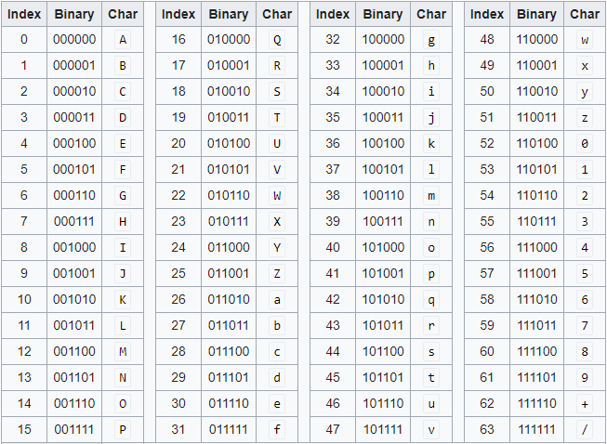
Figure.1 Base64 Encoding Table

Assignment Proposal

- Goals
- Capture your own SMTP traffic
- Explore other encoding schemes
- Investigate the impact of encryption on forensic analysis

- Steps
- Open smtp.pcap in Wireshark
- Locate SMTP handshake (“service ready” response)
- Decode Base64 to retrieve username/password
- Reassemble TCP to recover complete email text
- Document sender/receiver IP, MAC, and ports

- Assignment Questions
- When was the email sent?
Check the timestamp of the relevant SMTP packets in Wireshark. The “Frame” or “Packet Details” section will display the exact date and time when the email was transmitted.

- Which email client was used?
Inspect the SMTP headers or message body within the reassembled TCP stream. The “User-Agent” or “X-Mailer” field usually indicates the client software (e.g., Outlook 12.0).

- What is the email content?
Use Wireshark’s “Follow TCP Stream” feature to reassemble the SMTP traffic. Review the ASCII output to read the email body, including plain text, HTML parts, or attachments.

- Which ports, IPs, and MACs were involved?
Look at the packet details in Wireshark for both source and destination fields. The IP addresses, port numbers (e.g., 25, 587), and MAC addresses of sender and receiver can be easily extracted from the Ethernet and TCP headers.

- What forensic methods were applied?
Summarize the steps you performed, such as filtering SMTP traffic, decoding Base64 credentials, reassembling TCP streams, and analyzing headers.

- What is the size of the captured SMTP .pcap file?
Check the file properties in your operating system or look at the capture file summary in Wireshark to view the file size.

- How many packets are included in the capture?
In Wireshark, refer to the status bar at the bottom of the window or use “Statistics → Capture File Properties” to see the total number of packets.

- What is the first SMTP command observed in the traffic?
Examine the earliest SMTP packets in the capture. Common commands include EHLO or HELO, visible directly in the packet details pane.

- What is the server’s initial response message (banner)?
Look at the first response from the server after the TCP handshake. Typically, this will be a “220 service ready” message displayed in the Info column or the packet details.

- What is the total number of TCP streams related to SMTP in the capture?
Use Wireshark’s “Statistics → Conversations” or apply the “Follow TCP Stream” feature. Count how many unique streams are associated with SMTP traffic.

