To continue this project, I decided to pursue the social engineering route, as I was struggling to obtain any information beyond the username. I also utilized Responder to attempt to capture additional details. Normally, Responder captures NTLM hashes when a user accesses a nonexistent directory via File Explorer or a URL. However, I encountered two issues: Responder was not capturing these requests, and I had to navigate to my Kali Linux VM's IP address, which prompted the Windows 11 VM for credentials.

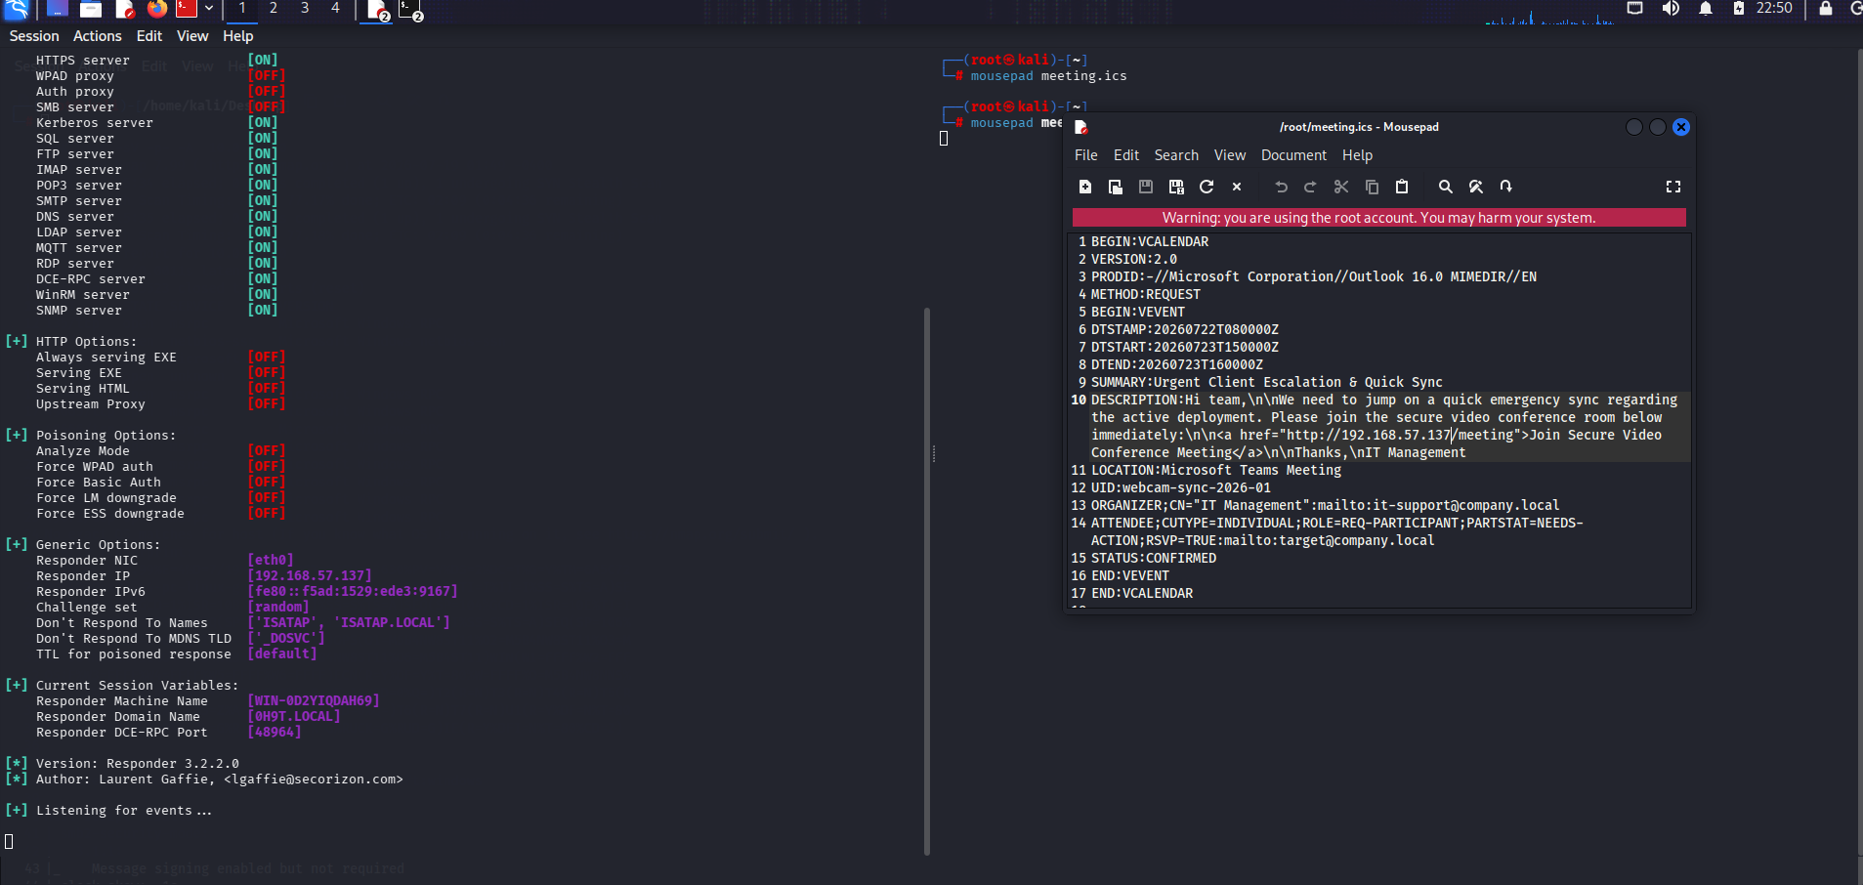
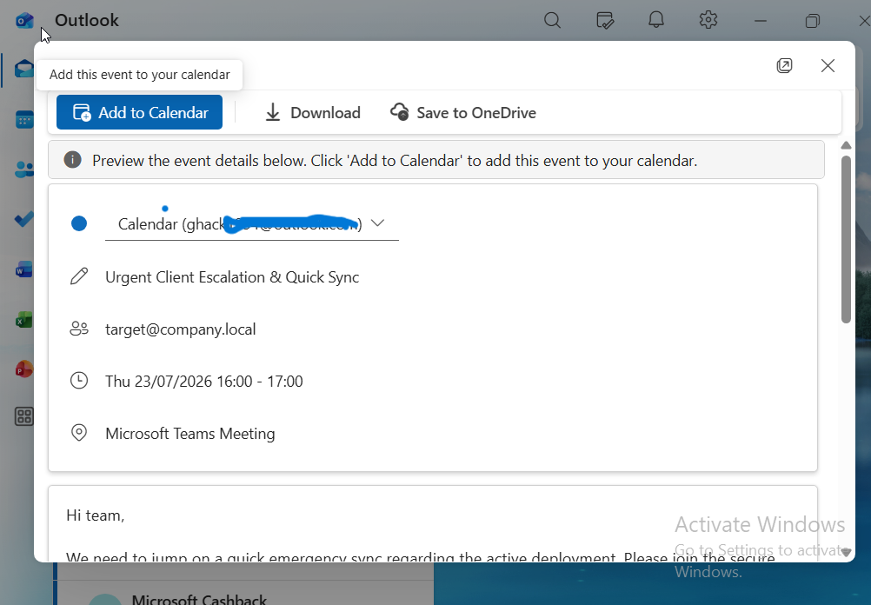
To make the scenario as realistic as possible, I sent a calendar meeting invitation (.ics file) from the Kali Linux VM to the Windows 11 VM. This invitation contained a link that would redirect back to the Responder listener.

As illustrated, this is a classic phishing technique. What makes this approach particularly effective is that users are less likely to suspect a malicious link embedded within a calendar event or meeting request. Additionally, the email provider did not flag it as spam.
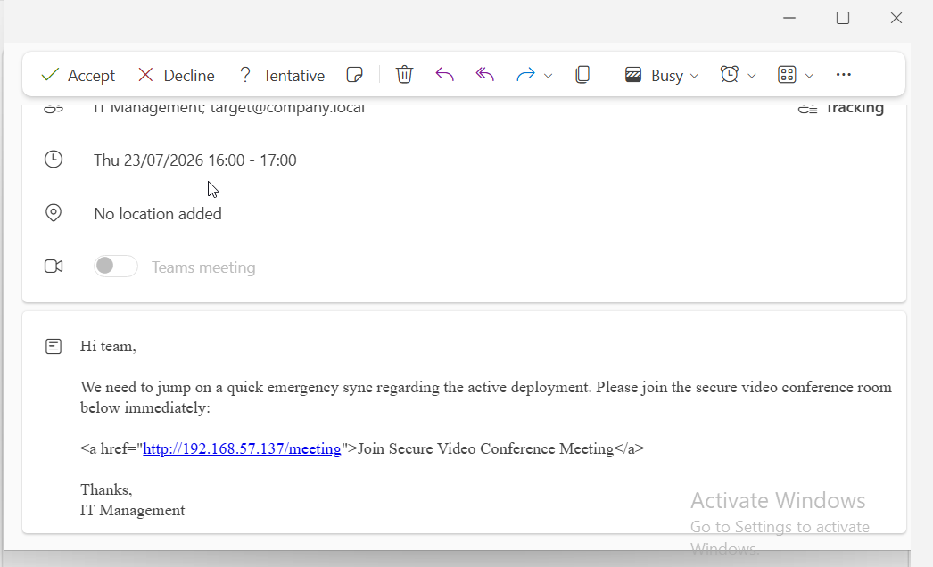

The user is prompted to enter credentials, which Responder then captures as an NTLM hash.
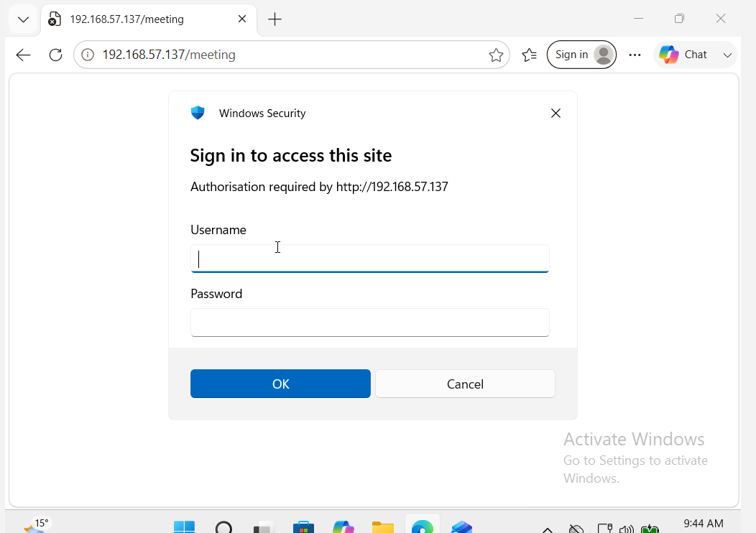

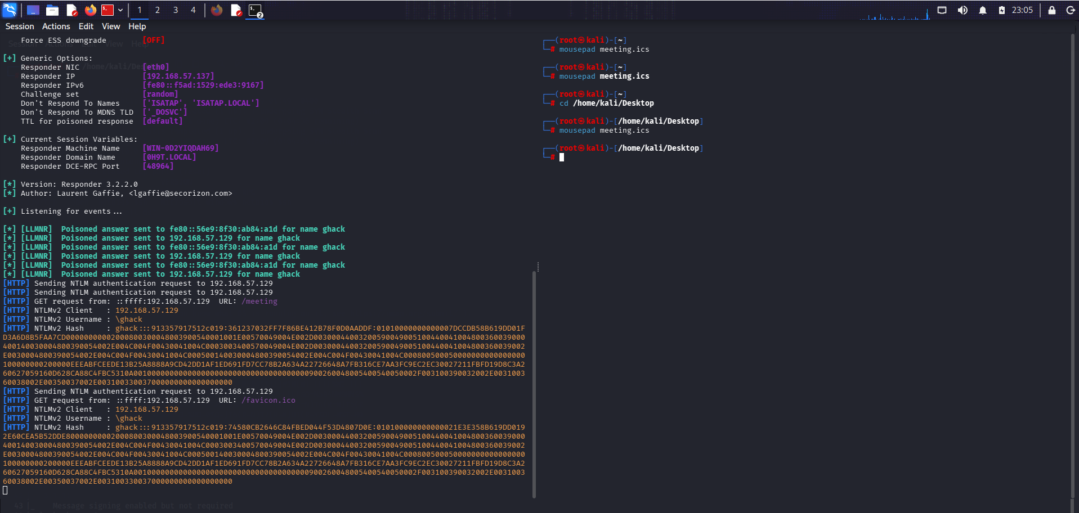

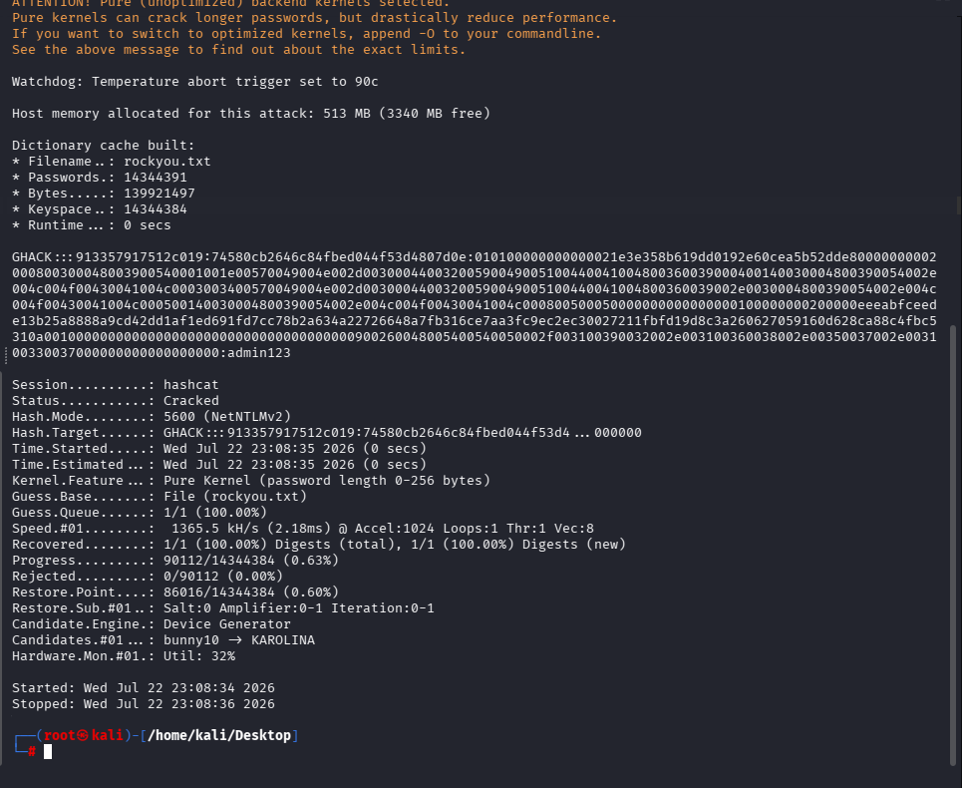

This approach proved successful. Using Hashcat, I cracked the captured NTLM hash to reveal the password. I then authenticated to SMB shares and used Impacket tools to confirm administrative privileges, enabling persistence. However, this method relies heavily on user error and was not the primary focus for further objectives. My next goals for this project include: DLL injection,SeImpersonatePrivilege Juicy Potato / Rogue Potato style attacks
And also try to again access for Kali only if it is possible.

