Assembly of electronic components.
Shield board with power supply 78M05

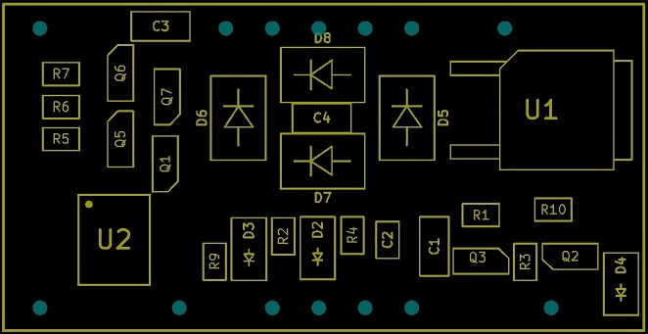

List :
D5, D6 ,D7, D8 : Rectifier diodes SS34 or SS24
U1 : Regulator 78M05
U2 : Driver DRV8870
Q5, Q6, Q7 : Transistor BCR148 or PDTC144
C1 : Cap.Tantal 47µF 16V (1206)
C4 : Capacitor 100n (1206)
R4 : Resistance 33K (0805)
R5,R6,R7 : 1K (0805)

Additional assembly if RailCom and braking ABC.
Q1 ; Transistor BC850
Q2,Q3 : Transistor BC860
D2, D3, D4: Diodes 1N4148 (1206)
R1 : Resistance 22 ohm (0805)
R2, R3 : 10K (0805)
R9: 2K2 (0805)
R10 : 1K (0805)
C2 : Capacitor 1n (0805)

Additional assembly if only braking ABC.
D2, D3: Diodes 1N4148 (1206)
R9: 2K2 (0805)
R10 : 1K (0805)
C2 : Capacitor 1n (0805)

Future extension for EMF feedback control
C3 : Capacitor 100n (0805)

