- Link to your updated fragments microservice Dockerfile on GitHub, showing your optimizations from step 20 above.
  - https://github.com/Lebnaa/fragments/blob/main/Dockerfile
- Link to your Docker Hub fragments repository
  - https://hub.docker.com/repository/docker/lebna/fragments/general
- Screenshot of all of the expected Docker Tags in your Docker Hub repository (see the Tags tab)
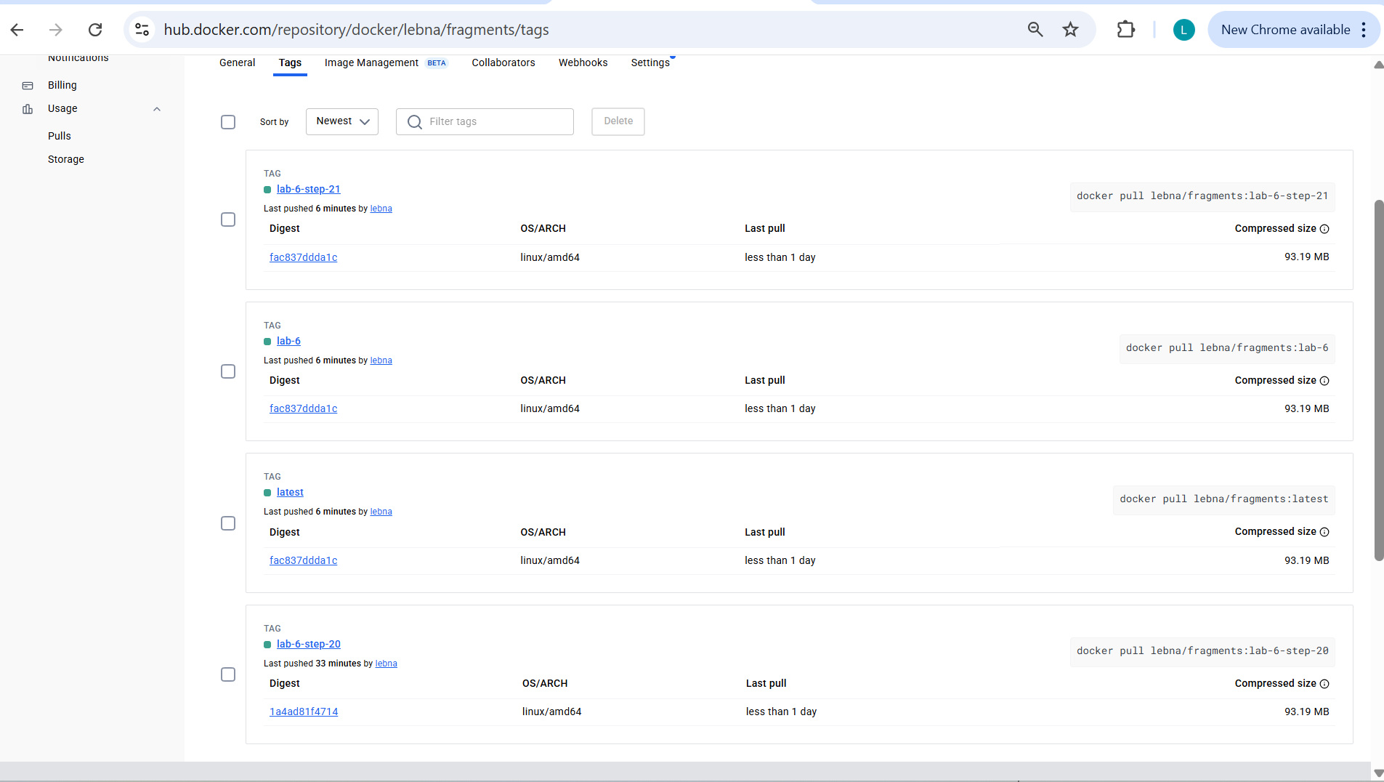
- Screenshot of an EC2 instance running your fragments Docker Hub image.
