An introductory paragraph that describes the system you are building
- I’m building a simple web-based system made up of a back-end microservice and a front-end interface. The back-end handles user authentication and lets users create, store, and retrieve small pieces of content called fragments. These fragments can be plain text or other supported types. Users must log in to use the system, and each person can only access their own data. The front-end connects to the back-end and provides a clean interface for users to manage their fragments easily and securely.
Links to both Private GitHub Repos. Your professor must be a collaborator in order to see them.
- Fragments=> https://github.com/Lebnaa/fragments
- Fragments-ui=> https://github.com/Lebnaa/fragments-ui
Link to successful GitHub Actions CI workflow runs with eslint and all unit tests passing.
- https://github.com/Lebnaa/fragments/actions/runs/15480121688/job/43584299638
- https://github.com/Lebnaa/fragments/actions/runs/15480121688/job/43584299644

Screenshots of the fragments API server running on an EC2 instance. Include a health check JSON response as well as the AWS EC2 URL in the browser
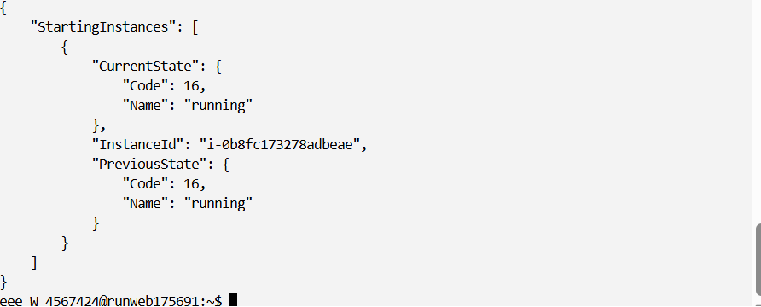
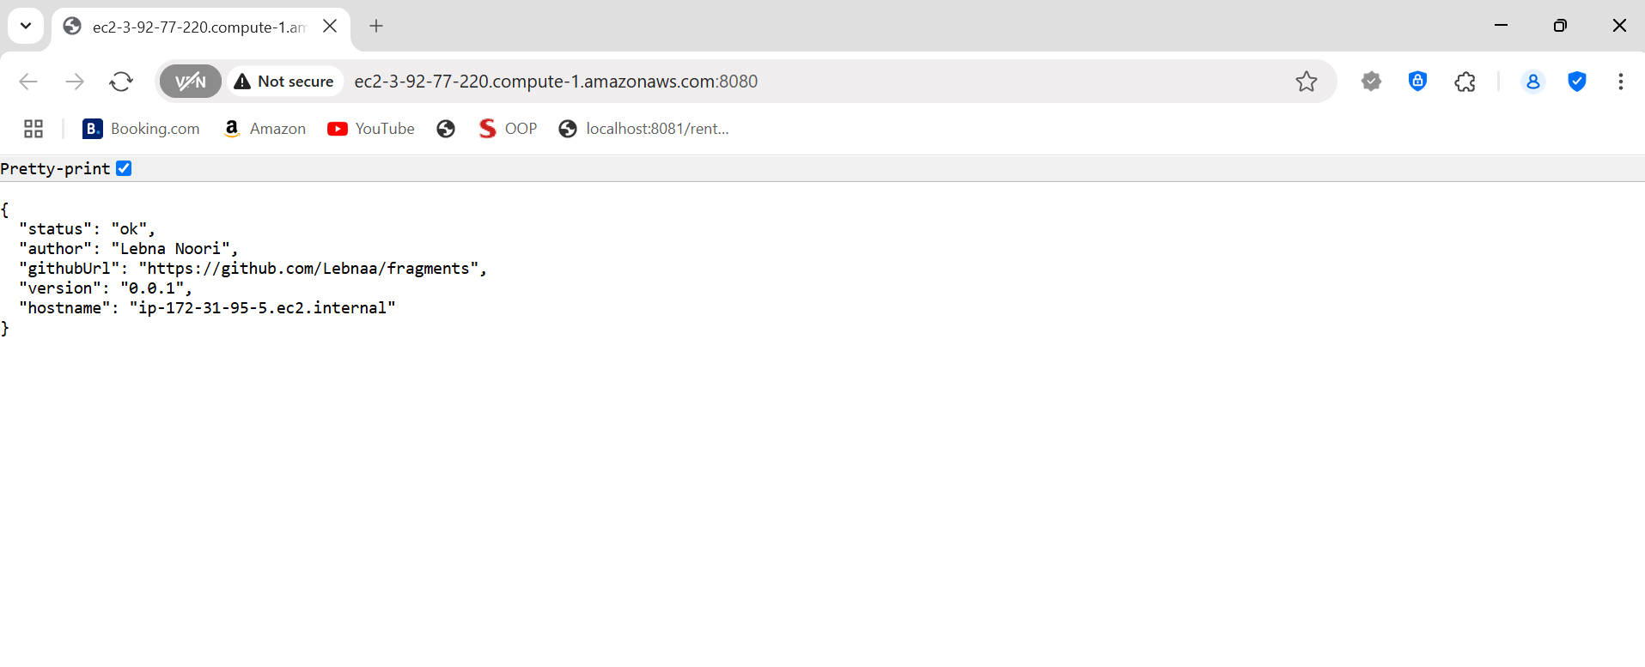

Screenshots of the fragments-ui web app running on localhost authenticating with Amazon Cognito's Hosted UI
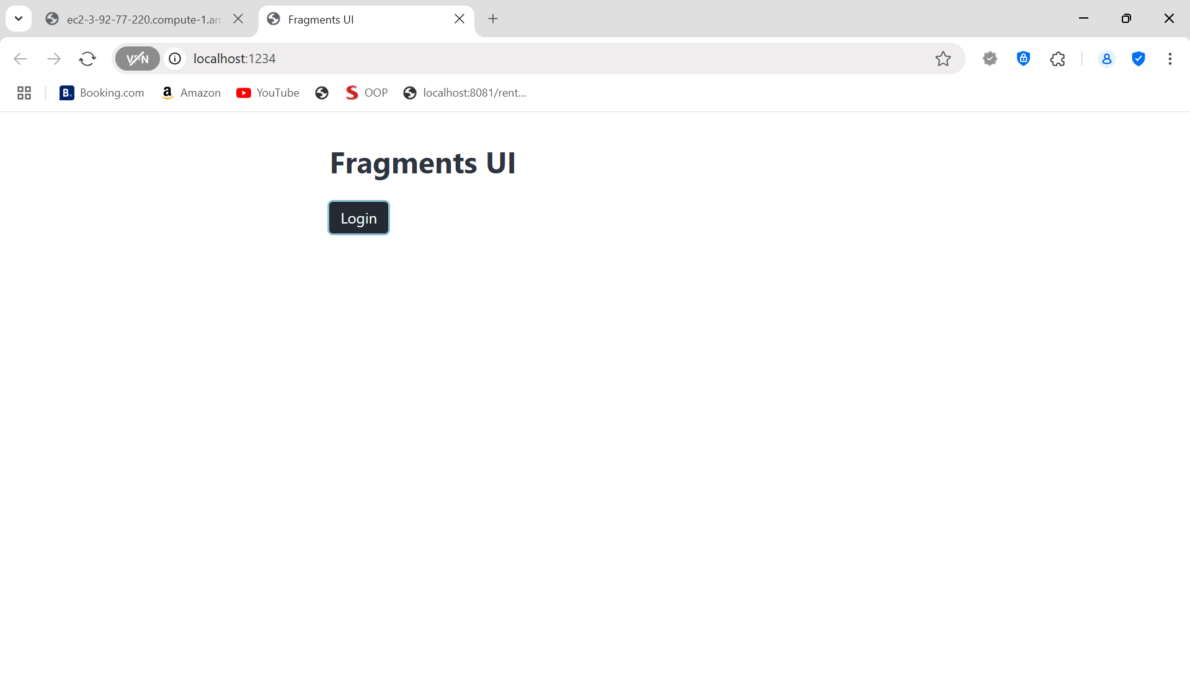
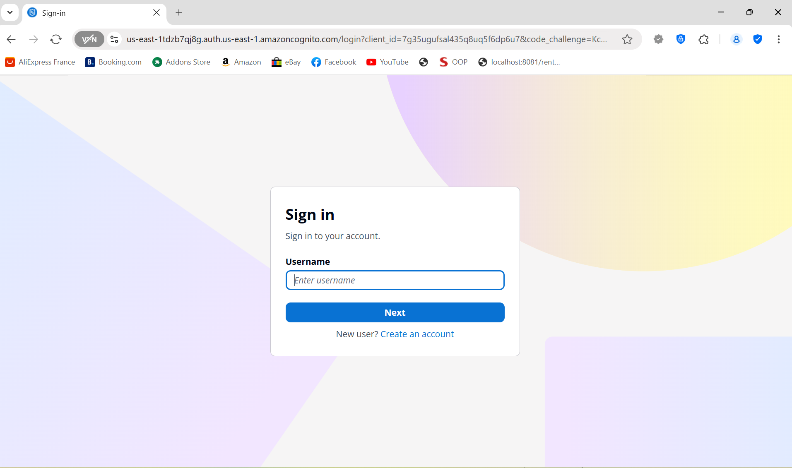

Screenshots of the fragments-ui web app running on localhost successfully creating a text fragment via an HTTP POST to the fragments API server running on EC2. Show the network response in the Dev Tools and make sure the Location header and JSON metadata for the resulting fragment are clearly visible and labelled.

Creates text but still get ‘Unauthorized’
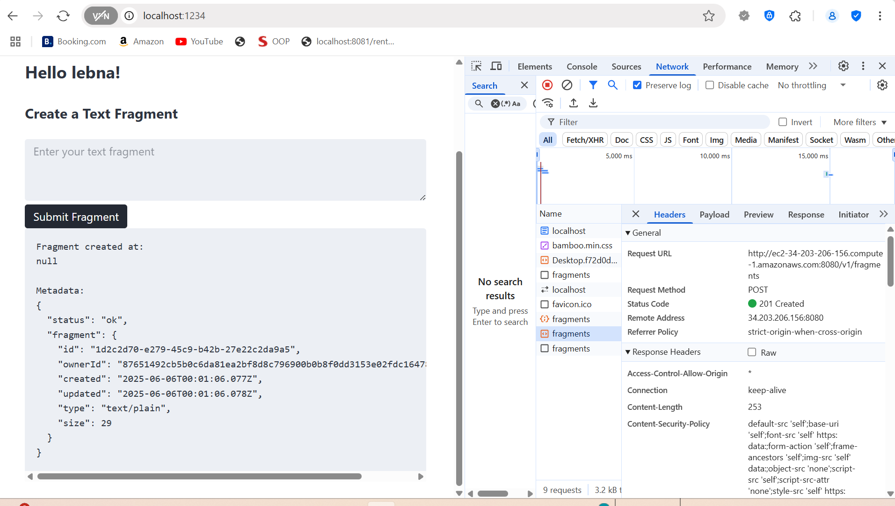

Screenshot of running npm run coverage to show that you've been able to properly cover the majority of your files and lines of code. Make sure your coverage rate is high enough to reflect proper testing for all units of code (above 85% for all files), and that all expected source files are included.
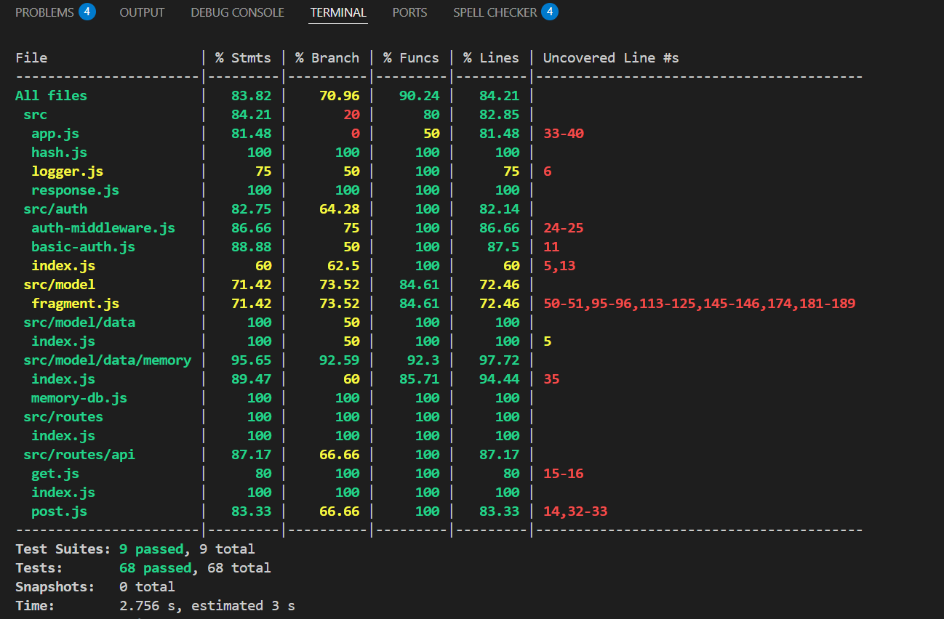

A concluding paragraph, including notes about any bugs or issues that you still need to address in subsequent releases.
- I couldn’t get the app to authorize properly at first, and I’m still not exactly sure why. When I tried posting a fragment, it kept failing due to authorization issues. I suspect it had to do with the environment variables — some parts of the app and test suite expect AWS_COGNITO_POOL_ID and AWS_COGNITO_CLIENT_ID to be set, and without them, the app just breaks. I was trying to use HTTP Basic Auth for local testing, but the app was still tightly coupled to Cognito in certain places. After many practices, I was able to figure it out and get a request to go through successfully. I managed to post data and get a valid response. Going forward, I plan to improve the way the app handles missing environment variables and make sure it can fall back more gracefully when Cognito isn’t configured.

