Links to both private GitHub repos
- https://github.com/Lebnaa/fragments
- https://github.com/Lebnaa/fragments-ui
Links to your public Docker Hub repos
- https://hub.docker.com/repository/docker/lebna/fragments/general
Link to AWS Elastic Container Service hosted version of fragments API server (i.e., load balancer URL)
- http://fragments-lb-1794806756.us-east-1.elb.amazonaws.com
Link to successful GitHub Actions CI workflow run, showing eslint, unit tests, integration tests, and Docker image publish to Docker Hub
- https://github.com/Lebnaa/fragments/actions/runs/16893621908
Link to successful GitHub Actions CD workflow run, showing Docker image publish to Amazon ECR, and deploy to AWS Elastic Container Service
- Previous successful run
  - https://github.com/Lebnaa/fragments/actions/runs/16531969057
- This new version 1.0.1 did not pass due to lack of permission
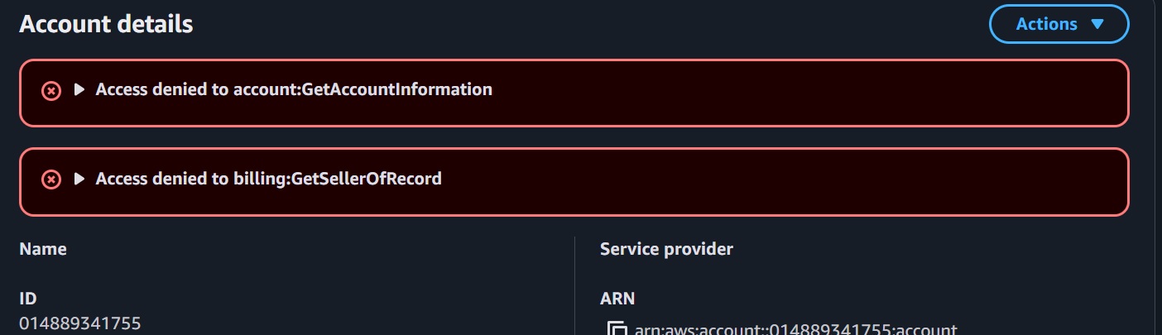

Screenshot of running npm run coverage to show that you've been able to properly cover the majority of your files and lines of code. Make sure your coverage rate is high enough to reflect proper testing for all units of code (>80% and includes all necessary files).
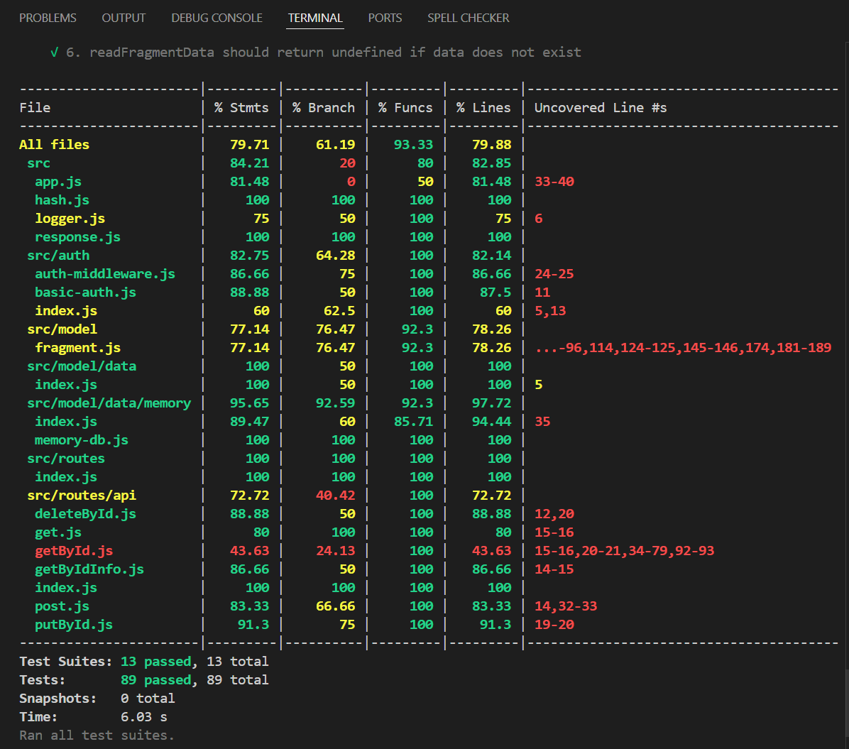
List of deficiencies: any known bugs, unsupported spec requirements, missing tests, or other issues that you did not, or could not complete. Discuss what still needs to be done in order to complete these.
- 500 Internal Server Error when Posting to Load Balancer URL
- When using the AWS Elastic Load Balancer URL for the Fragments API, POST /fragments consistently returns a 500 status code. The same request works correctly when posting to the API running locally (http://localhost:8080).
This suggests there might be a deployment configuration issue, environment variable mismatch, or a problem with how AWS ECS services communicate with S3/DynamoDB in production that I unfortunately could not figure out.
- Unresolved AWS ECR Authentication Issue in CI/CD
- GitHub Actions workflow encounters “ecr:GetAuthorizationToken” permission errors when attempting to push to AWS Elastic Container Registry.
The explicit deny in the IAM policy prevents automation of ECR pushes, limiting deployment to manual builds or Docker Hub.

