Link to your completed tests/integration/lab-9-s3.hurl in your fragments GitHub repo
- https://github.com/Lebnaa/fragments/actions/runs/16429042590/job/46426396747
Screenshot of your tests/integration/lab-9-s3.hurl test passing, when run against your fragments server and LocalStack using docker compose (i.e., show the terminal(s) running the necessary commands to make this happen)
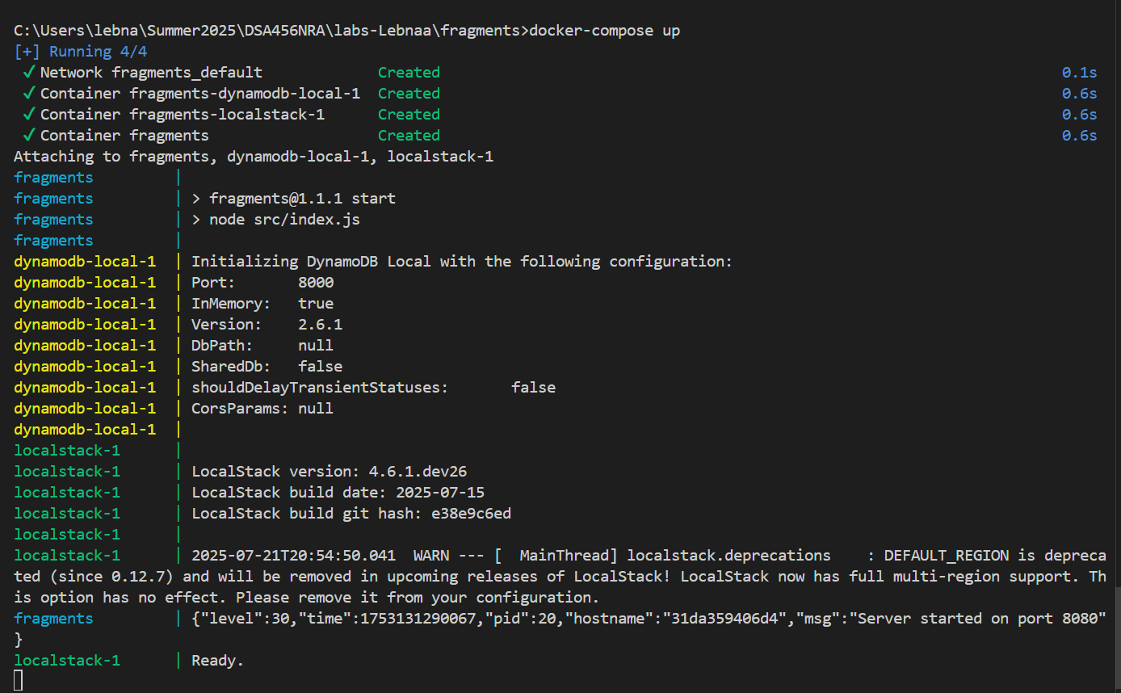
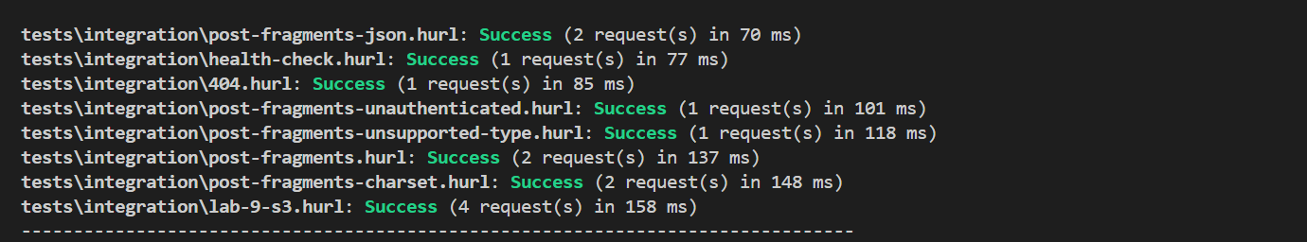

Screenshot of your fragments-ui creating a fragment using your Elastic Container Service deployment (i.e., show the Network tab to prove which back-end service is being used)
Not able to post, as I keep getting 500 internal error. My server keep crashing . I need to debug the server, I will have It fixed for our upcoming labs
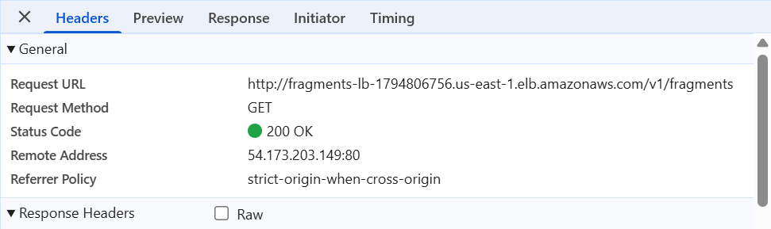
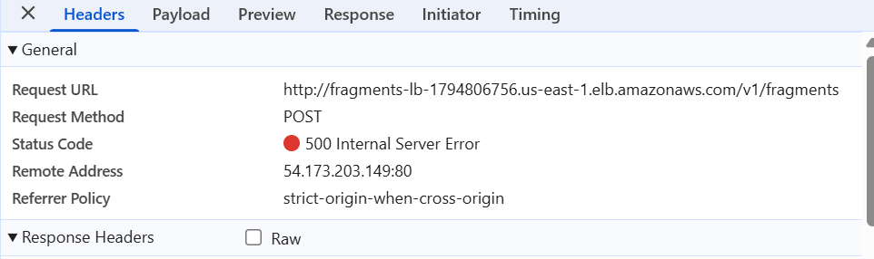

Screenshot of the AWS S3 Console showing the fragment you just created in S3 as an object in your bucket (i.e., prove that you've been able to create the fragment data in S3)
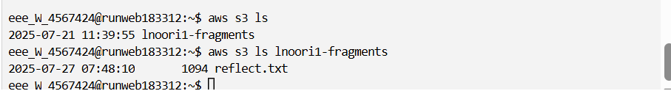s

