Link to your completed tests/integration/lab-10-dynamodb.hurl in your fragments GitHub repo
- https://github.com/Lebnaa/fragments/actions/runs/16705798737/job/47283688932
Screenshot of your tests/integration/lab-10-dynamodb.hurl test passing, when run against your fragments server, LocalStack, and DynamoDB Local using docker compose (i.e., show the terminal(s) running the necessary commands to make this happen).
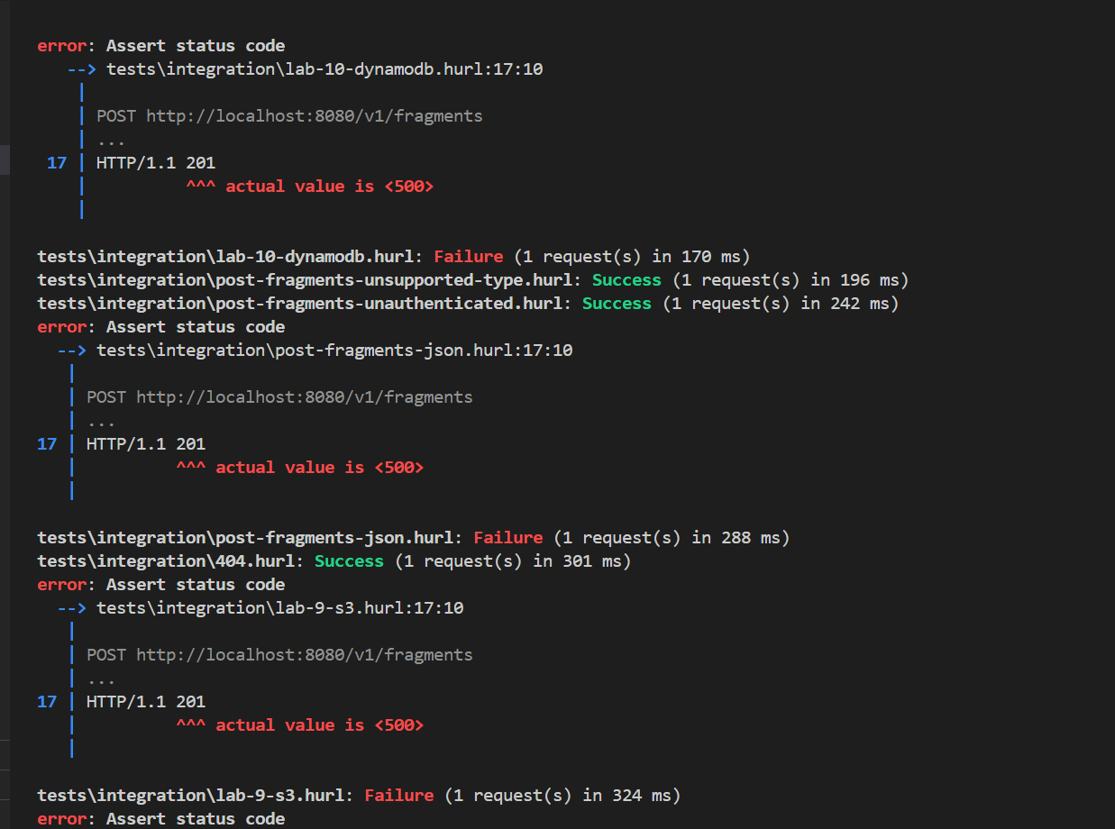

Screenshot of your ci.yml GitHub Actions Workflow passing everything, including your integration tests.
- Other then status code 500, all other tests have passed.
- 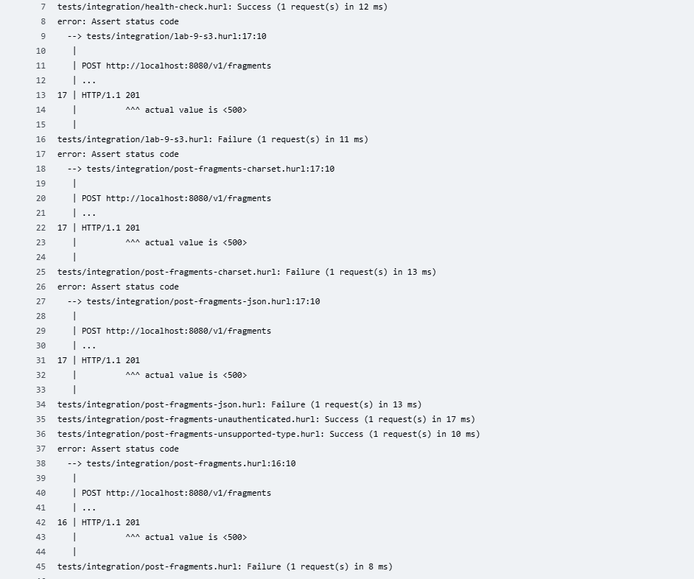

Screenshot of your fragments-ui creating a fragment using your Elastic Container Service deployment (i.e., show the Network tab to prove which back-end service is being used)
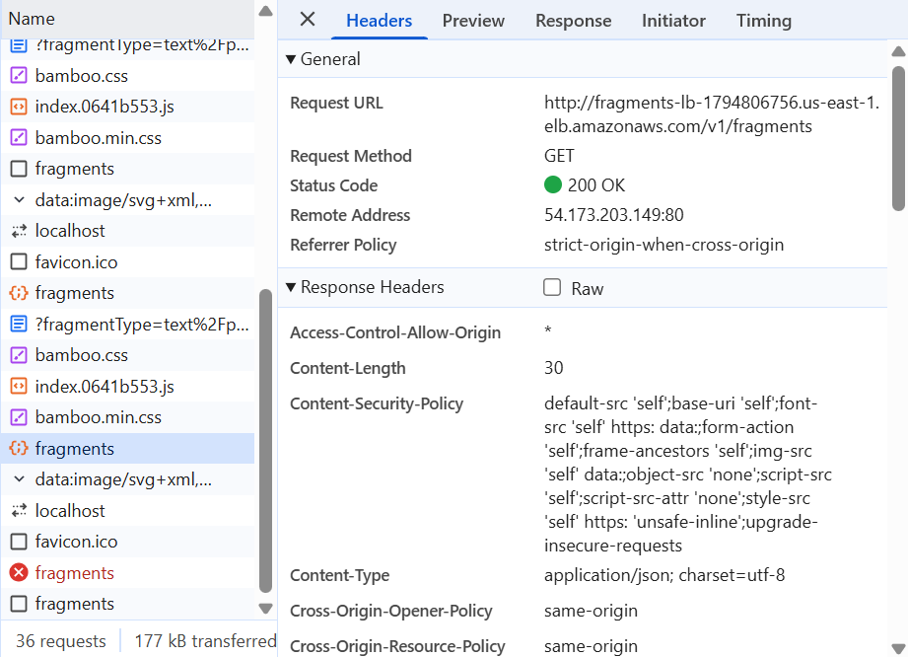
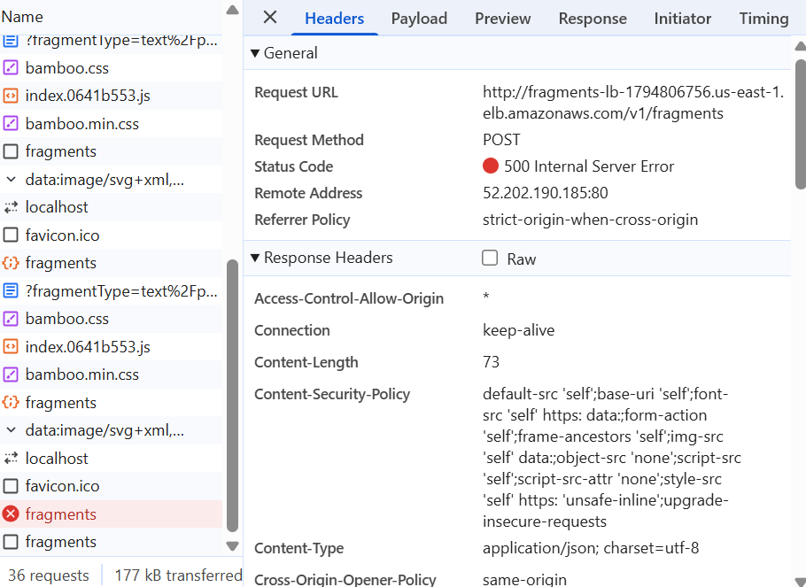
Screenshot of the AWS DynamoDB Console showing the fragment you just created in DynamoDB as an Item in your Table (i.e., prove that you've been able to create the fragment metadata in DynamoDB)
