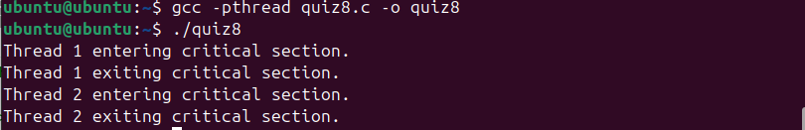
Number of Threads: 2 threads (Thread 1 and Thread 2).
Attributes Passed: Default joinable.
Number of Mutexes: 1 mutex.
Critical Section: Code between pthread_mutex_lock() and pthread_mutex_unlock().
Type of Threads: Joinable.

