3.1 Page load when not logged in
- 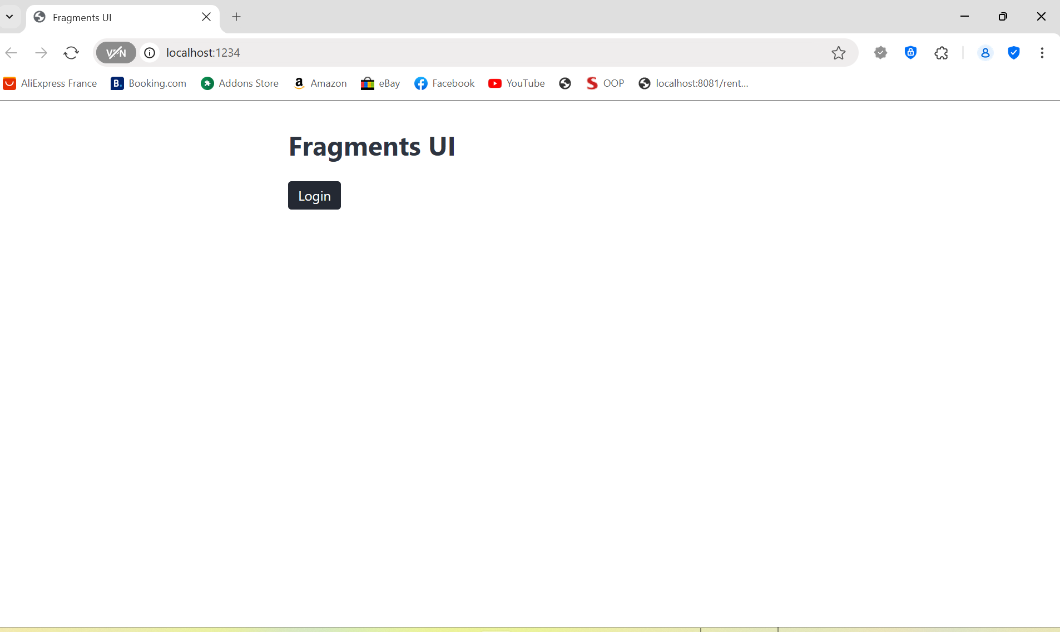
3.2 Clicking the Login button and being redirected to the Hosted UI
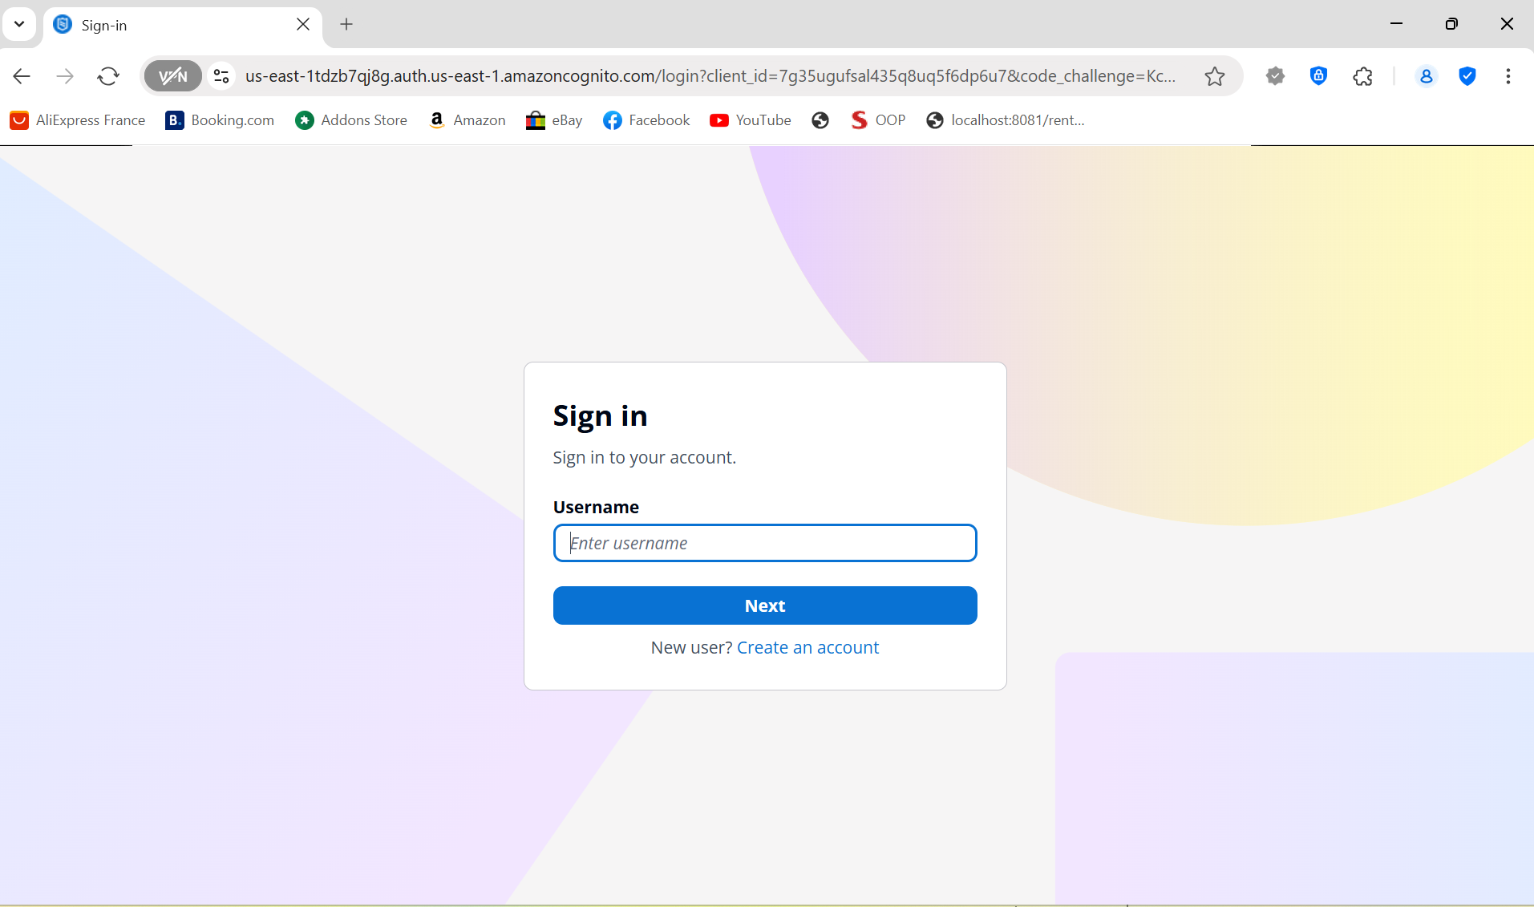

3.3 Page load when logged in (should display the username) and the Console should show a successful request to get the user's fragments.
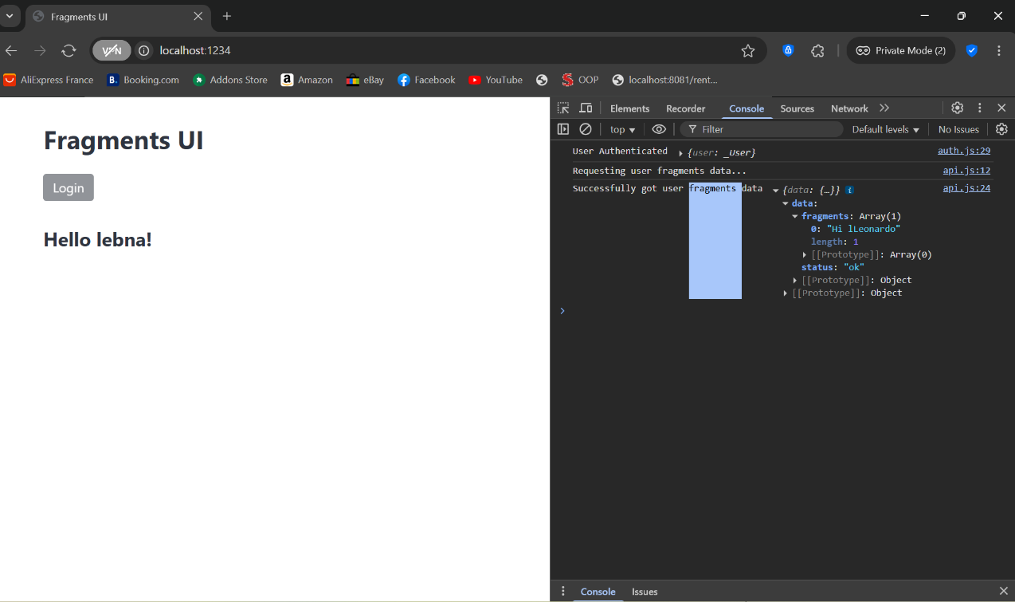
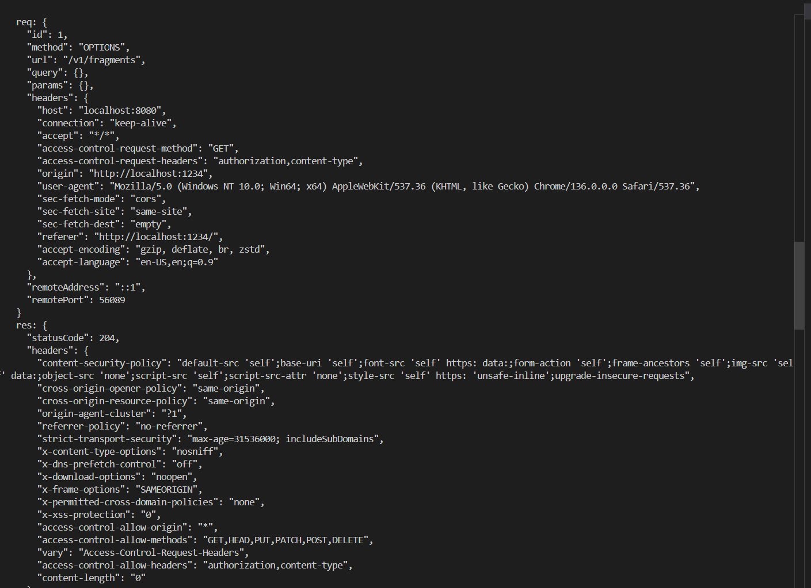
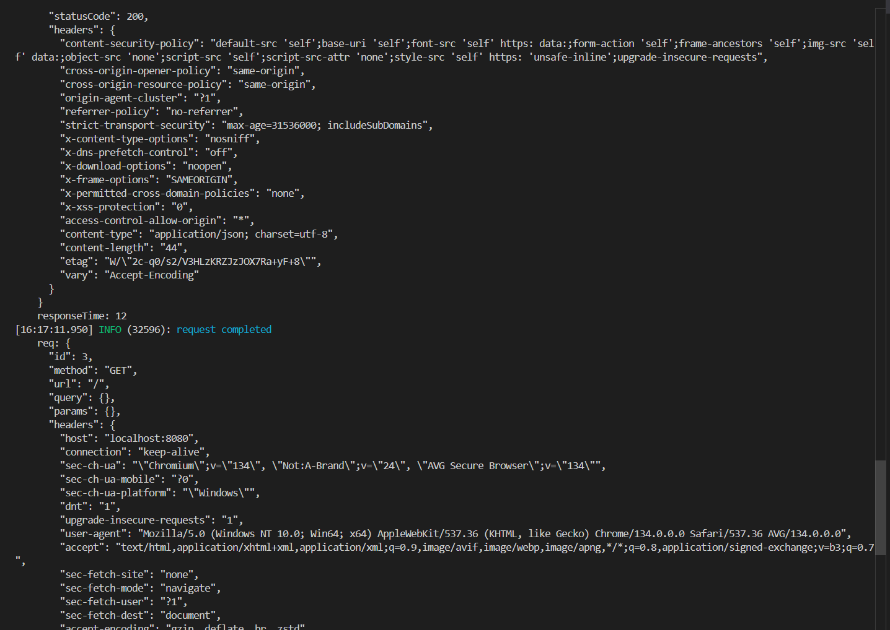

Take a screenshot of the AWS Console Cognito page in the Users and groups section for your User Pool, showing the user you created when you signed up.
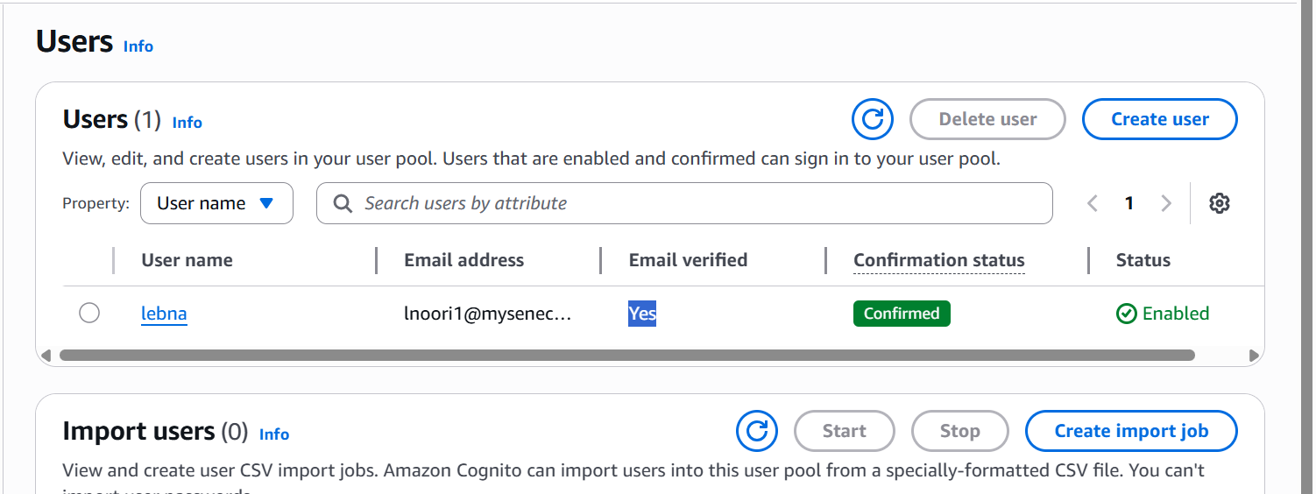

Take a screenshot(s) of your fragments server logs showing:
a) the Cognito service being started
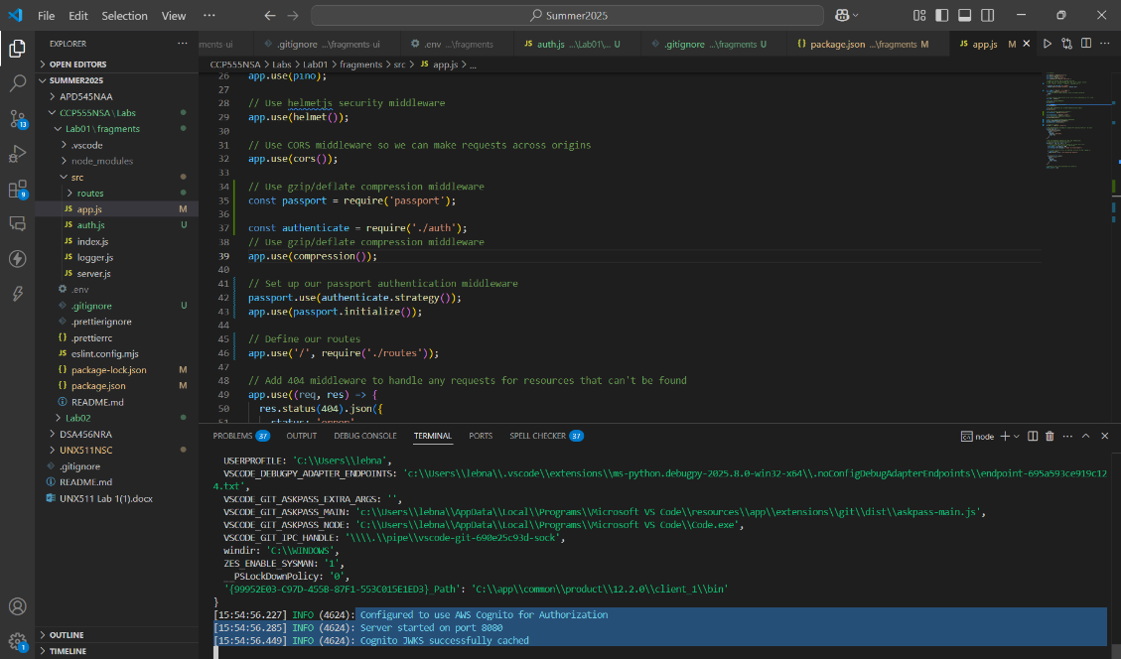
b) an authenticated user accessing a protected route successfully;

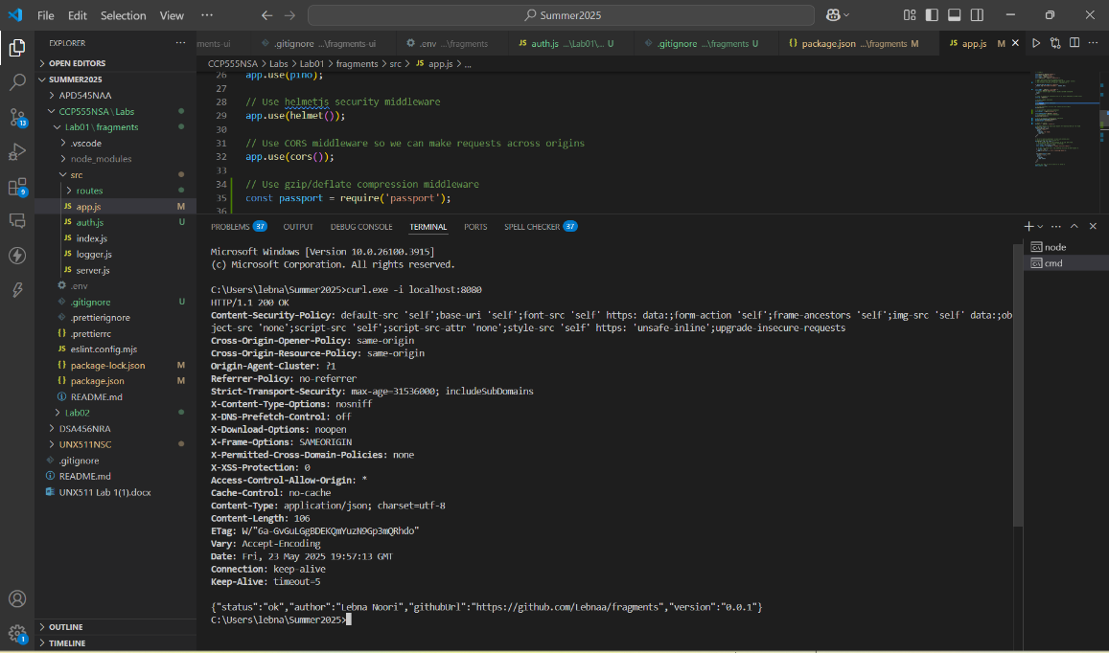

c) an unauthenticated user attempting to access a protected route, but it failing. The log messages and HTTP Status Codes should be clearly visible.
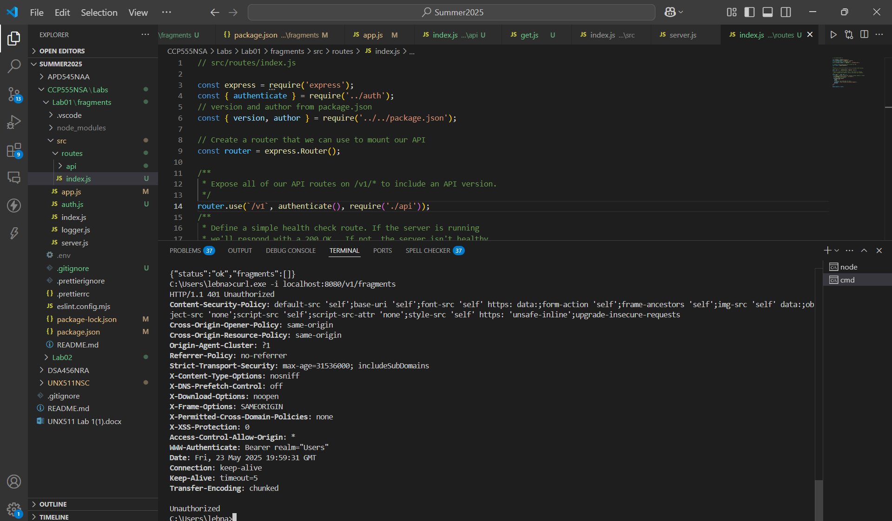

After you successfully log in, copy the idToken value from the user object in the console to your clipboard and paste it into the JWT Debugger at jwt.io. Take a screenshot of the Decoded payload.
