1) What does the above program do? explain each line of code.
- The code copies the contents of a file named foo to a new file named output.txt
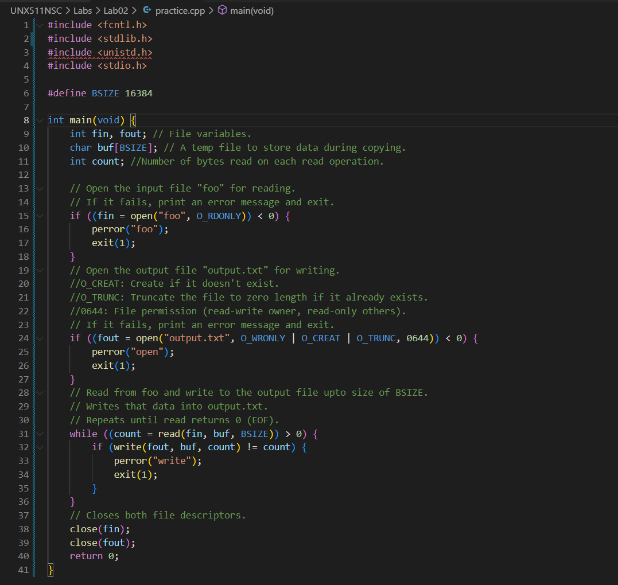

2) Try to run this code. You may get some errors that you need to fix them.
- missing library
- not returning anything
- missing library for read(), write(), and close()
3) Create a MakeFile for this program.
- created the file but since the ‘foo’ doesn’t exist, it wouldn’t be able to copy anything and generate the output.txt
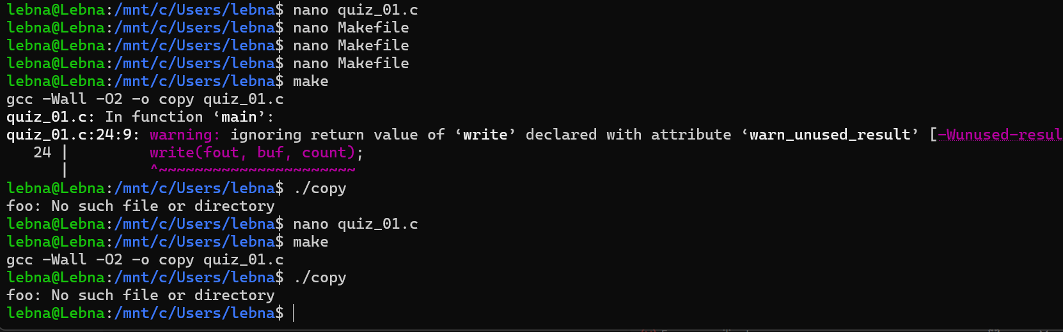

- I added some content to ‘foo
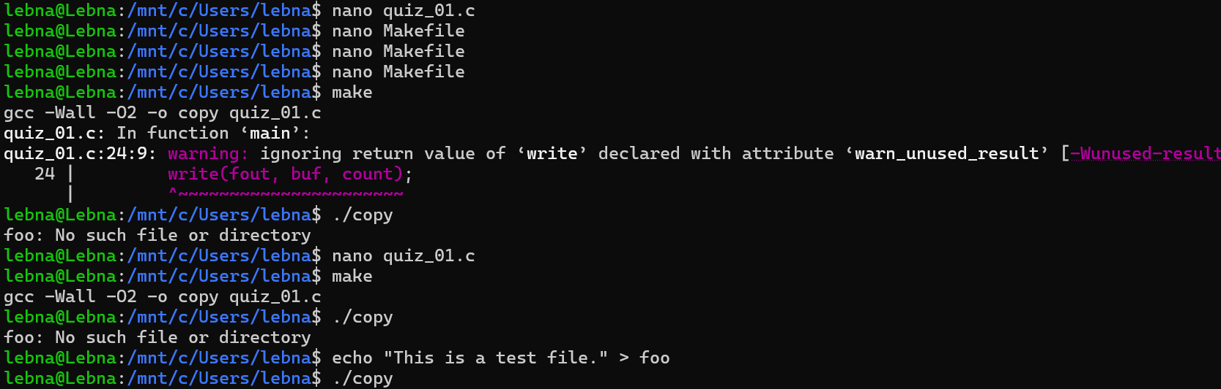

Result
-

