UNX511 Lab 5: I/O Control
Due: Sunday, June 15, 2025 (11:59pm)
Complete all steps, Add all output-screenshot and explanations (if required) to a MS-Word file.
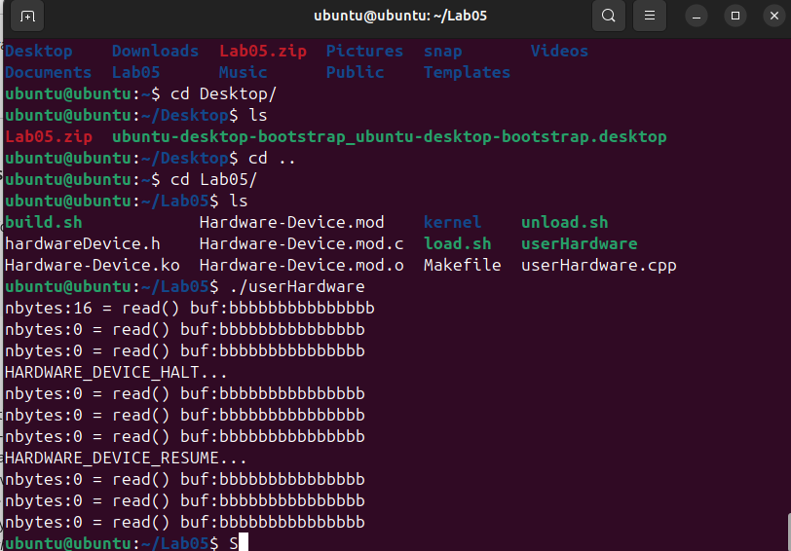

•
Please answer the following two declarations:
    - D1) On a scale from 1 to 5, How much did you use generative AI to complete this assignment?
      - where:
      - 1 means you did not use generative AI at all
      - 2 means you used it very minimally
      - 3 means you used it moderately
      - 4 means you used it significantly ▪
      - 5 means you relied on it almost entirely ▪
      - Your answer : I used generative AI minimally during this assignment. Mostly, I asked for help with specific coding questions, debugging tips, and clarifications on certain parts of the driver code. But, the design, implementation, and understanding of the assignment were done by me. AI was just a small support tool to speed up some steps and confirm details.

    - D2) On a scale from 1 to 5, How confident are you in your understanding of the generative AI support you utilized in this assignment, and in your ability to explain it if questioned?
      - where:
      - 1 means "Not confident at all – I do not understand the generative AI support I used and cannot explain it."
      - 2 means "Slightly confident – I understand a little, but I have many uncertainties."
      - 3 means "Moderately confident – I understand the majority of the support, though some parts are unclear."
      - 4 means "Very confident – I understand most of the AI support well and can explain it with minor gaps."
      - 5 means "Extremely confident – I fully understand the generative AI support I
used and can clearly explain or justify it if asked."
▪ Your answer : I’m very confident in my understanding of the generative AI support I used. I understood most of the explanations and suggestions it provided, and I can explain how and why I used that support in the assignment, with just a few minor details I might need to review further.

