- Screenshot of your running EC2 instance details in the AWS Console
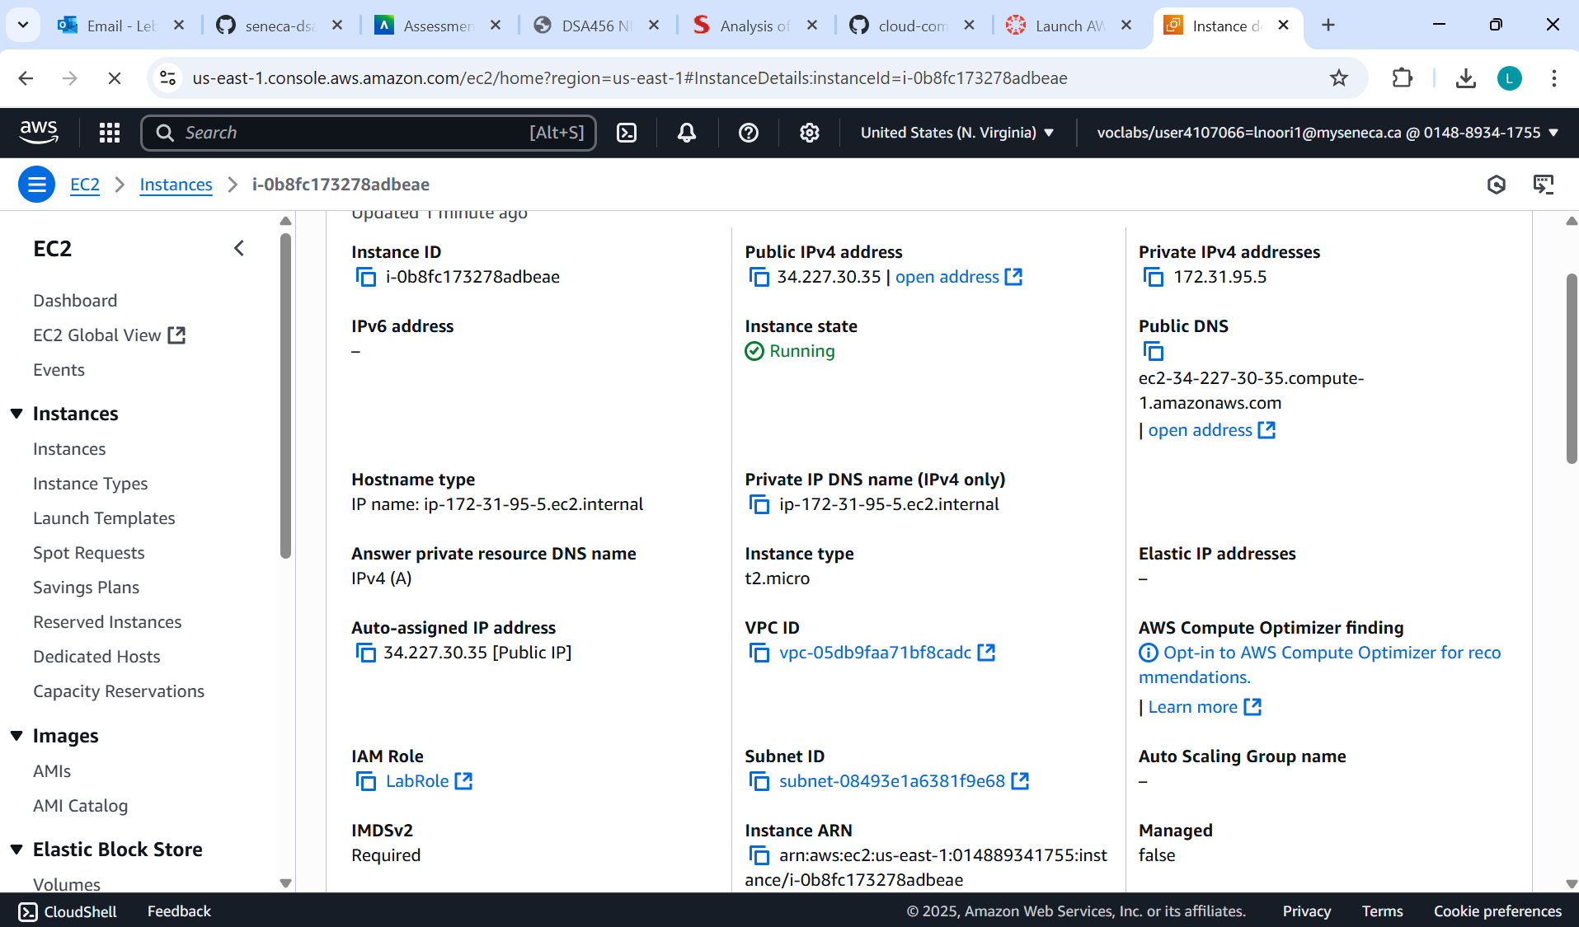
- Using your web browser. In the address bar, put the IPv4 DNS of your EC2 instance along with :8080 for the port number (i.e., our server is running on port 8080). Take a screenshot showing the result of the health check route (i.e., /), and also the URL in the address bar, showing your EC2 instance's URL.
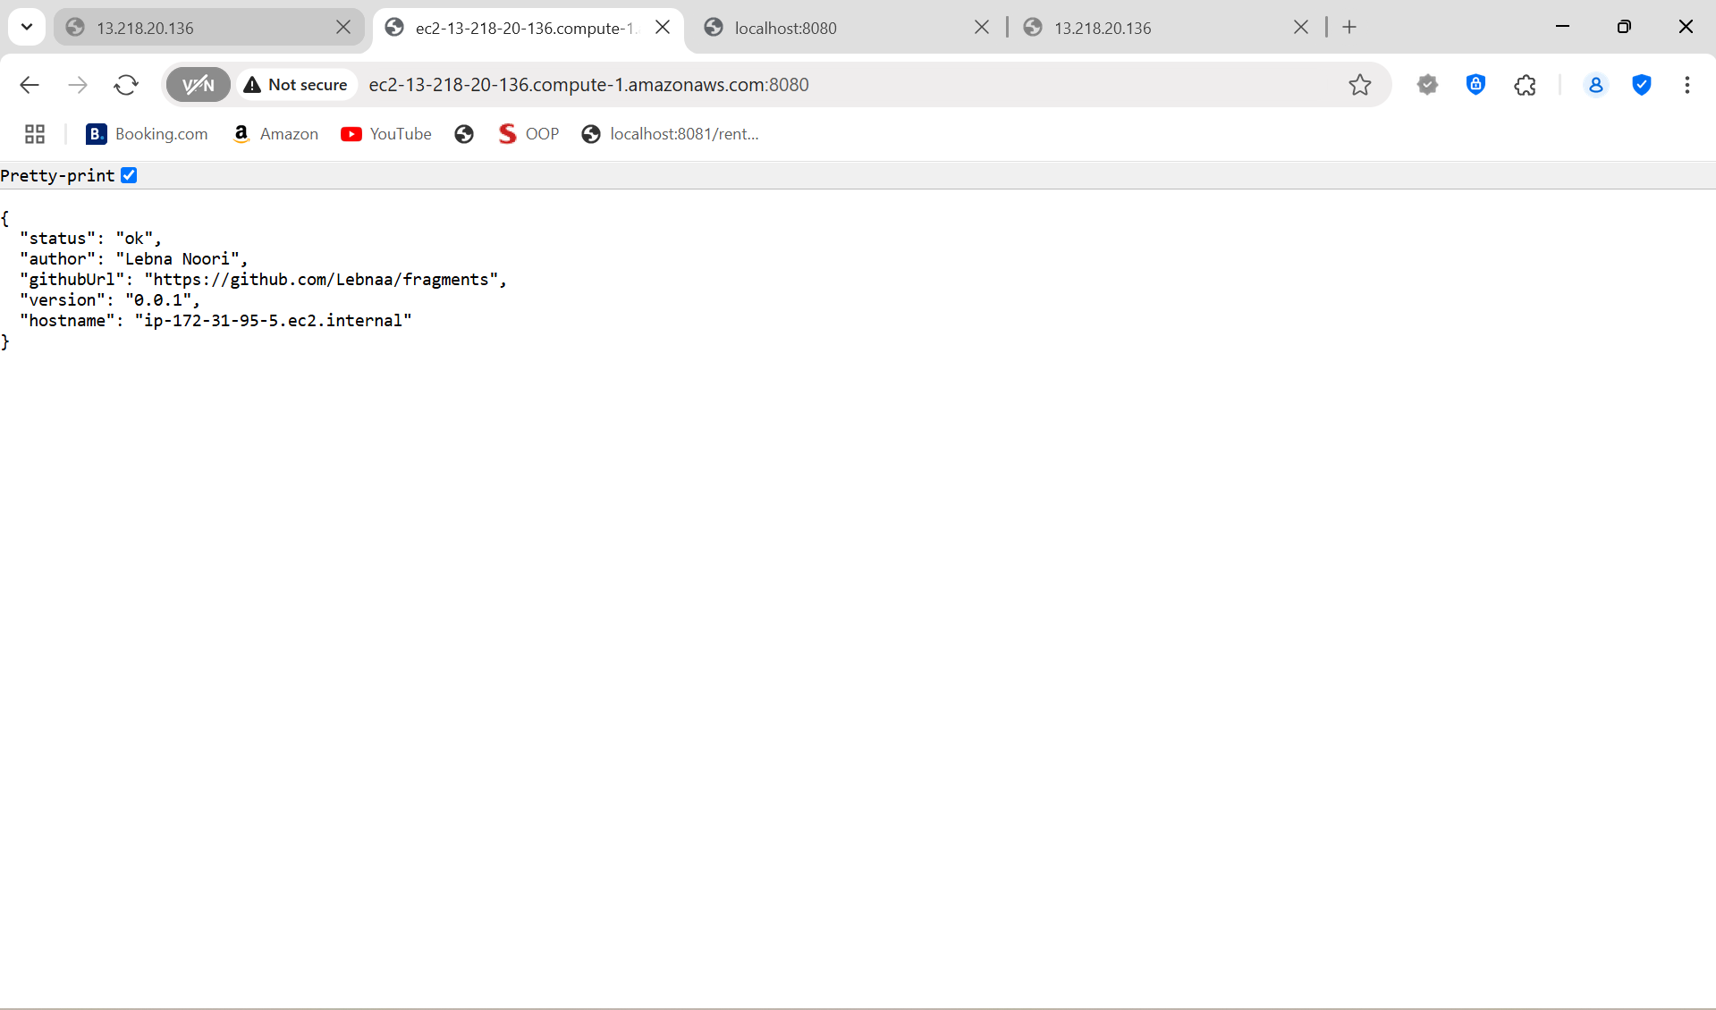
- Using curl on your local machine. Do the same thing you did in your browser, but use curl in the terminal. Take a screenshot.
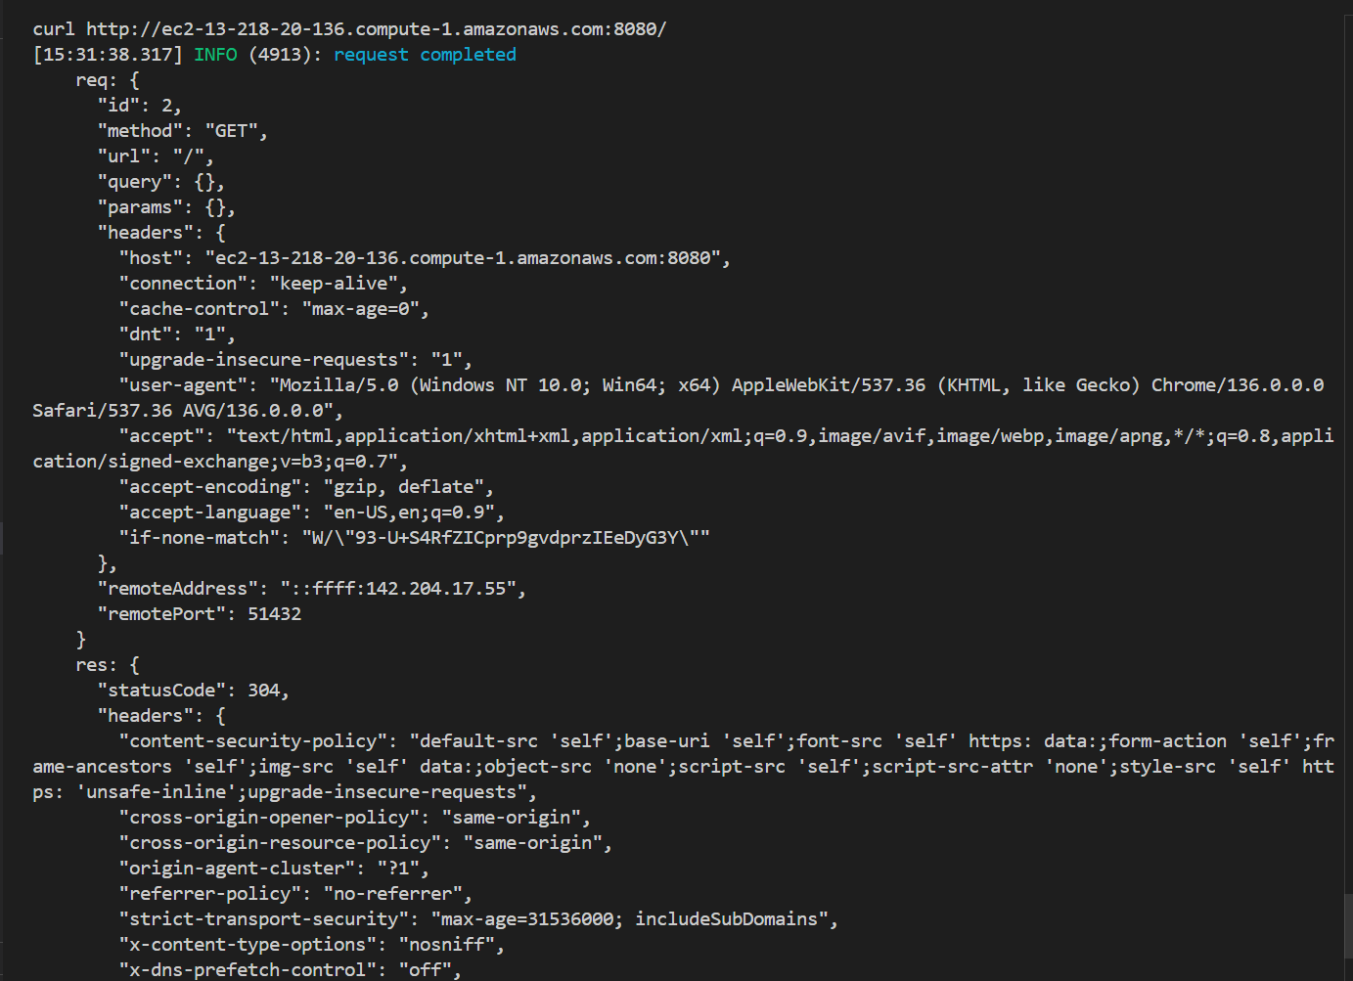
- Connect a second terminal to your EC2 instance (i.e., ssh into your EC2 instance a second time, while your server is running in the other terminal), and use curl to connect to your microservice running on localhost. Take a screenshot.
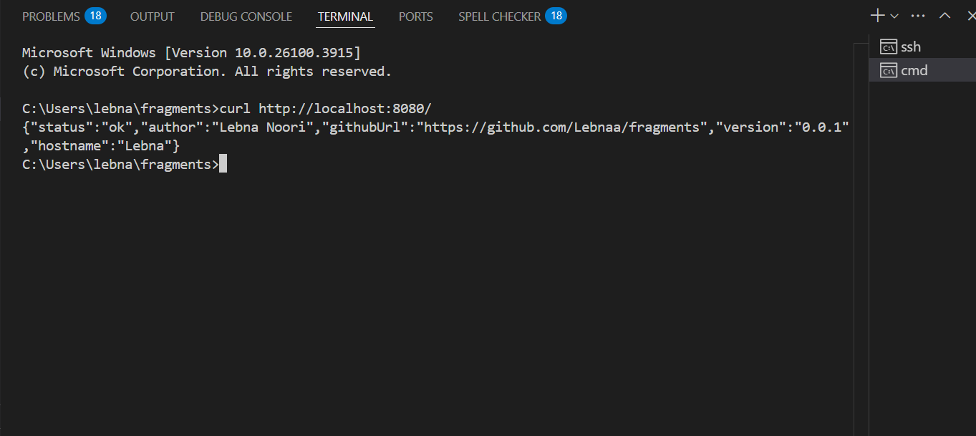

- Use the AWS CLI to start your instance with the aws ec2 start-instances command, replacing {instance-id} with your instance's Instance ID from step 39. You should get JSON output indicating that your instance is starting (i.e., CurrentState.Name = "pending") similar to what is included below:
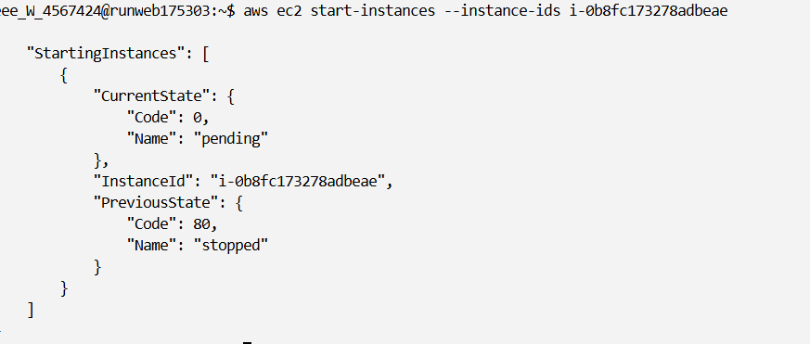
- Go to the AWS CLI in the Learner Lab and stop your instance with the aws ec2 stop-instances command, replacing {instance-id} with your Instance's Instance ID from step 32. You should get JSON output indicating that your instance is stopping (i.e., CurrentState.Name = "stopping") similar to what is included below:
