Fragments Microservice System
Technical Report

Student Name: Lebna Noori
Student ID: 157672205
Course: CCP555
Instructor: Robin Huang
Date: July 2025

1. Introduction
- This project is about building a Fragments Microservice system that allows users to create, store, and get small pieces of text data called fragments. Since Assignment 1, main progress has been made in developing both the back-end API server and the front-end web app to make the system more complete and reliable.

- On the back-end, the API server is built with Node.js and Express, following best practices for code organization and security. Key improvements include:
  - A properly configured project repository with clear documentation and configuration files.
  - Use of tools like ESLint and Prettier to maintain clean, consistent code.
  - Detailed logging using Pino with different log levels (info, debug, warn, error) to help track the system’s behavior and troubleshoot problems.
  - Secure API routes that require user authentication, implemented using Passport.js with options for either Basic Auth or Amazon Cognito.
  - Management of environment variables with dotenv to keep sensitive information out of the codebase.
  - An in-memory database to store fragment metadata and data, fully covered by unit tests to ensure reliability.
  - Well-defined success and error responses in JSON format to provide clear communication between client and server.
  - A GitHub Actions continuous integration workflow that automatically runs linting and unit tests on every code change.
  - Deployment of the API server inside a Docker container running on an AWS EC2 instance, connected to Amazon Cognito for user authentication.
On the front-end side, the fragments-ui web application supports user login via Amazon Cognito and allows users to create and view fragments. The app is built with a bundler for easy development and can connect to either a local or cloud-hosted backend API.
Together, these updates have made the system more secure, maintainable, and ready for real-world use, demonstrating a clear understanding of modern development practices and cloud deployment.

2. System Design and Implementation
2.1 Backend API
- Built using Node.js and Express
- Fragment data model uses an in-memory database (memory strategy)
- Authentication is handled via Passport.js with Amazon Cognito integration
- Logging uses Pino with structured logs (debug, info, warn, error)
- Environment variables managed securely with dotenv
- API routes versioned with /v1 prefix and properly secured
- Supports fragment creation, retrieval, and metadata endpoints
- Unit testing with Jest and Supertest included, with good coverage (>85%)
2.2 Frontend UI
- Simple web app built with HTML, CSS (Bamboo.css), and JavaScript
- Uses Amazon Cognito Hosted UI for OAuth2 login and authorization
- Configured to switch backend URLs for local development or AWS EC2 deployment
- Allows users to create and view text fragments securely
3. Testing and Results
3.1 Unit Testing
- All major backend functionality covered by Jest unit tests
- Tests cover authentication, fragment creation, retrieval, error cases
- Tests run successfully both locally and in GitHub Actions CI pipeline
- Coverage reports confirm over 85% coverage on all source files
3.2 API and UI Testing
- API endpoints tested with Postman and supertest scripts
- Frontend UI tested on localhost, successfully authenticating users
- Verified fragment creation via POST and retrieval via GET requests
- Proper HTTP status codes and JSON responses returned in all cases
4. Deployment on AWS EC2
- Backend API deployed manually on an EC2 instance using Docker containers
- Used official pre-built Docker Hub image for deployment (no local building on EC2)
- Configured environment variables for production and logging at debug level
- Fragments UI running on localhost successfully connects to EC2 backend API
- Verified using curl and browser screenshots that API health check returns correct JSON

Links to both Private GitHub Repos with all necessary files included in git
- https://github.com/Lebnaa/fragments
- https://github.com/Lebnaa/fragments-ui
Links to both your public Docker Hub repositories with your built Docker Images
- https://hub.docker.com/repository/docker/lebna/fragments/general
- https://hub.docker.com/repository/docker/lebna/fragments/tags
Link to a successful GitHub Actions CI workflow running your unit tests
- https://github.com/Lebnaa/fragments/actions

- Screenshots of your fragments API server running as a container on EC2 based on your Docker Hub image. Make sure you show and label the health heck JSON response in the browser or via curl.

- Screenshots of your fragments-ui web app running on localhost and connecting to your Docker Container running on EC2 and your Amazon Cognito User Pool, doing the following:
  - User authenticating with Cognito Hosted UI and showing the metadata for all of their existing fragments
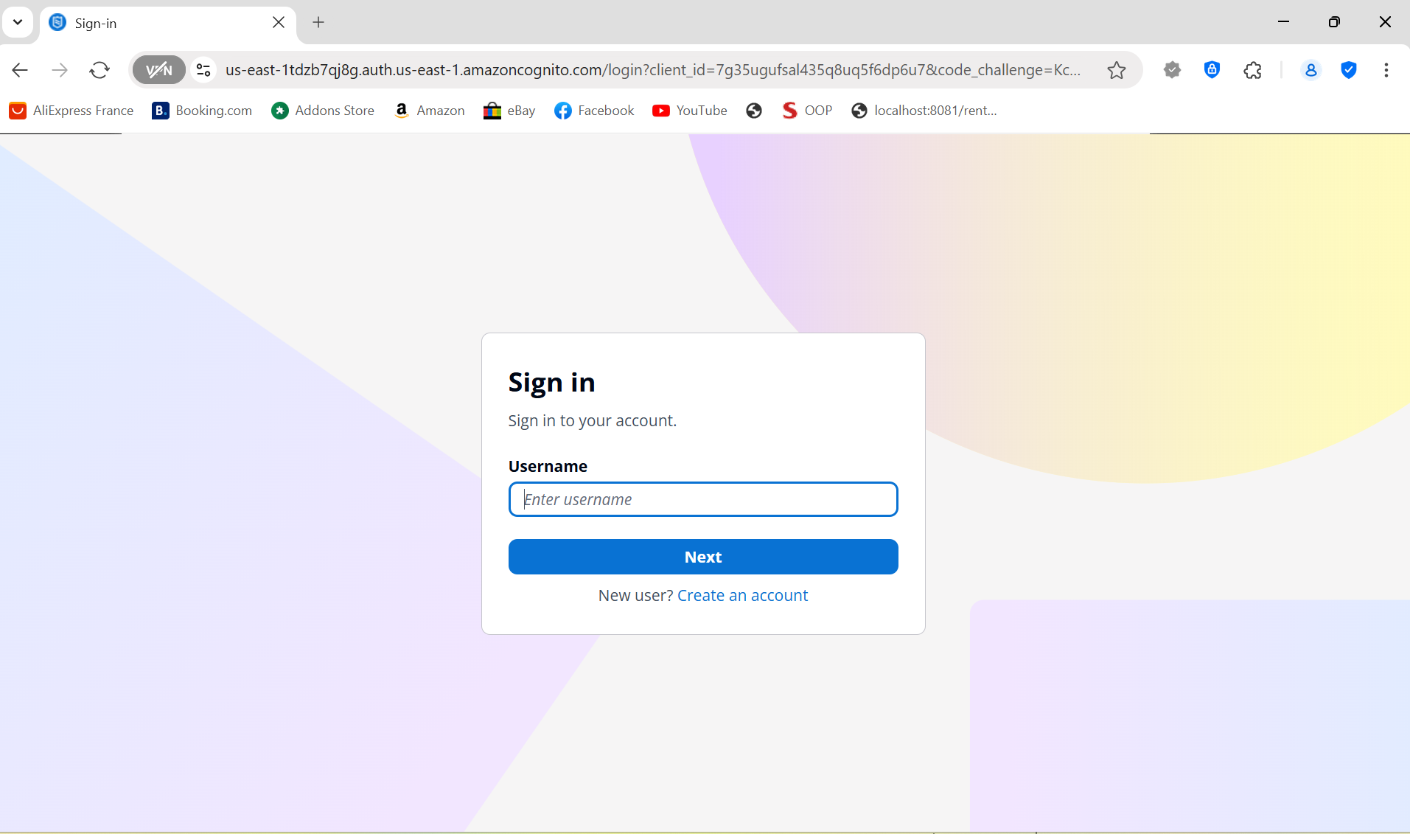
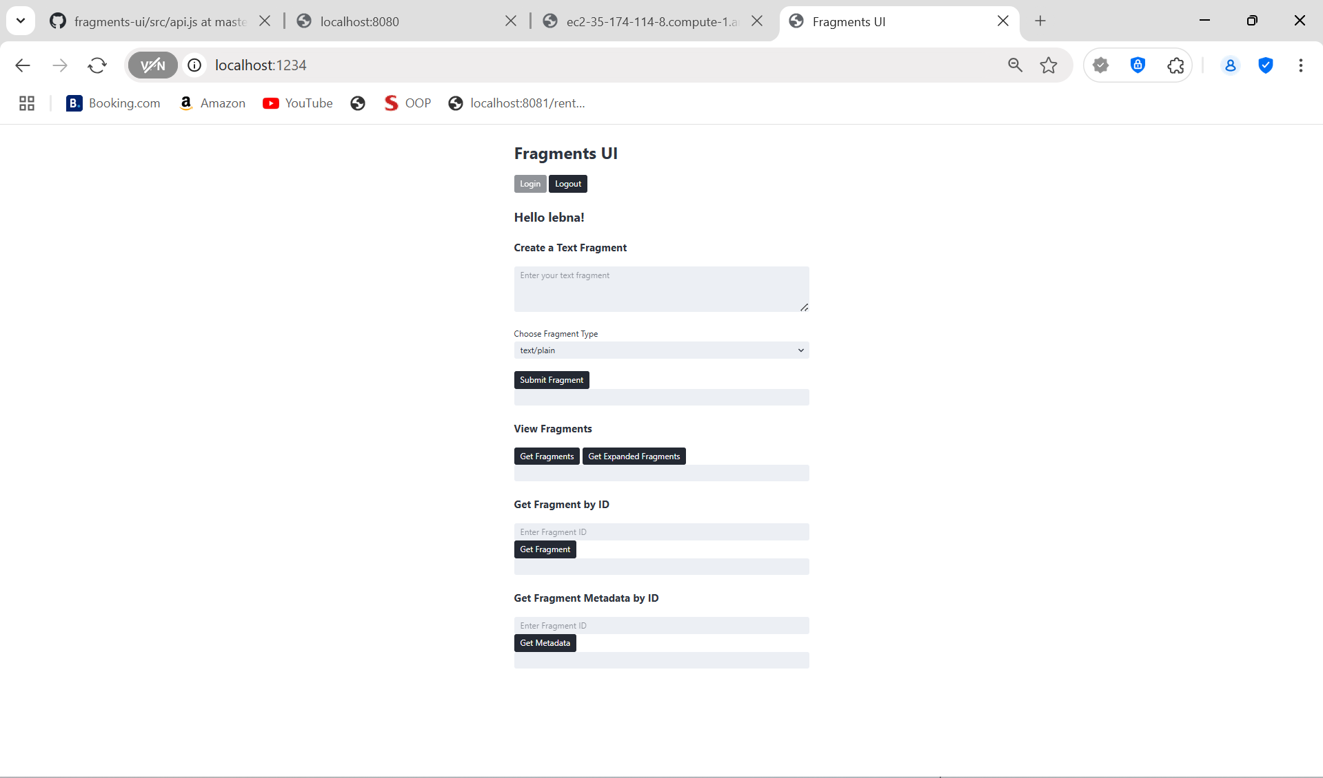
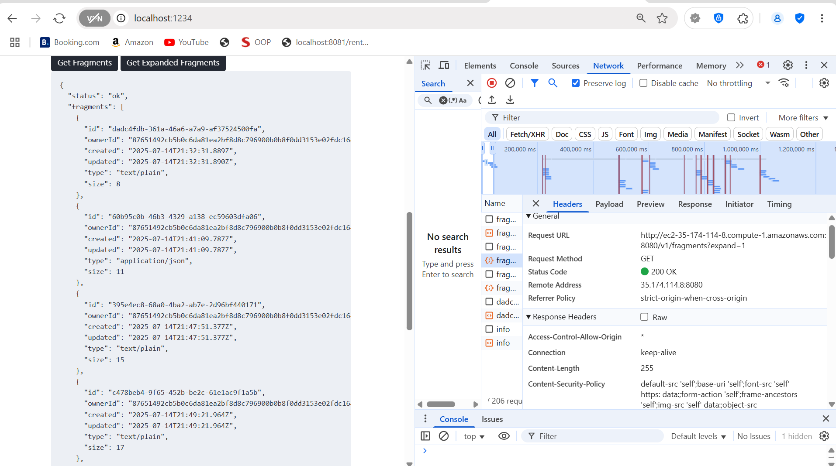
  - User creating a new JSON fragment
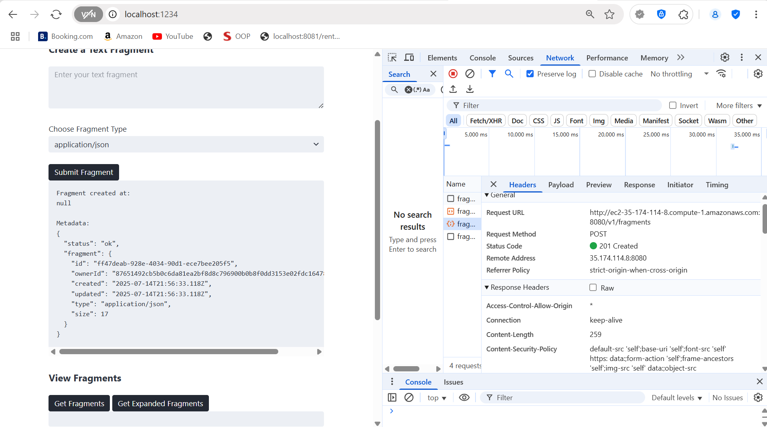
  - User creating a new Markdown fragment
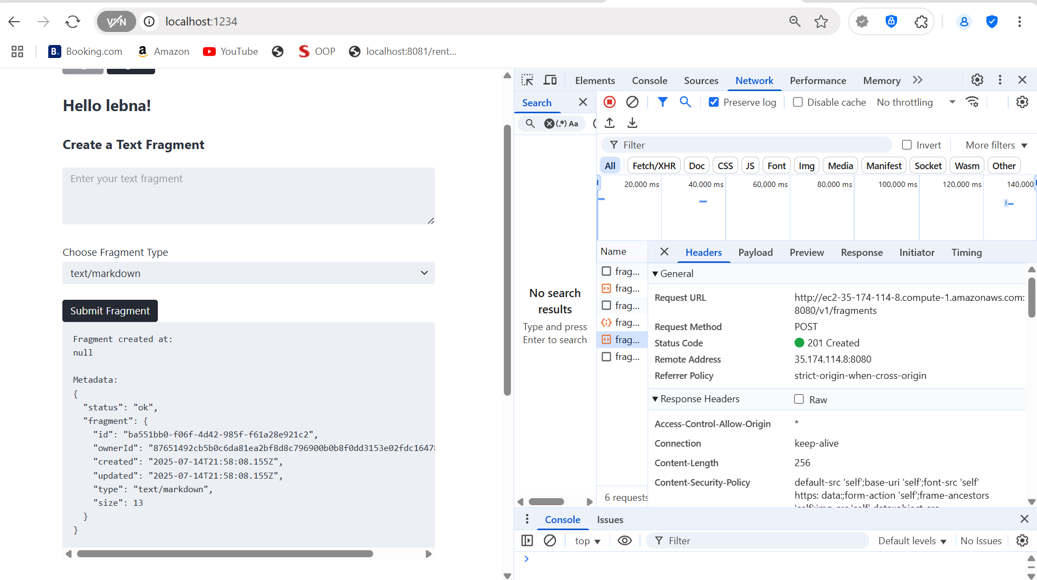

-docker logs
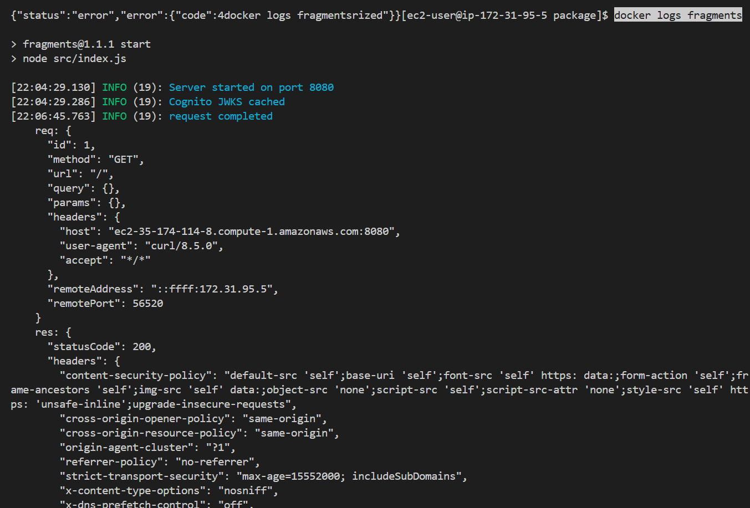

- Screenshot of running npm run coverage to show that you've been able to properly cover the majority of your files and lines of code. Make sure your coverage rate is high enough to reflect proper testing for all units of code (>80% and includes all source files in this release).
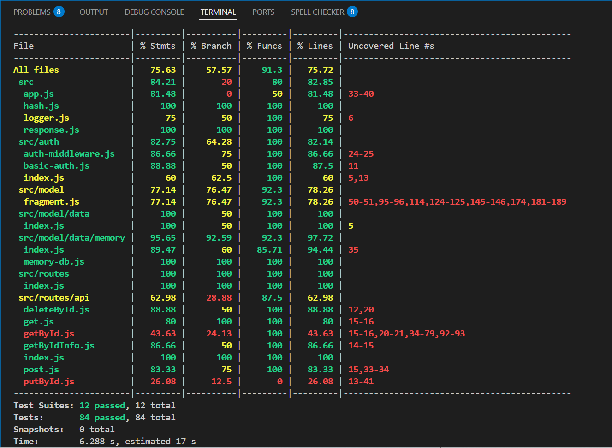

5. Conclusion
During this assignment, I faced multiple challenges integrating the backend API with the frontend UI, especially configuring authentication with Amazon Cognito and connecting the local UI with the EC2-hosted API. Additionally, deploying the Docker container on EC2 required troubleshooting environment variables and port access.
All major issues have been resolved, and the system now functions as expected: users can securely login, create, and retrieve fragments. Unit tests pass both locally and on GitHub Actions, and the Docker container runs smoothly on EC2.
Remaining issues to address in future releases include expanding support for fragment types beyond plain text, improving frontend usability, and migrating from the in-memory database to a persistent AWS backend data store.

