Screenshot of the first time you ran Hadolint on your Dockerfile, showing any warnings or errors you had to correct.
- At first I was getting this error, because I ran Hadolint locally with Docker and lints my Dockerfile, but running the `hadolint` runs it natively on windows.
- 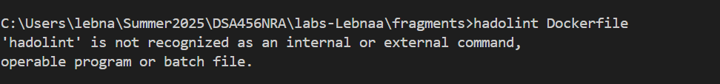

After running it on wsl, didn’t get no errors, as I run the command `hadolint Dockerfile` through wsl after downloading the latest Hadolint binary for Linux
  - sudo wget -O /usr/local/bin/hadolint https://github.com/hadolint/hadolint/releases/latest/download/hadolint-Linux-x86_64
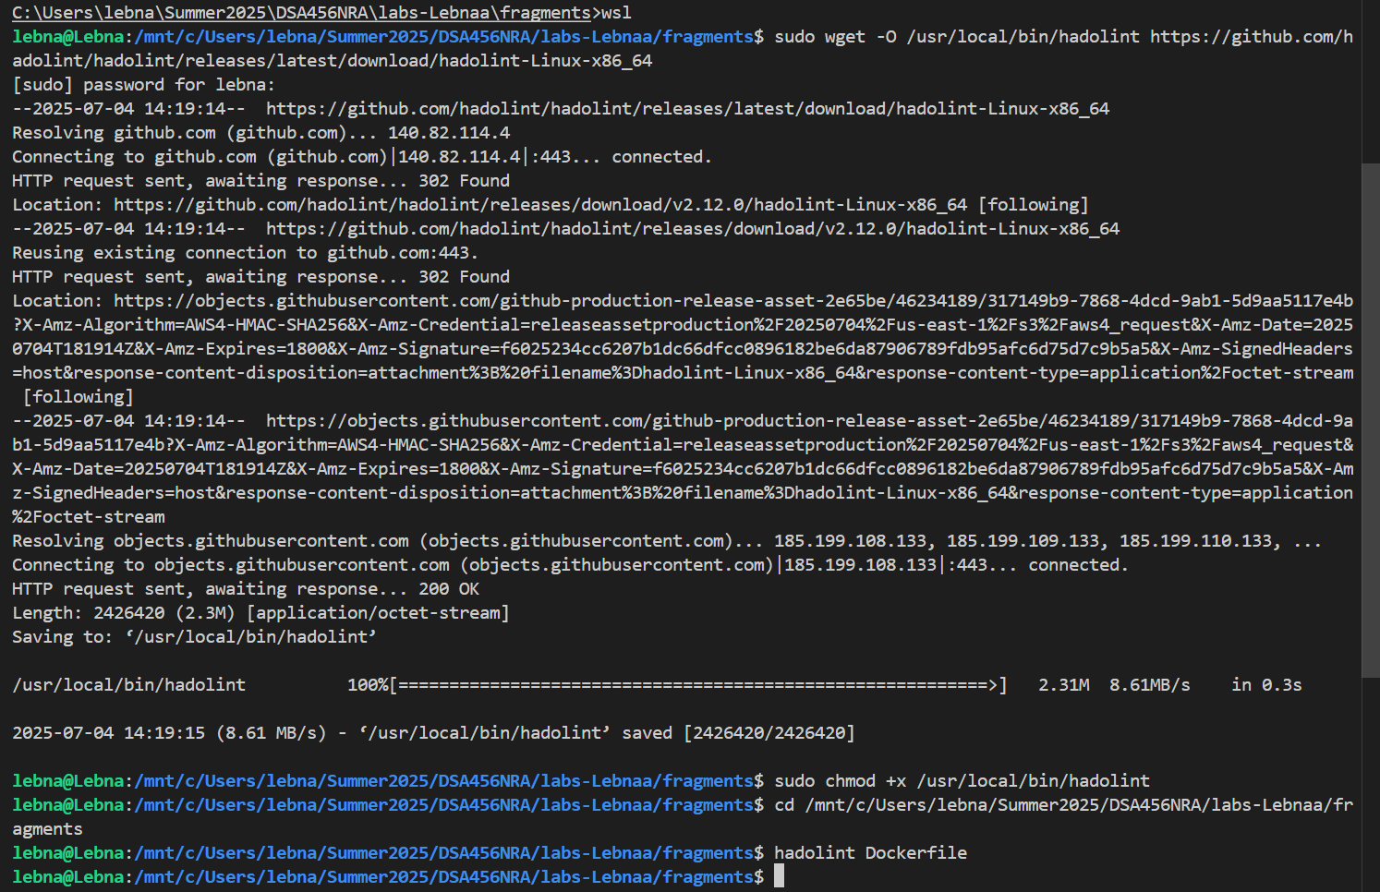

Screenshot of a successful CI workflow, showing your new Dockerfile Lint and Docker Hub jobs succeeding.
- 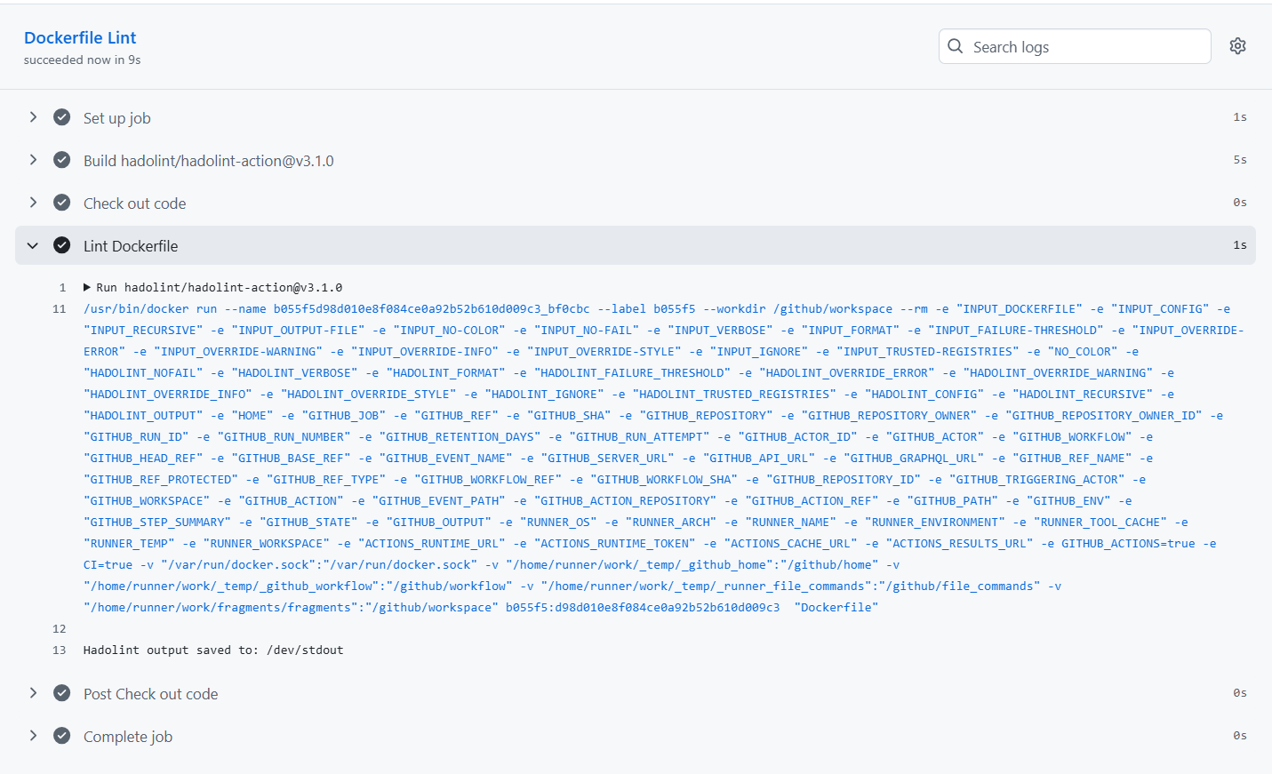

Screenshot of your main and latest Tags in Docker Hub, created by your GitHub Actions ci.yml workflow.
- 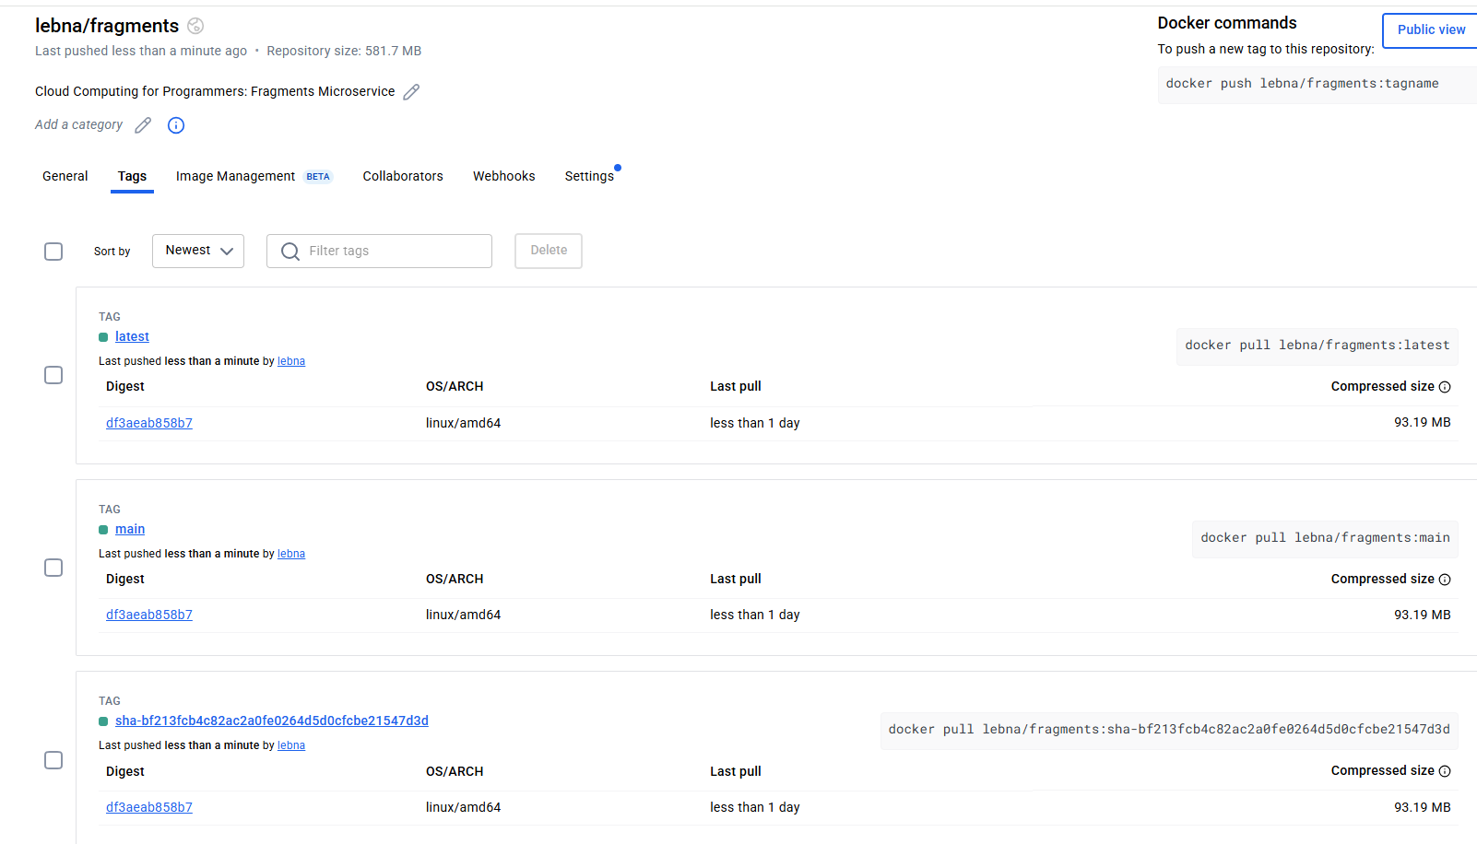

Screenshot of a successful CD workflow, showing your AWS login, build and push jobs succeeding.
- 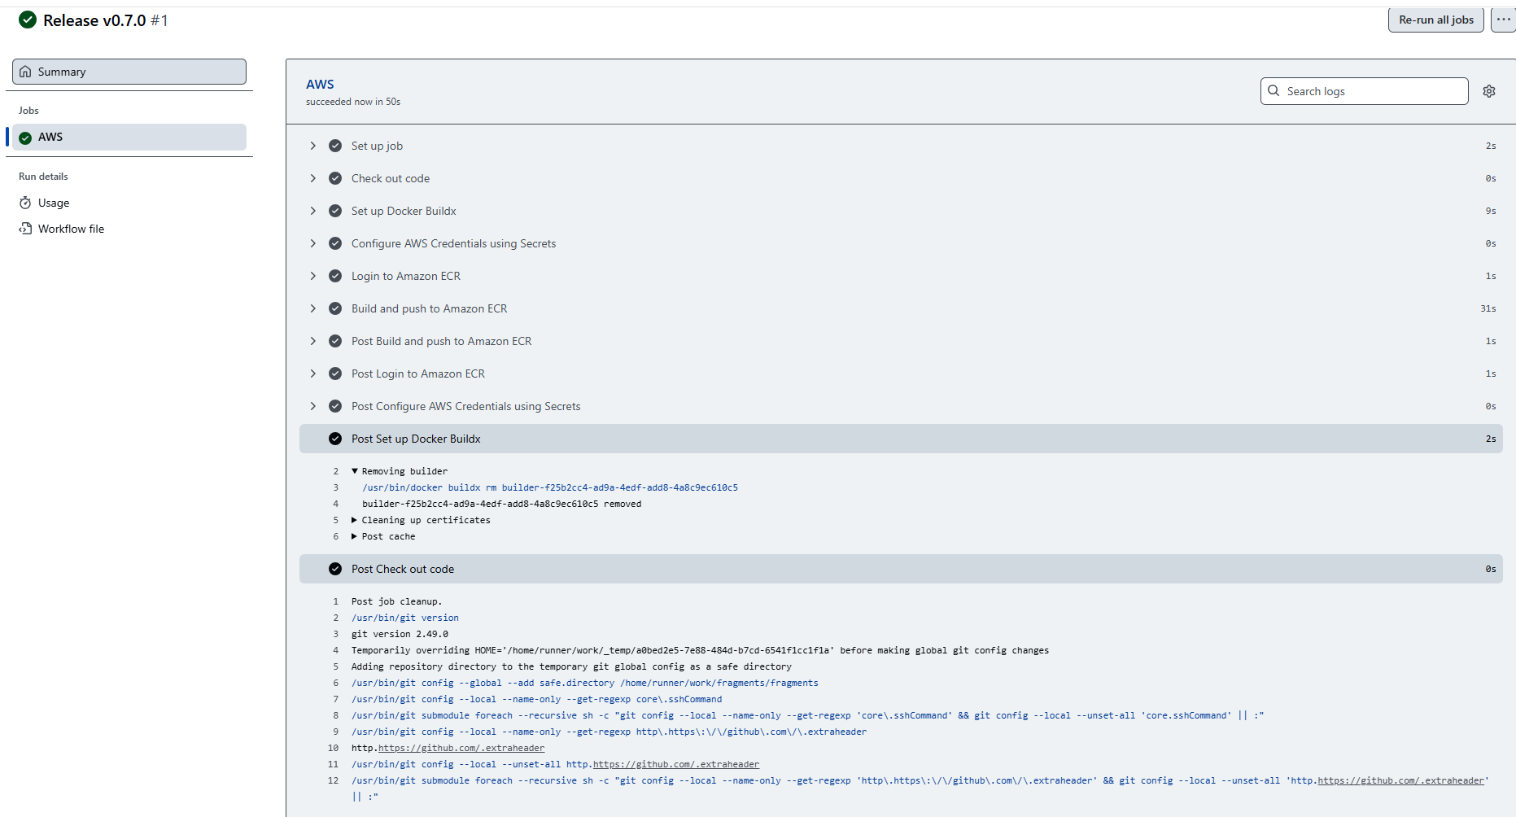
Screenshot of your Amazon Elastic Container Registry showing your fragments Image and tags, built via GitHub Actions.
- 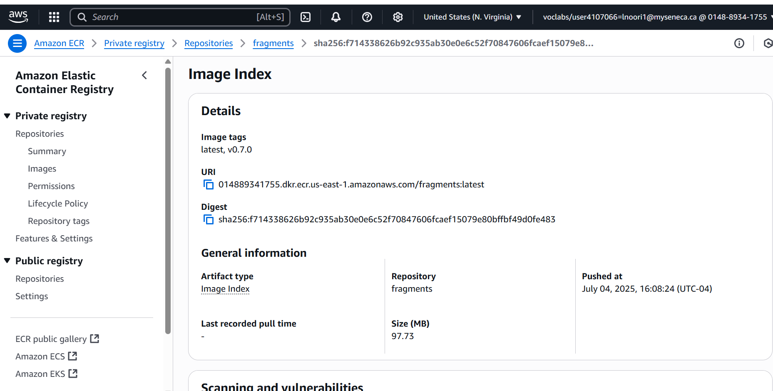

Screenshot of your local machine running the main image from Docker Hub, built and pushed by your GitHub Actions ci.yml workflow.
- 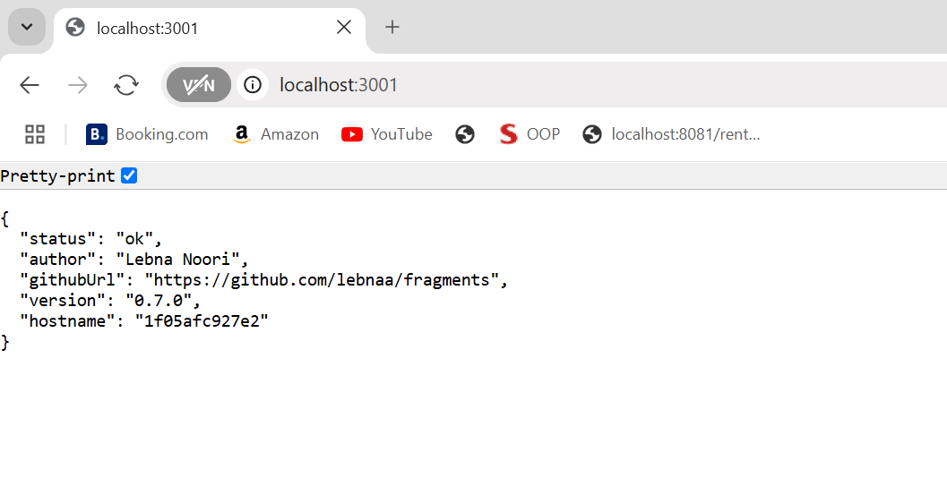

Screenshot of EC2 instance running the v0.7.0 image (or your latest version tag) your Amazon Elastic Container Registry and fragments repo, built and pushed by your GitHub Actions cd.yml workflow.
- 
 