Add all of the changes you've made to your code to git and push to GitHub. Link to the tests/integration folder on GitHub for your fragments repo, showing all of the .hurl files you wrote for the test cases above.
- https://github.com/Lebnaa/fragments/actions/runs/16304230462
Screenshot of all three containers successfully being started using docker compose.
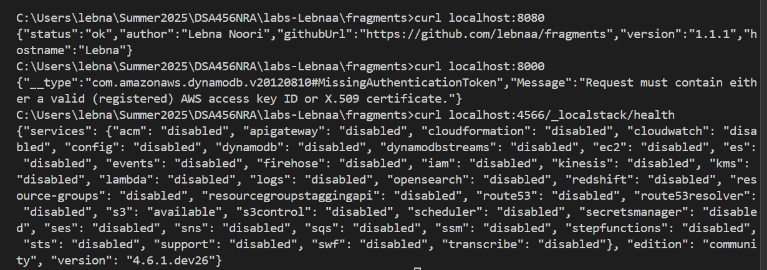
Screenshot of the local-aws-setup.sh running successfully against the running containers
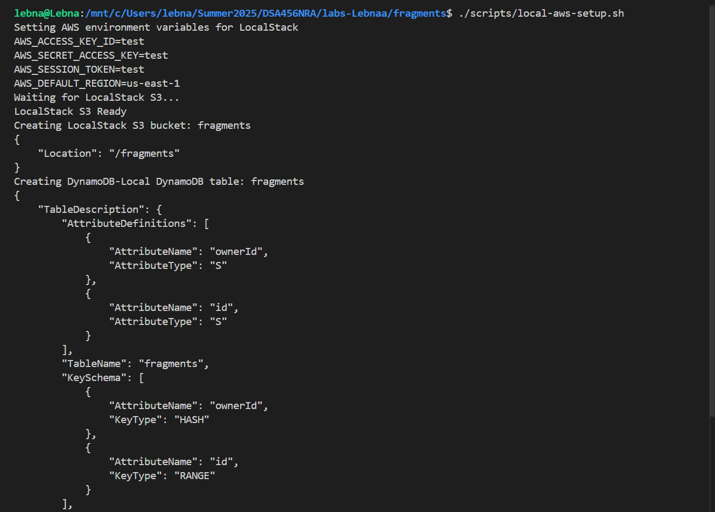
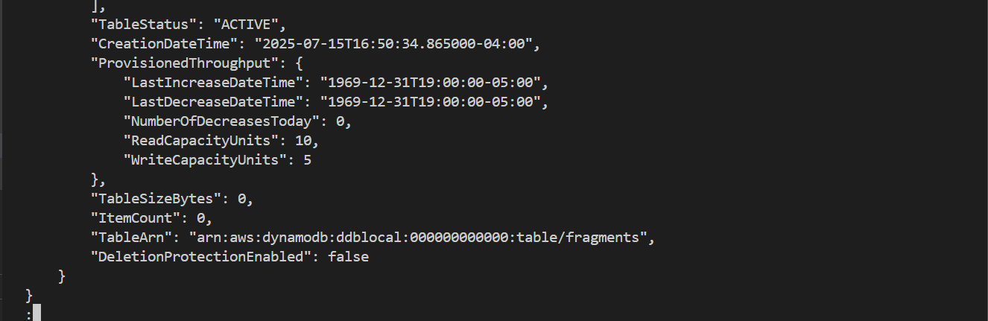

Screenshot of hurl successfully running all of the integration tests described above.
