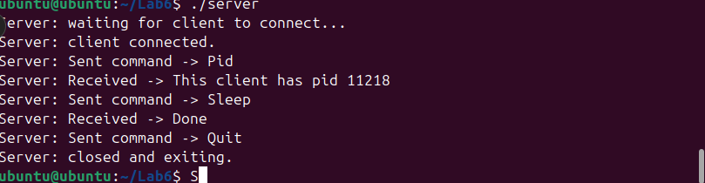


D1) On a scale from 1 to 5, How much did you use generative AI to complete this
assignment? Where:
- scale from 1 to 5, How confident are you in your understanding of the
generative AI support you utilized in this assignment, and in your ability to explain it if questioned?
- 1 means "Not confident at all – I do not understand the generative AI support I
used and cannot explain it.
- 2 means "Slightly confident – I understand a little, but I have many
uncertainties."
- 3 means "Moderately confident – I understand the majority of the support,
though some parts are unclear."
- 4 means "Very confident – I understand most of the AI support well and can
explain it with minor gaps."
- 5 means "Extremely confident – I fully understand the generative AI support I
used and can clearly explain or justify it if asked."
- Your answer : 4 – Very confident
used generative AI to help with the assignment, and I understand most of the support it provided. I can explain how and why I used it, with only minor gaps.

On a scale from 1 to 5, How confident are you in your understanding of the
generative AI support you utilized in this assignment, and in your ability to explain it if
questioned? Where:
- 1means "Not confident at all – I do not understand the generative AI support I
used and cannot explain it."
- 2 means "Slightly confident – I understand a little, but I have many
uncertainties."
- 3 means "Moderately confident – I understand the majority of the support,
though some parts are unclear."
- 4 means "Very confident – I understand most of the AI support well and can
explain it with minor gaps."
- 5 means "Extremely confident – I fully understand the generative AI support I
used and can clearly explain or justify it if asked."
- Your answer :5 – Extremely confident, I fully understand the generative AI support I used in this assignment and can clearly explain or justify how I used it if asked

